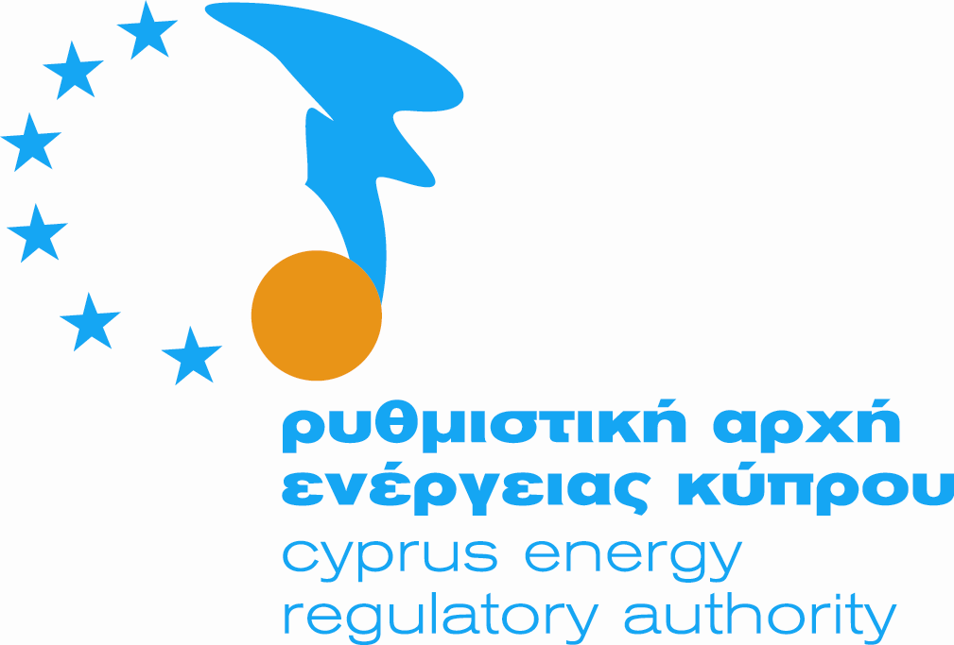


CYPRUS ENERGY REGULATORY AUTHORITY (CERA)

Report to the European Commission
in line with the Electricity and Gas Directives
for the period July 2005 to July 2006

July 2006

REPORT TO THE EUROPEAN COMMISSION
IN LINE WITH ELECTRICITY AND GAS DIRECTIVES
FOR THE PERIOD JULY 2005 TO JULY 2006

FOREWORD

The Cyprus Energy Regulatory Authority (CERA) was established by virtue of the Law on Regulating the Electricity Market of 2003 N.122(I)/2003, which was enacted by the House of Representatives on 25 July 2003, for harmonisation purposes with the Aquis Communitaire. The Members of CERA were appointed on 21 January 2004 and took up their duties on 4 February 2004 after giving the prescribed affirmation for the faithful execution of their duties, to the President of the Republic of Cyprus.

The present Report covers the period from July 2005 to July 2006 and is the second one to be issued.

In reading this Report one should bear in mind that Cyprus operates under the provisions of the Directive, for "Small Isolated Systems".

The establishment of the Cyprus Energy Regulatory Authority (CERA) and the appointment of the Transmission System Operator (TSO) during 2004 constitute two very important events in the field of Energy, a field that prior to the entry of Cyprus into the European Union (EU), had a purely monopolistic character. It was and still is among the basic priorities of Cyprus to get fully harmonised with the Acquis Communitaire in the field of Energy. This process passes through a series of actions, the most important being the one that aims at a healthy competition with the abolition of monopolistic attitudes and conduct.

One of the urgent priorities of CERA was the opening of the Electricity Market. This was achieved and the Electricity Market was liberalised by 35% on 1st May 2004. This percentage now includes the 726 biggest electricity consumers in Cyprus, each of whom consumes at least 350,000 kilowatt-hours per year. The annual electricity bill of these 726 consumers amounts to about CY£75 (€130) million. These consumers are now free to select the Supplier that will supply them with electricity. In the next few years the market will be liberalised 100% as the ultimate target is for all consumers of electrical energy to be able to select their Supplier according to what is in their best interest.

During 2005, the Electrical Energy Sector in Cyprus has its own historical landmark. In this period the important event was the issue of New Licences for the Construction and Operation of Power Stations for the Generation of Electricity. By this development, the monopoly regime which existed for more than half century, comes to an end.

It now remains for the Projects to materialise so that their unhindered access to the Electricity Network may follow. This will allow Eligible Consumers the free choice of their Supplier which is the essence of free competition in the Energy Market. CERA, is also giving due importance to the matter of rational and gradual liberalisation of the Electricity Market in order not to upset the smooth operation of the Market.

The securing of the quality and reliability of Electrical Energy was amongst the top priorities of CERA while creating favourable conditions to promote the use of Renewable Sources of Energy.

Furthermore, new Regulations were prepared by CERA and approved by Parliament safeguarding consumers’ rights, namely the Regulations on the Procedure for Submitting Complaints, and the Performance Indicators Regulations.

A Regulatory Decision was also issued by CERA in 2005 on the Methodology of Electricity Tariffs. At the same time, discussions, meetings and deliberations are constantly in process with all parties involved in the Energy Sector on various important itemised issues among which were the Market Rules, the Transmission and Distribution System Rules, already revised once, the connection and use charges of the Transmission and Distribution System.

Although Natural Gas is still not available on the island, all necessary Regulations were enacted to complete the Legal framework on Regulating the Natural Gas Market. On the subject a Ministerial Directive was issued defining the natural gas as the primary fuel for generation of electricity by sizeable capacity installations.

It would be an omission not to thank all those who helped CERA in its first years by offering their cooperation and assistance. These definitely include ERGEG and CEER. The bridges of communication built and the cooperation and common understanding between everybody involved help greatly the work of CERA.

COSTAS IOANNOU
Chairman
Cyprus Energy Regulatory Authority

SUMMARY \ MAJOR DEVELOPMENTS IN THE LAST YEAR

  - Basic Organisational Structure of the Regulatory Agency
    - Composition of Regulatory Authority

The Cyprus Energy Regulatory Authority (CERA) has three Members who were appointed on 21 January 2004 for a 6-year term by the Council of Ministers. The Cyprus Energy Regulatory Authority consists of:
- Costas Ioannou Chairman
- Stelios Petrides Vice-Chairman
- Kypros Kyprianides Member

(Refer to the organogram of CERA shown on page 6)

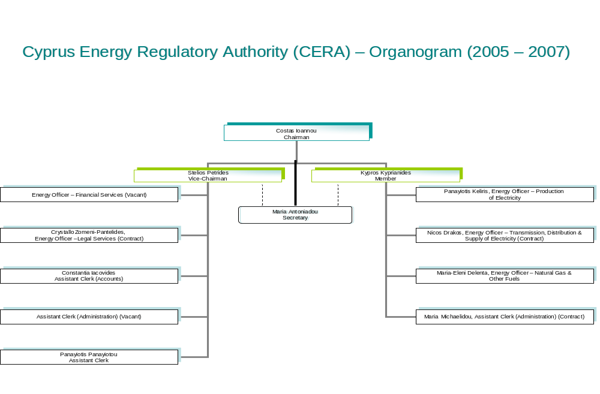

    - Main Statutory Objectives

The main statutory objectives of CERA are set out below:

- To encourage, promote and safeguard the healthy and essential competition in the Electricity and Natural Gas Markets.
- To protect Consumers’ interests.
- To promote the development of economically viable and efficient Electricity and Natural Gas Markets.
- To ensure the Security, Continuation, Quality and Reliability of Electricity Supply.
- To take into consideration the Protection of the Environment.
- To encourage the efficient generation and use of Electricity.
- To promote the use of Renewable Energy Sources (RES).

2.1.3 Main Enforcement Powers

The Cyprus Energy Regulatory Authority is an independent authority of the Republic of Cyprus and has executive powers and competences in the Energy Field.

Among others, CERA has the following powers and competences:

Electrical Energy

- Issues, controls, enforces, amends and revokes Licences to Generate and Supply of Electricity.
- Advises the Minister* in all subjects relating to electricity.
- Ensures that the Rules for the Transmission and Distribution and the Rules for the Electricity Market are prepared and approved in accordance with the Law.
- Safeguards the adequacy in electrical energy for the satisfaction of all reasonable needs and demands for electricity.
- Regulates tariffs, charges and other conditions and presuppositions which are imposed on the Licence Holders for any services offered in accordance with the conditions of their Licences.
- Determines, publicises and enforces quality standards with which the Licence Holders must comply.
- Determines the rules and the procedures according to which complaints are examined which relate to services offered by the Licence Holders including, when it considers it appropriate, the carrying out of investigations and the taking of decisions for such complaints.
- Encourages and facilitates competition with the ultimate target of lowering of prices.
- Protects the interests of the consumers.

- In this Report Minister / Ministry refers to the Minister / Ministry of Commerce, Industry and Tourism

- Ensures the Continuation, Quality, Reliability and Security of Electricity Supply.
- Protects the Environment.
- Encourages the use of Renewable Energy Sources (RES)
- Encourages Research and Development in the field.
- Ensures that the Licence Holders operate efficiently and have the ability to finance the business activities for which they are licenced.
- Promotes the development of an economically viable and efficient electricity market.
- Takes into consideration the needs of the consumers of rural areas, the consumers who are in a disadvantageous position and the elderly.

Natural gas

- Issues, controls, amends, suspends and revokes Licences for the Import, Storage, Distribution and Supply of Natural Gas.
- Approves the conditions and presuppositions for the connection and access to the network, including the transmission and distribution tariffs as well as the conditions, presuppositions and tariffs for access to the installations of Liquified Natural Gas.
- Determines the rules for the management and the distribution potential of interconnection, in consultation with the appropriate authority or authorities of the Member States with which there is interconnection.
- Sets up or approves mechanisms to face the congestion in the natural gas network.
- Protects the interests of natural gas consumers.
- Regulates tariff rates, charges and other conditions and presuppositions imposed on the Licence Holders for any offered service based on the conditions of their Licences.
- Enacts, publishes and puts into force Regulations for quality standards with which the Licence Holders must comply.
- Takes suitable and effective measures for control and transparency, so as to avoid possible misuse of dominant positions, to the detriment of consumers.
- Safeguards the observance of the competition rules in the field of transmission, distribution, storage and supply of natural gas.
- Safeguards the satisfaction of the demand for natural gas.
- Ensures that the Licence Holders are able to finance the business for which a Licence is issued.
- Promotes the development of an economically strong and effective natural gas market.
- Safeguards the Safety, Continuity, Quality and Effectiveness in the supply of natural gas.
- Protects the environment.
- Encourages the research and development regarding the transmission, distribution, storage, supply and use of natural gas.

It is also the duty of CERA to:

- Safeguard and publicise measures which may be taken in case of unforeseeable crisis in the energy field, or when there is a danger to the safety of people, works, installations or the integrity of the networks, and
- Follow up the issues of security of the supply, and especially the balance of supply and demand in the market, the level of the expected future demand and the available plant, as well as the level of competition in the market.

During the execution of its duties, CERA takes the necessary measures to comply with the Public Service Obligations. The ultimate aim of CERA is to protect in the best possible way the interests of Energy Consumers, but at the same time to protect the public interest.

2.1.4 Independence and Accountability

The Cyprus Energy Regulatory Authority is an independent Authority of the Republic of Cyprus and has executive powers and competences in the Energy Field. CERA is appointed in office for six years by the Ministerial Council in accordance with the Electricity Market Regulatory Law N.122 (I) of 2003 and the Natural Gas Market Regulatory Law N.183 (I) of 2004 and through provisions in the above laws it reports directly to the President of the Republic. Its annual budget, however, has to be approved firstly by the Council of Ministers (after the Council receives comments and recommendations from the Ministry of Commerce, Industry and Tourism and the Ministry of Finance) and then by the Parliament.

2.1.5 Overlapping jurisdictions with other Governmental agencies / authorities (national and supranational)

As it can be seen from previous sections CERA has almost full authority in the Electricity and Gas markets and is adequately empowered to operate efficiently and to safeguard a reliable supply to all consumers of the markets. The Ministry is given through the above referred laws some competencies as far as policy issues are concerned e.g. approval of PSOs (Public Service Obligations). There is, however, definitely overlapping jurisdiction with the Cyprus Competition Authority and this is already creating “some difficulties”. Representatives from both Authorities are working on issues of possible concurrent powers in an effort to prepare a code of practice whereby overlapping powers are smoothed out.

2.2 Main developments in the gas and electricity markets

The following Legal framework has been put in place:

No. |  |  | Title of Law/ Regulations | Number of  Regulations | Number of  Gazette |  | Date of Publication
LAWS ENACTED
1. |  |  | The Law of 2003 on Regulating the Electricity Market | L.122(I)/2003 |  | 3742 | 25/07/03
2. |  |  | The Law of 2004 on Regulating the Electricity Market– AMENDMENT | L.239(I)/2004 |  | 3918 | 05/11/04
3. |  |  | The Law of 2005 on Regulating the Electricity Market – AMENDMENT | L.143(I)/2005 |  | 4057 | 09/12/05
4. |  |  | The Law of 2004 on Regulating the Natural Gas Market | L.183(I)/2004 |  | 3852 | 30/04/04
5. |  |  | The Law of 2006 on Regulating the Natural Gas Market – AMENDMENT | L.103(I)/2006 |  | 4088 | 21/07/06
REGULATIONS ISSUED BY VIRTUE OF THE PROVISIONS OF THE LAW OF 2003 – 2005 ON REGULATING THE ELECTRICITY MARKET, 122(I)/2003
1. |  | The INVESTIGATIONS PROCEDURE Regulations of 2004 |  | Reg. 465/2004 |  | 3851 | 30/04/04
2. |  | The ISSUING OF LICENCES Regulations of 2004 |  | Reg. 538/2004 |  | 3853 | 30/04/04
3. |  | The LICENCE REGISTER Regulations of 2004 |  | Reg. 466/2004 |  | 3851 | 30/04/04
4. |  | The LICENCE FEES Regulations of 2004 |  | Reg. 467/2004 |  | 3851 | 30/04/04
5. |  | The ADMINISTRATIVE FINES Regulations of 2004 |  | Reg. 468/2004 |  | 3851 | 30/04/04
6. |  | The ELECTRICITY TARIFFS Regulations of 2004 |  | Reg. 472/2004 |  | 3851 | 30/04/04
7. |  | The CERA STAFF Regulations of 2004 (APPOINTMENT, PROMOTION, SERVICE AND DISCIPLINARY CODE) |  | Reg. 528/2004 |  | 3853 | 30/04/04
8. |  | The PROCEDURE FOR SUBMITTING COMPLAINTS Regulations of 2005 |  | Reg. 570/2005 |  | 4058 | 16/12/05
9. |  | The PERFORMANCE INDICATORS Regulations of 2005 |  | Reg. 571/2005 |  | 4058 | 16/12/05
Regulations issued by virtue of the provisions of the law of 2004 ON regulating the natural gas market, l.183(I)/2004
1. |  | The INVESTIGATIONS PROCEDURE Regulations of 2006 |  | Reg. 297/2006 |  | 4122 | 21/07/06
2. |  | The ISSUING OF LICENCES Regulations of 2006 |  | Reg. 298/2006 |  | 4122 | 21/07/06
3. |  | The LICENCE FEES Regulations of 2006 |  | Reg. 299/2006 |  | 4122 | 21/07/06
Laws in progress
1. | The Law for the Promotion of Electricity produced from Renewable Energy Sources in the Internal Electricity Market of 2003 – AMENDMENT -
2. | The Law for the Promotion of Cogeneration of Energy
3. | The Law regarding Measures to Safeguard Security on Natural Gas Supply

DECREES, DecisionS and/or DirectiveS by the Minister of Commerce, Industry and Tourism
1. | The Eligible Consumer Ministerial Decree of 2004 | 340/04 | 3847 | 30/04/04
2. | Ministerial Directions of 2006 regarding The Natural Gas as a primary source for production of Energy for all future sizeable capacity installations | 115/06 | 4088 | 17/03/06
3. | The Public Service Obligation Ministerial Decision of 2006 regarding the electricity price charged to families (over 6 members) and disadvantaged families | 200/06 | 4098 | 28/04/04
Regulatory Decisions
1. | Generation Exemptions from Licence for Units of less than 10KW capacity | - | 3967 | 18/03/05
2. | Statement of Regulatory Practice and Methodology on Electricity Tariffs – Regulatory Decision No. 01/2006 | 177/06 | 4096 | 14/04/06
RULES
1. | The Electricity Transmission/ Distribution Rules | Approved on 07/10/04  Revised on 19/06/06
2. | The Electricity Market Rules | Approval due in 2006 - Approval in essence granted, subject to simplification of the Rules to be effected.
Charges
1. | New Charges for Customer Services by EAC | Approved on 01/11/05  In Effect from 01/01/06
2. | New EAC Tariff Charges | Approval due in 2006/2007
3. | Charges for the Use of the Transmission System | Approval due in 2006/2007
4. | Charges for the Use of the Distribution System | Approval due in 2006/2007
5. | Charges for the Connection to the Transmission Network | Approval due in 2006/2007
6. | Charges for the Connection to the Distribution Network | Approval due in 2006/2007

The Market Rules referred to above are based on the operating model of the liberalised electrical energy market shown on page 15. From the diagram it can be seen that the market is characterised by the following:

- Market Regulation: CERA (with almost full authority)
- Operation of System & Market: Manager TSO (independent in legal and
management terms).
- Basic Trading Arrangement: Bilateral Agreements
- Balancing Market: 2% to 3% of energy traded through TSO
- Captive Market: EAC, 65% (small industrial, commercial
and domestic)
- Eligible Market*: 35% (big industrial and commercial)
- Competition in generation: EAC, IPPs, RES and Autoproducers

- The Government of Cyprus has applied to the European Commission for a derogation regarding the further opening of the electricity market. It was reported that there are reasons that support some delay in the further opening of the market i.e. on 1 January 2009 for all non domestic consumers and full opening of the market on the 1 January 2014. CERA has been verbally informed that approval for the derogation has been granted. However, formal confirmation of the European Commission’s Decision is awaited.

2.3 Major issues dealt with by CERA

CERA, since its appointment in January 2004, has been actively involved in the preparation of all the legislation referred to above in Section 2.2. Furthermore, CERA moved quickly to acquire and organize the necessary independent office facilities and has done all that was required to appoint basic support staff.

Apart from the above, one of the urgent priorities of CERA was the opening of the Electricity Market. This was achieved and the Electricity Market was liberalised by 35% on 1st May 2004. This percentage includes the 726 biggest electricity consumers in Cyprus, each of whom consumes at least 350,000 kilowatt-hours per year. The annual electricity bill of these 726 consumers amounts to about C£75 million (approximately EURO 130 million). These consumers are now free to select the company that will supply them with energy. In the next few years the market will be liberalised 100% as the ultimate target is for all consumers of electrical energy to be able to select their Supplier according to what is in their best interest.

A Regulatory Decision was issued on 01/12/04, on the basis of which Autogeneration Units up to 1MW, Generation Units from RES (Renewable Energy Sources) up to 5MW and the Supply of electricity up to 500KW are issued with exemption from Licence. The decision exempts these categories from the obligation to own and renew various licences, provided that an application for exemption has been submitted and approved through a simplified procedure.

The Regulatory Decision included also the provision that no licence or exemption issue from Licence is needed for RES systems up to 10KW.

CERA has also decided that small generating units, for domestic use, up to 10 kW, in isolated areas where there is still no distribution network, do not require a licence to operate. In addition a simplified procedure has been introduced for the licensing of stand-by generating units.

CERA has done a lot of preparatory work in order to be able to issue the various licences to the TSO, the network owners and previously existing generators. More details of this work appear in section 5 below.

A Regulatory Decision was published on 14/04/06 regarding the Methodology of Tariffs, which among others, entailed months of intense preparation work, publication of a draft methodology, and consideration of comments made by all concerned.

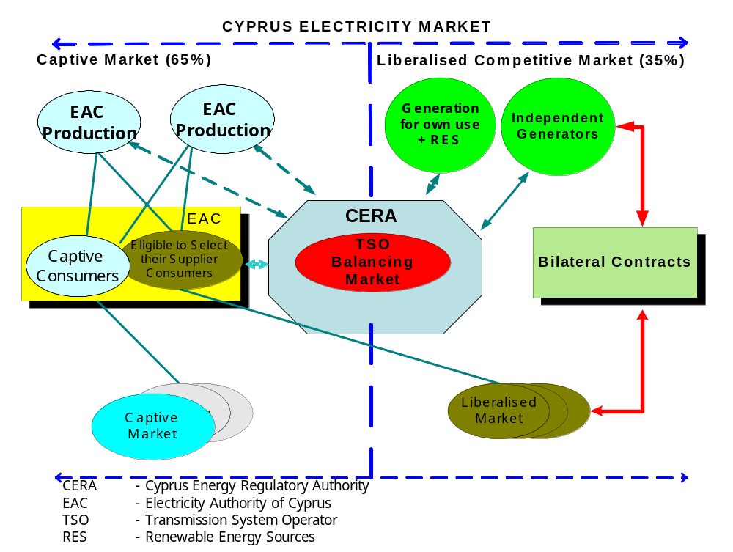
5

3. REGULATION AND PERFORMANCE OF THE ELECTRICITY MARKET
3.1 Regulatory Issues [Article 23(1) except “h”]

3.1.1 General

As already mentioned, one of the urgent priorities of CERA was the opening of the Electricity Market. This was achieved and the Electricity Market was liberalised by 35% on 1st May 2004. This percentage includes the 726 largest electricity consumers in Cyprus, each of whom consumes at least 350,000 kilowatt-hours per year.

Cyprus has applied for a derogation regarding the time table for the further opening of the market, in accordance with Article 21 of the Directive and verbal approval has been granted. It was requested that the definition of the Eligible consumers change as follows to include:

- From 1 January 2009, all non-household consumers
- From 1 January 2014, all consumers.

Table 3.1.1
Electricity Market Opening Table
Year | Threshold GWh/year | % Market Open
1995 |  | 0
1997 |  | 0
1999 |  | 0
2001 |  | 0
2003 |  | 0
2005 | 0,35 | 35
2007 | 0,35 | 35

3.1.2 Management and Allocation of interconnection capacity and mechanisms to deal with congestion

At present, Cyprus, as an island, operates without cross-border links. Thus, cross-border congestion management rules are not applicable. In the primary legislation, there is a clear definition of the role of the TSO to observe and record on an annual basis an assessment regarding expected flows and other conditions related to transmission capacity and ensuring that measures are taken to avoid breaching security of supply standards. According to the primary legislation, the TSO is obliged to publish a ten-year development plan which will be available to all market participants.

3.1.3 The regulation of the tasks of transmission and distribution companies

Cyprus, being a small isolated system, has opted through the Law of 2003 on Regulating the Electricity Market, L.122(I)/2003, (further down referred to as the Law) for,

(a) a single TSO unbundled in legal and management terms from the System Owner.

(b) a common, bundled distribution network, Owner & DSO, as part of the Electricity Authority of Cyprus (EAC) which is the vertically integrated utility of Cyprus involved in all the functions of the electricity market.

For network tariffs, in close cooperation with the TSO and EAC, reports have been prepared using outside consultants (from Greece, UK, Ireland, and Netherlands) and these are currently under consideration for approval. The methodology developed in the reports is based on the following principles:

- Unbunding of EAC accounts under the following broad categories:
- Generation
- Transmission Network
- Transmission System Operator (EAC related costs)
- Distribution
- Supply
- Other business
- Re-evaluation of generation and network assets
- Identification of ancillary services and cost valuation of each one separately
- Identification of Public Service Obligations
- Benchmarking of various activities with reference to published performance indices of European Utilities.

The above referred reports are currently under review for final approval. These will facilitate the formulation of network tariffs that will guarantee the following pre-requisites:

- Economic Efficiency/cost reflectivity
- Cost recovery
- Efficient Regulation
- Simplicity, transparency and stability
- Non-discrimination
- Facilitation of competition

The Cyprus Energy Regulatory Authority (CERA) has been vested through the Law with the responsibility of approving tariff methodologies and actual tariffs and charges of the Monopoly Sectors of the industry and all activities of EAC who is the dominant participant in the Electricity Market.

The Electricity Market Law of 2003 covers adequately the requirements of the Electricity Directive under Article 3 for consumer protection and performance standards that affect the quality of supply to all consumers with particular emphasis to vulnerable consumers. Regulations were enacted pursuant to Article 88 of the Law laying down demanding obligations on the network owner and on suppliers to meet such quality standards that will safeguard the quality and continuity of electricity supply to all consumers.

The TSO in close cooperation with EAC has drafted proposals for the Use of System Charges and Connection Charges and these are under consideration by CERA for final approval. Once these are approved they shall be made public and accessible to all interested parties.

The current electricity consumption charges using the tariffs in force are as follows using the corresponding Eurostat definitions. For further details see attached table of electricity prices:

- Dc : Price all taxes included: 8,21 Cyprus cent
- Ib : Price all taxes included: 14,30 Cyprus cent
- Ig : Price all taxes included: 7,07 Cyprus cent.
(1 Cyprus cent = approx. 1,74 Eurocents)

In addition EAC has produced a study through the support of an outside consultant that takes into consideration the unbundled accounts and revalued assets referred to above and through this report the proposed national average network costs are estimated as shown in the table below (these costs have not yet been approved by CERA):

Item | Max. Demand Charge CYP/MW/Month * | Energy Charge CYP/MWh | Average KWhr Charge CYPcent/KWhr **
High Voltage (66-132kV) | 2159,21 | - | 0,532
Medium Voltage (11kV) | 2099,15 | 5,17 | 1,034
Low Voltage (400 Volts) | - | 8,46 | 0,846
Transmission System Operator | - | 0,43 | 0,043
Ancillary Services | - | 1,65 | 0,165
Long term cold reserve | - | 2,71 | 0,271
Average Total CYP cent/kWhr |  |  | 2,891
EURO cent/kWhr |  |  | 5,023,
€1 = 0,5755 CYP
* MW sent out
**kWh sold

From the above the following average network costs can be deduced:

- Consumers fed from low voltage network: 2,891 CYP cent / kWhr
- Consumers fed from medium voltage network: 2,045 CYP cent / kWhr
- Consumers fed from high voltage network: 1,011 CYP cent / kWhr

EAC is preparing a proposal for submission to CERA, which will be soon under scrutiny for consideration and final approval. On the basis of the above study EAC will proceed to analyse the current tariff structure and propose to CERA new consumption tariffs for approval.

It is worth noting that the procedures and conditions for connection to the transmission or distribution system are included in the Transmission and Distribution Rules, which have been approved by CERA in October 2004 and the revised version was approved on 19/06/06. All information regarding connection charges will be published on the TSO’s website as soon as they are finalised.

Table 3.1.3
Regulation of network companies
 | Number of regulated | Approx network access charge |  |  | Interruptions
 | Companies | (Euro/MWh) |  |  | minutes lost per customer per year
 |  | Ig | Ib | Dc
Transmission | 1 | * | * | * | 0,00101
Distribution | 1 | * | * | * | No data available at present
* Connection policy is currently under scrutiny and has not been approved as yet(see above)

Balancing

The Market Rules are proposed by the TSO, approved by CERA and the Ministry, and published by the TSO. They provide all necessary information concerning operation of the electricity market in the country. The balancing arrangements are also described in the Transmission and Distribution Rules.

The balancing interval is 30min. The system applied in Cyprus is based on Bilateral Agreements between producers and their customers, who must nominate their productions to the TSO 24hrs ahead of their planned production. Their production must balance within ±10% of their customers demand. The difference between total supply and total demand is settled through the balancing market. Gate closure is applied at midnight – as provided by Market Rules. Settlement of imbalances will be arranged on a monthly basis.

The market is not yet operating in practise since there is only one Power Producer and Supplier, namely EAC. The Market Rules will be published on the TSO’s website once they are approved. Currently, they are under review and they provide that EAC, as the dominant and last resort producer, supports small market participants in absorbing “spilling” or provide “topping up” as well as supplying customers of IPPs during any short time weaknesses to support their customers.

3.1.4 Effective unbundling

As already indicated in paragraph 3.1.3 above:

- Cyprus has established a single TSO, independent in legal terms (the Manager of TSO’s Office being appointed by the Council of Ministers), in management terms (organization and decision making) as per Law L.122(I)/2003.
- The function of the single DSO has remained within the Network Business Unit of EAC in agreement with the relevant clauses of the Electricity Directive (see Article 15) and the approval of the Government of Cyprus.
- Neither the TSO or DSO are ownership unbundled.
- Although the DSO has no legal independence, the accounts of this activity are unbundled and all medium and low voltage installations of the Distribution System are among the assets allocated as own.

Table 3.1.4
Summary Information on TSO & DSO Unbundling (Electricity)
Generation Supply and Transmission Activities | TSO | DSO
Separate Headquarters (Y/N) | Yes | No
Separate corporate presentation (Y/N) | Yes | No
Unbundled regulatory accounts as per guidelines (Y/N) | Yes | Yes
Audit of unbundled accounts (Y/N) | No | No
Publication of unbundled accounts (Y/N) | No | No
Separate board of Directors without Directors from other group companies? (Y/N) | No | No

On the basis of the above the following are adhered to:

- Unbundled corporate accounts of EAC will include separate accounts for Transmission as Owner, Transmission as Operator and Distribution as Owner and Operator.
- The unbundling methodology of EAC has been prepared by reputable consultants (ESBI Ireland) and the Board of EAC has given its preliminary approval. The methodology has been submitted to CERA together with historic accounts and these are currently in the final stages of clarifications and approval.

- It was agreed with EAC that unified accounts should be acceptable for the time being. In the future however, its intended that unbundled accounts will be issued and separately audited by external auditors.

- In accordance with article 27 of Law 122(I)/2003, sanctions available to the Regulator for Companies failing to comply with management or accounts unbundling vary in accordance with the seriousness of the breach, from fines of a minimum of C£1,000 up to 10% of the gross annual income of the enterprise.

In the event that the breach continues, inspite of the fine imposed, CERA may additionally impose an administrative fine of CY£50.00 to CY£5,000 for each day that the breach continues taking into consideration the seriousness of the breach.

In the event that the person/legal entity responsible for the breach has obtained illegal gain due to the breach, CERA has the power to impose a fine which may reach a sum double that of the proven sum illegally gained.

CERA may also revoke the Licence.

TSO is located separately from EAC. The TSO presents himself to customers as a separate entity with his own name, logo and website.

Share of TSO employees approximates to 0.75% and of DSO approximates to 51% (as Operator and Owner) to total number in electricity sector amounting to 2200.

TSO and DSO are provided with all of their employees by the single vertically integrated utility, namely EAC.

Share of shared services adds up to 100% and shared employees likewise.

3.2 Competition Issues [Article 23(8) and 23(1)(h)]

3.2.1 Description of the wholesale market

Cyprus has opened the electricity market by 35% of the annual consumption as from 1st May 2004 and up to now only one generator (EAC) is operating in Cyprus covering all the needs of the country. Furthermore, the Trading and Settlement Rules (Market Rules) have been approved in 2005 subject to further reviewing and simplification procedures to be undertaken. The Law allows a retail market to operate for participants that own and operate enough generation for the needs of their customers.

In this respect no wholesale market is envisaged to function in Cyprus in the near future.

The installed generating capacity in Cyprus is 1118 MW with a recorded maximum demand of 821 MW in 2004 and 856 MW in July 2005 and an annual consumption of 3.742 GWh for 2004 and 3940GWh for 2005.

Cyprus is currently operating a national electricity market that is totally (100%) dominated by EAC who is the provider of ancillary services as well. In the future, market participants, with generating capacity exceeding 50MW can participate in the market for ancillary services.

Although demand side management is covered in the approved Transmission and Distribution Rules there is not yet any active participation in demand side management.

Since there is no whole-sale market in Cyprus the Table 3.2.1 is not applicable. Furthermore, there is only one supplier the Electricity Authority of Cyprus (EAC) and trading is carried out only through bilateral agreements (by choice of available tariffs). Hence Table 3.2.1(a) is not applicable.

Table 3.2.1
Development of wholesale market – NOT APPLICABLE
 | Demand |  | Installed capacity | No. of companies | Share of largest | HHI (where available)
 | Total (TWh) | Peak (GW) | (GW) | with >5% generation | three generation companies | All plant, by capacity | All plant, by volume
2001 | N/A | N/A | N/A | N/A | N/A | N/A | N/A
2002 | N/A | N/A | N/A | N/A | N/A | N/A | N/A
2003 | N/A | N/A | N/A | N/A | N/A | N/A | N/A
2004 | N/A | N/A | N/A | N/A | N/A | N/A | N/A
2005 | N/A | N/A | N/A | N/A | N/A | N/A | N/A

Table 3.2.1a
Volume of electricity traded (TWh) – NOT APPLICABLE
 | Total consumption | traded in spot PX market | traded in forward PX market | bilateral OTC trading
2002 | N/A | N/A | N/A | N/A
2003 | N/A | N/A | N/A | N/A
2004 | N/A | N/A | N/A | N/A
2005 | N/A | N/A | N/A | N/A

3.2.2 Description of the retail market

As already pointed out, Cyprus has opened the Electricity Market on the 1st May 2004 for the 35% of the annual consumption. Before May 2004, EAC was the sole licencee to produce and sell electricity in Cyprus and the situation remains the same up until today, as no new players already being Licenced have been put into operation. EAC is currently supplying the following groups of consumers:

- Households and small commercial sector: 433417 consumers (less 50 kW) - 100% share
- Medium sized industrial and commercial sector: 2.420 consumers (above 50 kW, LV metering) – 100% share
- Large and very large industrial customers: 442 consumers (MV and HV metering) – 100% share

All tariffs and charges are regulated and they are currently under a process of re-adjustment to gradually overcome any remaining cross subsidies.

It should be noted that according to the Law, suppliers should own at least adequate generating capacity to satisfy the needs of their consumers aggregate demand, thus integrating producers with supply activities.

No switching procedures are as yet into force for customers to change suppliers.

The retail prices are split as shown in the attached tables referred to in paragraph 3.1.3 above.

Table 3.2.2
Development of retail market
 |  |  |  | Market share of three largest companies (Producers) |  |  | Cumulative % customers having changed supplier (by volume)
 | Total consumption (TWh) | No. of companies with >5% retail market | Number of fully independent suppliers (1) | large and very large industrial | small-medium industrial and business | very small business and household | large and very large industrial | small-medium industrial and business | very small business and household
2001 | 3,13 | 1 | 0 | N/A | N/A | N/A | 0 | 0 | 0
2002 | 3,40 | 1 | 0 | N/A | N/A | N/A | 0 | 0 | 0
2003 | 3,66 | 1 | 0 | N/A | N/A | N/A | 0 | 0 | 0
2004 | 3,74 | 1 | 0 | N/A | N/A | N/A | 0 | 0 | 0
2005 | 3,93 | 1 | 0 | N/A | N/A | N/A | 0 | 0 | 0
(1) | i.e. fully independent from Production companies

Table 3.2.2a
Breakdown of currently prevailing price levels
 | Ig | Ib | Dc
Network charges (excl. levies | 2,045 | 2,045 | 2,891
Levies included in network charges | 0,130 | 0,130 | 0,130
Energy costs and supply margin | 3,990 | 10,277 | 4,135
Taxes (15% V.A.T.) | 0,905 | 1,848 | 1,054
Total (including all taxes) | 7,070 | 14,30 | 8,210 | Prices as on 01/01/06

* Note: Primary Fuel is Heavy Fuel Oil (HFO)

3.2.3 Measures to avoid abuses of dominance

All information regarding generation, planned and actual, together with all the necessary transmission system developments is published on CERA’s and TSO’s websites. Furthermore, the current vertically integrated utility (EAC) is going to be totally regulated both for the network activities, but also for generation and supply with fully unbundled accounts to the requirements of the Directive and its tariffs and other charges will be approved by CERA. This situation will continue until competitive conditions are established after new entrance come into operation. In addition, as already pointed out in other sections of the report:

- The TSO is independent from the vertically integrated Utility (EAC) in management (organisation and decision making) terms and is totally responsible for the operation of the electricity transmission system and the market as far as generation, supply, the balancing market and the provision of ancillary services.

- Performance quality indices are already in effect for all critical factors of the electricity network with penalties on the provider so that actual service to electricity consumers is closely monitored.
- All applications for connection to the Transmission network shall be totally the responsibility of the TSO as far as the issuing of terms for connection to the network and furthermore to oversee that the system owner (EAC) shall take all the necessary steps to construct the necessary network without delay.
- The TSO is vested with the responsibility of submitting the Transmission Use of System Charge to CERA for approval.

- CERA is the responsible Authority to regulate and monitor conditions of the market, so that abuses of dominance as well as other breaches of the Rules of the free Market are avoided.

REGULATION AND PERFORMANCE OF THE NATURAL GAS MARKET [Article 25(1)]

Natural Gas is still not available on the island. In spite of this, natural gas was defined by a Ministerial Direction as the basic fuel for the production of electricity with regards to future installations of sizeable capacity. The following actions have been taken by CERA.

(a) The basic Gas Law, termed "The Law of 2004 Regulating the Natural Gas Market, L.183(I)/2004, was prepared by CERA, approved by Parliament and published on 30/04/04. Amendment to this Law was published on 21/07/06.

(b) Regulations issued by virtue of the Provisions of the Law of 2004 Regulating the Natural Gas Market regarding:

- The issue of licences (Import, Storage, Transmission, Distribution and Supply)
- Licence Fees, and
- Investigations Procedure

were prepared by CERA, approved by Parliament and published on 21/07/06.

In view of the fact that the gas market is still non-existent in Cyprus Tables 4.1.1, 4.1.3, 4.1.4, 4.2.1, 4.2.1a, 4.2.2 and 4.2.2a are not applicable.

Table 4.1.1
Gas Market Opening Table – NOT APPLICABLE
Year | Threshold GWh/year | % Market Open
1995 | N/A | N/A
1997 | N/A | N/A
1999 | N/A | N/A
2001 | N/A | N/A
2003 | N/A | N/A
2005 | N/A | N/A
2007 | N/A | N/A

Table 4.1.3
Regulation of network companies – NOT APPLICABLE
 | Number of regulated | Approx network access charge |  |  | Interruptions
 | companies | Euro/cubic metre |  |  | minutes lost per customer per year
 |  | I4 | I1 | D3
Transmission | N/A | N/A | N/A | N/A | N/A
Distribution | N/A | N/A | N/A | N/A | N/A

Table 4.1.4
Summary Information on Unbundling (Gas) – NOT APPLICABLE
 | Transmission | Distribution
Separate Headquarters (Y/N) | N/A | N/A
Separate corporate presentation (Y/N) | N/A | N/A
Unbundled regulatory accounts with guidelines (Y/N) | N/A | N/A
Audit of unbundled accounts (Y/N) | N/A | N/A
Publication of unbundled accounts (Y/N) | N/A | N/A
Separate board of Directors without Directors from other group companies? (Y/N) | N/A | N/A

Table 4.2.1
Development of wholesale market – NOT APPLICABLE
 | Demand |  | Production | Import capacity (bcm/year) |  |  |  | No. of companies | No. of companies | Share of largest
 | Total (bcm) | Peak (bcm/year) | bcm | total | reserved transit | reserved other LT | unreserved | with >5% production and import capacity | with >5% available gas | three gas wholesalers
2001 | N/A | N/A | N/A | N/A | N/A | N/A | N/A | N/A | N/A | N/A
2002 | N/A | N/A | N/A | N/A | N/A | N/A | N/A | N/A | N/A | N/A
2003 | N/A | N/A | N/A | N/A | N/A | N/A | N/A | N/A | N/A | N/A
2004 | N/A | N/A | N/A | N/A | N/A | N/A | N/A | N/A | N/A | N/A
2005 | N/A | N/A | N/A | N/A | N/A | N/A | N/A | N/A | N/A | N/A

Table 4.2.1a
Volume of gas traded (bcm) – NOT APPLICABLE
 | Total consumption | traded in spot hub market | traded in forward hub market | bilateral OTC trading
2002 | N/A | N/A | N/A | N/A
2003 | N/A | N/A | N/A | N/A
2004 | N/A | N/A | N/A | N/A
2005 | N/A | N/A | N/A | N/A

Table 4.2.2
Development of retail market – NOT APPLICABLE
 |  |  |  | Market share of three largest companies |  |  |  | Cumulative % customers having changed supplier (by volume)
 | Total consumption (bcm) | No. of companies with >5% retail market | Number of fully independent suppliers (1) | power plants | large and very large industrial | small-medium industrial and busines | very small business and household | power plants | large and very large industrial | small-medium industrial and busines | very small business and household
2001 | N/A | N/A | N/A | N/A | N/A | N/A | N/A | N/A | N/A | N/A | N/A
2002 | N/A | N/A | N/A | N/A | N/A | N/A | N/A | N/A | N/A | N/A | N/A
2003 | N/A | N/A | N/A | N/A | N/A | N/A | N/A | N/A | N/A | N/A | N/A
2004 | N/A | N/A | N/A | N/A | N/A | N/A | N/A | N/A | N/A | N/A | N/A
2005 | N/A | N/A | N/A | N/A | N/A | N/A | N/A | N/A | N/A | N/A | N/A
(1) | i.e. fully independent from network companies

Table 4.2.2a
Breakdown of currently prevailing price levels – NOT APPLICABLE
 | I4 | I1 | D3
Network charges (excl. levies) | N/A | N/A | N/A
Levies included in network charges | N/A | N/A | N/A
Energy costs and supply margin | N/A | N/A | N/A
Taxes | N/A | N/A | N/A
Total (including all taxes) | N/A | N/A | N/A
- SECURITY OF SUPPLY

Electricity [Article 4]

The forecasted maximum demand for electricity is as follows:
- 2005 (forecasted) 856MW
- 2006 (forecasted) 910MW
- 2007 (forecasted) 955MW
- 2008 (forecasted) 1005MW
- 2009 (forecasted 1055MW
The currently available generation capacity is 1118MW.

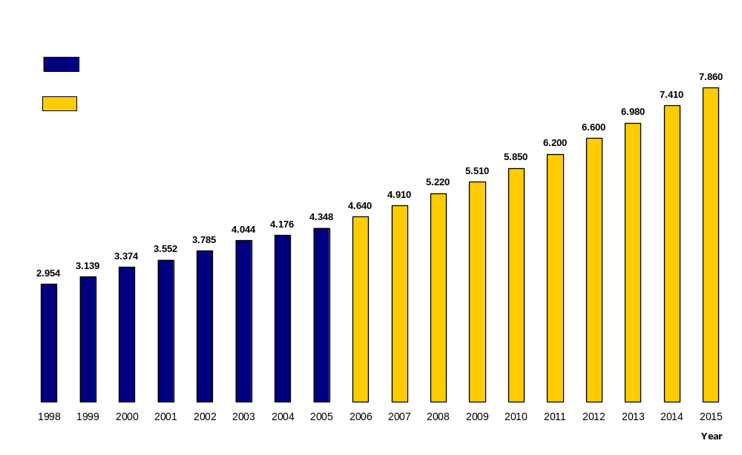
Graphs below present historical data for the period 1998-2005 and the forecasted quantities for the period 2006 to 2015.

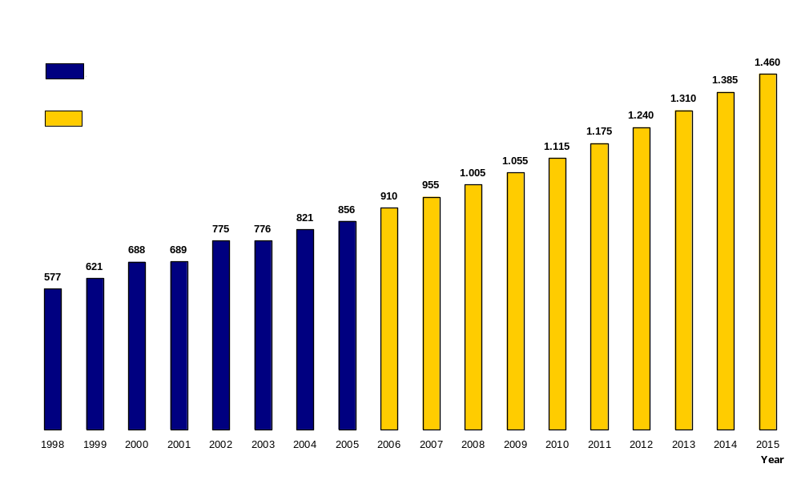

Generation Licences Issued

Until July 2006, CERA issued Licences for existing and new Electrical Energy Generating Stations as follows:

S/N | COMPANY NAME | TYPE OF LICENCE | MW
1 | EAC (Heavy Fuel Oil & Diesel) | Operation of Power Plant at Vasilikos (Existing Units) | 298
2 | EAC (Heavy Fuel Oil) | Construction and Operation of Power Plant at Vasilikos (Unit No.3) | 130
3 | EAC (Heavy Fuel Oil) | Operation of Power Plant at Dhekelia (Existing Units) | 360
4 | EAC (Heavy Fuel Oil & Diesel) | Operation of Power Plant at Moni (Existing Units) | 330
5 | Vasilikos Cement Works Ltd | Operation of Power Plant (Existing Unit – Autogeneration) | 6
6 | Hellenic Copper Mines | Operation of Power Plant at Skouriotissa (Existing Unit – Autogeneration) | 7
7 | Vouros Power Industries Ltd  (Heavy Fuel Oil) | Construction and Operation of Power Plant (ICE – Various alternative sites are considered) | 49,9
8 | EAC | Construction and Operation of Power Plant at Vasilikos – Unit No.4 (CCGT) | 220
9 | EAC | Construction and Operation –  Unit No.5 at Vasilikos (CCGT) | 220
10 | EAC | Construction and Operation –  Unit No.6 at Vasilikos (CCGT) | 220
11 | Unenes Ltd | Construction and Operation of Power Plant at Vassilikos Area (CCGT) | 230
12 | Vasilikos Cement Works Ltd | Construction and Operation  (ICE – Autogeneration) | 5
13 | Elmeni Quarries Ltd | Construction and Operation  (ICE – Autogeneration) | 4,7
14 | Ketonis Developments Ltd | Construction and Operation of  Wind Farm (Mari – Larnaca Area) | 12
15 | Aerotricity Ltd | Construction and Operation of a  Wind Farm (Kampi – Nicosia Area) | 10,1

16 | Ketonis Developments Ltd | Construction and Operation of a Wind Farm (Klavdia-Tersefanou-Alethrico – Larnaka Area) | 34,5
17 | EAC | Construction and Operation of a Wind Farm “Kouris” (Kantou-Limassol Area) | 6
18 | Aeoliki Akti Ltd | Construction and Operation of a Wind Farm (Sanida – Limassol Area) | 10
 |  | Total (100%) | 2.153.2
 |  | Conventional Units | 2080,6
 |  | RES | 72,6

EAC – Electricity Authority of Cyprus
RES - Renewable Energy Sources
IPPs - Independed Power Producers
CCGT - Combined Cycle Gas Turbine
ICE - Internal Combustion Engine

Licenced Capacity of Electricity Generation is:

By conventional means, 2080,6MW which include:

- EAC: 1118MW (53,73%) existing units
- EAC: 660MW (31,72%) new units
- Two IPPs 13MW (0,63%) existing units
- Four IPPs 289,6MW (13,92%) new units

By Renewable Energy Sources, 72,6MW which include:

- EAC: 6MW (8,27%)
- Three IPPS (at four sites) 66,6MW (91,73%)

Applications Under Consideration

On July 2006 CERA was examining the following applications for the purpose of authorising new generation investments.

S/N | COMPANY NAME | TYPE OF LICENCE | MW
1 | Golar Energy Ltd | Construction and Operation of a Floating Power Plant – Near Vasilikos (CCGT) – Natural Gas | 240

2 | Rokas Aeoliki (Cyprus) Ltd | Construction of Wind Farm  (Agios Theodoros & Maroni – Larnaca Area) | 52,9
3 | D. K. Windsupply Ltd | Construction and Operation of a Wind Farm (Pano Archimandrita, Kouklia and Alektora – Paphos Area) | 143,5
4 | K. E. Aerodynamics Ltd | Construction and Operation of Wind Farm (Agios Theodoros – Larnaca Area) | 51,25
5 | K. E. Aerodynamics Ltd | Construction and Operation of Wind Farm (Agios Theodoros – Larnaca Area) | 41
6 | M. P. Aerosupply Ltd | Construction and Operation of Wind Farm (Vavla, Ora, Hirokitia, Kato Dris, Kalavasos – Limassol Area) | 20,5
7 | Rokas Aeoliki (Cyprus) Ltd | Construction and Operation of Wind Farm (Klavdia – Larnaka Area) | 80,5
8 | Rokas Aeoliki (Cyprus) Ltd | Construction and Operation of Wind Farm (Kivisili – Larnaka Area) | 20,7
9 | Rokas Aeoliki (Cyprus) Ltd | Construction of Wind Farm (Agia Anna – Larnaka Area) | 25,3
10 | Wind Power Ltd | Construction of Wind Farm (Orites Forest – Paphos Area) | 18
11 | Med Wind Ltd | Construction of Wind Farm  (Agios Amvrosios, Xylokastro– Limassol Area) | 12
12 | Med Wind Ltd | Construction of Wind Farm  (Pyrga, Papalia – Larnaka Area) | 12
13 | Med Wind Ltd | Construction of Wind Farm  (Psevdas, Appidaki – Larnaka Area) | 16
14 | Med Wind Ltd | Construction of Wind Farm (Psevdas, Schinomoutis – Larnaka Area) | 16
15 | Med Wind Ltd | Construction of Wind Farm (Sanida – Limassol Area) | 18
16 | Med Wind Ltd | Construction of Wind Farm (Asgata – Limassol Area) | 20

17 | Med Wind Ltd | Construction of Wind Farm  (Kathikas, Agios Georgios – Paphos Area) | 20
18 | Med Wind Ltd | Construction of Wind Farm  (Agia Napa – Famagusta Area) | 14
19 | Stivo Trading Ltd | Construction and Operation of Wind Farm (Pyrga – Larnaka Area) | 100
20 | Trebi Trading Ltd | Construction and Operation of Wind Farm (Avdelero – Larnaka Area) | 30
21 | Moglia Trading Ltd | Construction and Operation of Wind Farm (Agia Anna – Larnaka Area) | 50
22 | Maseru Trading Ltd | Construction and Operation of Wind Farm (Vavatsinia – Larnaka Area) | 30
23 | Vorima Trading Ltd | Construction and Operation of Wind Farm (Stavrovouni – Larnaka Area) | 30
24 | TSP Aeolian Dynamics Ltd | Construction and Operation of Wind Farm (Pyrga – Larnaka Area) | 50
25 | Ketonis Developments Ltd | Construction of Wind Farm  (Sotera – Famagusta Area) | 33
26 | Ketonis Developments Ltd | Construction of Wind Farm  (Kellia – Larnaka Area) | 16,5
 |  | Total (100%) | 1.161,15
 |  | Conventional Units | 240,00
 |  | RES | 921,15

Applications under consideration for Generation of Electricity are:

- By conventional means, one (1) application from IPPs for a total capacity of 240 MW

- By Renewable Energy Sources, twenty five (25) applications from IPPs for a total capacity of 921,15MW

Currently Cyprus is totally dependent on Heavy Fuel Oil and Diesel, which are 100% imported. It is expected that there will be a better generation mix in the near future that shall include renewable generation sources (wind, solar, animal waist etc) and natural gas.

The TSO, in close cooperation with EAC, (the Transmission network owner) has the legal responsibility of preparing a ten year plan for the network requirements to satisfy the secure flow of energy from the generators to the distribution network and customers connected to the transmission network.

The ten-year plan has already been submitted to CERA and has been approved. Same will be under annual review.

The authorisation procedure and criteria for new generation investments are as follows:

1. | For the purpose of acquiring a License for the Construction and Operation of Electricity Generating Units for the purpose of Supplying Electricity to Eligible Consumers, or for Autogeneration, a specific Application should be submitted, in accordance with Law No. 112(I)/2003 and the Relevant Regulations. The Application must be accompanied by the prescribed Fees and all necessary supporting documents that would allow CERA to complete a detailed examination of the Application and reach a decision.
2. | The original “Form of Application of Licence” Part I of the relevant Regulation in accordance to Article 97(2)(d) of the Law of 2003 on Regulating the Electricity Market accompanied with all documents as required by Part II of the same Regulation must be filled in and submitted.
3. | The Application Fee covers the registration, examination, evaluation and decision taking process regarding the Application and is not refundable.
4. | In addition to other issues, the following are considered important and integral parts of the application:
 | - Designation of the specific proposed erection location (plot of land) which must be accompanied with the written and binding consent of the owner, referring to memos on the title deed, if it is the case
 |  | - General site planning drawings for the installation of the Units
 |  | - Environmental Study, carried out by an independent specialist, in which it should be clearly concluded that all criteria for the protection of the Environment will be met and an explicit written undertaking, by the Applicant, of fulfilling these criteria during the Construction and Operation of the Units if the requested licence is granted
 |  | - Comprehensive and binding time schedule indicating monthly progress of the Project
 |  | - Financial and/or other Guarantees for the Completion of the Project

5. | Applications are examined according to the order of receipt once they are considered as being COMPLETE (i.e. all required documents and information have been submitted).
6. | In its decision regarding the issue of Licences and the size of the new Units that will be licensed, CERA seriously takes into consideration, among other criteria, the following:
- The Adequacy, Reliability and Security of Supply for the
following years
- The Safety of the electricity system, installations and associated
equipment
 | - The Protection of the Environment
 | - The Protection of public Health and Safety
 | - Energy Efficiency
- The introduction and continuation of a healthy Competition for
the best interest of the Consumers
 | - The Viability of the Project
 | - The Fuel to be used
 | - The repercussions in the Price of the kilowatt-hour (kWh)
 | - The Time Schedule for the completion of the Project
 | - Guarantees for the Completion of the Project
7. | CERA has the right to cancel the issued Licence in case the agreed timetable, for the completion of the Project, is unduly delayed at any stage beyond three (3) months.
8. | In accordance to Law N.122(I)/2003, Article 34(3), the issue of a Licence for the Construction and Operation of a Power Station does not exempt the holder of such licence from the obligation of obtaining other approvals and authorizations (e.g. a Building Permit and a Planning Permit) as required by any other Law.
9. | The relevant Law provides, that the Applicant, in the case of an Individual, must be a citizen of the European Union and be resident in a Member State, and in the case of a Legal Entity must be based and have a Registered Company in a Member State of the European Union.

The flowchart below shows the process for the examination of application towards granting a licence.

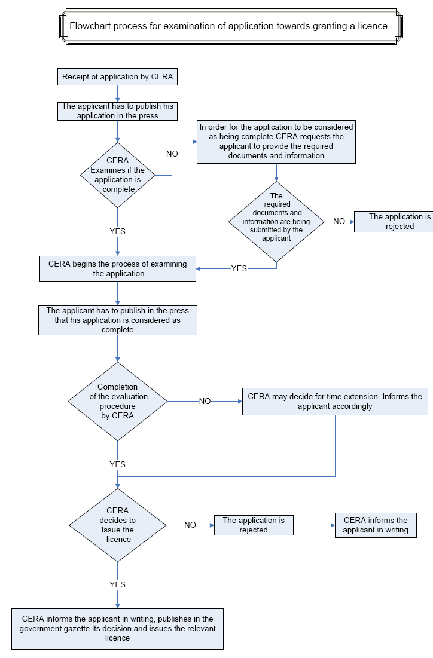

Table 5.1
Security of supply evolution
 | Peak electricity demand (GW) | Available capacity (GW) | For next three (3) years  Forthcoming new plant (GW) |  | Plant completed minus plant closed in the year (GW)
 |  |  | authorised | under construction | coal and oil | gas | RES | CHP | nuclear
2000 | 0,688 | 0,988 |  |  | 0,988 | 0 | 0 | 0 | 0
2001 | 0,689 | 0,988 |  |  | 0,988 | 0 | 0 | 0 | 0
2002 | 0,775 | 0,988 |  |  | 0,988 | 0 | 0 | 0 | 0
2003 | 0,776 | 0,988 |  | 0,130 | 0,988 | 0 | 0 | 0 | 0
2004 | 0,821 | 0,988 | 0,310 | 0,130 | 0,988 | 0 | 0 | 0 | 0
2005 | 0,856 | 1,118 | 0,246* | 0,180 | 1118 | 0 | 0 | 0 | 0
2006 est | 0,910 | 1,118 | - | -
2008 est | 1,005 | 1,364* | - | -

* Includes 0,046GW from RES

Gas [Article 5]

Within the framework of its responsibilities CERA prepared Regulations on the organisation and operation of the Natural Gas Sector, access to the market, the criteria and procedures for the granting of Licences for the transportation, the supply and the storage of Natural Gas. The relevant Regulations have been approved by Parliament and were published on 21/07/06.

Government policy on gas is currently very active and it should facilitate the importing of natural gas in liquid form by 2009, for electricity generation, if not earlier by independent power producers. Facilities for distributing natural gas in other parts of the Island, apart from the planned site for the gas terminal, are being discussed but nothing has been decided up to now.

At the same time investors have approached CERA declaring their interest for the construction and operation of an off-shore Floating Storage Station and Regasification of Liquified Natural Gas near Vasilikos. Now that the Regulations regarding Natural Gas Market are in force, applications are expected to be submitted to CERA for possible eventual Licencing.

Interest was also expressed for the construction in the same area of a Floating Power Station for electricity generating using Liquified Natural Gas.

Table 5.2
Security of supply evolution (gas) – NOT APPLICABLE
 | Total gas demand (bcm) | Production capacity (bcm) | Pipeline import capacity (bcm) | LNG import capacity (bcm) | Forthcoming new capacity (bcm)
 |  |  |  |  | authorised | under construction
2000 | N/A | N/A | N/A | N/A | N/A | N/A
2004 | N/A | N/A | N/A | N/A | N/A | N/A
2005 | N/A | N/A | N/A | N/A | N/A | N/A
2006 est | N/A | N/A | N/A | N/A | N/A | N/A
2008 est | N/A | N/A | N/A | N/A | N/A | N/A
2010 est | N/A | N/A | N/A | N/A | N/A | N/A

6 PUBLIC SERVICE ISSUES [Article 3(9) for electricity and 3(6) for gas]

As already pointed out in section 3.1.3 above legislation both primary and secondary, has been enacted covering all the requirements of the Electricity Directive regarding consumer protection complaints procedure, treatment of vulnerable consumers and performance indices that are intended to safeguard quality of service and supply to all consumers.

All Public Service Obligations (PSO’s) that EAC had before liberalization are still in force such as universal electricity service provider, and the supplier of last resort, by virtue of the Law 122(I)/2003, and EAC, the Ministry and CERA are currently discussing the PSO regime that will be applicable in the future. Already a Public Service Obligation regarding energy produced by RES has been imposed by the Law, L.33(I)/2003 on EAC whereby EAC or any other supplier shall buy from RES Producers all energy produced at a price defined by CERA.

Furthermore, a decree regarding relief from the price of electricity for multimember families over six (6) members and for disadvantaged families has been issued in April 2006.

Preparatory work is being carried out for the treatment of vulnerable consumers which is expected to be finalized in 2007.

Regarding labeling, at present Electricity bills, apart from basic information, only identify the “extra” amount billed for funding an ongoing “RES Incentive Plan”. Future bills will give details for primary energy sources, etc.

EAC is the only licensed supplier in Cyprus supplying the following categories of consumers (April 2006):

- Domestic | 337.025
- Commercial | 75.054
- Industrial | 10.999
- Agricultural | 11.088
- Public lighting | 7.294
Total | 441.460

Table 6
Regulation of end user prices
 | Electricity |  |  | Gas
 | large and very large | medium industrial and commercial | small commercial and household | power plants | large and very large | medium industrial and commercial | small commercial and household
Existence of regulated tariff (Y/N) | Y | Y | Y
% customers still on tariff | 100 | 100 | 100 | NOT APPLICABLE
possibility to switch back to regulated tariff (Y/N)
Number of suppliers covered by the obligation to supply at tariff (could be all suppliers) | 1 | 1 | 1

Due to non-payment 12.800 consumers were disconnected in 2005. Approximately 80% of those disconnected were re-connected after settling their accounts. Performance indicator refers to 24 hours as the time of response.

EAC as the dominant supplier in the electricity market of Cyprus has been nominated as the Supplier of Last Resort in line with the requirements of the Electricity Directive.

ANNEX 1

ELECTRICITY PRICES FOR DOMESTIC AND INDUSTRIAL STANDARD CONSUMERS

ELECTRICITY PRICES FOR INDUSTRIAL STANDARD CONSUMERS
Country / Region : CYPRUS
Date: 01/01/2006 (Most recent available data)
Standard Consumer | Annual Consumption | Maximum Demand | Local Factor | Price exclusive of taxes | Price exclusive of VAT | Price all taxes included
Standard Consumer | kWh | kW | h | Cyprus cent per kWh
1 | 2 | 3 | 4 | 5 | 6 | 7
1a | 30.000 | 30 | 1.000 | 12,41 | 12,54 | 14,41
1b | 50.000 | 50 | 1.000 | 12,32 | 12,45 | 14,30
1c | 160.000 | 100 | 1.600 | 9,75 | 9,88 | 11,35
1d | 1.250.000 | 500 | 2.500 | 7,05 | 7,18 | 8,23
1e | 2.000.000 | 500 | 4.000 | 6,39 | 6,52 | 7,48
1f | 10.000.000 | 2.500 | 4.000 | 6,39 | 6,52 | 7,47
1g | 24.000.000 | 4.000 | 6.000 | 6,03 | 6,16 | 7,07
1h | 50.000.000 | 10.000 | 5.000 | 6,14 | 6,27 | 7,19
1i | 70.000.000 | 10.000 | 7.000 | 5,87 | 6,00 | 6,88
Taxes applied: | VAT @15% |  |  |  | CY Cent = Euro Cent
 | Renewable Energy Sources charges for 0,13cent/kWh |  |  |  | Almost 100% HFO

ELECTRICITY PRICES FOR HOUSEHOLDS
Country / Region : CYPRUS
Date: 01/01/2006 (Most recent available data)
Standard Consumer | Annual Consumption |  |  | Approximate subscribed demand (kW) | Price exclusive of taxes | Price exclusive of VAT |  | Price all taxes included
Standard Consumer | Total | Of which night |  | Approximate subscribed demand (kW) | Cyprus cent per kWh
Da | 600 | - |  | 3 | 7,78 | 7,91 |  | 9,07
Db | 1.200 | - |  | 3 – 4 | 7,45 | 7,58 |  | 8,70
Dc | 3.500 | 1.300 |  | 4 – 9 | 7,03 | 7,16 |  | 8,21
Dd | 7.500 | 2.500 |  | 6 – 9 | 6,96 | 7,09 |  | 8,13
De | 20.000 | 15.000 |  | 9 | 5,28 | 5,41 |  | 6,20
MARKER PRICES
 |  | Not Applicable - |  |  | No consumers in any of these CATEGORIES
 | CATEGORY
 | 17.5 - 37.5 MW |  |  |  | 37.5 - 62.5 MW |  |  |  | 62.5 - 75 MW
Currency/kWh | Price exclusive of taxes | Price exclusive of VAT |  | Price all taxes included | Price exclusive of taxes |  | Price exclusive of VAT | Price all taxes included | Price exclusive of taxes | Price exclusive of VAT | Price all taxes included
Marker price | N/A | N/A |  | N/A | N/A |  | N/A | N/A | N/A | N/A | N/A
Taxes applied: | VAT @15% (recoverable)
 | Renewable Energy Sources charges for 0,13cent/kWh

