ENERGY MARKET INSPECTORATE

ESTONIAN ELECTRICITY AND GAS MARKET

REPORT

TALLINN 2006

Contents
1. Foreword 3
2. Energy market regulatory authority review 5
3. Electricity market review 9
3.1. Review of regulation 9
3.1.1. Electricity market organisation review 9
3.1.2. Cross-border power connections, availability of power reserve and its distribution 13
3.2. Regulation of electricity networks 14
3.2.1. Regulation period 2005 to 2008 21
3.2.2. Electricity quality of supply 21
3.2.2.1. Customer service quality requirements 22
3.2.2.2. Network services quality requirements 22
3.2.3. Balance responsibility 24
3.2.4. Unbundling of activities 25
3.3. Competition in electricity market 29
3.3.1. Wholesale market 29
3.3.2. Retail market 30
3.3.3. Competition supervision 31
4. Gas market 35
4.1. Review of gas market and its regulation 35
4.1.1. Cross-border connections, availability and distribution of capacity reserves 37
4.1.2. Price regulation of gas networks 38
4.1.3. Quality of gas supply 43
4.1.4. Balance responsibility 43
4.1.5. Unbundling of activities 44
4.2. Competition in gas market 47
4.2.1. Wholesale market 47
4.2.2. Retail market 48
4.2.3. Competition supervision 49
5. Security of supply review 52
5.1. Electricity 52
5.1.1. Estlink and other connections 56
5.1.2. Lithuanian nuclear power plant 56
5.2. Gas 56
6. Public service obligation review 60
6.1. Electricity 60
6.1.1. Obligations of market participants 60
6.1.2. Public service obligation and final customer price regulation 61
6.1.3. Customer information 64
6.1.4. Customer contract, supply limitations and interruptions, extra-judicial proceedings 65
6.2. Gas 67
6.2.1. Obligations of market participants 67
6.2.2. Selling obligation and final customer price regulation 68
6.2.3. Customer information 70
6.2.4. Customer contracts, suspension and limitation of supply and extra-judicial proceedings 71

Foreword

The present report has been prepared on the basis of the EU Electricity and Natural Gas Directives. According to the Directives the energy market regulatory authorities of Member States shall report on the functioning of electricity and gas markets. Similar obligations for the Energy Market Inspectorate are also set out by national legislation, namely by the Electricity Market Act and the Natural Gas Act.
In 2005 the words fuel and energy became important key words for both undertakings and their customers. The easiest way to realize that is looking at gasoline and diesel fuel prices, which suffered from remarkable increase during the year. It should be noted yet that both electricity and natural gas, and district heating sectors as well are directly or indirectly dependent on the world market price for oil. This does not have a direct impact on electricity consumers in Estonia, as the major portion of electricity is produced from local oil shale. However, the consumers of natural gas and district heat are still influenced, as the natural gas price directly depends on oil price in the world market.
An important circumstance to consider is that both electricity and gas, as well as district heat reaches customers by means of respective network infrastructure. The charges for using of an infrastructure and the network are completely independent from oil price fluctuations in the world market. As an infrastructure is a natural monopoly, its price regulation is under control of the Energy Market Inspectorate. The formation of infrastructure service prices first of all depends on local economic situation, such as investment needs, changes in the prices for goods and services according to national rate of inflation, technical efficiency. Thus, infrastructure charges have no relation to the changes in the world market fuel prices, the prices for those services are stable and as a rule, change at a slower rate than the rate of inflation. According to enforced law the supplier has to separate on customer bills the cost for network service or, what is the same, for using of an infrastructure and the cost for energy or fuel. Thereby customers can observe what electricity or a gas bills total is formed of.
According to the Electricity and Gas Directives electricity and gas customers should have a non-discriminatory access to the network and should be able to choose their supplier freely and change the supplier, if wished. It can be compared, for instance, with telecom service market in which customers can change the service provider/operator, while the network owner must give access to his telecom network to all operators. Estonia has a transitional period until 2013 for electricity market opening. By 2009 35 per cent of the market should be opened. This means that already then larger industrial consumers can themselves choose the preferable supplier or producer of electricity. As regards gas market there is no transitional period and according to the new Natural Gas Act that entered into force in the end of 2005 all industrial and commercial consumers have the right to choose supplier.
A significant event in 2005 was the indexation of electricity network charges. Namely, beginning from 2005 the network charges are approved for a three-year period and adjusted annually according to inflation rate, as well as according to the cost uncontrollable to undertakings. A major article of uncontrollable cost is the electricity purchased from renewable sources and it forms part of the charges for use of network.

The present report intends to provide best possible overview of the functioning of energy market and security of supply. We sincerely hope that through this report readers can clarify the organisation of market and its regulation as well.

With best wishes,

Märt Ots
Director General
Energy Market Inspectorate

Energy market regulatory authority review

According to the EU Electricity and Gas Directive Member States shall have an independent energy market regulatory authority. Respective authority in Estonia, the Estonian Energy Market Inspectorate, hereinafter the EMI, was established before joining the EU, in 1st January 1998. According to the structural build-up of the Government the EMI is a government agency within the area of government of the Ministry of Economic Affairs and Communications. Other market regulators like Railway Inspectorate, National Communications Board, Technical Inspectorate and some others operate similar way. Functions and activities of the EMI are stipulated by the Government of the Republic Act, special laws that regulate energy sector (Electricity Market Act, Natural Gas Act, District Heating Act and Liquid Fuels Act), as well as by the Statute of the Inspectorate. In compliance with above legal acts the EMI carries out activities in order to perform its main functions as follows:

1. Approves prices for electricity and gas network services prior to entry into force (so-called ex-ante price regulation).

2. Approves methodologies for connecting with electricity and gas networks prior to entry into force.

3. Approves weighted average price for electricity sold to non-eligible customers and the price of gas sold to household customers.

4. Approves district heat prices in case the undertaking’s annual consolidated sales is over 50 000 MWh. For undertakings with the sales volume of below 50 000 MWh the price is approved by local municipal authorities.

5. Approves the price for heat produced in the process of heat and power co-generation.

6. Settles disputes between local municipal authorities and undertakings supplying district heat on the pricing of heat.

7. Approves standard terms and conditions of contracts for electricity network services, electricity supply for non-eligible customers and gas supply for household customers.

8. Issues activity licences for undertakings providing network services, producing and supplying electricity, providing gas network services, supplying gas, producing and supplying district heat.

9. Monitors the adequacy of prices for the balance energy sold by the transmission system operator (National Grid) and conditions of balance contracts.

10. Supervises observing by market participants provisions of law, requirements of regulations, fulfilment of relevant obligations like separation of accounts, independence of the system operator, disclosure of information, third-party access to the network, etc.

11. Discloses the approved prices, tariffs and charges on the web site.

12. Controls quality testing of liquid fuels sold in the market and supervises quality of electricity supply.

13. Settles disputes between market participants.

14. Cooperates with other Estonian supervisory institutions and regulatory authorities of other countries, as well as performs other tasks provided by law and the Statute.

The EMI is an institution independent in its decision making. According to the Administrative Procedure Act and other legal acts applicable within the energy sector (Electricity Market, Natural Gas Market, District Heating and Liquid Fuels Acts) the EMI issues administrative acts: decisions and precepts. Some examples of those can be as follows. By decisions, for instance, the EMI either grants approval to prices or refuses to. By decisions market licences to undertakings are issued or refused to. Also, by decisions customer complaints against undertakings’ performance or disputes between market participants are settled. Precepts are issued when provisions of law are violated by undertakings. Law stipulates that the decisions have to be motivated and justified. A decision, by which the price is approved, may serve as an example. The scope of such decision may be up to 20 pages, as it includes a detailed analysis of all components forming the price and its calculation as well. Another example may be a decision, which settles a complaint of an electricity customer about activity of his supplier. Such a decision describes the nature of the problem, arguments the EMI’s decision and its scope may be up to ten pages. In essence, the latter case forms the so-called pre-court settlement decision. The purpose indeed is to give customers a chance to refer to the EMI instead of court. This way a decision can be received faster, as a rule, because law stipulates that the EMI has to make its decision during 60 days at the latest.

The EMI’s decisions are independent both politically and from energy undertakings. The EMI’s decision cannot be changed or invalidated neither by the Minister nor by the Government. The EMI is guided in its activities exclusively by law. Respective regulation is provided by the Government of the Republic Act. Its paragraph 93 (6) stipulates that the procedure for governmental supervisory control shall not extend to:
1) acts of state supervision and decisions made in the application of enforcement powers of the state;
2) pre-court settlement of a complaint or protest made with respect to a legal instrument or act of an agency of executive power or of an official, in the cases prescribed by law.

The EMI’s decisions and precepts can be challenged with an administrative court in 30 days since receiving of a decision or a precept. Decisions of an administrative court can in return be appealed with a circuit court and the decisions of a circuit court with the Supreme Court. Estonia is the state based on the rule of law and that is why challenging of decisions and precepts shall be deemed a normal process in which for both undertakings and customers their legal protection is guaranteed. In the period from 2003 to 2005 the EMI has made 577 decisions and precepts, thus about 200 per year. Only 4 out of them have been lost by court decisions. This can be regarded as a good result and as an indicator of quality of the EMI’s work.

The EMI is one of the smallest state institution in Estonia, as regards the number of employees. Currently, 10 staff members are employed. Due to the small staff an extremely simple flat management structure is applied without any specialised department. The Inspectorate is managed by the Director General, in his absence by his deputy. The rest are senior specialists with some specialisation in certain fields of activity. The fields are: price approval, licensing, dispute settlement and market supervision. The specialists are subordinated directly to the Director General. Because of smallness the only administrative employee is the secretary/administrative assistant. Other administrative services like accounting, legal advice, IT and others are outsourced. An example of significant cost reduction is the good cooperation through jointly administered IT system with Consumer Protection Board.

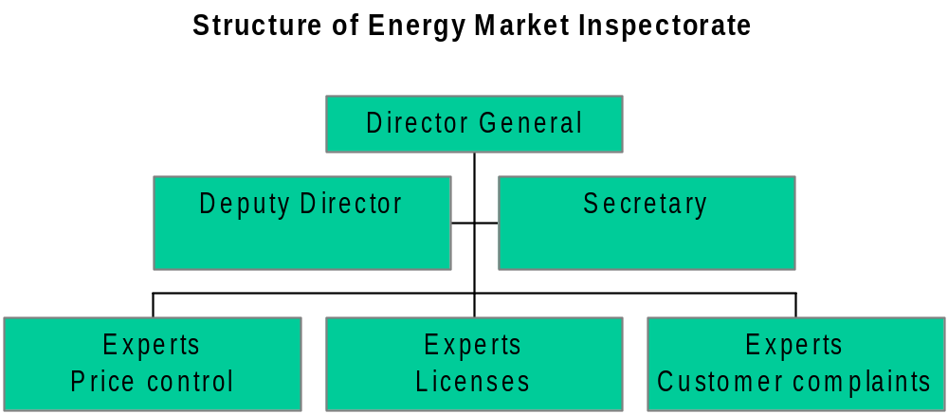

The appointment into office of the Director General and all other EMI employees is based on the Public Service Act. The Director General is appointed by the Minister of Economic Affairs and Communications at proposal by the Chancellor of the Ministry. A precondition for appointment is his attestation by a commission at the State Chancellery. Director General is nominated without a specified term.

Dismissing from office of the Director General is similar to appointment, on the basis of the Public Service Act and Government of the Republic Act at proposal by the Chancellor of the Ministry. Director General cannot be dismissed because of political reasons.

The EMI is financed from state budget. The budget for 2006 is 5,076 million kroons (324 000 €). 0,2 million (12 800 €) out of it is the fee for membership in international organisations: CEER (council of energy regulators) and ERRA (regional association of energy regulators). 3,2 million kroons (205 000 €) are employee salaries and 1,676 million (106 200 €) are administrative and R&D cost. The latter also includes office cost, outsourced expert analyses and liquid fuels quality testing cost.

In accordance with the state budget preparation procedures every spring time the EMI submits a preliminary draft application together with the statement of grounds to the Ministry of Economic Affairs and Communications. The final budget is approved by the Parliament. Until now the budget has been sufficient to carry out functions the EMI has. Along with the increased scope of work and enlargement of functions in 2006 the EMI has applied for a budget raise by 0,9 million kroons. The biggest portion of the budget is the employment cost; in 2006 it is 3,2 million. 0,8 million out of it is social tax, which, according to the Estonian taxation law has to be paid by the employer, i.e. in the present context by the EMI. So the actual salaries total 2,4 million, which gives a monthly average salary level of 24 000 kroons. Such a level shall be deemed competitive in Estonia and this enables the EMI to employ people with good professional skills in their specific field. Within the public sector the EMI’s salary level is higher than an average, actually one of the highest among ministries, agencies and inspectorates, as per the Public Service Yearbook for 2004. At the same time it is lower than the private business sector level.

The EMI’s scope of work can be evaluated by the number of decisions and precepts made during a year, as well as by the number of analyses of economic performance of the regulated undertakings and by the total number of the latter.
Some key performance figures for 2005 can be outlined as follows:
101 licence issuance decisions;
31 decisions and precepts on the settlement of market participants’ disputes;
104 decisions on granting price approval or disapproval.

The biggest scope of work is within the price control and approval process. Therefore the best indication of the Inspectorate’s performance is the number of undertakings for which the price regulation is applied to. As per 2006 the EMI carries out price control on undertakings as follows:
Electricity transmission network 1
Electricity distribution networks 42
Gas transmission network 1
Gas distribution networks 26
District heat suppliers 40
Electricity and heat production,
Oil shale mining 3

So the number of undertakings to which regular price control is imposed totals 115. In fact, during the last three years the number of regulated enterprises has increased significantly. The reason is the development of gas networks and acquisition of district heat suppliers by larger companies. In such cases the price regulation is transferred from local municipal authorities to the EMI, as provided for by the District Heating Act.

The requirement for independence of regulatory authorities is stipulated by the EU Electricity and Gas Directives. With respect to different independence criteria: independence in decision making, management and financing, it can be concluded – the EMI is an independent market regulatory authority.

Electricity market review

Review of regulation

Electricity market organisation review

The Estonian electricity system has been built up as part of the north-western common power system of the former Soviet Union. Estonia is part of the common synchronised system together with Russia, Belarus, Latvia and Lithuania. The map of the Estonian power system is presented in drawing 3.1.1.

As seen in the drawing, with neighbouring countries Estonia currently has connections only with Russia and Latvia. By the end of 2006 a new 350 MW direct current connection with Finland adds. It should be clarified yet that Finland is part of the Nordic power system Nordel, which is not synchronised with the north-western Russian system.

In comparison with other EU countries the Estonian electricity market is one of the smallest. In 2005 the load peaked at 1660 MW with an annual production of 9,1 TWh. Out of this 6,4 TWh was domestic consumption, while export totalled 1,6 TWh. Another specific of the Estonian electricity market is an extreme concentration and reliance on a single fuel. Namely, 93 per cent of electricity is produced with oil shale, the share of other fuels is very modest. For example, the next position belongs to natural gas with its share of only 4,7 per cent (see drawing 3.1.2). Essentially, all the production is controlled by the largest energy enterprise Eesti Energia AS that possesses 96 per cent of installed capacity. In 2005 it gave 97 per cent of the Estonian electricity production. However, a decrease of the share of oil shale and increase of the share of natural gas is anticipated by 2015, as per the long-term development plan of the Estonian energy sector.

A positive side of the power system in all Baltic countries is the very strong power transmission infrastructure. That is why in two Baltic electricity market forums held in February 2005 in Riga and in April 2006 in Tallinn it was underlined that the Baltic countries are the only EU region in which transmission power deficiency and the so-called bottle-necks does not exist. At the same time rather poor cross-border connections of Baltic countries with other Member States should be taken into account. In fact, the only one will be the 350 MW Estonian-Finnish connection (DC sea cable), which will start commercial operation in the end of 2006. Since the connection with other EU countries is weak the area can be regarded as Baltic electricity market in which the non-member Russia can be involved and to some extent also Finland through the mentioned Estonian-Finnish sea cable.

An extreme concentration features also other Estonian electricity market sectors. Besides the 97 per cent of production capacity also both transmission and 85 per cent of the distribution networks belong to the Eesti Energia AS group, as well as the largest oil shale producer, mining industry AS Eesti Põlevkivi.
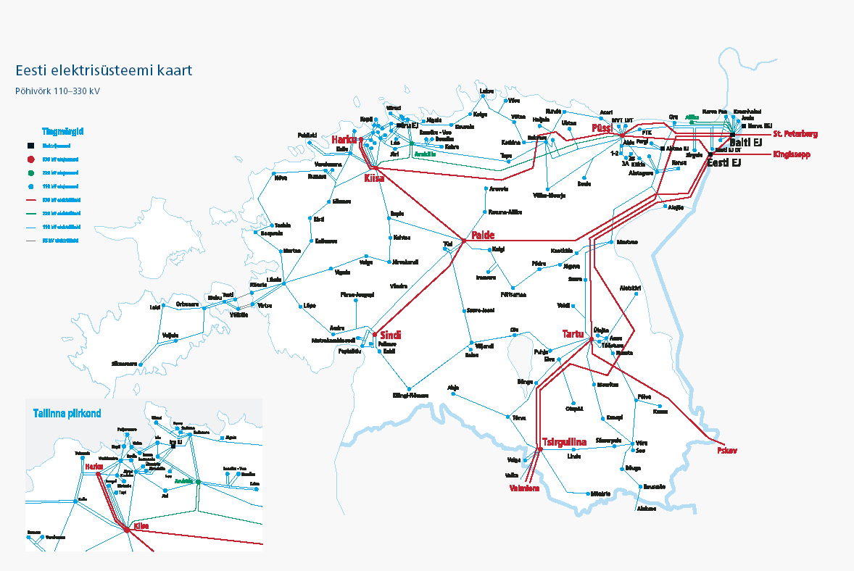
Drawing 3.1.1. Map of Estonian power system

oil shale
92,60%
others
2,40%
hydro and wind
0,30%
natural gas
4,70%
Drawing 3.1.2. Structure of electricity production in Estonia in 2004. Source: Estonian Energy Review, Ministry of Economic Affairs and Communications 2005

Formation of the Estonian electricity market dates back to 1998, when the Energy Act was enforced. On the basis of the Act four sectors were regulated: electricity, heat, natural gas and liquid fuels. The regulatory authority – Energy Market Inspectorate was also established upon the Act. Since 2003 the Energy Act was replaced by four separate acts: Electricity Market, Natural Gas, District Heating and Liquid Fuels Acts.

In the 1998 Energy Act the status of an eligible electricity customer was defined: customer with an annual consumption of over 40 GWh. The Electricity Market Act, which entered into force in 2003, did not change the determination. In 1st May 2004 Estonia joined EU. Together with the joining an exemption became enforced for Estonia. According to it 35 per cent of the market shall be opened by 2009, while by 2013 the market shall be opened for all customers. Table 3.1.1 presents the dynamics of market opening. As the openness for 2009 is determined as a percentage and not an annual consumption the definition of an eligible customer is based on the prognosis for 2009.

Table 3.1.1. Market opening in Estonia
Year | Definition of eligible customer annual consumption GWh | % of market opening
1995 | 0 | 0
1997 | 0 | 0
1999 | 40 | 10
2001 | 40 | 10
2003 | 40 | 12
2005 | 40 | 12
2007 | 40 | 12
2008 | 40 | 12
2009 | 5¹ | 35
2013 | All customers
¹ Note: the definition of an eligible customer for 2009 is based on an evaluated annual consumption (GWh). The Electricity Market Act stipulates market opening of 35% as of 1st January 2009.

According to the Electricity Market Act the non-eligible customers shall buy electricity from their distribution network operator, while the energy has to be produced by either oil shale using Narva Power Plants (AS Narva Elektrijaamad), in the process of heat and power cogeneration or by a small producer. The latter is the producer with a generating capacity of less than 10 MW.

Cross-border power connections, availability of power reserve and its distribution

As mentioned above Estonia has electrical power transmission connections with Russia and Latvia, and from the end of 2006 also the direct current (sea cable) connection with Finland with the capacity of 350 MW. Existing connections are shown in drawing 3.1.1. From Narva two lines lead to Russia at the voltage level of 330 kV and 220 kV and with the total capacity of 1050 MW. From southern part of Estonia one 330 kV line with the capacity of 500 MW connects with Russia. In the opposite direction of Russia-Estonia the same line has pass-through capacity of 400 MW. In the southern part of Estonia there are also 330 kV lines to Latvia with the capacity of 750 MW.

By statistics of 2005 the peak load from Narva to the direction of Russia was 450 MW, while form south Estonia to Russia 236 MW. Peak load towards Latvia was 885 MW. Hence the technical capacity is much higher than the actually needed one and a lack of capacity has never been experienced. The transmission capacity data are presented in table 3.1.2. According to the prognosis submitted by the transmission network operator any transmission capacity deficiency is not foreseen before 2012. Due to the circumstances the regulatory authority has no need for capacity distribution.

Table 3.1.2. Cross-border transmission capacity
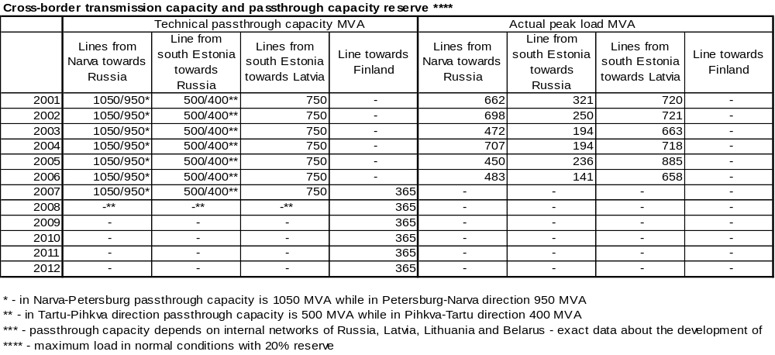

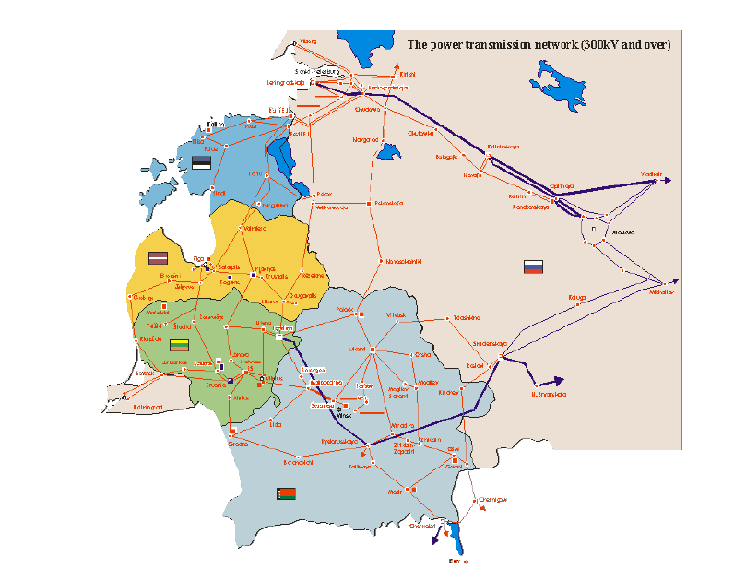
Drawing 3.1.3. Map of power system of Baltic countries and north-western Russia

Regulation of electricity networks

In compliance with the currently valid Electricity Market Act for electricity networks the so-called exclusive right or, what is same, the principle of concession, is applied. This means that the transmission network operator has exclusive right to perform power transmission and system services. The same principle is applied to distribution network operators as well, whereas for the operators a service area, determined by geographical coordinates, is assigned. Within the area they have exclusive rights to provide network services. Thereby competition between lines and parallel lines are not allowed. The principle of concession minimises business risk for network operators, since the status of a monopoly originates not only from the actual situation but is also from the provisions of law. Reasoning from exclusive right the network operators have also an obligation of developing the network in a manner that enables security of supply to already connected and new customers, which intend to connect.

In Estonia the transmission network operator is OÜ Põhivõrk. 100 per cent of its shares belong to Eesti Energia AS. The number of distribution network operators is 42, which due to smallness of Estonia is a rather big number. Although, the concentration of distribution service market is very high. The largest enterprise is OÜ Jaotusvõrk that belongs to Eesti Energia AS and has a market share of 85 per cent. Its annual sale is 5300 GWh (together with the sale to other distribution networks 6000 GWh) and the number of customers is 500 000. The second largest distribution enterprise is AS Narva Elektrivõrk, which belongs to Austrian private capital. It has 35 000 customers and an annual sales of 300 GWh. The third largest is AS Fortum Elekter with sales volume of 175 GWh annually and supplying 23 000 customers. An annual sale of the rest 39 distribution undertakings is below 50 GWh.

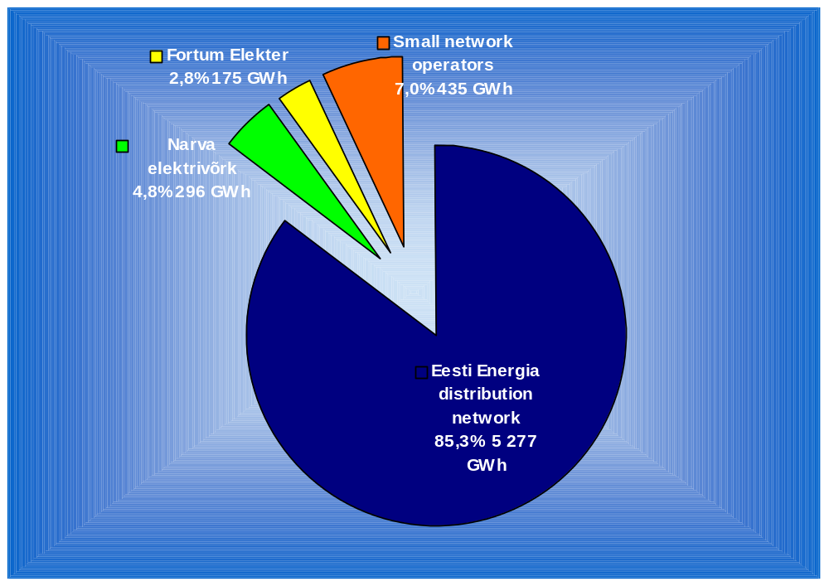Drawing 3.2.1. Market share of distribution enterprises

The market share of distribution undertakings is presented in drawing 3.2.1. The share of small networks is relatively marginal. However, their 7 per cent total share assumes stronger regulation, which is similar to large ones.

A summary of basic indicators for network operators is presented in table 3.2.1.

Table 3.2.1. Basic indicators of network operators
 | Number of operators | Average price for transmission or distribution €/MWh (Estonian cent/kWh) |  |  | Quality of supply indicator –an average time in minutes of an interruption caused by faults per customer
 |  | Large industrial customer | Commercial customer | Household customer
Transmission network  (Põhivõrk) | 1 | 7,64 (11,96) |  |  | 3,36
Distribution networks | 42 | 13,32 (20,85) | 29,00 (45,39) | 39,21 (61,37) | 468,76
Notes:
According to Eurostat definitions:
- large industrial customer, one with an annual consumption of 24 GWh, max capacity 4000 kW
- commercial customer, one with an annual consumption of 50 000 kWh, max capacity 50 kW
- household customer, one with an annual consumption of 3 500 kWh.
Distribution indicators are based on OÜ Jaotusvõrk information.
1 €=15,65 EEK

Law provides for equal price regulation for all network enterprises irrespective of their size. This adds an extra load for the EMI, as the volume of work with price approval primarily depends on the number of undertakings and almost does not depend on the size of an enterprise.

The only exemption in electricity network operator’s regulation is the requirement for legal unbundling of network activities in case the number of customers is over 100 000. Due to that the only operator with legal unbundling is the network belonging to Eesti Energia AS, where since 2004 a separate business entity OÜ Jaotusvõrk was established. For others law stipulates only separation of accounts and the obligation of auditing.

According to law the EMI approves separately the following charges and methodologies:

- a charge for transmission of electricity, i.e. the variable component of network services
- a charge for using a network connection, i.e. the fixed component of network services
- ancillary services provided by network operator (e.g. replacement of main protective fuse or sealing of meters at the customer and some others)
- methodology for calculation of a charge for connection to the network

The EMI has the right to monitor the price for balance energy and the charges for transit of electricity, although those prices are not approved.

The EMI elaborates methodologies for calculation of network charges. They serve as the basis for formation of charges and their approval as well. The methodologies are disclosed at the EMI’s web site. The site also includes specially elaborated tables for collection of input data to be filled in for approval process. The tables are relatively comprehensive and include technical data and detailed accounts (profit and loss statement and balance sheet, and data about assets). Enterprises shall also submit a detailed investment plan and separately the expected sales volumes of network services. Since the tables are comprehensive, and the price is approved by a formula for a 3-year period, it is required to fill them in for respective regulation period once in three years. In the meantime an updating is not required but the EMI is entitled to request additional information about economic performance and technical indicators.

Submission of input data is an obligation stipulated by law. The EMI can request any information needed for price approval and performing of supervisory proceedings. The EMI employees can also visit the enterprises any time and request data and copies of documents. The practice so far has shown that undertakings do not refuse submitting information and the established procedures for data acquisition work problemless.

In the regulation of network prices the EMI has a determining role in the selection of methodologies. However, the following is stipulated by law:

- The EMI has to approve all individual network charges and the methodology for calculation of the charges for connection to the network prior to entry into force.

- The size of network charges must enable the enterprise fulfil its obligations determined by legal acts and market licence conditions, as well as to have justified return on invested capital.

- The EMI elaborates and discloses unified methodologies for calculation of network charges, which serve as the basis for approval.

So it is up to the regulatory authority to decide upon the selection of methodologies. In the elaboration of methodologies opinion of enterprises has been considered. In fact it has been the process of long period disputes and mutual consultations between the EMI and regulated undertakings. In the regulation of network prices the so-called long-term RPI-x indexation method is applied. Currently the network charges are approved for a 3-year period and adjusted annually. In future it is intended to prolong it to a 5-year regulation period.

The formation of network charges is first of all based on the prognosis of sales revenue for a 3-year period. Other basics are outlined below.

Sale volume of network services
Evaluation of the volumes of sale is extremely important. As regards network services, fixed cost is dominant in the cost structure. Hence, the higher the sales, the lower the charge for use of network. Also in the indexation a formula is used, by which the charge changes along with the change of sale volume. In the evaluation of the sale volume of network services statistic data are used, i.e. the dynamics of sale during the last 5 years. At the same time a general rule is considered – together with an economic growth electricity consumption grows as well. Basically, a 3 per cent annual increase of the distribution service is taken into account. The increase of sale volume is fixed for the whole regulation period and no adjustments are made within the period. This means that undertakings bare the risk of sale volume. If the volume is exceeded compared to prognosis, an extra income is earned. Otherwise income decreases. The EMI is in a position that the application of such principle follows customer protection interests, as well as leaves for undertakings enough motivation to make efforts for earning extra income through increase of sale. Besides, through that undertakings are motivated to connect new customers at a faster rate.

Losses of electrical energy
In Estonia the highest potential for loss reduction lies within distribution networks. For that reason an obligation for reduction of power losses is stipulated for all operators. In 2004 the distribution network losses totalled 10,8 per cent. The target has been set out to achieve loss reduction down to 8 per cent by 2008. From that level achieving of further reduction is complicated, as per expert opinions technical loss of 8 per cent in distribution networks is an average value. Further loss reduction is achievable only through technical innovations, which require large investments. As an example, for the largest network operator, OÜ Jaotusvõrk that belongs to Eesti Energia AS group, a target of 0,5 per cent annual loss reduction obligation has been set. In the operator succeeds to achieve the target earlier, it earns extra income. Otherwise its failure to achieve the task shall be covered at the cost of its profit. In the transmission network the potential for cutting losses is lower. In 2004 the losses totalled 2,8 per cent and the potential according to expert opinions is not higher than 0,1 per cent annually.

As outlined above, Estonia has a transitional period for electricity market opening until 2013. This means that a network operator has to purchase electrical energy for re-selling to non-eligible customers and for compensation of network losses either from oil shale fired power plant (AS Narva Elektrijaamad), from heat and power cogeneration plants or, from small producers (under 10 MW capacity). The EMI approves the price limit for electricity sold by the power plants in Narva. This price limit serves also as a component of network charges, as these charges must include electricity for compensation of losses.

Uncontrollable cost
Cost is considered uncontrollable if undertakings cannot influence it by their economic performance and this naturally means that no saving obligation can be imposed on it. The major uncontrollable cost for undertakings is the cost of renewable energy, which shall be purchased in the framework of the purchase obligation. Legislation stipulates that both transmission and distribution network operators are obliged to purchase the energy produced from renewable sources at a fixed price of 81 cent/kWh. This is almost twice as high as the market price. In the beginning of regulation period undertakings submit a prognosis of the quantity of renewable energy, which is adjusted annually together with the indexation of network charges. As according to the price regulation methodology in the network charges the cost components are included exactly as they are, a correction for renewable energy quantity is needed respectively in case of under or over prognosis. If over prognosed, the compensation is given to customers and in case of under prognosis, to undertakings.

The Ministry of Economic Affairs and Communications has commenced elaboration of a new support scheme for energy produced from renewable sources. The main change considered is that all cost related to support of renewable energy will be separated from the network charges and customers shall get a separate bill reflecting the cost for renewable energy. The system operator will be the transmission network operator. The EMI is in a position that this is a very positive development, which gives to customers transparency of cost. Upon implementation of the new support scheme in consumer bills there will be separation of electrical energy, network distribution service and cost for renewable energy sources.

In addition to renewable energy cost there are some other uncontrollable cost components. For example, the state fee (levy) for issuance of an activity licence. Another example of an uncontrollable cost is the so-called obligation to tolerate (technical structures etc.). That means, a network operator has to pay rent to land owners for the structures located on their land, like power lines, transformers, substations.

Fixed cost
Fixed cost is subject to very deep analysis by the EMI. Basic methods for evaluation of fixed cost is comparison with similar undertakings (benchmarking), analysis of cost dynamics and the analysis of individual cost components. A precondition for using comparison is an availability of a number of similar undertakings. When it comes to smaller distribution operators it is successfully possible, as the number of them in Estonia is 42. At the same time the comparative analysis (benchmaking) is problematic when it comes to Eesti Energia AS group. Their only distribution operator OÜ Jaotusvõrk is many times larger than the other network operators. To overcome this problem the EMI has used cooperation with other regulators from Check Republic and Baltic countries

Other substantial methods in the analysis of fixed cost is the dynamics of cost in time and detailed analysis of individual cost components. In the analysis of dynamics it is assumed that their growth is not steeper that the inflation reflected by consumer price index. In addition, undertakings shall achieve cost reductions through higher efficiency and productivity. In the analysis of individual cost components justification of them is verified. Basic cost articles of network operators are operation and maintenance, labour expenses, sales cost etc. Among others the EMI verifies in the analysis process whether operators buy services at a market price, whether goods, works and services are purchased in compliance with procurement rules and alike.

For the regulation period the EMI imposes an obligation to reduce fixed cost, which means that fixed cost shall not develop more rapidly than RPI-x. In practice exercised so far the cost saving obligation or, the value of x has been from 1 to 3 per cent, depending on the cost saving potential of individual undertakings.

Capital expenditure (depreciation of fixed assets)
For depreciation of fixed assets the EMI uses a regulatory capital expenditure method, which differs from accounting depreciation. Advantages of the regulatory method are its simplicity of calculation and transparency for both customers and undertakings, as well as to the regulatory authority. The regulatory depreciation method uses only two fixed assets’ depreciation rates. Therefore, it is very simple and easily understandable way to monitor the value of regulated assets and verify accounting of capital cost.

Accounting of the regulatory depreciation uses a principle, where capital cost is included in the network charges on the basis of its technical life span. It is known that the life span of networks may last up to 50-60 years. Due to so long life span a number of assets’ re-valuations may have taken place, in Estonia also the entire political system has changed. The oldest currently operational equipment was built before World War II. However, a real network development began in years 1940-50. The largest part of networks was erected between 1960-90. A large scale reconstruction and extension of power networks restarted again since 2000. Thus, equipment with very different age is in operation.

In the regulatory capital expenditure accounting a principle is used in which, from a certain moment in time, fixed assets are divided into two parts, the old ones and the new investments. For power networks the moment has been selected as 1st January 2003. The assets acquired before that date are regarded old ones and for them an accelerated rate of depreciation is applied. The EMI has ordered an expert analysis from Tallinn Technical University in which the structure and the technical condition of both transmission and distribution network’s assets was analysed. As a result of the analysis an average evaluated residual life time for old (acquired before 2003) assets is in the transmission networks 16 years and in the distribution networks 11-14 years. The assets acquired since 2003 are considered new investments and for them a single constant weighted average rate of depreciation is applied, with respect to the structure of the assets. Particularly, the evaluated life time for new investments of the transmission networks is 40 years. The same in the distribution networks from 30 to 35 years. The described method enables better prognosis of network services’ price development.

Justified rate of return
Similarly to other regulatory authorities for calculation of the justified return a model is used, which considers a weighted average cost of capital (WACC) and the regulatory assets. WACC for networks depends on the risks involved in individual undertakings. Transmission network has the lowest risk with its nominal WACC at the current interest rates about 7 per cent. WACC for distribution networks is determined in the range between 7,5 and 8,5 per cent. Herewith the EMI has evaluated the capital cost for distribution network of Eesti Energia AS group somewhat lower that for others because of its dominant position on the market and therefore, having lower risk level. A foundation for determination of WACC is risk free rate of return. In Estonia governmental bonds are essentially missing. For that reason the EMI bases in the determination of risk free return on the German 10-year state bond return in the last 5 years. To this an Estonian state risk is added. The 5-year historic return is used in order to eliminate market fluctuations in the calculation of a justified return.

Regulatory asset base
The basis for determination of both the cost of capital (capital expenditure) and a justified return is the regulatory asset base, for which the EMI applies principles similar to those used by other regulatory authorities. In accounting of the regulatory assets its continuity is of an extreme importance. Accounting of regulatory assets commences from year 2003, where to the book value of assets investments are added and a regulatory capital expenditure is subtracted. In exceptional cases for smaller undertakings other values, different from the book one, may be accepted in case the book value is obviously below the actual value. Yet there have been cases where the EMI has not accepted revaluation of assets by undertakings, as the raised value were clearly higher than the actual one. For the three largest network operators (OÜ Jaotusvõrk, Fortum Elekter AS and AS Narva Elektrivõrk) the EMI has ordered an expertise, which show that their assets’ value corresponded to the actual one. In determination of assets’ value of smaller undertakings the EMI has used a comparative method, where the value of assets of various undertakings were compared per kilometre of lines, number of substations and sale volume. Such method enables identifying undertakings with an obvious over or under valued assets.

Regulation period 2005 to 2008

The first year of the regulation period appear favourable first of all to consumers. The network charges of Eesti Energia AS group’s distribution network fell by 1 per cent while the inflation rate being 4,15 per cent. That gives an extremely high x value of 5,15 per cent. The transmission network charges rose by 1,3 per cent, which gives a relatively high value for x of 2,85 per cent. The decrease of the distribution network’s charges is caused by an increase of sale volume, reduction of power losses and savings of fixed cost. The transmission network charges were first of all influenced by increase of subsidy paid to renewable energy, which of course damages the actual size of the charges to some extent. That is why the EMI very much appreciates the new scheme that is under preparation in the Ministry of Economic Affairs and Communications and according to which the subsidy will be separated from the network service charges.

Disclosure of information
According to legislation all network operators shall maintain a web site in which their network charges and the basis for their formation shall be disclosed. Besides, there shall be fees payable for connection to the grid and the method of their formation, standard terms and conditions of customer contracts, quality of supply, productivity and efficiency indicators.

Conclusively, the EMI’s opinion is that the regulation of network charges in Estonia is in a good level. The applied methodologies are similar to those used by other EU regulatory authorities with a special attention paid to cost savings and efficiency increase. In the evaluation of small network operators comparative analysis can be successfully used. In the cost analysis of the Eesti Energia group’s transmission and distribution networks the EMI has applied deep cost analysis, which has given quite good results. Today a 3-year RPI-x regulation is used. In the next regulation period that begins in 2008 it is intended to prolong the period to four years.

Electricity quality of supply

Quality of supply requirements are based on the Electricity Market Act. According to it the requirements are established by the Minister of Economic Affairs and Communications. Following of the requirements is obligatory and sanctions can be imposed in case of violation of the requirements. Quality of supply requirements contains requirements for customer service, and acceptable duration of supply interruptions, separately: caused by faults and caused by planned activity. A function of the EMI is to monitor of undertaking’s performance in fulfilment of the quality requirements, adequacy of accounting of quality indicators and in case of violation impose sanctions. The EMI has elaborated corresponding guidelines and a form for recording of statistics on quality indicators. Disclose of the indicators on web site is obligatory for all undertakings.

Customer service quality requirements

Requirements for the quality of customer service determine maximum acceptable time, during which certain operational procedures have to done. Table below presents specific requirements.

Table 3.2.2. Quality of service requirements for network operators
Operational procedure |  | Maximum acceptable time for procedure
Within distribution network service area
Reconnection following lack of payment after bill is paid | If supply interruption in the grid is not deeded | 5 working days since reception of the payment for reconnection
Reconnection following lack of payment after bill is paid | If supply interruption in the grid is deeded | 8 working days since reception of the payment for reconnection
Customer site inspection in connection with metering problems |  | 5 working days since customer complaint
Responding to queries about charges and payments |  | 5 working days since customer inquiry
Deactivation of grid connection at customers request | If supply interruption in the grid is not deeded | 5 working days since customer request
Deactivation of grid connection at customers request | If supply interruption in the grid is deeded | 8 working days since customer request
Meter replacement or change of meter settings at customer request |  | 7 working days since customer request
Customer information about planned supply interruption |  | At least 2 days prior to planned interruption
Within transmission network service area
Customer site inspection in connection with metering problems |  | 5 working days since customer complaint
Information of concerned customers about planned works in connection with meter |  | At least 5 days prior to commencement of works
Coordination of planned supply interruption with customers concerned |  | Written information by the 15th date of preceding month

Undertakings shall submit to the EMI information about the extent of compliance with the quality requirements. Based on the information it is possible to calculate the percentage of compliance with the service quality requirements. As well it is possible to analyse the trend: whether it is increasing or decreasing. In case of failure to comply with requirements customers have the right to submit a complaint to the EMI. The EMI may initiate a misdemeanour procedure in each specific case and impose a fine in an amount of up 50 000 kroons (3195 €) for a single violation. So it is quite remarkable punishment. The money is transferred to the state budget.

Network services quality requirements

Regarding network service quality both supply interruptions caused by faults (not planned) and planned interruptions are regulated. Supply interruptions lasting less than 3 minutes are not considered interruptions. According to quality requirements time limits (maximum acceptable durations) are stipulated, during which customers shall be re-supplied. The time limits are distinguished for summer and winter period.

Table 3.2.3. Network service quality requirements
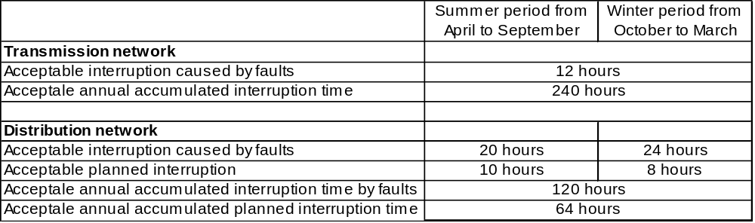
If undertakings fail to comply with the acceptable time limits they are required to pay compensation to customers. As well the EMI may initiate a misdemeanour procedure in each specific case and impose a fine in an amount of up 50 000 kroons (3195 €) for a single violation.

The EMI has elaborated a specific form for reporting. Undertakings are required to fill it in and disclose. In addition it is required to disclose how many times and in how many grid connection points they failed to comply with quality requirements. In connection with customer service requirements undertakings shall submit data on how man times they failed to fulfil service quality requirements. Network operators shall disclose the following network quality (continuity of supply) indicators:
- average fault caused interruption frequency per consumption point per year (CI; SAIFI);
- average interruption time per consumption point per year (SAIDI);
- average duration of an interruption (CAIDI);
- average planned interruption frequency per consumption point per year;
- average planned interruption time per consumption point per year;
- average duration of a planned interruption.

All above mentioned data on network quality are disclosed on the EMI web site.

As an example, a table with electricity supply quality requirements is presented below. Respective tables are disclosed in the EMI web site.

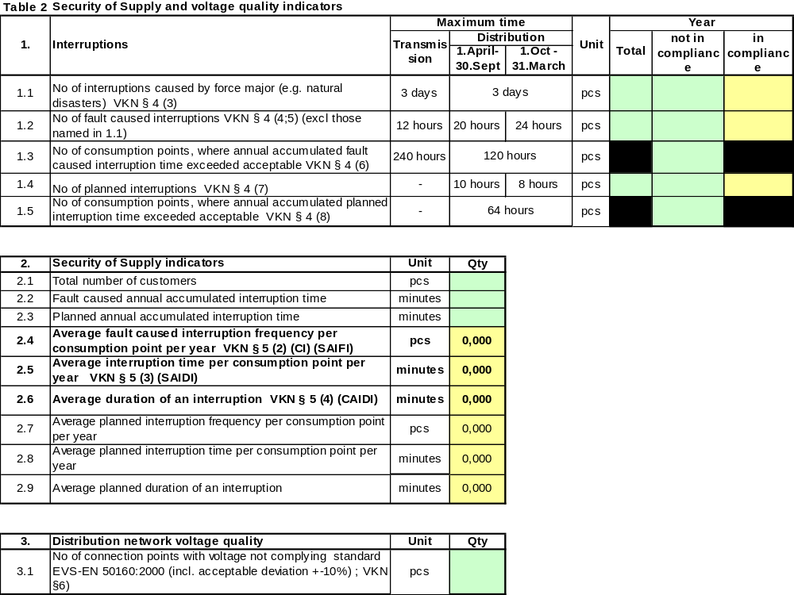

Balance responsibility

The Electricity Market Act and the grid code stipulate regulation of balance responsibility in detail. According to it every market participant is responsible for its balance. The balance period is one full hour and the balance day begins at 00:00. A balance provider shall provide the system operator preliminary balance plan for a calendar month, week and day. Final balance plan is provided at 14:00 at the latest in preceding day.

The market is organised in the principle that the transmission network operator is responsible for the balance of the whole system and there can be many balance providers operating in the market. For providing balance the transmission network operator buys and sells balance energy. The methodology for calculating balance energy price and standard term and conditions of balance agreements shall be approved by the EMI. In formation of balancing energy price the transmission network operator is obliged to buy and sell electrical energy at best possible price.

Balance is determined by means of remote reading device (on-line) in case the customer’s electrical connection capacity exceeds 63 A. For determination of other customer’s balance standard load curves are used. This means that for household customers an on-line metering is not necessary.

Since the Estonian electricity market is opened only in a 10 per cent extent, a real balancing energy market is missing today and distribution network operators are responsible for non-eligible consumer’s balance. The only balance provider is Eesti Energia AS that provides service where sold electricity price includes also balance responsibility service or, the so-called open supply. The EMI is in a position that a real balancing energy market can appear only when electricity market will be fully opened in 2013.

Unbundling of activities

A short overview of fulfilment of activity unbundling requirement is presented in below table 3.2.3.

Table 3.2.3. Unbundling of activities
 | Transmission | Distribution
Separate headquarters (yes/no) | Yes | Yes
Undertakings acting as separate business entities (yes/no) | Yes | Yes
Separate accounts together with guidelines of the regulatory authority (yes/no) | Yes | Yes
Auditing of separation of account (yes/no) | Yes | Yes
Disclosure of separated accounts (yes/no) | Yes | Yes
Separate management board in which board members of other group undertaking’s do not participate (yes/no) | Yes | Yes

According to law the transmission and distribution networks shall form separate business entities and shall not operate in other area of activity than network service, system service and providing balancing energy. A distributing network shall form a separate business entity if the number of customers exceeds 100 000. The latter applies in reality only to the distribution network of Eesti Energia AS group, OÜ Jaotusvõrk, as all other networks have less than 100 000 customers. Above mentioned requirements are applied equally to vertically integrated energy undertakings and other undertakings operating in the principle of a group. The Electricity Market Act stipulates also requirements for management of legally separated transmission and distribution network operators. Thus, a member of the management board of a network operator may not at the same time be a member of the management board of another electricity undertaking belonging to the same group or be in charge of everyday economic activities of another network operator. However, it is allowed to be, at the same time, a member of the management board of a network operator and a member of the supervisory board of another electricity undertaking belonging to the same group.

A distribution network operator with the number of customers below 100 000 shall separate its accounts as follows:

- provision of network service
- sale of electrical energy
- non-core activities

The accounts of undertakings shall be kept on the same principles as separate undertakings operating in the same field of activity should have kept. Therefore, a distribution network operator that is not required to form a separate business entity is obliged to keep its account similarly to a business entity and shall submit in its accounts balance sheet, profit and loss account, management report and other reports provided for in the Accounting Act separately for network services, electricity sales and secondary (ancillary) activities. Respective information shall be submitted in annual report and disclosed. The separation of accounts shall be audited and auditor’s opinion attached.

The EMI has elaborated and disclosed on its web site respective guidelines and the reporting form, which can serve as a basis for separation of activities for undertakings

In addition to separation of network services, electricity sale and secondary activity undertakings shall separate their accounts also by different services (so-called the regulatory stipulated activity separation).

The transmission network operator shall separate its accounts as follows:
- sale of network service (ex-ante regulation, the EMI approves network charges prior to their entry into force)
- transit of electrical energy (ex-post regulation, the EMI has the right to verify justification of prices)
- charges paid by customers for connecting to the network (ex-ante regulation, the EMI approves methodology for calculation of connection charges separately for every undertaking)
- sale of balancing energy (ex-post regulation, the EMI has the right to verify justification of prices)
- non-core activities

A distribution network operator that is required to form a separate business entity shall also separate its accounts as follows:
- sale of network service (ex-ante regulation, the EMI approves network charges prior to their entry into force)
- charges paid by customers for connection to the network (ex-ante regulation, the EMI approves methodology for calculation of connection fees separately for every undertaking)
- non-core activities

A distribution network operator that is not required to form a separate business entity shall separate its accounts as follows:
- electricity sale to non-eligible customers (the EMI approves weighted average price)
- electricity wholesale, including to eligible customers (the EMI has the right to verify whether cross-subsidising is avoided in the sale of electricity to eligible and non-eligible customers)
- sale of network service (ex-ante regulation, the EMI approves network charges prior to their entry into force)
- customers’ paid charges for connecting to the network (ex-ante regulation, the EMI approves methodology for calculation of connection charges separately for every undertaking)
- non-core activities

All network operators are obliged to elaborate a compliance programme with measures for equal treatment of other electricity undertakings and customers including duties of employees in implementation of these measures. The EMI has prepared guidelines for elaboration of such plan. It is disclosed in the EMI’s web site. According to the guidelines it is recommended to compile the plan in a 3-year perspective. Annually, a report shall be submitted to the EMI on implementation of the plan. Both the plan and the report are public documents and all interested parties can acquaint them. If the EMI is in an opinion that the plan is not sufficient and does not comply with requirements a revision of the plan and its changing may be required.

In Estonia two energy undertakings can be considered vertically integrated ones. These are Eesti Energia AS group and undertakings belonging to Fortum OY group.

To Eesti Energia AS group belong oil shale production, electricity generation, transmission network, distribution network, sale undertaking and undertakings dealing with secondary activities. 100 per cent Eesti Energia’s shares belong to the Estonian state. The structure of Eesti Energia AS is presented below.

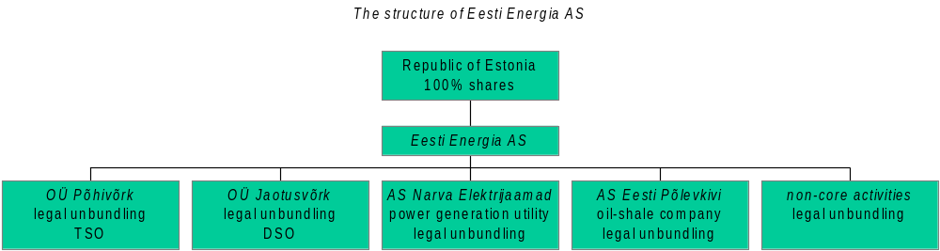
The undertakings belonging to Fortum OY group and operating in the Estonian energy market are Fortum Elekter AS and Fortum Termest AS. Fortum Elekter AS possesses electricity distribution network and Fortum Termest AS heat production facilities and gas distribution networks.

OÜ Põhivõrk is the transmission network operator and is responsible for provision of transmission network services. It is a separate independent business entity. The management board has a single member and according to law the person in charge may not at the same time be a member of the management board of another electricity undertaking belonging to the same group. According to submitted action plan it is intended in the near future change the board to a three member one. The supervisory board at the same time consists dominantly of the group’s mother company members of the board. The office together with dispatch centre is located in a separate building. The transmission network operator has its own logo, which is apparently is very similar to the group’s logo. The only difference is the text “OÜ PÕHIVÕRK”. So it seems obvious that it is intended to present the transmission network as part of the group.




A similar situation is in the distribution network that belongs to Eesti Energia group, in which the undertaking’s members of the board do not belong to management boards of other undertakings. It has an office building separately from the group’s mother company and its own logo that is again extremely similar to the group’s one.

An extremely important factor from the independence point of view is management of undertakings. Essentially, the mother company’s competence should only be limited to investments into productivity of assets, annual budget and approval of the long-term business plan. In the rest the networks should be independent in decision making. In this respect it should be mentioned that together with the formation of separate business entities in 2004 the independence has significantly risen and the EMI has not observed intervention into direct management by the group’s Mother Company.

As regards the transmission network an important issue is the action plan for a crisis situation, in which limitation of consumption may become unavoidable. The operator has a detailed plan.

In promotion of networks’ independence and their price regulation it is important to supervise the price formation for services purchased from Mother Company and other undertakings belonging to the group. As mentioned before there are three network operators belonging to a group: the transmission and distribution operators belonging to Eesti Energia AS group and Fortum Elekter AS distribution operator belonging to Fortum OY group. In comparison with the distribution network belonging to Eesti Energia AS group the Fortum’s undertaking is a small one – the number of customers respectively 500 000 and 23 000. From Mother Company Fortum Elekter AS buys only IT services. The services bought from Mother Company and other undertakings of Eesti Energia’s have important share in the cost structure of both the transmission and the distribution network. In the services bought from Mother Company a remarkable share have IT services, rent of office premises (these are owned by Mother Company), as well as security and legal services.

The largest part of outsourced services is the electricity purchased for compensation of power losses from power plants in Narva, which belong to the group. This directly complies with the Electricity Market Act, which stipulates purchase obligation form Narva power plants. Similarly, the transmission networks purchase from Narva power plants also reserve capacity that is needed for provision of system services. Two other undertakings belonging to Eesti Energia AS group are AS Televõrk that provides telecommunication services and AS Elektriteenused providing electricity network construction, repair and maintenance services. From these both transmission and distribution network operators purchase mentioned services.

Regarding services purchased from Mother Company the EMI has followed principles that the prices may not exceed the market ones and all procurement rules have to be complied with. According to the Public Procurement Act network undertakings as natural monopolies have to fulfil certain rules and requirements in their procurements.

It can be concluded that regarding unbundling of activities Estonia complies in full with the stipulations of UE Directives.

In May this year Eesti Energia AS group’s transmission operator OÜ Põhivõrk and its distribution operator OÜ Jaotusvõrk presented their compliance programme for equal treatment of market participants. The EMI is in a position that the level of independence of both undertakings is satisfactory, the plans have been prepared in a good level and provide sufficient actions to strengthen independence and equal treatment of all market participants. A very positive development has been proposed by the transmission operator OÜ Põhivõrk in connection with public relations. Particularly, it plans to compile a web site that presents information independently from Mother Company. During the year it is planned to prepare a deep risk analysis concerning possible conflict of interests with Mother Company and an action plan for mitigation of foreseeable risks

Competition in electricity market

Wholesale market

The main features of the Estonian electricity market are transitional period until 2013 and an extreme concentration of the market and since 2009 until 2013 the intended openness range shall be 35 per cent. Thus, there is no effective electricity market in Estonia. Only one out of the ten eligible customers is purchasing electricity from supplier other than its own network service provider. Currently there is no any independent seller. The larges electricity wholeseller in Estonia is Eesti Energia AS with its market share of 99 per cent.

Compared to other EU Member States one more specific of the Estonian market is its little volume. In 2005 electricity sale totalled only 7,52 TWh and system peak load 1,660 GW.
Some general indicators of the market are presented in below table 3.3.1.

Table 3.3.1. General indicators of wholesale market. Source: Statistical Office and OÜ Põhivõrk
 | Electricity consumption (incl network losses) TWh | Peak load GW | Installed capacity GW | No of producers with more than 5% market share | Market share of 3 largest producers %
2001 | 6,97 | 1,321 | 2,876 | 1 | 99
2002 | 6,94 | 1,336 | 2,726 | 1 | 99
2003 | 7,21 | 1,475 | 2,723 | 1 | 99
2004 | 7,44 | 1,318 | 2,675 | 1 | 99
2005 | 7,51 | 1,660 | 2,230 | 1 | 99

As seen from the table electricity consumption has been gradually increasing since 2001. Estonia in net exporter, i.e. it covers all of its own needs for electricity itself.

According to the organisation of closed market non-eligible customers may buy electricity only from the serving network operator. Network operators in turn shall purchase electricity for compensation of power losses or for re-selling to eligible customers produced either in Narva power plants, in cogeneration process or produced by small producers (below 10 MW capacity). Essentially the majority of Estonian producers comply with these criteria. Therewith, the electricity shall not necessarily be purchased directly from a power plant as an important issue is the origin. For example, Eesti Energia AS sale undertaking buys electricity from various power plants located in Estonia and re-sells it to other network operators. Other sellers may perform similarly.

The share of eligible market in 2005 was 850 GWh, 95 per cent of it was sold by Eesti Energia AS. Relevant figures are presented in table 3.3.2 below. The right hand column contains the electricity quantity bought by eligible customers.

Table 3.3.2. Electricity consumption in Estonia
 | Total consumption (without network losses) TWh | Sold to eligible customers on bilateral contracts TWh
2002 | 5,686 | 0,670
2003 | 6,013 | 0,760
2004 | 6,326 | 0,880
2005 | 6,403 | 0,850

In conclusion it can be said that there is no electricity market in Estonia. The formation of market can be expected beginning from 2009, when the level of openness shall reach 35 per cent.

Retail market

The specific of retail market is determined by the transitional period as well. Since non-eligible customers are obliged to buy electricity from the servicing network operator they have no possibility to change the supplier. As electricity trade is essentially missing the electricity consumed by eligible customers can be deemed retail one. In the retail market the undertaking with the biggest share is Eesti Energia AS. Its market share can be evaluated to be about 88 per cent.
The information related to retail market is presented in table 3.3.3 below.

Table 3.3.3. General retail market information
 |  |  |  | Market share of three biggest sellers |  |  | Change of seller
 | Total consumption TWh | No of undertakings with more than 5% market share | No of independent electricity sellers | Large and very large industries | Medium and small industries | Small undertakings and household customers | Large and very large industries | Medium and small industries | Small undertakings and household customers
2001 | 5,607 | 1 | 0 | 100 | 93 | 93 | 0 | 0 | 0
2002 | 5,686 | 1 | 0 | 100 | 93 | 93 | 0 | 0 | 0
2003 | 6,013 | 1 | 0 | 100 | 93 | 93 | 0 | 0 | 0
2004 | 6,326 | 1 | 0 | 100 | 93 | 93 | 0 | 0 | 0
2005 | 6,403 | 1 | 0 | 100 | 93 | 93 | 0 | 0 | 0

The data on formation of the prices paid by final customers (network services + electricity) are presented in the following table.

Table 3.3.4. Electricity final consumer prices
Prices €/MWh (Estonian cent/kWh) | Large industrial customer | Commercial customer | Household customer
Network service (without taxes)¹ | 13,32  (20,85) | 29,00  (45,39) | 39,21  (61,36)
Taxes as part of network charge | 0,00 | 0,00 | 0,00
Electricity | 23,79  (37,23) | 27,52  (43,07) | 28,99  (45,37)
VAT 18% | 6,68  (10,45) | 10,17  (15,92) | 12,28  (19,28)
Total (with taxes) | 43,79  (68,53) | 66,69  (104,37) | 80,48  (125,95)
Notes:
According to Eurostat definitions:
- large industrial customer, one with an annual consumption of 24 GWh, max capacity 4000 kW
- commercial customer, one with an annual consumption of 50 000 kWh, max capacity 50 kW
- household customer, one with an annual consumption of 3 500 kWh.
Prices according to Eesti Energia AS and OÜ Jaotusvõrk price list
¹ the charge for network service includes the subsidy paid to renewable energy sources
1 €=15,65 EEK

Competition supervision

In Estonia the authority responsible for competition supervision is first of all the Competition Board. The Competition Act provides definitions for undertakings with market dominant position, undertakings having special and exclusive rights and undertakings possessing and controlling essential facility.

An undertaking, or several undertakings operating on the same goods market, has a dominant position if the position enables it/them to operate in the market to an appreciable extent independently of competitors, suppliers and buyers. Dominant position is presumed if an undertaking or several undertakings operating on the same market account for at least 40 per cent of the turnover in the market.

According to the Competition Act any direct or indirect abuse by an undertaking or several undertakings of the dominant position in the goods market is prohibited, including:
1) directly or indirectly imposing unfair purchase or selling prices or other unfair trading conditions;
2) limiting production, service, goods markets, technical development or investment;
3) offering or applying dissimilar conditions to equivalent agreements with other trading parties, thereby placing some of them at a competitive disadvantage;
4) making entry into an agreement subject to acceptance by the other parties of supplementary obligations which have no connection with the subject of such agreement;
5) forcing an undertaking to concentrate, enter into an agreement which restricts competition, engage in concerted practices or adopt a decision together with the undertaking or another undertaking;
6) unjustified refusal to sell or buy goods.

Special or exclusive rights are deemed the rights granted to an undertaking by the state or a local government which enable the undertaking to have a competitive advantage over other undertakings in a goods market or to be the only undertaking in the market. An undertaking is deemed to control essential facilities or to have a natural monopoly if it owns, possesses or operates a network, infrastructure or any other essential facility which other persons cannot duplicate or for whom it is economically inexpedient to duplicate but without access to which or the existence of which it is impossible to operate in the goods market.

The Competition Act stipulates obligations of undertakings with special or exclusive rights or in control of essential facilities according to which above mentioned undertakings shall:
1) permit other undertakings to gain access to the network, infrastructure or other essential facility under reasonable and non-discriminatory conditions for the purposes of the supply or sale of goods;
2) keep clear separation of accounts for different primary and secondary activities (e.g. production, transmission, marketing and other areas of activity) enabling thereby transparency of economic performance;
3) maintain separate records on revenue and expenditure related to each product or service on the basis of consistently applied and objectively justified principles of calculation which shall be clearly specified in the internal rules of the undertaking. The calculation of revenue and expenses must enable to assess whether the price of a product or service is in a reasonable ratio with the value of the product or service.

An undertaking with special or exclusive rights or in control of an essential facility may refuse to grant other undertakings access to the network, infrastructure or other essential facility if the refusal is based on objective reasons, including cases where:
1) the safety and security of the equipment connected with the network, infrastructure or other essential facility or the efficiency and security of the operation of such network, infrastructure or facility are endangered;
2) maintenance of the integrity or the inter-operability of the network, infrastructure or other essential facility is endangered;
3) equipment to be connected to the network, infrastructure or other essential facility is not in conformity with the established technical standards or rules;
4) the undertaking applying for access lacks the technical and financial capability and resources to provide services efficiently and safely to the necessary extent through or with the assistance of the network, infrastructure or other essential facility;
5) the undertaking applying for access does not hold the permit prescribed by law for the corresponding activity;
6) as a result of such access, data protection provided by law is no longer ensured.

On the basis of the Act all network operators are undertakings with special and exclusive rights, as well as the undertakings possessing essential facility. The exclusive right is granted also by the concession principle, as described in section 3.2 above, by which to every distribution network has service area assigned to it and in which only one operator may provide network services. The Electricity Market Act regulates the activities of network operators in detail and assigns the supervisory function to the EMI. This does not prevent the Competition Board from its right of supervising of network operator’s performance. In practice primarily the EMI supervises and controls the activities of network operators.

Eesti Energia AS has market dominant position both as a producer and as a seller. On the basis of the Electricity Market Act the EMI is obliged to approve the price of electricity sold to non-eligible customers and in the framework of this also the production price of Narva power plants. The EMI has also the right to verify the prices of a market dominant seller and of the electricity sold by producer. The regulation of prices of electricity production side and sale is explained in more detail in section 6.1.2.

A big part of smaller network operators are members of the Estonian Association of District Heating and Power Plants. In the beginning of 2006 the Association submitted a complaint to the EMI stating that Eesti Energia AS sells them electricity at an unjustified high price. The EMI verified grounds of the complaint and came to a conclusion that Eesti Energia AS had not breached the principle of equal treatment and had not sold electricity to other distribution networks at a price higher than to OÜ Jaotusvõrk, which is the network operator that belongs to Eesti Energia AS group.

Besides the EMI also the Competition Board supervises the activities of Eesti Energia AS and other producers and sellers. The EMI has entered into corresponding contract agreement with the Competition Board. According to it the EMI provides advice and assistance in all questions related to energy markets.

Conclusively, the situation in the Estonian electricity market is determined by the circumstance that because of the transitional period the market is opened only by about 10 per cent and this actually means that substantially there is no market. There is no competition also in connection with the sale of electricity to eligible customers, as only one eligible customer has changed the supplier from one to another. Another feature of the market is an extreme concentration. Eesti Energia AS share in the wholesale market is close to 100 per cent and in the retail market 88 per cent. The second largest Fortum Elekter AS and the third largest AS Narva Elektrivõrk have shares respectively 3 and 2,5 per cent. Considering high concentration it is not very realistic to expect competition even after 2009, when 35 per cent of the market shall be opened. Better chances for competition would be provided by a common market of the three Baltic countries. It is a unique situation in the whole EU, as there are no limitations for cross-border transmission capacity. Another circumstance that may facilitate competition is the Estonian-Finnish sea cable that shall start commercial operation in the end of 2006.

Gas market

Review of gas market and its regulation

Similarly to electricity system also the gas supply system was built during the former Soviet Union and historically formed part of the Soviet gas supply system. Map of the Estonian gas supply system is presented in drawing 4.1.1 below.

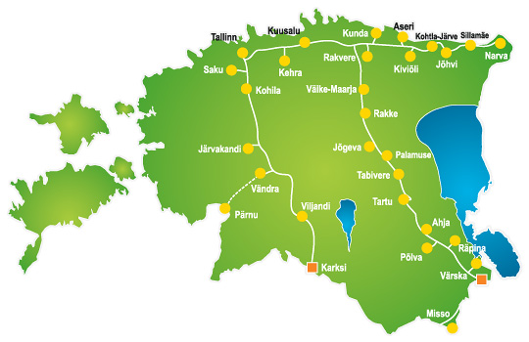
Drawing 4.1.1. Natural gas network in Estonia

Estonia has cross-border connections only with Russia and Latvia, and that is why Estonia is in similar position with other Baltic countries and Finland. There is no connections with other Member States and the only source of supply is Russia.

A specific of the Estonian gas market is its smallness. In 2005 consumption totalled 990 000 thousand m³. 83 000 thousand m³out of it was used for electricity generation, 374 000 for heat production in power plants and boiler houses, 159 000 by household and business customers primarily for heating 374 000 thousand m³ for industrial purpose. Thus, another specific in Estonia is that the largest share of the gas is used for industrial purpose and heating and the share used for electricity production is low. Consumption of gas by different customer groups is presented in below diagram 4.1.2.

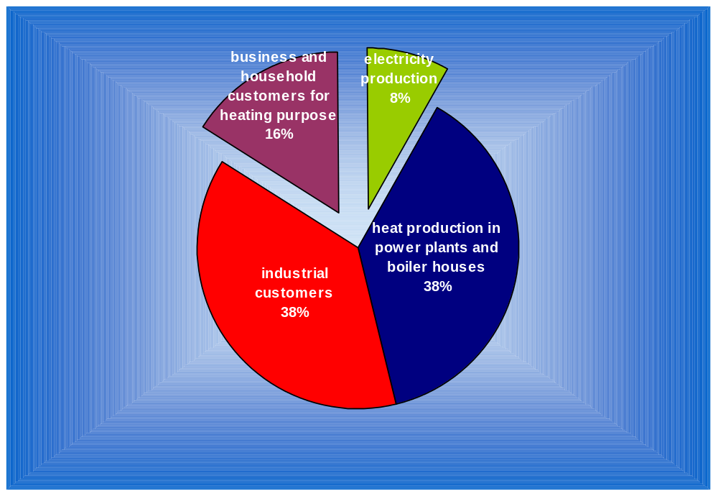Drawing 4.1.2. Consumption of natural gas by customer groups

Drawing 4.1.3 presents the Estonian primary energy balance in 2004. The share of natural gas is 14,7 per cent, so the share is not very large and as mentioned before, first of all district heating sector is dependent on gas. Therewith the share of gas in electricity generation is only 4,7 per cent, but in heat production as high as 41,5 per cent. According to the long-term energy sector development plan (decided by the Parliament – Riigikogu) the share of gas is predicted to increase in the future.

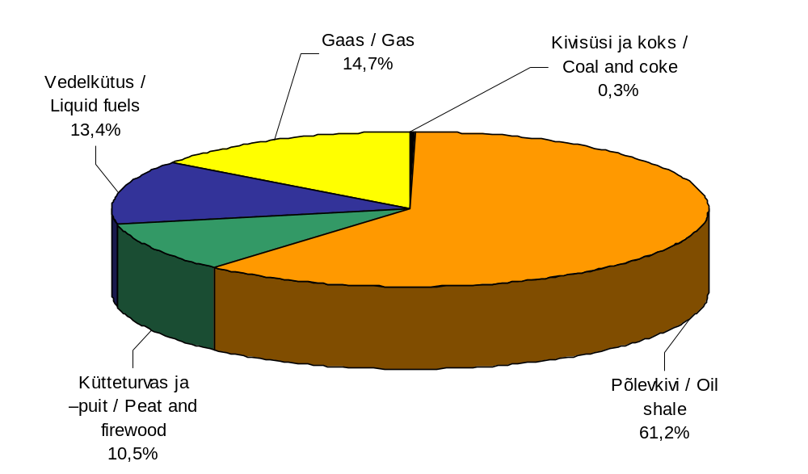
Drawing 4.1.3. Estonian primary energy balance in 2004

Besides above the Estonian gas supply is also characterised by the circumstance that in many areas like western part of Estonia including islands and central Estonia is without gas supply. To a large extent the reason is low population density of the territory. However, in 2006 one of the biggest gas projects is the construction of gas supply network in Pärnu town.

Similarly to the electricity system it should be emphasised that the transmission infrastructure is strong, there is no cross-border transmission capacity deficit between Baltic countries. At the same time a specific is total dependence on supplies from Russia.

Organisation of the Estonian gas market dates back to 1998 when the Energy Act entered into force, by which all customers except households were determined as eligible ones. In 1st January 2003 the Natural Gas Act entered into force. It determines eligible customers as ones with an annual consumption over 200 thousand m³, but this has no impact to the share of open market. In December 2005 an amendment was made to the Act, which stipulates that until 1st July 2007 all customers except households are eligible ones and from this date all customers are eligible. Table 4.1.1 presents the dynamics of the gas market opening.

Table 4.1.1. Gas market opening
Year | Annual consumption GWh | Percentage of market opening
1998 | All, excl. households | 95
1999 | All, excl. households | 95
2000 | All, excl. households | 95
2001 | All, excl. households | 95
2002 | All, excl. households | 95
2003 | 1,8 | 95
2004 | 1,8 | 95
2005 | 1,8 | 95
2006 | All, excl. households | 95
2007 | All customers | 100

Cross-border connections, availability and distribution of capacity reserves

Estonia has network connections with Russia and Latvia. Altogether there is three connections: from Narva and Värska to Russia and from Karksi to Latvia (drawing 4.1.1) with the total capacity of 11 000 thousand m³ daily. As a rule, only the Värska and Karksi connections are operational. The Narva connection is typically closed because of limitations in the Russian side network. The pass-through capacities of particular connections are the following:

Karksi connection with Latvia 7000 thousand m³ daily;
Värska connection with Russia 4000 thousand m³ daily;
Narva connection with Russia, with a theoretical pass-through capacity of 4000 thousand m³ daily, the actual pass-through capacity is not more than 500 thousand m³ daily.

Because of very cold weather conditions in 10th January 2006 the consumption reached its last years peak of 6700 m³ daily, yet it did not exceed the pass-through capacity, which is 11 000 m³ daily. Natural gas annual peak consumptions are presented in table 4.1.2.

Table 4.1.2. Natural gas peak consumption and pass-through capacity of transmission system
Year | Consumption peak |  | Pass-through capacity of transmission system
 | 1 000 m³ daily | MW | 1 000 m³ daily | MW
2001 | 5 400 | 2 099 | 11 000 | 4 276
2002 | 5 000 | 1 944 | 11 000 | 4 276
2003 | 5 500 | 2 138 | 11 000 | 4 276
2004 | 5 100 | 1 983 | 11 000 | 4 276
2005 | 5 200 | 2 022 | 11 000 | 4 276
2006 | 6 700 | 2 605 | 11 000 | 4 276

Therefore, there is no lack of pass-through capacity. According to a prognosis of the System operator AS EG Võrguteenus there shall no capacity deficiency by 2012. That is why the regulatory authority has no need for capacity distribution. In 2012 the pass-through capacity may increase because of reconstruction of the Russian side network in Narva direction. Even today the technical capacity is 4000 m³ daily (1555 MW), but it cannot be utilised because of network limitations on the Russian side.

In conclusion: the Estonian gas transmission system today has sufficient pass-through capacity and until 2012 there will be no capacity deficiency. Moreover, the Estonian side pass-through capacity is 15 000 m³ daily, but it cannot be utilised because of network limitations on the Russian side in Narva direction. A precondition for capacity increase is investing into the Russian side network.

Price regulation of gas networks

Unlike electricity networks in issuing activity licences the so-called exclusive right principle is not applied for gas networks and according to the Natural Gas Act erection of parallel networks is allowed. In practice so far no case of construction of a parallel network has been recorded

In issuing activity licences to distribution network operators the EMI determines the service area for the undertakings. The operator is obliged to develop the network in its service area in a manner that ensures gas supply to all already connected customers and to new customers that wish to connect.

AS EG Võrguteenus possesses both the transmission network and the largest distribution network. The shares of AS EG Võrguteenus belong to AS Eesti Gaas, which is the largest undertaking in the Estonian gas market. Its major shareholders are Gazprom, Eon Ruhrgas and Fortum. The total number of distribution network operators is 25. This is quite big number, considering the smallness of Estonia. However, the concentration is very high. Thus, AS EG Võrguteenus has a market share of about 97 per cent and the number of its customers is 60 000. Other distribution operators have relatively little sale volume, typically of less than 3000 thousand m³ annually and the number of customers below 1000. The market share of small distribution operators is only 3 per cent today. However, the development of small networks is rapid and in perspective their market share may increase up to 10 per cent.

The main summary data of gas networks are presented in below table 4.1.3.

Table 4.1.3. Summary of gas network operators
 | No of regulated undertakings | Price for network service  €/MWh (EEK/thousand m³) |  |  | Gas supply quality indicators
 |  | Large industry (I4) | Commercial (I1) | Household (D3)
Transmission | 1 | 0,604 (87) |  |  | Will be fixed since 2007
Distribution | 25 | 1,465 (211) | 1,465 (211) | 5,320 (766) | Will be fixed since 2007
Notes:
According to Eurostat definitions:
- large industrial customer (I4) with an annual consumption of 116 300 MWh or 12 600 thou m³
- commercial customer (I1) one with an annual consumption of 116,3 MWh or 12,6 thou m³
- household customer (D3) one with an annual consumption of 23 260 kWh or 2,53 thou m³
Prices of network services according to AS EG Network service price list.
Since the unit for network service prices is thousand m³, then in brackets also prices in EEK/thou m³); calorific heat value of gas is 9,2 MWh/thou m³
1 €= 15,65 EEK

According to law price regulation is uniformly applied to all network operators irrespective of their size. This adds significant amount of work to the EMI as first of all the volume depends on the number undertakings and not the size of the market. Saying in other words, the amount of work is more or less the same, irrespective of whether a large or a small undertaking is concerned.

The only exemption in regulation of gas network operators is the requirement for their legal unbundling. According to the Natural Gas Act legal unbundling is required when the number of customers is over 100 000 or, the same undertaking performs both transmission and distribution activities. Due to that the only undertaking with legal unbundling from AS Eesti Gaas is its distribution operator AS EG Võrguteenus. For undertakings law stipulates requirement for separation of accounts. Since AS EG Võrguteenus performs both transmission and distribution activities therefore, separation of accounts for both services is required.

According to law the EMI approves separately the following network services and methodologies:
- transmission service
- distribution service
- methodology of calculation of the charge for connecting to the network

The price for balancing gas and the charge for gas transit are not approved. For these prices the EMI applies ex-post regulation, i.e. supervision/monitoring of the price.

The principles of regulation of gas network operators are the same with those applied in electricity networks regulation. The EMI elaborates a uniform methodology for calculation of network service prices that forms a basis for both transmission and distribution service regulation and price approval. The methodology is disclosed on the EMI web site. The site also includes specially elaborated tables for collection of input data to be filled in for approval process. The tables are comprehensive and include technical data and detailed accounts (profit and loss statement, balance sheet, and data about assets). The enterprises shall also submit a detailed investment plan and separately the expected sale volumes of network services. Since the tables are very comprehensive, it is required to fill them in only for price approval purpose. Regular updating of the tables is not required, but the EMI is entitled to request additional information about economic performance and technical indicators and in case of necessity require filling in the tables disclosed on the web site. At the same time undertakings are obliged to separate in their annual accounts network services and the sale of gas. The annual accounts are public documents that can be acquainted by all interested parties.

Submission of input data is an obligation stipulated by law. The EMI can request any information needed for price approval and performing of supervisory proceedings. The EMI employees can also visit the enterprises any time and request data and copies of documents. The practice so far has shown that undertakings do not refuse submitting information and the established procedures for data acquisition work problem less.

In the regulation of network prices the EMI has a determining role in the selection of methodologies. However, the following is stipulated by law:

- The regulatory authority has to approve all individual network charges and the methodology for calculation of the charges for connection to the network prior to entry into force.

- The prices for network services shall be justified based on the expenses necessary for the operation and development of the network, reliability and security of supply, metering of the gas distributed through the network, communication and computation of meter readings and earning of a justified profit to ensure a smooth supply of gas to final customers.

- The price of network services shall be set in a manner which ensures:
1) that necessary operating expenses are covered;
2) that investments for operational performance and meeting of development obligations are made;
3) compliance with environmental requirements;
4) compliance with quality and safety requirements;
5) justified profitability.

- The EMI elaborates and discloses unified methodologies for calculation of network charges, which serve as the basis for approval.

So it is up to the regulatory authority to decide upon the selection of methodologies. In the elaboration of methodologies opinion of enterprises has been considered and in fact the methodologies were prepared in the process of mutual consultations between the EMI and the undertakings. In the regulation of network charges a principle is used by which an undertaking submits application for price approval according to necessity and the approved prices are valid until approval of new prices. Already in the near future it is intended to switch over to a long-term RPI-x regulation.

In the following the basics of price formation is described.

Sale volume of network service
Evaluation of the volumes of sale is of an extreme importance. As regards network services, fixed cost is dominant in the cost structure. Hence, the higher the sales, the lower the charge for the use of network. In the evaluation of the sale volume of network services historic statistical data are used, as well as the comparison of consumption and the number of customers. The latter method is effective first of all in case of household customers since there are some certain established levels of consumption per one customer.

Uncontrollable cost
Cost is considered uncontrollable if undertakings cannot influence them by their economic performance and this means that no saving obligation can be imposed on it. Unlike electricity networks in gas networks the uncontrollable cost is very low and as a rule it only consists of the state fee charged for the issuance of activity licence. In the future uncontrollable cost may also include compensation to the owners of land for the toleration of technical structures in case a gas network crosses owners’ territory.

Fixed cost
Fixed cost is subject to a very deep analysis by the EMI. Basic methods for evaluation of fixed cost is comparison with similar undertakings (benchmarking), analysis of cost dynamics and the analysis and audit of individual cost components. A precondition for using comparison is an availability of a number of similar undertakings. In the regulation of distribution networks comparison can be successfully used only for regulation of smaller network operators. As mentioned before there are 25 distribution operators in Estonia. At the same time it is problematic to apply comparison method for the regulation of the distribution network belonging to AS EG Võrguteenus, as this network is tens of times larger than other comparable networks. This makes using of benchmarking in cost analysis of this undertaking practically impossible. The only chance is comparison with the distribution networks of other countries. Similar problem exists also with the transmission network of AS EG Võrguteenus, where it can be compared only with the transmission networks of other countries.

Other substantial methods for fixed cost analysis are the dynamics of cost and the analysis of individual cost components. In the analysis of dynamics it is assumed that their growth shall not exceed the inflation reflected by consumer price index (RPI). In addition, undertakings shall achieve cost reductions through higher efficiency and productivity. In the analysis of individual cost components justification of them is verified. Basic cost articles of network operators are operation and maintenance, labour expenses, sales cost etc. Among others the EMI verifies in the analysis process whether an undertaking buys services at a competitive market price, whether goods, works and services are purchased in compliance with procurement rules.

Capital expenditure (depreciation of fixed assets)
Similarly to the regulation of electricity networks for gas networks the EMI also uses a regulatory capital cost method that, as a rule, differs from accounting depreciation. Advantages of the regulatory method are its simplicity of calculation and transparency for both customers and undertakings, as well as to the regulatory authority. The regulatory depreciation method uses only two fixed assets’ depreciation rates. Therefore, it is very simple and easily understandable way to monitor the value of regulated assets and verify accounting of capital cost.

In the regulatory capital cost accounting a principle is used in which, from a certain selected moment in time, the fixed assets are divided into two parts, the old ones and the new investments. The assets acquired before that are regarded old ones and for them a single constant rate of depreciation is applied, which considers both the structure and the age of assets. A single constant weighted average depreciation rate is applied also to the new investments. A basis for calculation of the rate is the structure of assets.

The majority of the networks of small undertakings have been built during the last five years. Therefore, these are new investments that are considered new assets and in the accounting of capital cost a single depreciation rate for new fixed assets is used. Contrary, the transmission and distribution networks of AS EG Võrguteenus were built during the former Soviet Union and for these networks separate old and new fixed assets’ depreciation rate is used.

Justified profitability
Similarly to other regulatory authorities for calculation of the justified return a model is used, which considers a weighted average cost of capital (WACC) and the regulatory assets. Besides other factors, a weighted average cost of capital depends on the risks involved in individual undertakings. Particularly, the WACC value calculated by the EMI for AS EG Võrguteenus is 8,5 per cent and for small network operators 10 per cent. A foundation for determination of WACC is a risk free rate of return. In Estonia governmental bonds are essentially missing. For that reason the EMI bases in the determination of risk free return on the German 10-year state bond return in the last 5 years. To this an Estonian state risk is added. The 5-year historic return is used in order to eliminate market fluctuations in the calculation of a justified return.

Regulatory asset base
The basis for determination of both cost of capital (capital expenditure) and a justified return is the regulatory asset base, for which the EMI applies principles similar to those used by other regulatory authorities. In accounting of the regulatory assets its continuity is of an extreme importance. Accounting of the regulatory assets is based on the principle according to which to an initial value of assets the investments are added and a regulatory capital cost is subtracted. As a rule, for initial value the book value is taken. In verification of the value of assets of small undertakings the EMI has used comparative method as well. In this case the asset value of particular undertakings is compared with the length of network (in kilometres) and with the volume of consumption. As the investments of smaller network operators have been made mainly after 2000, in the analysis of regulatory assets the EMI has also verified economic feasibility of the investments made.

Information disclosure
According to the Public Information Act all network operators have to maintain a web site, which discloses network charges and the base of their formation, charges for connecting to the network and the methodology of their formation, as well as the standard terms and conditions of customer contracts.

Conclusion: the EMI’s opinion is that similarly to the price regulation of electricity networks also gas networks’ price regulation is in a sufficiently good level. The next step intention is to switch over to RPI-x type regulation in the near future and to index prices for a 5-year period.

Quality of gas supply

Currently there is no gas supply quality requirements in Estonia. According to the Natural Gas Act, that entered into force in the end of 2005 and was amended recently, a gas seller has to approve with the EMI standard conditions of contracts for selling gas to household customers. Among others the contracts shall also include limit values for the quality of offered service. As these standard conditions regulate the sale of gas under public service obligation, it becomes possible to expand the regulation of quality also to the network service sold to household customers. So, under quality it is meant besides calorific heat value of gas also the quality related to provision of network service, like interruption frequency, duration of interruptions, etc. Thus, the EMI can control the regulation of gas supply quality by approval of standard terms and conditions of consumer contracts and by requiring equal treatment for all household customers.

The quality conditions of gas sold to eligible customers are determined by the contracts between parties, which are subject to negotiations. In May this year the Ministry of Economic Affairs and Communications proposed amendments to the Natural Gas Act, which, among others, stipulate some gas supply quality requirements. According to them an interruption in supply may not last longer than 72 hours and an annual accumulated interruption time shall not exceed 130 hours.

Balance responsibility

The Natural Gas Act stipulates the regulation of balance responsibility. According to it all market participants are responsible for their balance. For household customers’ balance the network operator is responsible. The trading period is one twenty four hour period. The market is organised in a principle, where the system operator (transmission network) is responsible for the balance of the whole system and there may be several balance providers. In order to ensure balance the transmission network operator buys or sells balancing gas. In the balancing gas price formation the transmission network operator is obliged to buy or sell gas at most favourable price. According to law the EMI exercises in the balance market ex-post regulation, where the regulator is responsible for verification of the balance agreement conditions and the balance gas price.

A specific of the Estonian gas market is very high concentration. Only two undertakings import gas: AS Eesti Gaas and AS Nitrofert. AS Nitrofert is chemical industry using gas in its technological process and importing gas for its own needs only. AS Eesti Gaas besides selling gas to other network operators is also the balance provider. In doing so the sale price of gas also includes balancing service. Considering the concentration of market it is unlikely that new balance providers enter the market in the near future.

Unbundling of activities

A review of activity unbundling is presented in following table.

Table 4.1.4. Unbundling of activities in natural gas sectors
 | Gas transmission | Gas distribution
Separate headquarters (yes/no) | Yes | Yes
Undertakings acting as separate business entities (yes/no) | Yes | Yes
Separate accounts together with guidelines of the regulatory authority (yes/no) | Yes | Yes
Auditing of separation of account (yes/no)¹ | No | No
Disclosure of separated accounts (yes/no) | Yes | Yes
Separate management board in which board members of other group undertaking’s do not participate (yes/no) | Yes | Yes
¹ Note: As the undertaking providing transmission and distribution service was established in the end of 2005 no auditing has been yet. New Gas Market Act amendment will stipulate obligation of auditing of account separation.

According to the Natural Gas Act the distribution network operator shall form a separate undertaking if the number of customers is over 100 000. Actually, there is no distribution network operators with more than 100 000 customers in Estonia. The transmission network operator shall be legally unbundled. However, it is allowed to establish a business entity that performs both transmission and distribution service provision. AS Eesti Gaas that possesses both the transmission network and the distribution network with the largest market share has established business entity AS EG Võrguteenus that provides both transmission and distribution service. So it is the so-called combined network operator within which transmission, distribution and secondary (ancillary) activities are separated by accounts and disclosed. In doing so the undertaking is obliged to establish accounting rules for distribution of assets and liabilities, revenue and cost. The annual report shall be supplemented by an auditor’s evaluation of justification of the cost distribution.

The structure of AS Eesti Gaas is presented in below drawing 4.1.4.

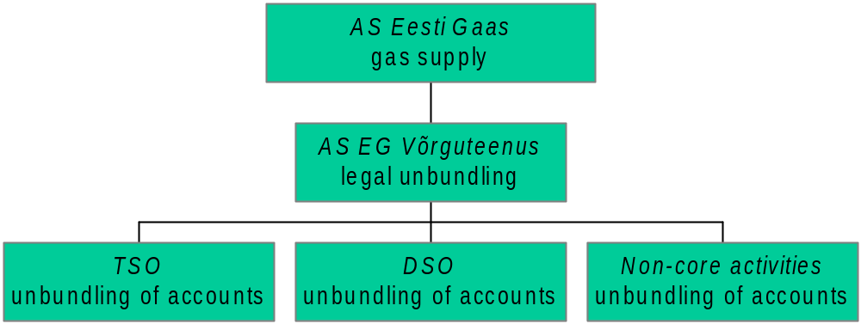Drawing 4.1.4. Structure of AS Eesti Gaas

All other distribution networks besides AS EG Võrguteenus, altogether 24 undertakings, as well as undertakings with less than 100 000 customers shall separate their accounts as by areas of activity as follows:
- distribution service
- sale of gas to non-eligible customers
- sale of gas to household customers (until the opening of market 1st July 2007)
- non-core activities

The EMI has elaborated and disclosed on its web site respective guidelines and report forms which may be helpful for undertakings in separation of accounts. In doing so the undertakings are obliged to establish accounting rules for distribution of assets, liabilities, revenue and cost. The annual report shall be supplemented by an auditor’s evaluation of justification of the cost distribution.

In addition of account separation for network service, gas sale and secondary activity undertakings shall separate their accounts also by different services (the so-called regulatory stipulated activity separation).

Combined network operators (AS EG Võrguteenus) are obliged to separate their accounts as follows:
- sale of transmission service (ex-ante regulation, the EMI approves network charges prior to their entry into force)
- sale of distribution service (ex-ante regulation, the EMI approves network charges prior to their entry into force)
- transit (ex-post regulation, the EMI has the right to verify justification of prices)
- charges paid by customers for connecting to network (ex-ante regulation, the EMI approves methodology for calculation of connection fees separately for every undertaking)
- sale of balancing energy (ex-post regulation, the EMI has the right to verify justification of prices)
- non-core activities

A distribution network operator that is obliged to form a separate business entity shall also separate its accounts as follows:
- natural gas sale to non-eligible customers (the EMI approves weighted average price)
- natural gas sale to eligible customers (the EMI has the right to verify whether cross-subsidising is avoided in the sale to eligible and non-eligible customers)
- sale of distribution service (ex-ante regulation, the EMI approves network charges prior to their entry into force)
- customers paid charges for connecting to the network (ex-ante regulation, the EMI approves methodology for calculation of connection charges separately for every undertaking)
- non-core activities

AS EG Võrguteenus is obliged to elaborate a compliance programme with measures for equal treatment of other gas undertakings and customers including duties of employees in implementation of these measures. The EMI has prepared guidelines for elaboration of such plan. It is disclosed on the EMI’s web site. According to the guidelines it is recommended to compile the plan in a 3-year perspective. Annually, AS EG Võrguteenus shall report to the EMI on implementation of the plan. Both the plan and the report are public documents and all interested parties can acquaint with them. If the EMI is in an opinion that the plan is not sufficient and does not comply with requirements, a revision of the plan and its changing may be required.

From the point of view of activity separation the most important is the separation within AS Eesti Gaas as the group which has market dominant position not only in network service provision but also in sale. As explained above AS EG Võrguteenus is a separate business entity with 100 per cent shares belonging to AS Eesti Gaas. Unlike the Electricity Market Act the Natural as Act does not stipulate limitations for management and supervisory board. The management board has a single member, while the supervisory board has three members. However, all members are employees of mother company AS Eesti Gaas. The company office together with dispatch centre locates in a separate building and the logo, which is remarkably different from the Mother Company’s logo, is an indicator of wishes to present the company to public as an undertaking different from Mother Company.



An extremely important factor from the point of view of gas network operators’ independence is the management of undertakings. Essentially, the Mother Company’s competence should only be limited to investments into productivity of assets, annual budget and approval of the long-term business plan. In the rest the networks should be independent. As the independent network operator AS EG Võrguteenus was established just in the end of 2005 and it is obviously too early to make conclusions about independence. Also, the EMI has not yet received their compliance programme with measures for equal treatment.

As regards AS EG Võrguteenus and belonging to it the system operator (the transmission network operator) an important issue is to have an action plan for possible crisis situation in which limitation of consumption may become unavoidable. Today the company has an internal action plan for possible crisis situation. However, the principles of the plan are not regulated by legislation. In connection with entering into force of the EU Directive 2004/67/EU, which deals with the measures of gas security of supply, the Ministry of Economic Affairs and Communications has proposed an amendment to the Natural Gas Act. Among others it regulates system operator’s actions in possible crisis situation in which consumption limitations may become necessary.

In promotion of networks’ independence and their price regulation it is important to supervise the price formation for services purchased from Mother Company and other undertakings belonging to the group. Regarding services purchased from Mother Company the EMI has followed principles that the prices may not exceed competitive market ones and all procurement rules have to be complied with. According to the Public Procurement Act the gas network undertakings as natural monopolies have to fulfil certain requirements in procurement procedures stipulated in the Act.

As a summary it can be realised that Estonia fulfils EU Directive requirements for unbundling completely. AS Eesti Gaas has less than 100 000 customers and according to that the combined network operator AS EG Võrguteenus that provides both transmission and distribution services has been established. Transmission and distribution have separate accounts. Other distribution network operators (having less than 100 000 customers) have separate accounts for distribution service and sale.

Competition in gas market

Wholesale market

A feature of Estonian gas market is openness – in 2006 the market is opened by 95 per cent (all customers but households are eligible). Since 1st July 2007 the market shall be opened in the whole. However, in essence the market is opened just formally as there is no real competition.

As explained above Estonia has cross-border connections only with Russia and Latvia, and the only supplier of gas is Russia. All the gas sold in the wholesale market is imported by AS Eesti Gaas as there is no other wholesellers. In addition the chemical industry AS Nitrofert also imports gas, but exclusively for its own technological needs. Law allows import of gas for all market participants. However, the Natural Gas Act provides for an activity licence if gas is imported from outside of the EU, but the application of it is simple, just fulfilment of some formal requirements.

Price regulation is not applied in case of wholesale and in case of sale to eligible customers. AS Eesti Gaas, as the only wholesaler, sells gas to eligible customers connected to its network, as well as re-sells gas to other network operators.

The gas wholesale market general indicators are presented in table 4.2.1 below.

Table 4.2.1. Gas wholesale market overview
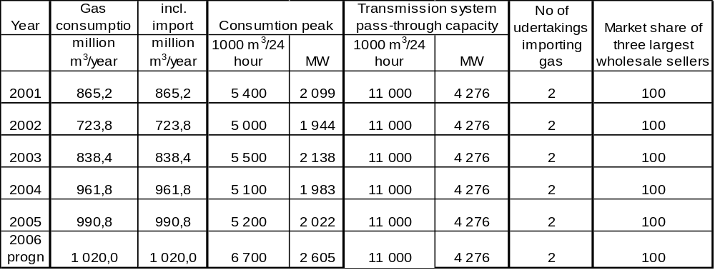

Retail market

AS Eesti Gaas is in the leading position also in retail market. Its retail market share is 97 per cent, thus being undisputable market leader, as also the rest of retail gas is also purchased from AS Eesti Gaas. The second largest undertaking has the retail quantity of only 3 thousand m³. This expressively shows how large is the AS Eesti Gaas’ share in the market. Besides AS Eesti Gaas there is 24 smaller network operators that sell both network service and gas to customers connected to their network. There is no sellers which are independent from gas network operators and no one customer has changed the seller, although it is fully possible to eligible customers. Table 4.2.2 below presents a retail market overview.

The EMI anticipates appearance of a certain retail market after full opening of the market in 1st July 2007. Namely, it can be foreseen that many customers presently connected to their respective networks may wish to buy gas directly from AS Eesti Gaas. Since AS Eesti Gaas, as the seller of gas and at the same time, according to the Competition Act, an undertaking with a market dominant position, it has an obligation to sell gas to all customers connected to other networks at equal conditions. Thus, after full opening of market some changes of sellers can be expected by customers.

Table 4.2.2. Gas retail market overview
 |  |  |  | Market share of three largest undertakings
Year | Retail market consumption  mill. m³ | No of undertakings with market share of over 5% | No of sellers independent from network operators | Power plants | Large industries | Medium industries | Small business and households | No of customers that changed supplier
2001 | 789,0 | 1 | 0 | 100 | 100 | 100 | 100% | 0
2002 | 675,4 | 1 | 0 | 100 | 100 | 100 | 99% | 0
2003 | 732,4 | 1 | 0 | 100 | 100 | 100 | 99% | 0
2004 | 748,9 | 1 | 0 | 100 | 100 | 100 | 98% | 0
2005 | 774,4 | 1 | 0 | 100 | 100 | 100 | 97% | 0
2006 prog | 800,0 | 1 | 0 | 100 | 100 | 100 | 97% | 0

Data about gas prices are presented in table 4.2.3 below. It can be stated that both network charges and gas prices were relatively favourable in 2005. The network charges rose by 3 per cent in average compared to previous year, but the gas price for eligible customers increased by 30 per cent in average.

Table 4.2.3. Gas final consumer price
€/MWh | I4 | I1 | D3
(EEK/1000 m3)
Network service | 1,465 | 1,465 | 5,320
Network service | (211) | (211) | (766)
Taxes incl in network charges | 0,000 | 0,000 | 0,000
Nat gas price without network service | 11,384 | 16,176 | 16,176
Nat gas price without network service | (1639) | (2329) | (2329)
VAT 18% | 2,313 | 3,175 | 3,869
VAT 18% | (333) | (457) | (557)
Final consumer price incl VAT | 15,161 | 20,816 | 25,365
Final consumer price incl VAT | (2183) | (2997) | (3652)
Notes:
According to Eurostat definitions:
- large industrial customer (I4) with an annual consumption of 116 300 MWh or 12 600 thou m³
- commercial customer (I1) one with an annual consumption of 116,3 MWh or 12,6 thou m³
- household customer (D3) one with an annual consumption of 23 260 kWh or 2,53 thou m³
Prices of network services according to AS EG Network service price list.
Since the unit for network service prices is thousand m³, then in brackets also prices in EEK/thou m³); calorific heat value of gas is 9,2 MWh/thou m³
1 €= 15,65 EEK

Competition supervision

As it was described in section 3.3.3 in connection with electricity market supervision the authority responsible for competition supervision is first of all the Competition Board. The function of the EMI is first of all supervision of network operators, while the Competition Board has concentrated primarily on supervision of natural gas sale issues.

As regards sales, AS Eesti Gaas is indisputably in a market dominant position, as it is in essence the only gas importer and re-seller (AS Nitrofert has so far imported gas for its own production needs and has never acted as a re-seller of gas). As the undertaking with market dominant position AS Eesti Gaas is obliged to comply with requirements of the Competition Act, according to which any direct or indirect abuse of the dominant position is prohibited, including:

1) directly or indirectly imposing unfair purchase or selling prices or other unfair trading conditions;
2) limiting production, service, goods markets, technical development or investment;
3) offering or applying dissimilar conditions to equivalent agreements with other trading parties, thereby placing some of them at a competitive disadvantage;
4) making entry into an agreement subject to acceptance by the other parties of supplementary obligations which have no connection with the subject of such agreement;
5) forcing an undertaking to concentrate, enter into an agreement which restricts competition, engage in concerted practices or adopt a decision together with the undertaking or another undertaking;
6) unjustified refusal to sell or buy goods.

As the EMI regulates also prices of the major part of district heating undertakings and the price of gas sold to households by distribution networks is regulated as well, there is a good overview of prices that AS Eesti Gaas applies to different customers. Thus, the EMI also continuously monitors the prices applied to individual customers.

The Competition Act stipulates obligations for undertakings with special or exclusive rights or in control of essential facilities according to which above mentioned undertakings shall:
1) permit other undertakings to gain access to the network, infrastructure or other essential facility under reasonable and non-discriminatory conditions for the purposes of the supply or sale of goods;
2) keep clear separation of accounts for different primary and secondary activities (e.g. production, transmission, marketing and other areas of activity) enabling thereby transparency of economic performance;
3) maintain separate records on revenue and expenditure related to each product or service on the basis of consistently applied and objectively justified principles of calculation which shall be clearly specified in the internal rules of the undertaking. The calculation of revenue and expenses must enable to assess whether the price of a product or service is in a reasonable ratio with the value of the product or service.

An undertaking with special or exclusive rights or in control of an essential facility may refuse to grant other undertakings access to the network, infrastructure or other essential facility if the refusal is based on objective reasons, including cases where:
1) the safety and security of the equipment connected with the network, infrastructure or other essential facility or the efficiency and security of the operation of such network, infrastructure or facility are endangered;
2) maintenance of the integrity or the inter-operability of the network, infrastructure or other essential facility is endangered;
3) equipment to be connected to the network, infrastructure or other essential facility is not in conformity with the established technical standards or rules;
4) the undertaking applying for access lacks the technical and financial capability and resources to provide services efficiently and safely to the necessary extent through or with the assistance of the network, infrastructure or other essential facility;
5) the undertaking applying for access does not hold the permit prescribed by law for the corresponding activity;
6) as a result of such access, data protection provided by law is no longer ensured.

Therefore the gas networks are undertakings possessing essential facility, as per the Competition Act. The Natural Gas Act regulates the activities of network operators in detail and assigns the supervisory function to the EMI. Although the supervision of the activities of network operators is first of all the EMI competence, this does not prevent the Competition Board from carrying out its supervision over network operators.

In conclusion it should be realised that in spite of good legislative base there is no operational gas market in Estonia. Moreover, appearance of an operational gas market is unlikely also in the future as all three Baltic countries are supplied with gas from a single source – from Russia. A little volume market may appear in the future in connection with balancing gas. It can also be assumed that together with the opening of household customer market changes of seller may take place.

5. Security of supply review

Electricity

For electricity production the fundamental fuel in Estonia is oil shale. In 2004 93 per cent of electricity was produced from it, 4,7 per cent from natural gas and the rest 2 per cent from other energy sources. Drawing 5.1.1 presents the structure of fuels used for electricity generation.

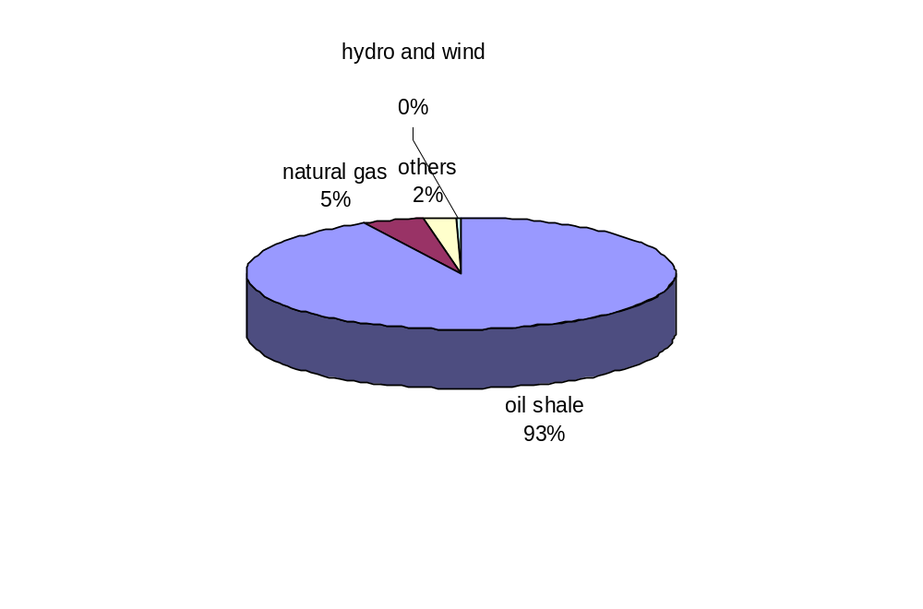Drawing 5.1.1. Electricity production structure in Estonia in 2004. Source: Estonian Energy Review, Ministry of Economic Affairs and Communications 2005

As regards installed electrical capacity the largest share also belongs to oil shale fired power plants. Below table 5.1.1 presents data about installed capacity.

Table 5.1.1. Installed electrical capacities in 2006
Name of power plant | Installed capacity MW | Fuel | Owner or belonging to a group
Narva Power Plants | 2 142 | Oil shale | Eesti Energia AS
Iru Power Plant | 171 | Natural gas | Eesti Energia AS
Cogeneration plants total | 85 | Oil shale, natural gas | Eesti Energia AS, private capital
Renewable energy sources (wind, small hydro, others) | 35 | Wind, hydro, biogas | Private capital
Total | 2 433

In the present analysis of security of supply the EMI has considered coverage of consumption capacity (load) by year 2012. In the evaluation of coverage two extremely important factors shall be considered: firstly, Estonia is net exporter and secondly, installed capacities exceed peak load.

Table 5.1.2 presents electricity balance from 2001 to 2005. Drawing 5.1.2 shows graphically the share of net export and domestic consumption of electricity. As seen the share of export has risen since 2003 and constitutes up to 20 per cent of production. Moreover, the Estonian-Finnish sea cable, which shall start commercial operation in the end of 2006, gives good export opportunities to Eesti Energia AS. An increase in export volumes can be predicted since Estonia has sufficient reserve capacities available.

Table 5.1.2. Estonian power balance. Source: Statistical Office
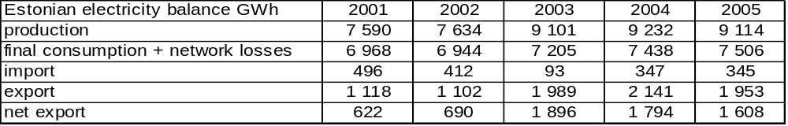
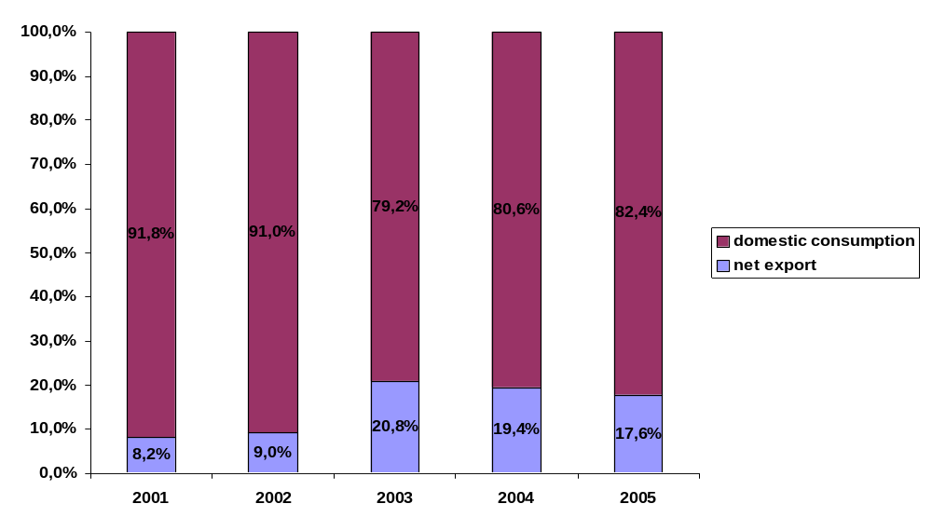
Drawing 5.1.2. Share of domestic consumption and export of electricity. Source: Statistical Office

The installed capacity and the system’s peak loads are presented in following table 5.1.3.

Table 5.1.3. Electrical installed capacity and peak loads
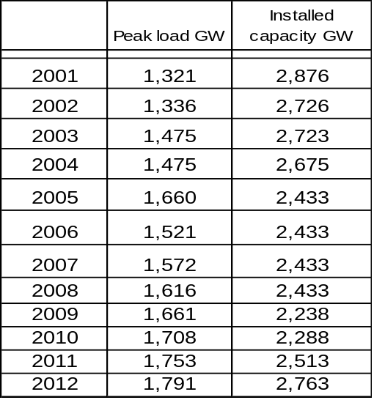

Based on peak load prognosis and the installed capacities no lack of capacity is foreseen until 2012. Regarding capacity problems they may arise in 2016 when AS Narva Elektrijaamad shall comply with the SO2 and NOx emission limitations stipulated by the Directive on large combustion plants. The problem is that the old energy blocks do not comply with the requirements of the Directive. It should be mentioned that the emission limitations does not necessarily mean immediate closing down the blocks. Modern technologies may offer opportunities for modernisation of old block and thereby bringing them into compliance with the requirements of Directives.

Especially important are Eesti Energia AS, as the market participant with the largest share, plans in connection with Narva Power Plans (AS Narva Elektrijaamad) and also with Iru and Ahtme Power Plant. According to presented information the following capacity developments are planned in the power plants in question:

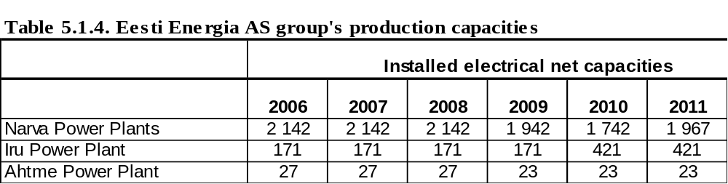

Possible new projects are the following:

2×250 MW_{el} oil shale fluidized bed technology 2009 until 2010;
250 MW_{el} gas turbine in Iru Power Plant by year 2010,
23 MW_{el} biofuel cogeneration plant in Ahtme Power Plant

The Long-term Development Plan for Electricity Sector sets a target to cover national electricity needs until 2015 by production capacities located in Estonia. To that end three scenarios are considered. The main fuel shall be either oil shale or natural gas. It is predicted that AS Narva Elektrijaamad shall replace up to 950 MW of capacity either with oil shale or natural gas fired blocks. In addition it is assessed that 150 MW of cogeneration plant capacity shall be implemented and 8 per cent of the total consumption shall be covered by renewable energy sources. Also, the implementation of at least 50 MW of fast start-up reserve capacity with a gas turbine is planned. A peak load of 2000 MW is predicted in 2015. This prognosis corresponds to the prognosis made by the transmission network operator. Generally it is foreseen that the share of oil shale shall fall to 68 per cent, while the share of natural gas shall rise to 23 per cent.

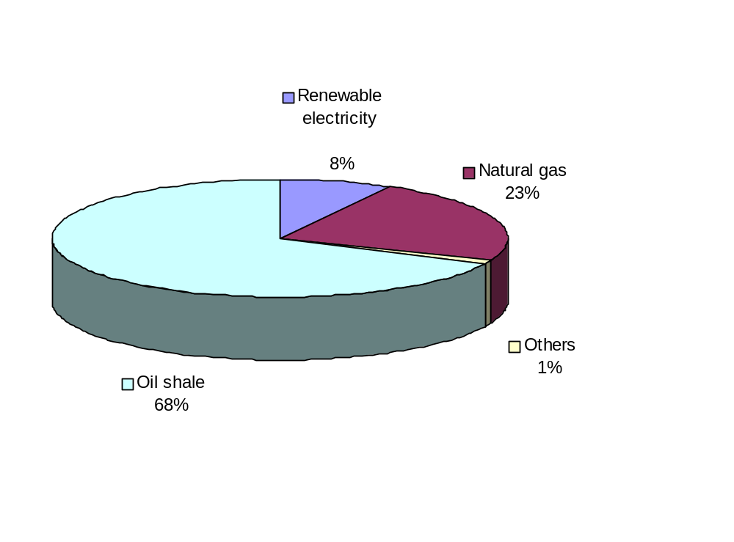
Drawing 5.1.3. Electricity production structure prognosis by year 2015. Source: Estonian Electricity Sector Development Plan 2005

However, the EMI is in an opinion that installation of 900 MW of new electrical capacity is not realistic as this would assume a significant increase of gas consumption peak load up to by about 4500 thousand m3 daily. Issues of security of supply of gas supplies for electricity production are described in more detail in section 5.2.

In conclusion: Estonia has no problems today in connection with electricity security of supply but vice versa, the installed capacities exceed domestic consumption peak and an export of electricity is possible. A lack of capacity is not foreseen in the period observed until 2012 and presumably also not in the next decade until 2016.

Estlink and other connections

The most important infrastructure project is the Baltic-Finnish sea cable Estlink under which the DC connection with the capacity of 350 MW between Estonia and Finland will be installed. The cable owner is AS Nordic Energy Link, whose shareholders are:
Eesti Energia AS (Estonia) 39,9%,
Lietuvos Energija AB (Lithuania) 25%
VAS Latvenergo (Latvia) 25%
Finestlink (Finland) 10,1%

Both the Finnish energy market regulatory authority and the Estonian Ministry of Economic Affairs and Communications granted an exemption to utilise it as a commercial project, without applying to it the principle of third party free access. All the available capacity is distributed between the owners on contractual basis until 2013. The EU Commission has accepted the exemption. If the owners are not utilising their contractual capacity reservations, they are obliged to facilitate third party access to available capacity. After termination of the exemption the acquisition cost will be included in the regulated asset base of the transmission network operator and third party free access shall be validated. The Baltic-Finnish sea cable Estlink shall be commissioned and commence commercial operation in December 2006, according to the time schedule.

Regarding other infrastructure projects the transmission network operator plans in addition to the 350 MW Finnish sea cable, to be commissioned in 2006, installation of another 650 MW capacity sea cable by year 2010. At the latest by 2015 it is planned to raise the pass-through connection capacity between Estonia and Latvia by 200 MW.

Lithuanian nuclear power plant

In 28th February 2006 the prime ministers of the three Baltic countries signed joint declaration on possible erection of a new nuclear power plant in Lithuania. In 8th March respective agreement was signed also by CEO of the leading energy companies of the three Baltic: Eesti Energia AS, Lietuvos Energija AB and VAS Latvenergo. According to the agreement a joint feasibility study will be carried out upon possible new nuclear plant in Lithuania. According to the information available to the EMI a capacity of the plant shall be between 1300 and 1600 MW and the energy companies of all three Baltic countries shall have equal shareholding in it. It should be taken into account that currently it is only an idea for analysis and this has been several times stressed also by Eesti Energia AS.

Gas
In the Estonian primary energy supply balance the share of gas is 14,7 per cent, while among fuels used for electricity production its share is only 4,7 per cent. Considering security of supply gas is very important in the production of heat in district heat supply systems where its share is up to 41,5 per cent. In some bigger sites and towns, like Tallinn, Rakvere, Jõgeva and some others the district heat supply bases 100 per cent on natural gas. The share of gas is high also in Tartu, Viljandi, Sillamäe and several other towns’ district heat supply. In 2006 Pärnu and Rapla towns are planned to be connected with the natural gas supply network. Thereby Rapla will base 100 per cent on gas, while in Pärnu an important share will still remain with solid fuels (peat and wood). Thus, from security of supply point of view, natural gas has highest importance in the district heat supply sector.

Compared to Western Europe local gas heating is relatively little spread in Estonia. The development of smaller gas networks is more intense in real estate development areas. However, the share of natural gas in household consumption is still only 7 per cent from the total gas consumption. The share of gas in electricity production is very little. Besides, Estonia has sufficient oil shale based reserve capacity. Hence, from security of supply view, gas has no importance in electricity generation.

Table 5.2.1 presents general gas supply and consumption figures, while table 5.2.2 gives gas utilisation figures by sectors.

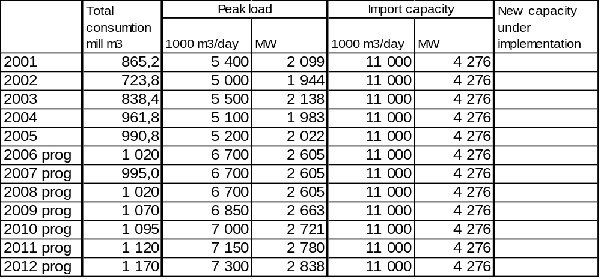Table 5.2.1. General information about gas supply

Table 5.2.2. Use of gas by sectors (2005 data)
 | Gas consumption thousand m³ | Share
Production of electricity | 82 889 | 8,4%
Production of heat in power plants and boiler houses | 374 230 | 37,7%
Industrial customers | 374 474 | 37,7%
Business and households for heating | 160 534 | 16,2%
Total | 992 127

Concerning gas quality of supply Estonia completely depends on the Russian gas supplies. Estonia has two cross-border transmission connections with Russia: one in Narva (east) direction and the other in Värska (south-east) direction and one connection with Latvia in Karksi. In normal situation only two of these connections are operational: the Latvian connection and the Russian connection in Värska. The Narva connection pass-through capacity is limited because of network limitations on the Russian side and it is opened only in emergency situations. For example, in January 2006 the supplies of gas were increased by 480 thousand m³ daily. As was described in section 4.1.1 Estonia has no problems with exhaustion of pass-through capacity, but problems may arise only in extreme peak load conditions.

Gas is imported to Estonia by AS Eesti Gaas and the chemical industry AS Nitrofert. In fact, AS Nitrofert is not involved in selling of gas but imports it exclusively for its own technological needs. In winter period from November to April AS Eesti Gaas covers the gas consumption only with the gas from Latvia located Inčukalns gas storage, while AS Nitrofert imports it directly from Russia. Actually, in winter both Estonia and Latvia, and to partly also Russia itself and Lithuania are primarily supplied with gas from the Inčukalns storage that has an active capacity of 2300 million m³. According to the storage agreement with AS Läti Gaas the storage and respectively stored gas volume belonging to Estonia is 500 million m³ and the gas quantity Estonia can consume daily to cover its needs from the Latvian storage is 500 million m³. The analysis of consumption peak loads in year 2001 to 2005 shows that the volume has been sufficient to cover Estonian peak load. The consumption peak of AS Nitrofert is about 700 thousand m³ daily. This has to be subtracted from the Estonian totals as AS Nitrofert buys gas directly from Russia and is not using Inčukalns gas storage.

In January 2006 between dates 19th to 22nd when weather conditions were extremely cold both in Russia and Estonia some disturbances occurred in supply. The peak consumption in these days reached last years maximum of 6700 m³ daily. The EMI has initiated a supervisory proceeding in which also employees of the Ministry of Economic Affairs and Communications were involved. The proceedings identified that the legislation related to security of supply has to be amended remarkably. The Ministry has elaborated proposals for amending the Natural Gas Act with measures ensuring security of supply of gas. In doing so the system operator shall prepare and approve with the EMI a plan of actions in a situation where the balance operator fails to secure balance and limitations of consumption by certain customer groups become unavoidable. Since in Estonia most important is to secure natural gas supply for heat supply facilities, limitations of consumption first of all may be imposed for industrial customers and electricity producers. In Estonia it is acceptable as the share of gas in electricity generation is modest and the power plants using gas constitute less than 10 per cent of the installed capacity. According to explanations submitted by AS Eesti Gaas security of supply of gas depends on outdoor temperature and at –21°C and below gas supply disturbances may occur. In order to raise supply security AS Eesti Gaas is planning concluding special agreements for covering peak consumption of 6000 thousand m³ daily. That would cover the total Estonian peak consumption of 6700 thousand m³ daily, as the rest 700 thousand of the peak will be covered by AS Nitrofert. Particularly, it is intended to increase supplies from both the Latvian gas storage and directly from Russia.

In conclusion it can be said that in Estonia there is no lack of transmission capacity. Based on the consumption and transmission capacity prognosis submitted by AS Eesti Gaas there shall be no deficiency of transmission capacity until 2012 and very likely also not in longer perspective. However, problems may arise in connection with security of supply, which can endanger reliability of heat supply, which is highly dependent on gas supplies. Since in the European part of Russia gas consumption is overall increasing, then in winter period it is possible to cover Estonian peak load primarily from the Latvian gas storage. For the coming years AS Eesti Gaas foresees an increase of peak load consumption of up to the level of 7000 thousand m³/daily. The prognosis assumes that AS Nitrofert will cover his daily consumption of 700 thousand m³ itself. This means that in addition to the current Latvian gas storage supply of 5000 thousand m³ daily an extra supply of up to 1300 thousand m³ daily is needed. According to an explanation of AS Eesti Gaas it is expected to cover it both by an increase from the Latvian storage and an increase of direct Russian supplies.

In case of possible supply disturbances it is feasible to limit gas consumption by limitation of electricity generation. Since gas fuelled power plants have no significant role in the coverage of electrical load, then such limitation does not hinder electricity security of supply in Estonia. The Long-term Development Plan for Electricity Sector foresees, as one of the scenarios, a significant rise of the share of gas in electricity generation, through increase of installed capacity up to 900 MW_{el}. Such increase provides for an increase of gas supplies by about 4500 thousand m³ daily. Considering the events that took place in January 2006 the scenario, which assumes rapid increase of gas generated electricity, is very risky from security of supply point of view to the country.

Conclusively, the EMI is in a position that in spite of AS Eesti Gaas’ planned activities towards raising security of supply a risk remains in connection with gas supplies, first of all for district heat supply companies and for households using gas for heating purpose as well.

Public service obligation review

Electricity

Obligations of market participants

The obligations of market participants are stipulated in the Electricity Market Act. In addition to law stipulations the EMI issues an activity licence with conditions set forth in it. An activity licence is required in order to:

1) terminate the exploitation of a generating installation with a net capacity of over 1 MW;
2) generate electricity, except for generation by one producer using generating installations having a total net capacity of less than 100 kW;
3) provide network services through a distribution network;
4) provide network services through the transmission network;
5) transmit electricity through a direct current line crossing the state border;
6) transmit electricity through a direct line;
7) sell electricity;
8) import electricity, except for the import of electricity by the system operator.

An activity licence together with conditions thereon is issued by the EMI. After issuing the licence the EMI may change the conditions or validate new conditions if this becomes necessary due to amendments of legislation, for maintaining of security of supply or in order to ensure fulfilment of obligations in compliance with the Electricity Market Act or other legal acts.

The Electricity Market Act regulates in most detail activities of network operators, with their main obligations stipulated as follows. A network operator shall provide the following network services to the customers, producers, line possessors or any other network operators within its service area:
1) on the basis of a corresponding request, connect any electrical installation conforming to the requirements and located in its service area to the network at the connection point;
2) on the basis of a corresponding request, amend the consumption or generation conditions;
3) enable a network connection to be used at the connection point;
4) transmit electricity through its network to the connection point or from the connection point;
5) ensure the installation of a metering device conforming to the requirements of legislation to determine the amounts of electricity transmitted through its network;
6) ensure the collection and processing of measurement data;
7) provide extra services directly related to the network services.

A network operator shall observe the principle of equal treatment of market participants when providing network services. A network operator has the right to refuse to provide network services if:
1) the electrical installations of the user of network services do not conform to the requirements of legislation or to the technical conditions established by the network operator for connection to the network;
2) the provision of network services is not possible for any other reason dependent on the user of network services;
3) the provision of network services is not possible for reasons independent of the network operator;
4) the network of the network operator lacks the necessary transmission capacity for the provision of network services.

A network operator shall provide the reasons for any refusal to provide network services. In the reasoning, the legal basis for refusal shall be indicated and the EMI shall be notified of refusal to provide network services. A network operator shall develop the network within its service area such that the continued provision of network services is ensured to all customers, producers, line possessors and any other network operators connected to the network, in accordance with their justified needs, legislation and conditions of the activity licence.

In essence the described regulation ensures provision of network services to all market participants and third party free access to the network. Possibilities of refusal to provide network services are extremely limited and in practice no cases of refusal has been recorded.

Compared to network operators the Electricity Market Act sets much less obligations to producers of electricity. According to the Act the generating installations of producers shall conform to the technical requirements established by the grid code. Producers’ actions shall comply with orders issued by the system operator. A producer shall notify the system operator promptly of any dangerous situations, accidents or other circumstances that endanger or could endanger security of supply or the performance of any contractual obligations.

In addition to law the EMI has set forth an obligation to the market dominant producer AS Narva Elektrijaamad (Narva Power Plants Ltd.) to secure uninterruptible supply of electrical energy to customers. Since AS Narva Elektrijaamad and OÜ Iru Elektrijaamad (Iru Power Plan Ltd.) are extremely important for securing of district heat supply to Narva and Tallinn city respectively, the EMI has set in their activity licences the obligation of uninterruptible supply of heat to the cities.

An electricity selling licence is required for both the network operators that sell electricity to the customers connected to their network and for undertakings performing electricity sale.

Public service obligation and final customer price regulation

General information about regulation of final customer price is presented in following table 6.1.1.

Table 6.1.1. Electricity price regulation
 | Large customers | Medium size business customers | Small businesses and households
Regulated price (Yes/No) | Yes | Yes | Yes
Percentage share of customers buying electricity at regulated price | 95 | 100 | 100
Possibility to switch back from market price to regulated price (Yes/No) | Yes | Yes | Yes
Electricity sellers with obligation to sell at regulated price | All sellers | All sellers | All sellers

Until 2009 the market is opened only by about 10 per cent and the electricity sold to non-eligible customers shall be produced either in Narva power plants, in cogeneration process or produced by small producers (with capacity below 10 MW). Both AS Narva Elektrijaamad and Iru Elektrijaam belong to Eesti Energia group, while the market share of AS Narva Elektrijaamad in production is 91 per cent. AS Narva Elektrijaamad uses oil shale fuel mined in Estonia. Oil shale is mined by AS Eesti Põlevkivi, which has a market dominant position and belongs to Eesti Energia AS group. According to the Electricity Market Act the EMI shall approve prices for the following:

- the price for oil shale, which is an important input in formation of production cost of AS Narva Elektrijaamad
- the production price for AS Narva Elektrijaamad, which is an important input in the formation of the price of electricity sold to non-eligible customers
- the price of electricity sold to non-eligible customers under selling obligation.

In addition to price approval the Electricity Market Act also stipulates selling obligation according to which network operators are obliged to sell electricity to all non-eligible customers connected to their network. If eligible customers connected to the network of a network operator have no economically competitive possibility to purchase electricity from another seller, they also have the right to purchase electricity at a price for non-eligible customers in the framework of the selling obligation. Network operators have obligation to perform the selling obligation themselves or, they have also the right to designate another seller to perform the selling obligation. For example, OÜ Jaotusvõrk, the distribution network operator belonging to Eesti Energia AS group, has designated Eesti Energia AS as the seller of electricity.

The principles of approval of prices for oil shale, for production and sale by AS Narva Elektrijaamad are similar to those of the network services. The price is formed of justified, capital expenditure (depreciation of fixed assets) and justified return. In the evaluation of justified costs the EMI considers technical efficiency indicators, cost saving principles and verifies whether cross subsidising is avoided. The main difference compared to the regulation of networks operators is that in production and sale price regulation there is no regulation period and the regulatory authority verifies prices upon undertaking’s application, while network charges are approved for a certain fixed period and is indexed by changes of consumer price index (RPI-x regulation). The general principles of price approval were described in detail in section 3.2 “Regulation of electricity networks”.

Regarding sale price the EMI approves weighted average limit price and an undertaking has the right to form different prices for different customer groups within this weighted average limit. So the regulation leaves a flexible possibility to undertakings for formation of different prices within the weighted average. It the undertaking’s risk if it sells below the weighted average price. If the actual weighted average sale price appears higher than the EMI approved limit, then it shall be paid back to customers. According to the Electricity Market Act the EMI has elaborated and disclosed unified methodology for calculation of a justified weighted average price limit for performing of selling obligation. The methodology determines the price period, which is one year. If during the price period the actual price appeared higher than the EMI approved weighted average price limit, it shall be compensated for to customers during the next price period. This means the next period price shall be decreased. If the actual price appeared lower than the EMI approved weighted average price limit, it is considered undertaking’s risk and shall not be compensated for by customers.

In November 2004 the EMI approved for the largest sale undertaking Eesti Energia AS weighted average price limit for electrical energy 41,83 cent/kWh (26,73 €/MWh). Based on this limit the undertaking formed its detailed price list in 1st March 2005. In 1st March 2006 it formed a new price list, somewhat raising the prices. In 1st May 2006 they presented to the EMI data, including the method of calculations. It appeared that actual weighted average price in the period from 1st March 2005 to 28th February 2006 was lower than the approved limit. Thus the undertaking sold below accepted limit and that was the reason for raising prices in the new period.

It can be said that both production and final consumer price regulations are cost-oriented price regulations. The price reflects coverage of justified operational cost, reasonable return (profit) on invested capital and possible situation of selling below cost is avoided. For example, for AS Narva Elektrijaamad, as the producer in market dominant position, a return on invested capital of 8,5 per cent is accepted. Such level should be deemed justified considering its market dominant position.

The EMI is in opinion that since the market is opened only by 10 per cent and customers cannot choose supplier, the regulation of both production and sale price is necessary and justified in order to protect customers and avoid earning of unjustified high profits by market dominating undertakings. Without production and sale price regulation the undertakings may form their sale prices on a level of neighbouring markets and thereby earn unjustified high profits on invested capital. The stipulations of the Electricity Market Act prevent from situations of selling to eligible customers at a higher price than to non-eligible customers.

Conclusively, the EMI is in an opinion that the regulation currently imposed on the market dominant producer and seller is optimal in circumstances where opening of electricity market takes place gradually and today it is opened only 10 per cent.

The Electricity Market Act prevents also from occurrence of a situation in which in case of sharp rise of production cost it is impossible to transfer it to final customers. In case of rapid changes in electricity market and if the weighted average price limit does not cover all costs the company may, at its own initiative, apply prices exceeding the limit and after that submit new weighted average price limit for approval to the EMI. If the price appears not justified, the undertaking shall compensate for the difference to customers.

Customer information

Network operators are obliged to maintain a web site and to disclose in it the following information:
- principles for establishing connection charges;
- basic information reflecting effectiveness, quality and profitability of activities;
- information about the seller in case a network operator has designated another undertaking to execute the selling obligation;
- charges for network services;
- standard conditions for provision of network services.

The seller of electrical energy shall disclose on its web site:

- prices of electricity sold (to non-eligible customers) in the framework of the selling obligation;
- standard terms and conditions of electricity sale;
- information concerning the environmental impact resulting from CO2 and SO2 emissions, disposed oil shale ash and radioactive waste created upon generation of electricity during a financial year preceding the selling period.

A network charge established by a network operator and the price for electricity sold in the framework of selling obligation shall become valid on the date designated by the network operator after its publication in at least one daily national newspaper, provided that at least ninety days have passed since publication. The standard terms and conditions for the provision of network services and for the selling of electricity shall be disclosed at least thirty days before becoming valid. In addition to publication the above information shall be disclosed on the network operator’s web site.

If a network operator sells both network service and electrical energy, it is obliged to separate on customer bills the prices. All sellers of energy are obliged to inform customers about the distribution of energy sources used in production. Respective information shall be attached to the customer bill.

In conclusion the EMI is in a position that the customer information in the Estonian electricity sector is quite well regulated. The customer pre-information time about price changes is sufficient and most network operators have good web sites from which customers can get enough information about network services and electricity sale as well.

Customer contract, supply limitations and interruptions, extra-judicial proceedings

As regards customer contracts the EMI is in a position that it is a well regulated field and customer interests are well protected. According to the Electricity Market Act standard terms and conditions of contacts for provision of network services, for electricity sale to non-eligible customers under selling obligation and connection to network shall be approved by the EMI. In approval of above mentioned standard contract conditions the EMI follows the principle of proportionality, aiming balance of rights and obligations of both undertakings and customers. An important criterion in approval of standard terms and conditions is also their compliance with the Law of Obligations Act.

The contract entered into with customers for provision of network services may be both with a specified term or termless. As rule, termless contracts are entered into. Network operators and sellers of electricity may change conditions of contract only if there is an objective reason for that in order to take into account changes of circumstances and only if the EMI has granted approval to a change of standard conditions.

Interruption of network connection for reasons dependent on customer is regulated very detailed and the EMI is in a position that the protection of socially vulnerable customers in possible case of failure to pay in time is sufficient. A network operator may interrupt the connection of a customer to the network if the customer has failed to pay the amount payable on the basis of the contract entered into with the network operator or seller or, has materially breached an obligation arising from the contract entered into with the network operator or seller in another manner. Before interruption of a network connection a notice concerning the planned interruption of the network connection shall be sent to the customer. The notice shall set out the grounds for interrupting the network connection and the planned time of the interruption. The network connection of a customer may be interrupted after at least fifteen days have passed since the notice was sent and if, during that period, the customer has failed to eliminate the circumstances which were the grounds for interruption of the network connection and has not notified the network operator or seller, as appropriate, thereof.

If a network connection is interrupted on the grounds that a customer who is a natural person has failed to pay an amount payable according to the contract entered into with a distribution network operator or seller due to the temporary insolvency of the customer as a result of his or her serious illness or unemployment, the customer may notify the network operator or seller thereof in writing. Evidence of those circumstances shall be annexed to the notice. On receiving the notice and evidence, a network operator may interrupt the network connection of a customer who is a natural person after at least thirty days have passed since the notice was sent and if, during that period, the customer has failed to eliminate the circumstances which were the grounds for interruption of the network connection and has not notified the network operator or seller, as appropriate, thereof.

If a network connection is interrupted on the grounds that the amount payable has not been paid, the network connection may be interrupted during the period from 1st October to 30th April in a building or a part thereof which is residential space, used as a permanent residence and heated in full or primarily by electricity only when at least ninety days have passed since the notice and if, during that period, the customer fails to remove the circumstances which were the grounds for the interruption and has not notified the network operator or seller, as appropriate, thereof. A network operator may limit the capacity of the network connection of a customer. The customer shall be notified of such limitation at least fifteen days in advance.

A network operator may promptly interrupt the network connection of a customer if the customer increases, without authorisation, the limited capacity, uses electricity or network services without authorisation, uses electrical installations which do not meet the requirements, are dangerous or interfere with the operation of the network as a whole or prejudice security of supply.

Possible cancellation of both network contract and electricity sale contract is precisely regulated by the Electricity Market Act. A network operator may cancel a network contract and disconnect the place of consumption from the network: if the network connection has been interrupted by the network operator due to a breach of the network contract and the interruption has lasted for at least 180 consecutive days and the customer has failed, during that period, to eliminate the circumstances which were the grounds for the interruption of the network connection or commence the consumption of electricity; and the customer has materially breached obligations arising from the network contract and the breach has not been remedied within a reasonable period of time granted by the network operator meaning that, as a result, the network operator cannot reasonably be expected to continue performing the contract.

A network operator shall give notice of the cancellation of a network contract at least thirty days in advance. The notice shall set out the grounds for cancellation and the date of termination of the contract.

A seller or a network operator has the right to cancel an electricity contract if the customer has materially breached obligations arising from the contract and has not remedied the breach within a reasonable period of time granted by the seller or network operator. The network connection through which electricity was sold on the basis of the electricity contract has been interrupted on the grounds that the customer has failed to pay the amount payable on the basis of the contract entered into with the network operator or seller or has materially breached an obligation arising from the contract entered into with the network operator or seller in another manner and the interruption has lasted for at least sixty days; the customer has used electricity or network services without authorisation or has intentionally or due to gross negligence caused damage to the property of the network operator or the seals or verification marks placed on the metering devices by the network operator or the seller. A customer shall be notified of the cancellation of an electricity contract at least thirty days in advance. The notice shall indicate the grounds for cancellation of the contract and the date of termination of the contract.

All market participants, both undertakings and customers have the right to refer to the EMI as to the extra-judicial body. A market participant may file a written complaint with the EMI against the action or omission of another market participant that is in conflict with the Electricity Market Act or legislation established on the basis thereof. The EMI reviews a complaint and makes a decision thereon within thirty days as of the receipt of the complaint. If the EMI requests information necessary for resolving a complaint, the passage of the term shall be suspended, but not for longer than thirty days. The EMI’s decisions can be challenged with an administrative court in 30 days since receiving of a decision.

Conclusively, the EMI is in a position that electricity customers are quite well protected. The price for electricity sold to non-eligible customers is regulated, the costs forming it is under control of the regulatory authority and for undertakings justified return on invested capital is ensured. If eligible customers fail to purchase electricity at a more favourable price they have the right to buy at the price regulated in the framework of selling obligation. The currently enforced regulation of market dominant producer and seller is necessary in the situation of gradual market opening and to-days opening level of 10per cent. Without regulation a situation is likely to arise in which both producers and sellers attempt earning unjustified high profit.

Sufficient information is available to customers about the formation of prices, standard terms and conditions of contracts, energy sources used for production, etc. Most network operators have well shaped web sites that contain sufficient information. The standard terms and conditions of contracts for provision of network services and sale of electricity shall be approved by the EMI and possible interruption of network connection or cancelling of sale contracts are very detailed regulated by law.

Gas

Obligations of market participants

Obligations of market participants are stipulated in the Natural Gas Act. Besides obligations stipulated by the Act the EMI issues activity licences that include also some specific conditions. An activity licence is required for the following activities:

  - gas import (from outside EU);
  - sale of gas;
  - gas transmission service;
  - gas distribution service

In most detail the Natural Gas Act regulates activities of network operators. Their main obligations are stipulated as follows:

- A network operator is required to ensure that persons who have a network connection are supplied with gas in accordance with this Act, the conditions of the activity licence and contracts entered into;

- A network operator is responsible for the functioning and maintenance of the network which it owns or possesses;

- A network operator is required to develop the network in a manner which ensures that all consumer installations located within its network area are connected to the network;

- A network operator shall organise the metering of gas consumed from the network and maintain corresponding records, unless agreed otherwise;

- A network operator is required to provide other network operators with all the necessary information to ensure the distribution and sale of gas in a manner which enables interconnected networks to be used securely and effectively;

- A network operator may not disclose the information gained in connection with performing of its duties and obligations to third parties, except if disclosure is provided for by law or, information shall be submitted for carrying out of duties and obligations provider for by this Act;

- A network operator may terminate its activities only if it transfers its obligations arising from this section to another network operator,

- A network operator shall give the EMI at least twelve months' advance written notice of the termination of its activities, specifying the date and schedule for termination, and provide a sufficiently detailed overview of the circumstances which ensure that the requirements provided for shall be met;

- A network operator is obliged to follow the principle of equal treatment of market participants in provision of network services.

In essence the described regulation ensures provision of network services to all market participants and third party free access to the network. Possibilities of refusal to provide network services are extremely limited.

For gas sale undertakings law stipulates the following obligations:

  - a gas undertaking shall ensure that final customers are supplied with gas in compliance with the Natural Gas Act, the conditions of the activity licence and contracts entered into;

  - a gas undertaking that performs both provision of network services and sale of gas shall keep separate accounts for the activities.

Selling obligation and final customer price regulation

General information about regulation of final customer price is presented in the following table 6.2.1.

Table 6.2.1. Regulation of gas price for final customers
 | Large customers | Medium size business customers | Small businesses and households
Regulated price (Yes/No) | No | No | Yes
Percentage share of customers buying electricity at regulated price | 0 | 0 | 100
Possibility to switch back from market price to regulated price (Yes/No) | No | No | Yes
Electricity sellers with obligation to sell at regulated price | 0 | 0 | All network operators

The Natural Gas Act stipulates selling obligation to all network operators both to eligible and household customers. According to the Act a gas undertaking engaged in the sale of gas (seller of gas) is required, within the technical limits of the network, to sell gas to all final customers who have a network connection who are located within its network area. The obligation is valid if there is no other gas sellers from which customers could purchase gas. Since sellers independent from network operators are missing, the selling obligation lies on the network operators as well. At the same time the Act does not provide for obligation to sell to eligible customers at a regulated price. This means, that to eligible customers gas is to be sold in the framework of selling obligation at a negotiated price.

Regarding final customer price, regulation is imposed only in connection with household gas. The price of gas sold to eligible customers is not regulated. The Natural Gas Act stipulates only that a sale price is the price that contains the price for gas and the cost of selling. At the same time AS Eesti Gaas, as the market dominant undertaking controlling 100 per cent of the wholesale market, shall comply with requirement of the Competition Act.
The Competition Act any direct or indirect abuse by an undertaking or several undertakings of the dominant position in the goods market is prohibited, including:

1) directly or indirectly imposing unfair purchase or selling prices or other unfair trading conditions;
2) limiting production, service, goods markets, technical development or investment;
3) offering or applying dissimilar conditions to equivalent agreements with other trading parties, thereby placing some of them at a competitive disadvantage;
4) making entry into an agreement subject to acceptance by the other parties of supplementary obligations which have no connection with the subject of such agreement;
5) forcing an undertaking to concentrate, enter into an agreement which restricts competition, engage in concerted practices or adopt a decision together with the undertaking or another undertaking;
6) unjustified refusal to sell or buy goods.

In essence AS Eesti Gaas as the market dominant undertaking shall ensure that the costs related to sale and the profit are justified and reasonable and gas is sold to all customers at equal conditions. Saying in other words – to customers at the same conditions the same price shall be applicable.

The Natural Gas Act stipulates principles of regulation of the gas sold to households, which, according to the Act, shall be applicable also after full opening of market in 1st July 2007. The principles of household gas price regulation are similar to those of network service price regulation. The price implies three main components: justified costs, expenditure of capital (depreciation of fixed assets) and justified profitability. The EMI elaborates and discloses a uniform methodology for calculation of price limit for the household gas. The methodology is disclosed on the EMI web site. In the evaluation of justified cost elements the EMI first of all considers the principle of cost reduction and verifies whether cross-subsidising of various activities is avoided. The prices are not indexed and instead, are approved only upon application from undertakings.

Unlike electricity sale price for natural gas no weighted average price is approved. Instead, if gas is sold at different price to different customer groups, then the EMI approves price limits for all of them. AS Eesti Gaas has formed different limit prices dependent on the volume of annual consumption. Most smaller network operators have formed a single limit price for all household customers irrespective of their annual consumption.

Customer information

Both gas network operators and gas sellers are obliged to maintain a web site and disclose as a minimum the following information on it:
- charges for network services;
- gas limit prices;
- method of calculating the charge for connection to the network;
- standard terms and conditions of contracts.

The charges for network services and household customer gas prices shall be disclosed at least ninety days prior to their entry into force. In addition to the web site the prices shall be disclosed at least in one national daily newspaper. Besides undertakings also the EMI shall disclose all the approved prices on its own web site. If a gas undertaking sells both network services and gas, it is obliged to separate in customer bills the price for the network service and for the gas.

Customer contracts, suspension and limitation of supply and extra-judicial proceedings

In comparison with the Electricity Market Act the conditions of contract are much less regulated by the Natural Gas Act. According to the latter only standard conditions of selling to household customers have to be approved with the EMI. These standard conditions shall include:

1) sellers’ name and address;
2) service provided;
  - requirements for the quality level of provided service;
  - customer information about the tariffs and prices;
  - contract duration, conditions of updating and termination of the contract;
  - possibility of change of supplier for free;
  - possibilities of payment for the service;
  - possible compensations and the procedures;
  - settlement of complaints.

Standard terms and conditions of network service provision sale conditions of gas to eligible customers are not approved by the EMI. However, according to the Natural Gas Act and the Competition Act the market dominant seller (AS Eesti Gaas) shall ensure equal treatment of all market participants.

The Natural Gas Act provides for suspension of gas supply. According to it network operators have the right to suspend a network connection without giving advance notice thereof to the final customer if there is danger to the life, health or property of persons or to the environment. A network operator has the right to suspend a network connection immediately after it is established that there has been unauthorised consumption of gas. Besides, a network operator has the right to suspend gas supply, giving at least seven days' advance notice, if:
1) the consumer installation is adversely affecting the supply of gas to another final customer or damaging the technical parameters of the network;
2) the network operator is prevented from accessing a metering system located within territory owned or possessed by a final customer in order to inspect or replace the system or to perform necessary work for the gas installation to operate;
3) any conditions provided in the contract for the purchase and sale of gas or in legislation are violated.

Before the gas supply is suspended in cases described above, the network operator shall give the final customer a reasonable term to eliminate the deficiencies and shall notify the final customer of the pending suspension in writing. The notice shall set out the reason for suspension of the gas supply, the term for elimination of the deficiencies.

A network connection or gas supply suspended for the reasons provided for shall be restored after the final customer has paid for the justified costs of suspension and reconnection, unless the contract has been terminated.

All market participants, both undertakings and customers have the right to refer to the EMI as to the extra-judicial body. A market participant may file a written complaint with the EMI against the action or omission of another market participant that is in conflict with the Electricity Market Act or legislation established on the basis thereof. The EMI reviews a complaint and makes a decision thereon within thirty days as of the receipt of the complaint. If the EMI requests information necessary for resolving a complaint, the passage of the term shall be suspended, but not for longer than thirty days. The EMI’s decisions can be challenged with an administrative court in 30 days since receiving of a decision.

Conclusively, the EMI’s opinion is that in connections with the selling obligation customers are reasonably well protected. Network operators have the obligation to sell gas to all customers connected to the network. However, compared to the rights of electricity customers the rights of gas customers are less protected. According to the Electricity Market Act the standard terms and conditions are approved with EMI, in gas supply the conditions for network services it is a matter of negotiations between parties. A weak side is gas supply to socially vulnerable customers. For example, the electricity y Market Act stipulates detailed conditions for interruption of supply and in case of failure to pay in time customers living in premises heated with electricity have time of up to 90 days to eliminate their payment debts. In gas supply an undertaking shall give at least seven days' advance notice and give the so-called reasonable term to eliminate the deficiencies. However, the Act does not specify any duration for the reasonable term. This gives to undertakings relatively “free hands” to suspend gas supply to customers with payment problems.

The basis for computation of the market share is the sale of distribution service to final customers less sale to other distribution undertakings.

