ANNUAL REPORT
TO THE
EUROPEAN COMMISSION

September 2005

Table of Contents

1 INTRODUCTORY REMARKS 3
ACRONYMS 7
2 Summary/main events in the last year 9
2.1 Board of Directors 9
2.2 Advisory Board and Tariff Board 9
2.3 Main Statutory Objectives 10
2.4 Powers 11
2.4.1 Codes 11
2.4.2 Tariffs and Prices 12
2.4.3 Concessions 12
2.4.4 Inspection and Sanctions 13
2.4.5 Investigations and Audits 14
2.4.6 Dispute Settlement and Voluntary Arbitration 14
2.5 Independence and Accountability 14
2.5.1 Independence 14
2.5.2 Accountability 15
2.6 Key Developments in the Electricity Sector 16
2.7 Key Developments in the Natural Gas Sector 18
2.8 Main Matters Dealt With by ERSE 19
3 RegulaTION AND PERFORMANCE IN THE ELECTRICITY MARKET 23
3.1 Regulation Matters 23
3.1.1 General 23
3.1.2 Congestion management mechanisms for allocation of available capacity at the interconnections 27
3.1.3 Regulation of Transmission System Operators (TSOs) and Distribution System Operators (DSOs) 32
3.1.3.1 System Operators in Mainland Portugal and in the Autonomous Regions 32
3.1.3.2 Grid Tariffs 33
3.1.3.3 Balancing 54
3.1.4 Accounting unbundling 56
3.2 Competition 61
3.2.1 Characterization of the wholesale market 61
3.2.2 Characterization of the retail market 71
3.2.3 Measures for promoting competition 84
4 RegulaTION AND PERFORMANCE IN THE NATURAL GAS MARKET 89
4.1 Regulation matters 89
4.1.1 General 89
4.1.2 Mechanisms for managing congestions and awarding available capacity at the interconnections 89
4.1.3 Regulation of natural gas transmission and distribution 90
4.1.3.1 Grid tariffs 90
4.1.3.2 Quality of service 90
4.1.3.3 Balancing 90
4.1.4 Access to linepack, storage and other system services 90
4.1.5 Accounting unbundling 90
4.2 Competition 91
4.2.1 Characterization of the wholesale market 91
4.2.2 Characterization of the retail market 93
5 Security of supply 97
5.1 Electricity 97
5.1.1 2004 summary 97
5.1.2 Regulatory background 101
5.1.3 RNT planning and investments in interconnections 102
5.1.4 New investments in generation 103
5.2 Gas 104
5.2.1 2004 summary 104
5.2.2 Natural gas acquisition contracts 105
5.2.3 Natural gas transmission contracts 106
6 public service 109
6.1 Public service obligations 109
6.1.1 Electricity sector 109
6.1.2 Natural gas sector 111
6.2 End-User tariffs with variations restricted by law 112
6.3 General terms of supply contracts 113
6.3.1 Electricity sector 113
6.3.2 Natural gas sector 113

INTRODUCTORY REMARKS
These introductory remarks aim to present this report in the context of the obligations of the Energy Services Regulatory Authority (ERSE), on the one hand, and to briefly characterize the electricity and natural gas markets in Portugal, on the other hand.
In the early 1990’s the European Union began to set up its internal market in energy. Directives 2003/54/EC and 2003/55/EC significantly helped speed up this process. Together with the regulation on cross-border exchanges in electricity (EC Regulation no. 1228/2003) and natural gas (regulation approved at the last Council meeting, on July 12), the said directives constitute the central core of the “European model” of the electricity and natural gas markets. Among the most notable attributes of this model, special reference should be made to (i) the freedom to produce, import and supply within the entire space of the European Union, (ii) the freedom for all consumers to choose their supplier of electricity and natural gas, (iii) the regulated access to the transmission and distribution grids, and (iv) the compatibility between market and general interest missions.
In order for the model established by the EU law-makers to be fully implemented and become really effective for the consumers and energy operators in all the European Union, we need to develop a regulatory framework for the European market of electricity and natural gas, in line with the legal framework defined by the above directives and regulations. The EU law-makers also clearly stressed the need to ensure the consistency and transparency of the said framework, by promoting a closer co-operation between the national Regulators and the European Commission, while simultaneously defining the key regulatory topics to be addressed and the procedures to be adopted. In this context the European Comission decided to set up the European Regulators Group for Electricity and Gas (ERGEG) in November 2003, following the creation of the Council of European Energy Regulators in March 2000.
The ERGEG has already accomplished a number of tasks, namely the preparation of several “guidelines” (e.g. access to natural gas storage facilities, harmonization of electricity transmission tariffs, grid congestion management) and the co-ordination of monitoring activities defined in the EU law. In terms of contents and timeframe, the co-ordinated drafting of monitoring reports to be published by the Regulators and the European Commision enables all stakeholders – i.e. consumers, companies, political decision-makers – to get a more accurate picture of the actual situation of the single energy market, thus making it possible to perform benchmarking exercises.
Since its creation in 1997, ERSE has published an annual activity report describing both its initiatives and the main events occurred in the electricity and natural gas sectors. The 2004 activity report was published in March 2005. The present report has been produced to match the format agreed with the European Commission and the other EU Regulators in the framework of the ERGEG, placing special emphasis on the status of each market. Over the coming years, we hope to establish a more clear separation between the two documents and minimize duplicated information, so as to better comply with the legal obligations and fulfil the expectations of the target audience.
A legal package enacted in July 1995 established the organizational model of the electricity sector on Mainland Portugal, which is still partially in force. Such model relied on the existence of both a Public Service Electricity System (SEP)—based on long-term contracts (between binding generators and the transmission system operator, on the one hand, and the said transmission operator and the distribution system operators, on the other hand) and the non-eligibility of low voltage consumers—and a Non-binding Electricity System (SENV)—governed by contract freedom between generators/suppliers and eligible consumers.
Independent regulation, established in 1995 and formally implemented in February 1997, ensured the balance between the two systems and the development of competition, enabling the SENV to expand. In 2004, imports represented 14 percent of consumption and today more than 20 percent of consumption is supplied by SENV, based on bilateral contracts. Transparency and additivity of the tariff system launched by ERSE in 1998—and perfected since then with a view to matching tariffs with costs and avoiding cross-subsidization—decisively contributed to these results.
In 2004 the Portuguese law-maker decided that all electricity consumers were eligibile. Later on, after approval by the European Commission, they also established the regime for cessation of the long-term agreements between binding generators and the transmission system operator, as well as the forms of calculation and payment of the associated stranded costs. The actual eligibility of household customers can only be implemented when the required computer platform becomes operational. As for the actual cessation of long-term contracts, it can only happen when an organized (hopefully Iberian) electricity market begins to operate.
Foreseen by the Portuguese and Spanish governments since November 2001, and initially scheduled to start operating in January 2003, the Iberian electricity market is not yet functioning. Nevertheless the absence of a common organized market has not prevented Portuguese operators from working in the organized (spot and intraday) Spanish market, nor the main Spanish operators from working in the Portuguese market. Given the relatively small scale of the Portuguese market, the creation of an organized (spot, intraday and forward) Iberian market appears to be potentially the most efficient solution.
As regards non-binding generation, only the incumbent has its own resources—although several investors (both national and foreign) have applied for generation licenses.
The Autonomous Regions of Madeira and Azores, both ultraperipheral groups of Islands, are governed by specific legal schemes, approved by their respective governments. ERSE regulates the electricity sector in the Autonomous Regions since 2002.
The government has announced that a framework law will be adopted to replace the 1995 legal framework and transpose directive 2003/54/EC to the Portuguese law.
Natural gas was introduced in mainland Portugal in 1997 and is not available in the Autonomous Regions. Benefiting from its emerging market status, Portugal has not yet liberalized the natural gas market, although the previous government announced that liberalization would begin in July 2004.
The Government announced that a framework law for natural gas will be adopted to transpose directive 2003/55/EC to Portuguese law and establish a liberalization timeframe for this sector. According to its Activity Plan, ERSE hopes to publish Codes for the natural gas sector in the second half of 2005.
In the end of 2004 the European Commission rejected a concentration that proposed to gather in the same company group the electricity and natural gas distribution and supply activities. The government is currently preparing a new model of corporate organization for the energy sector.

Jorge Vasconcelos

ACRONYMS

- AEE – Power Purchase Activity.
- HV − High Voltage (voltage between phases whose root mean square value is higher than 45 kV and lower than, or equal to, 110 kV).
- LV − Low Voltage (voltage between phases whose root mean square value is equal to, or lower than, 1 kV).
- SpLV – Special Low Voltage (voltage between phases whose root mean square value is equal to, or higher than, 1 kV and subscribed demand power higher than 41,4 kW).
- StLV – Standard Low Voltage (voltage between phases whose root mean square value is equal to, or higher than, 1 kV and subscribed demand power equal to, or lower than, 41,4 kVA).
- CAE − Power Purchase Agreement.
- CEER – Council of European Energy Regulators.
- CENELEC – European Committee for Electrotechnical Standardization.
- CMEC – Costs of Maintaining the Contractual Balance.
- CR – Network Commercial Management Activity.
- CSEP – SEP Commercial Management Activity.
- CVEE – Electricity Buying-and-Selling Activity.
- DGGE − Directorate-General for Geology and Energy.
- ERGEG − European Regulators Group for Electricity and Gas.
- ERSE − Energy Services Regulatory Authority.
- GGS – Global System Management Activity.
- LNG – Liquefied natural gas.
- VAT − Value Added Tax.
- VHV − Very High Voltage (voltage between phases whose root mean square value is higher than 110 kV).
- MIBEL – Iberian Electricity Market.
- MV − Medium Voltage (voltage between phases whose root mean square value is higher than 1 kV and equal to, or lower than, 45 kV).
- OMI – Iberian Market Operator.
- OMIE – Spanish Iberian Market Operator.
- OMIP – Portuguese Iberian Market Operator.
- PRE – Special-Regime Generation.
- RMC – Code on Dispute Mediation and Conciliation.
- RNT − National Electricity Transmission System.
- RQS – Quality of Service Code.
- SAIDI – System Average Interruption Duration Index.
- SAIFI – System Average Interruption Frequency Index.
- SEI − Independent Electricity System.
- SENV − Non-binding Electricity System.
- SEP − Public Service Electricity System.
- TEE – Electricity Transmission System.
- TGCC – Combined-cycle gas turbines.
- TGCS – Single-cycle gas turbines.

Summary/main events in the last year

Board of Directors
The Board of Directors is composed of:
- One chairperson.
- Two members.
The members of the Board of Directors are appointed by the Council of Ministers, upon proposal made by the Minister of the Economy, for a five-year term that can be extended once, among people who have appropriate qualifications and well-established technical and professional skills. Their terms of office never start at the same time. People having served at the governing bodies of companies in the electricity and natural gas sectors in the previous two years (or having been permanent employees of the said companies, performing managing or executive functions in the same period) may not be appointed as members of the Board of ERSE. When they finish their term of office, members of the ERSE Board of Directors may not perform any functions in companies of the regulated sectors—nor provide any services to them. Members of the board of directors perform their functions on full-time dedicated basis, save that they may teach at higher education institutions on part-time basis.

Advisory Board and Tariff Board
The Advisory Board is ERSE’s governing body in charge of advising, supporting and helping ERSE define its action guidelines. The Advisory Board gives advice namely on matters such as:
- ERSE’s activity plan and budget.
- ERSE’s Annual Report and Accounts.
- ERSE’s advices on safety standards.
- Proposed regulation amendments.
- Other matters on which the Board of Directors may seek advice.
Advice given by the Advisory Board are not binding. They are made public by ERSE and become available for consultation on its website.
The Advisory Board is composed of 28 members, including representatives from the Central Government (Economy, Finance, Environment and Consumer Protection), the Regional Governments of the Azores and Madeira, the Municipalities, Public Administration (Consumer Institute, Directorate-General for Geology and Energy, Environment Institute), the Competition Regulatory Authority, consumers and regulated companies.
The Tariff Board is the governing body specifically in charge of advising ERSE’s regarding tariffs and prices issues. The Tariff Board gives advice on:
- Approval and review of Tariff Code.
- Tariffication and pricing.
Advice given by the Tariff Board are not binding. They are made public by ERSE and become available for consultation on its website.
The Tariff Board is composed of 16 members, including representatives from the Consumer Institute, the Municipalities, the consumers and the regulated companies.

Main Statutory Objectives
ERSE’s main statutory objectives are to:
- Protect the rights and interest of consumers with regard to prices, services and quality of service, as well as to foster the provision of information and clarification to energy consumers, in co-ordination with the competent authorities.
- Ensure, while respecting the powers given to other entities, that natural gas and electricity operators comply with the public service obligations – and other obligations – laid down in the law and regulations, as well as in concession contracts and licenses.
- Arbitrate and settle disputes that may arise in the sectors of electricity and natural gas, according to the terms established by law.
- Implement the liberalization of the electricity and natural gas sectors and foster competition, so as to improve the activities subject to its regulation.
- Make sure that regulation rules are objective and that commercial relationships among the operators and between the operators and the consumers are transparent.
- Help gradually improve the technical, economic and environmental conditions in the regulated sectors, namely by encouraging the adoption of practices that promote the efficient use of natural gas and electricity and the creation of appropriate standards of service quality and environmental protection.
- Help gradually adapt the regulatory framework to the development of the electricity and natural gas sectors and to its timely compliance with the applicable EU legislation, with a view to fully achieving the single energy market.
- Co-ordinate with the Competition Regulatory Authority the enforcement of the competition law in the energy sector.
- Follow up the activities developed by other regulators, as well as the experience of foreign energy regulators, and create relationships with their counterpart regulators and with the relevant EU and international agencies.
- Promote research on the market of electricity and natural gas and its regulation, develop initiatives and establish the association and co-operation protocols deemed appropriate, while preserving its independence.

Powers
ERSE has been given different kinds of regulatory, sanctioning, inspecting and consultative powers. The main instruments that ERSE has to fulfil its statutory objectives are the following:

Codes
Before making its codes public, ERSE must hold public hearings and seek advice from the Advisory Board or the Tariff Board.
ERSE is in charge, in the context of the electricity sector, of preparing the following codes and checking their compliance:
- Tariffs.
- Commercial Relations.
- Load dispatching.
- Access to Grids and Interconnections.
It is ERSE’s duty to submit to the Directorate-General for Geology and Energy (DGGE) a proposal regarding the commercial provisions of the Quality of Service Code, as well as to make sure that this code is fully complied with – including its technical provisions.
As regards the opening of the market, ERSE was asked to define the rules (i.e the elegibility criteria) for the SENV access, prior to low-voltage customers’ eligibility — established by law in 2004.
ERSE is in charge, in the context of the natural gas sector, of preparing the following codes and checking their compliance:
- Commercial Relations.
- Tariffs.
- Quality of Service.
- Access to Grids, Interconnections and Storage Facilities.
ERSE is also in charge of approving the operating and supplying codes prepared by the public service concession or license holders, namely as regards quality and safety standards.
ERSE will be in charge of preparing the Tariff Code and establishing tariffs and prices in the natural gas sector only after the end of the derogation period laid down in Directive 98/30/EC (emerging market) – i.e. when the sector’s liberalization begins.

Tariffs and Prices
In the electricity sector, ERSE periodically establishes the values of tariffs and prices to be applied, according to the Tariff Code terms. Advice is sought from the Tariff Board prior to their publication on the Official Journal (Diário da República).

Concessions
As regards the natural gas concessions, ERSE has the power to give advice on the following matters, before the Government makes any decision concerning them:
- The award of new regional distribution concessions, plus the draft versions of the schedules of conditions and the respective concession contracts;
- The authorization for cession, alienation or encubrance of concessions;
- The cessation of concession agreements, as well as the possible seizure or redemption of the concession;
- The annual definition of the minimum value of the third-party liability insurance of concession-holders;
- The authorization conceded to concession-holders to use the infra-structure retrofitting and maintenance fund for other purposes.
In the electricity sector, ERSE gives advice on the schedule of conditions drafted by the concession-holder of the National Electricity Transmission System (RNT) for selecting new binding-operators of electricity distribution in medium voltage (MV) and high voltage (HV), as well as on binding contracts with the binding electricity distribution operators in low voltage (LV).

Inspection and Sanctions
As regards consumer protection, ERSE should regularly inspect the records of complaints and claims filed to the concession- or license-holders by consumers. ERSE may also request the investigation of consumer complaints or claims that consumers may file to it – or to concession or license holders – as long as they fall under its powers. It may also recommend to concession or license holders that they take the necessary steps to compensate the users’ fair complaints.
In the scope of competition protection, ERSE should report to the Competition Regulatory Authority any offences to the competition law that may come to its knowledge while performing its functions.
As regards its sanctioning powers, ERSE may deal with administrative offences and apply fines and alternative sanctions in the following situations (related to generation, transmission and distribution):
- Non-compliance with the rules of commercial relationship applicable to the activity.
- Failure to send to ERSE information requested within its scope of competence.
- Failure to allow, or make it difficult for, the competent authorities to access facilities or documents concerning the activity.
- Apply tariffs or prices to the customers that have not been approved.
- Non-compliance with the rules of grid connection, use and operation of grids.
- Non-compliance with the decisions from centralized load dispatching.
ERSE’s sanctioning powers enable the Regulator to file administrative offence lawsuits – against holders of binding electricity generation licenses, the RNT concession-holder and the binding electricity distribution license-holders – and try them. In the framework of these cases, ERSE may apply a maximum fine of 30,000 euros.
ERSE also has sanctioning powers in the natural gas sector, but the applicable legal scheme of administrative offences and fines has not yet been defined.
ERSE may propose that the competent administrative body suspends a license, whenever the trial of an administrative offence case within its remit indicates that such sanction should be applied.
ERSE should report to the competent authorities any other offences that may come to its knowledge while performing its functions.

Investigations and Audits
On its own initiative or at the request of the Ministry of the Economy, ERSE may order any inquiries, investigations or audits to the concession or license holders that focus on matters falling under its powers.

Dispute Settlement and Voluntary Arbitration
ERSE’s role in the area of dispute settlement essentially consists in lodging mediation and settlement processes. Mediation and conciliation are voluntary mechanisms for extrajudicial dispute settlement, whereby ERSE cannot impose a concrete solution to the case but may recommend it (mediation), or suggest that the parties jointly find a solution for the dispute that opposes them (conciliation).
Following the EU recommendations on principles applicable to entities that act on behalf of the extrajudicial settlement of consumer disputes, ERSE approved in October 2002 its Code on Dispute Mediation and Conciliation (RMC). This code establishes the rules applicable to procedures of mediation and concilitation of commercial and contractual disputes arising from the relationship among electricity and natural gas operators and between them and the respective consumers.
As regards arbitration, ERSE should promote the voluntary arbitration for the settlement of commercial or contractual disputes among concession and license holders operating in the generation, transmission and distribution activities and between them and consumers. ERSE may also help create arbitration centres and sign agreements with arbitration centres.

Independence and Accountability

Independence
ERSE is a legal person governed by public law, with administrative and financial autonomy and its own assets. It is governed by its own Statutes, by legal provisions specifically applicable to it and, as subsidiary law, by the legal framework of state-owned enterprises, save any rules incompatible with its nature. ERSE performs its functions independently according to the Law, while taking stock of both the guiding principles of the energy policy established by Government in accordance with the Constitution and the Law, and the acts subject to ministerial oversight pursuant to Law.
While safeguarding its organic and functional independence, ERSE is subject, pursuant to its by-laws, to the oversight of the Minister for the Economy and, when applicable, the Finance Minister. As a consequence, the following require ministerial approval:
- Annual report and accounts.
- Regulation on services.
- Regulation on staff recruitment and the respective pay-roll.
Members of the Board of Directors can only be dismissed by the Government, in case of legal incapacity or proven serious misconduct.
ERSE’s budget is part of the National Budget. This incorporation restricts the independence of ERSE, subjecting the Regulator, in general terms, to a financial scheme influenced by the government – dependent upon clearance by the Energy and Finance Ministers, namely as regards the acquisition of equipment and the recruitment of staff.

Accountability
ERSE is accountable to the national organs of sovereignty, as follows:
- ERSE has to submit its draft budget (to be incorporated in the State Budget) to the appraisal of its Single Auditor, the Advisory Board and to the subsequent approval of the Ministry of the Economy. The State Budget is approved by the National Parliament (Assembleia da República).
- The Annual Report and Accounts are also submitted to advice by ERSE’s Single Auditor and the Advisory Board, being subsequently submitted to approval by the Economy and Finance Ministers.
- Every year an annual report on ERSE’s regulation activities is sent to the Government, to be also appraised by the National Parliament.
- The Chairperson of the Board of Directors will answer, at all times, any hearing requests that may be made by the competent commission of the National Parliament, asking for information or clarifications on its activities.
- ERSE is also accountable to the Judiciary, as the holders of positions in ERSE’s bodies, as well as its employees and agents, are liable in criminal and disciplinary terms for any acts and omissions practised while performing their functions, pursuant to the law.
- Administrative activities shall be subject to administrative jurisdiction, pursuant to administrative law. Generally speaking, sanctions for administrative offences imposed by ERSE can be impeached in a judicial court.
- ERSE is also subject to the jurisdiction of the Court of Auditors, pursuant to the competent legislation.

Key Developments in the Electricity Sector
National Legislation
The main changes in the Portuguese electricity sector occurred in 2004 resulted from the total opening of the market, meaning that all electricity users will be allowed to freely choose their supplier.
Following the political decisions laid down the Council of Ministers’ Resolution no. 63/2003, which approved Portugal’s energy policy guidelines, the following decrees were enacted, i.e. Decree-Law 184/2003 and Decree-Law 185/2003, both dated of August 20, Decree-Law 36/2004, dated February 26, Decree-Law 192/2004, dated August 17, and Decree-Law 240/2004, dated December 27. This legislation introduced many changes in the organization and functioning of the National Electricity System, namely:
- Institutionalization of the the electricity supplier figure.
- Freedom for all customers to choose their suppliers, as the market became opened to Special Low Voltage (SpLV) customers in February 2004 and to Standard Low Voltage (StLV) customers in August 2004.
- Approval of the compensatory mechanism (CMEC – Costs of Maintaining the Contractual Balance) for the cessation of Power Purchase Agreements (CAE) between REN and the SEP generators (long-term agreements).
The Framework Law of the electricity system, whose publication until the end of 2003 was foreseen in Decree-Law 185/2003, of August 20, has not yet been adopted.
More recently, Government Order 10 317/2005, of May 9, set up a working group co-ordinated by the Secretary of State for the Industry and Innovation with a view to preparing a draft framework law on electricity and a draft decree-law for transposing Directive 2003/54/EC, of June 26.
Decree-Law 69/2002, of March 25, extended ERSE’s regulatory powers to the Autonomous Regions of the Azores and Madeira in 2002, in the framework of tariff convergence and of the commercial relationship among electricity systems.
Iberian Electricity Market (MIBEL)
In November 2001, the governments of Portugal and Spain signed a protocol for creating the Iberian Electricity Market – MIBEL, scheduled to begin operating in January 2003. As determined by the said protocol, in late March 2002 ERSE and the Spanish Regulator (CNE) submitted an organizational model for the MIBEL.
As a result of consecutive changes in the governments of Portugal and Spain, MIBEL’s materialization was postponed.
On the 20 January 2004 the governments of Portugal and Spain signed in Lisbon an Agreement for the Creation of an Iberian Electricity Market (MIBEL). This Agreement was approved by Resolution of the Portuguese Parliament no. 33-A/2004, of April 15, and ratified by Decree of the President of the Republic no. 19-B/2004, of April 19. This Agreement, however, which stated that MIBEL would start to operate on the 20 April 2004, never came into force.
On the 1 October 2004, at Santiago de Compostela, the governments of Portugal and Spain signed a new Agreement for creating MIBEL. This new Agreement determines that MIBEL would start operating before the 30 June 2005, which never happened.
Pursuant to this new Agreement, the parties agreed to develop co-ordinated efforts aimed at preparing domestic legislation enabling MIBEL to operate. The Agreement foresees that the Regulators’ Board – composed of representatives from ERSE, the National Commission on Energy (CNE), the Commission on the Securities Market of Portugal (CMVM) and the National Securities Commission of Spain (CNVM) – will have its functions enlarged. The Regulators’ Board will have the power to settle cases related to the offences defined in the Agreement and to extrajudicially settle the disputes concerning the system’s economic management and technical management. In addition it will also deal with MIBEL’s enforcement and development, give advice on draft regulations on MIBEL’s operations and give advice on the draft regulations submitted by the companies responsible for managing markets that may be created.
Pursuant to the Agreement of the 1 October 2004, oversight of the markets defined in the scope of MIBEL shall be the responsibility of the supervising entities in Portugal and Spain – depending on the country where the markets are created, according to the respective legislation on this matter: the OMIP in Portugal, which will operate with derivatives (forward market) and the OMEL in Spain, which will operate with the physical markets. Both market operators will be foreseeably merged in April 2006, with the creation of the OMI – the single operator for the Iberian Electricity Market.
More recently, the governments of Portugal and Spain agreed to set up a working group to update the studies already made by ERSE and CNE, with a view to achieving the Iberian Electricity Market (Order no. 10 319/2005, of May 9).
The November 2001 protocol also established a schedule for developing interconnections between the electricity grids of both countries, including the construction of a new 400 kV-line between Alqueva (Portugal) and Balboa (Spain), a new line or a reinforcement of the existing one between Douro Internacional (Portugal) and Aldeadavila (Spain) and another 400 kV-line between Alto-Lindoso (Portugal) and Cartelle (Spain). The Alqueva-Balboa and Alto-Lindoso-Cartelle lines began operating in 2004.
The absence of an organized common market has not prevented Portuguese players from operating in the Spanish organized (spot and intraday) market, nor the main Spanish players from operating in the Portuguese market. As a consequence, cross-border flows have increased significantly: in 2004, imports from Spain accounted for 14 percent of Portuguese consumption.
Generation/Consumption
In 2004 the installed generation capacity increased by 8,7 percent vis-à-vis 2003. In 2004 operations began at the following new facilities: one more 392 MW group at the combined-cycle plant of Group EDP; 120 MW corresponding to the hidropower use of the Alqueva multipurpose project; 456 MW of special-regime generation. In 2004 electricity consumption increased by 5,6 percent vis-à-vis 2003. 16 percent of consumption was secured by suppliers outside the Public Service Electricity System.
In early 2005 applications were received for licenses concerning 7 groups of combined-cycle natural gas plants. Their appraisal is waiting for the review of the license awarding criteria announced by the Government.
Special-regime generation has increased significantly (produced energy doubled from 1999 to 2004) and the pace of growth is expected to speed up over the next few years, as a function of the government’s energy policy objectives.
In this framework, the government presented recently the schedule of conditions for the call for tenders concerning the construction of 1 700 MW of wind capacity, to be launched up to the end of 2005.

Key Developments in the Natural Gas Sector
One of the objectives laid down in the programme of the present Constitutional Government is to anticipate the timeframe of the natural gas market’s liberalization, while also stating its commitment towards the creation of an Iberian Natural Gas Market. Bearing this in mind, Government Order 10 317/2005, of May 9, recently established a working group to prepare a Draft Natural Gas Framework Law and transpose Directive 2003/55/EC. The government also issued Order 10 319/2005, of May 9, with a view to promoting the studies required for creating the Iberian Natural Gas Market.
In January 2004 commercial operations began at the LNG Sines Terminal, which has a capacity of 5 billion cubic metres per year and a maximum hourly flow, at present, of approximately 600 thousand cubic metres. It currently has two LNG storage tanks – each with 120 thousand cubic metres, plus a terminal for filling tank trucks.
On the other hand, the first two caves of underground storage at Carriço are currently at the commissioning phase. This project also foresees that two more caves will begin operations up to 2007, amounting to a total storage capacity of 195 million cubic metres of gas.
The re-structuring of companies in the natural gas sector, announced by the government in April 2003, has not yet taken place. The proposal submitted to the European Commission was rejected by the Commission’s Decision of the 9 December 2004, which considered that the proposed concentration was not compatible with the common market (case no. COMP/M.3440 - EDP/ENI/GDP).

Main Matters Dealt With by ERSE
Problems related with the execution of the “2002-2004 Activity Plan” which were referred in the Annual Report of 2003 became more serious in 2004, for two kinds of reasons:
- On the one hand, in the continued absence of ministerial authorization, ERSE could not hire new employees, in spite of its consecutive requests. Mandatory ministerial authorization stems from the incorporation of ERSE’s budget into the National Budget, effective as from 2002, thus subjecting ERSE to the rules of budget execution.
In 2002 ERSE had anticipated to hire thirteen new employees, following the amendment to its by-laws that determined the enlargement of its scope of action as regulator to the natural gas sector and to the electricity sector in the Autonomous Regions of the Azores and Madeira. ERSE’s budgets of 2003, 2004 and 2005 – all incorporated in the National Budget, foresee such recruitment, despite ERSE’s operating costs continue to be exclusively borne by the energy (electricity and natural gas) users. In these circumstances, worsened by the increasing number of requests for information and claims, ERSE could not develop all the activities schedule for 2004 in the “2002-2004 Activity Plan” mentioned above.
- On the other hand, the new legal framework of the electricity and natural gas sectors, defined by Council of Ministers’ Resolution no. 63/2003, of April 28, was not implemented. To the contrary, its evolution in 2004 was not consistent.
The publication of the Framework Law on the Electricity Sector, anticipated in Decree-Law 185/2003, of August 20, has not yet taken place. In its absence, three ad-hoc legal instruments were published in 2004 to allow for (i) the eligibility of special low-voltage consumers (February), (ii) the widespread elegibility of all electricity consumers on Mainland Portugal (August), and (iii) the cessation of power purchase agreements, accompanied by the calculation of the costs of maintaining the contractual balance (December). Due to the absence of the Framework Law, the delayed publication of these three decrees and their one-off unscheduled drafting, ERSE found it difficult to perform the tasks associated with the review of the regulations. In 2004, ERSE was therefore forced to perform two ad-hoc regulations reviews in order to enable the eligibility of electricity consumers. Tasks necessary to adapt the regulated companies to the new regulatory framework were postponed and generated overcosts. Therefore the right of the consumers of standard low voltage to choose their electricity suppliers will only be effective as from 2005.
In addition to the uncertainties mentioned above, reference should be made to the unstable evolution of the Iberian Electricity Market (MIBEL), which should have started to operate, as initially scheduled, on the 1 January 2003. An agreement signed by the governments of Portugal and Spain on the 20 January 2004 established that MIBEL would take off on the 20 April 2004. This did not take place and a second agreement was signed on the 1 October 2004, anticipating the start-up of MIBEL up to the 30 June 2005. This new agreement has not yet been ratified. Meanwhile a public hearing process is taking place in Spain on the reorganization of the Spanish electricity sector, due to come to a close no later than the end of 2005. Therefore, given the complex nature of certain issues that remain unaddressed, the start-up of operations in the framemork of MIBEL had to be postponed again.
Given the context of uncertainty that marked the electricity sector in 2004, ERSE decided – after seeking the advice of all stakeholders – to restrict the duration of the next period of tariff regulation to one year. Tariffs and parameters were therefore established only for 2005, and not for the 2005-2007 period – as should have normally occurred.
In January 2004 ERSE launched the public discussion process concerning its regulation of the natural gas sector. ERSE published two papers – once for information and the other for discussion – and organized one public hearing. In the meantime a government order set up a working group in charge of preparing a draft Framework Law, which was expected not only to ensure the access of electricity generators to the natural gas transmission grids from the 1 July 2004 onwards – as laid down in Council of Ministers’ Resolution 68/2003, of May 10, but also to fully re-structure the entire sector. As a consequence, ERSE suspended the public discussion process on the natural gas regulation. Meanwhile the government extinguished the working group and third-party access to the natural gas transmission grid was made impossible, for lack of enabling legislation and appropriate regulations.
The absence of a new clear legislative framework – which has been anticipated but not materialized, and the existence of a number of legislative initiatives not forecasted in the energy policy guidelines but successively carried forward, rendered the performance of ERSE particularly difficult in 2004.
In 2004 the Ministry of the Economy and the Competition Regulatory Authority sought (and received) advice from ERSE on matters dealing respectively with the electricity sector and the operations of concentration in the electricity and natural gas sectors. Among several requests of advice from the Ministry of the Economy, special reference should be made to the advice on the Draft Decree-Law on the anticipated cessation of Power Purchase Agreements (CAE), which included the methodology for calculating the Costs of Maintaining the Contractual Calance (CMEC) – one of the key issues that need to be addressed, both for complying with Directive 2003/54/EC and setting up MIBEL. In order to achieve this, while simultaneously taking stock of the methodology proposed for resolving the contracts covered by the said draft decree-law, ERSE prepared a document identifying the issues related with its enforcement and calling the government’s attention to the fact that the adoption of the methodology underlying the CMEC calculation could impact negatively on both tariff levels and the development of the liberalization process.
Activities developed by the Task Force of Support to Energy Users (NACE) take up a significant amount of ERSE’s resources. In 2004, NACE (on behalf of ERSE) replied in writing to 333 requests of information – 296 concerning the electricity sector and 37 the natural gas sector. At the end of the first half of 2005, NACE had replied to 177 request of information. The more often covered themes are tariffs & prices and sector characterization, in the electricity sector, and sector characterization and liberalization, in natural gas sector. As regards dispute settlement, in 2004 ERSE received 503 claims – 364 concerning electricity and 139 the natural gas sector. By the 30 June 2005, ERSE had received 384 claims. In the electricity sector, claims are essentially focused on service quality, including a significative number of complaints about damages caused in electrical equipaments, and billing. In the natural gas sector, the majority of claims filed stem from issued related with the maintenance and inspection of gas facilities and the billing of gas supply.
On behalf of ERSE, since the 15 March 2004 NACE is also available to provide information and clarification to energy consumers by phone (every working day, from 3:00 pm to 6:00 pm) or direct interview (by appointment). Since day one, NACE has answered 1 250 phone calls and booked 20 direct interviews.

RegulaTION AND PERFORMANCE IN THE ELECTRICITY MARKET

Regulation Matters

General
According to the 1995 legislation, the specific provisions that govern the market opening and the corresponding definition of eligible customers are laid down in the Commercial Relations Code, approved and published by ERSE, which gives eligible customers the possibility of freely choosing their electricity supplier. Nevertheless the said legislation clearly prevented low-voltage customers from being considered eligible. Pursuant to the legislation, the Regulation equally establishes that customers may choose their electricity supplier via the Non-Binding Electricity System (SENV), after obtaining the non-binding customer statute. Legislation newly published in 2004 gave the right to choose suppliers to all consumers. So, four different periods of enforcement of the electricity supply market opening can be identified and briefly characterized as follows:
- Up to the 31th December 2001, the SENV could be accessed only by electricity consumers in medium voltage (MV), high voltage (HV) and very high voltage (VHV), having a minimum annual consumption of 9 GWh.
- From the 1st January 2002 till late February 2004, all electricity users in VHV, HV or MV, with a non-zero (actual or forecasted) consumption were considered eligible to access the SENV.
- Following the publication of Decree-Law 36/2004, of February 26th, Special Low-Voltage (SpLV) Customers with a non-zero (actual or forecasted) consumption were equally considered eligible.,
- Once published, Decre-Law 192/2004, of August 17th, extended the right of eligibility to all customers on Mainland Portugal. The right of Standard Low-Voltage (StLV) Customers to choose suppliers is waiting for the required computer system to be implemented in order to manage the supplier switching procedures and rules concerning consumer profiles.
Market opening characterization is associated with the number of customers and the respective annual electricity consumptions of eligible and non-eligible customers. The analysis made herein is focused on the period ranging from 1999 – in which the first non-binding customers were created – and the end of the first half of 2005.
The variation of the number of eligible customers in Portugal reflects the change occurred between 2001 and 2002, concerning the eligibility criteria applicable to potential non-binding customers. Up to 2001, the criteria set a minimum amount of annual energy consumption and so the number of eligible customers remained within a range of 214 to 228, with few changes in those three years.
From 2002 onwards, any MV-, HV- or VHV-customer with a non-zero (actual or forecasted) consumption was entitiled to request the statute of non-binding customer and allowed to join SENV. As a result the number of eligible customers grew significantly, rising to more than 20 thousand. This figure more than doubled with the opening of the market to SpLV customers (to 52 thousand eligible customers, currently), legally in force as from February 2004. By the end of 2004, it reached the total number of StLV customers (approximately 5,8 million customers).
Figure 3-1 shows the evolution of eligible and non-eligible consumption on Mainland Portugal, as regards the consumption referential and the SEP’s free market parcel. We may infer from it that consumption on Mainland Portugal grew at an average yearly rate of approximately 3,8%, between 1999 and 2004. On the other hand, the eligibility status changed from 2001 to 2002 and caused the eligible consumption to significantly grow to approximately 16 426,1 GWh, henceforth representing more than 44 percent of total consumption on Mainland Portugal – vis-à-vis the previous 25 percent, recorded between 1999 and 2001 (eligible consumption value varying between 7 895,9 GWh and 8 496,6 GWh, respectively).
The successive opening of the market to SpLV and StLV customers caused the values of eligible consumption to grow to roughly 20 852 GWh (53., percent of total national consumption on Mainland Portugal) and 38 768 GWh (corresponding to 100 percent of national consumption on Mainland Portugal), respectively.
Figure 3-1 – Evolution of eligible and non-eligible consumption
Mainland Portugal
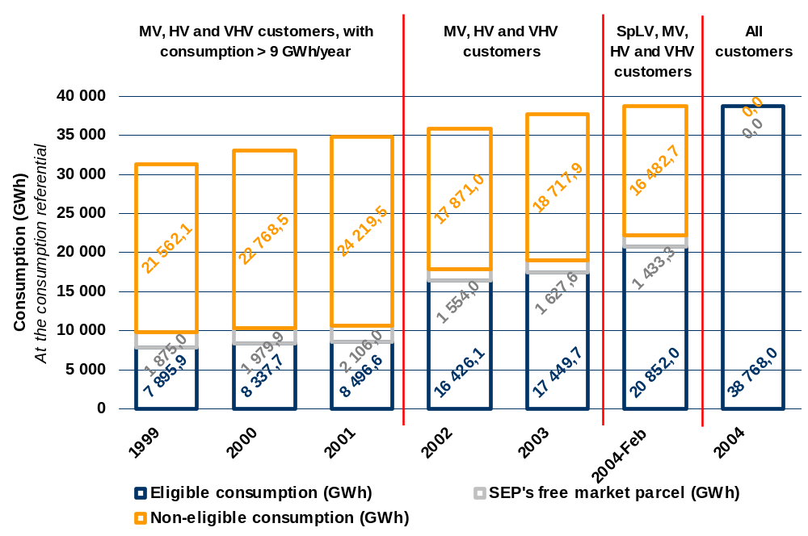
Figure 3-2 shows the evolution of actual consumption in the framework of the liberalized market (SENV), as well as the relative weight of such consumption in both total consumption and eligible consumption for each period under analysis. As the eligibility criteria changed, the year of 2004 is divided into two distinct periods, so as to establish a difference between the opening of the market to SpLV customers (referred to as “2004-Feb” on the said figure) and the subsequent opening to StLV customers (incorporated in the values of late 2004). Identically the period corresponding to the first half of 2005 is presented on Figure 3-2 in separate, as it does not refer to a full year.
The figure below shows that the relative weight of consumption in the liberalized market vis-à-vis the total national consumption has constantly increased. Discontinuities in the values of relative weight consumption vis-à-vis the eligible consumption can be explained by successive enlargements of the base of eligible consumers. On the other hand the values of relative weight consumption in SENV are identical to total consumption and eligible consumption in late 2004 and the first half of 2005, since in these periods all customers were already eligible.
Figure 3-2 – Evolution of SENV consumption and its relative weight in terms of both national consumption and eligible consumption
Mainland Portugal
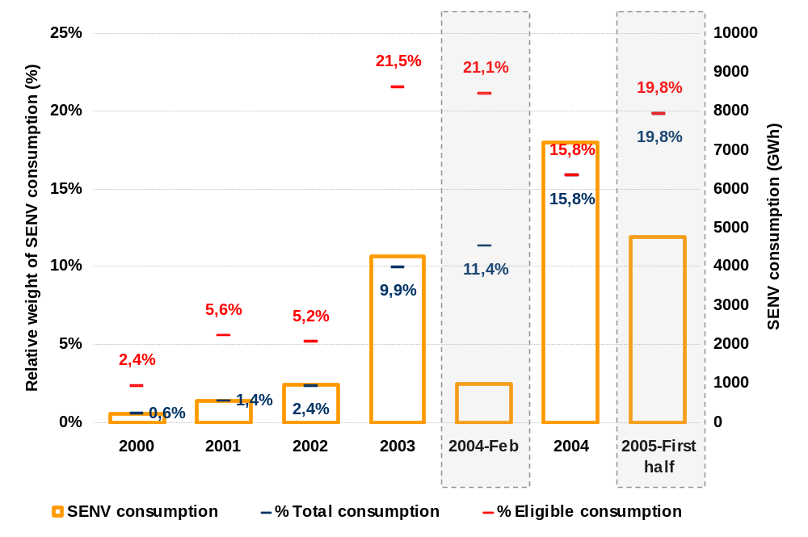

Lastly Figure 3-3 shows the breakdown by voltage level of actual consumption in the first half of 2005. It also provides a breakdown of consumption values into liberalized market customers (SENV) and public system customers (SEP). It clearly shows that approximately 51 percent of MV-customer consumption occurred in the liberalized market. It should be noted that, in little more than one year of segment opening, nearly 1/5 of SpLV consumption is supplied by the SENV.
Figure 3-3 – Breakdown of SENV and SEP consumption by voltage level
Mainland Portugal
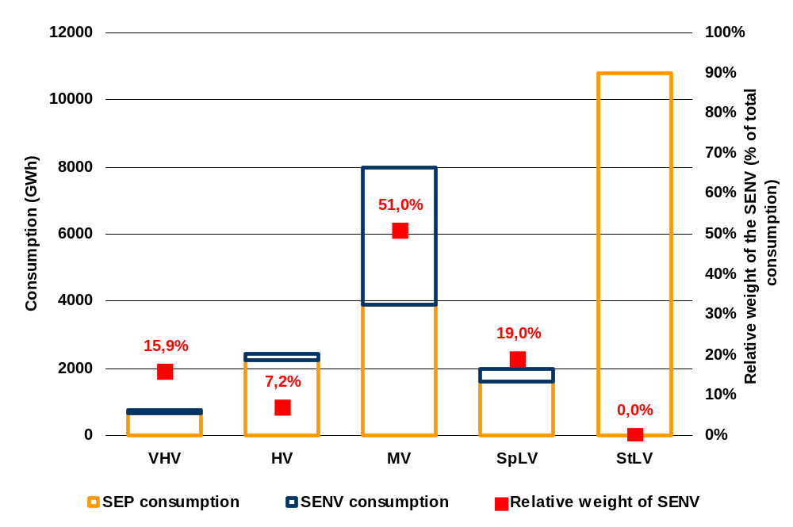

Congestion management mechanisms for allocation of available capacity at the interconnections
In Portugal there are no structural problems leading to the existence of permanent internal grid congestions. When such congestions occur, they usually result from an adverse combination of several factors and may take place in internal lines of the transmission grid or at the interconnections. They require different management mechanisms.
Management of Internal Congestions:
The system’s operator manages this type of congestion either by making topological changes to the grid configuration or by re-dispatching (changing the generation or consumption schedules at each grid node), so as to relieve the congested lines.
Customers of the Public Service Electricity System pay for the re-dispatching overcosts in their Energy & Power tariff.
Management of Interconnection Congestions:
Congestions at the interconnections are managed by the system’s operator of the country of origin of the electricity flow causing the congestion.
Congestions from Portugal to Spain are managed by the Portuguese system’s operator by means of a pro-rata mechanism, i.e. a reduction factor applicable to the subscribed export amounts, whose calculation is based on the quotient between the capacity available for commercial purposes and the balance between the export and import contracts forecasted for that period. Although theoretically possible, this situation never occurred in practice and the exporting schedules of both the SEP Commercial Agent and the non-binding generators were never changed.
Congestions from Spain to Portugal are managed by the Spanish system’s operator in two phases, i.e. in phase one a pro-rata mechanism is applied to the total amounts of electricity subscribed either by Bilateral Physical Contracts or at the energy pool; in phase two, the capacity awarded to each type of contract is shared by means of different mechanisms:
- Implicit auction for electricity subscribed at the energy pool.
- Explicit auction for the electricity subscribed by means of Bilateral Physical Contracts.
Customers of the Public Service Electricity System pay for the costs incurred in connection with congestions due to electricity imported for their consumption in their Energy & Power tariff.
Customers of the Non-Binding Electricity System pay for these costs via imbalance-linked penalties, or when their suppliers trigger the short-term security of supply contracts.
Figure 3-4 shows the evolution of interconnection capacity available for commercial use and its actual use in years 2002 to 2004, divided into working days and holidays and week-ends.
In turn, shows the evolution of the annual values of the import and export trading from 1998 to 2004. Special reference should be made to the importing trend registered in recent years.
Figure 3-4 – Evolution of the interconnection capacity available for commercial use and its actual use in years 2002 to 2004, on working days and holidays & week-ends

 | Working days | Holidays and week-ends
2002 | 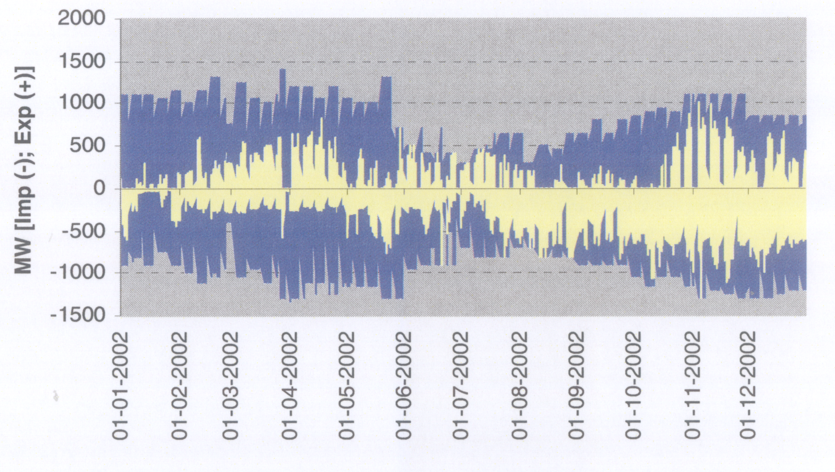 | 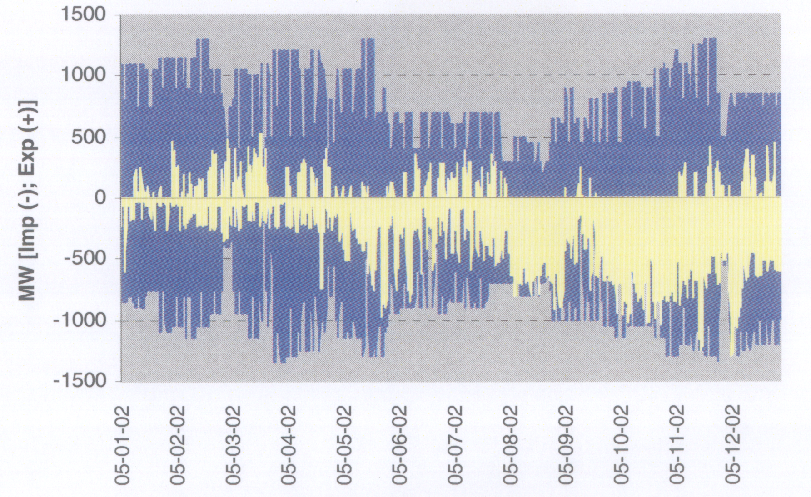
2003 | 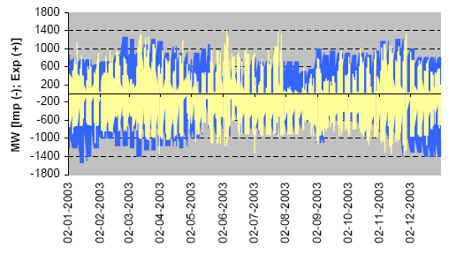 | 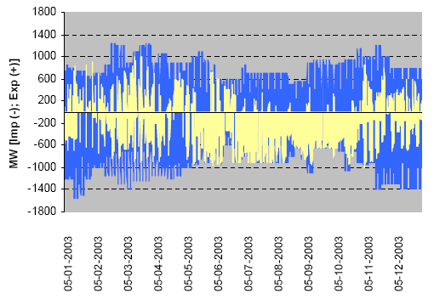
2004 | 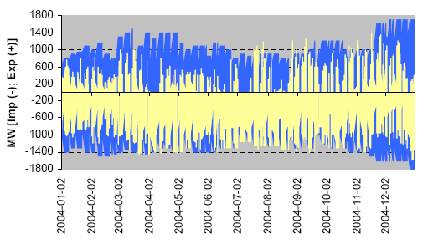 | 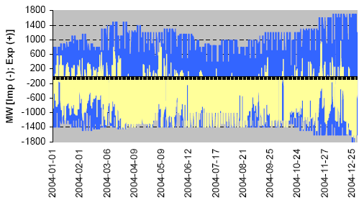

Figura 3-5 – Annual values of the import and export trading from 1999 to 2004
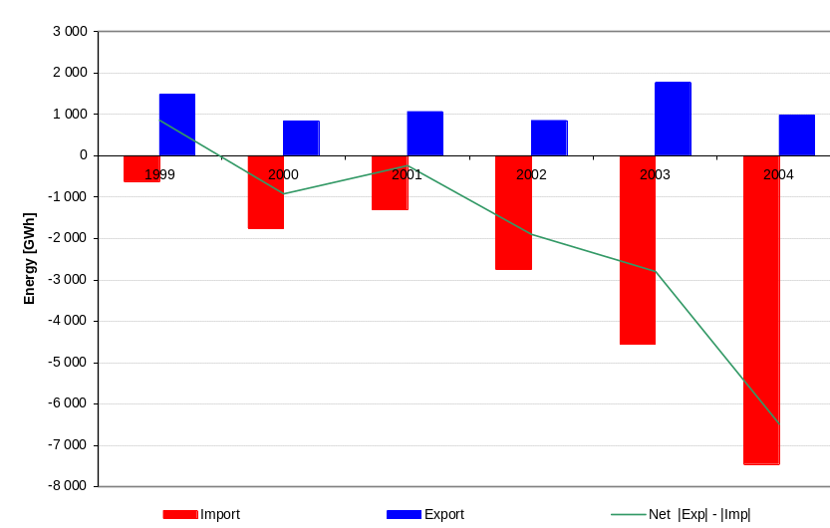
Calculation of the Interconnection Capacity Available for Commercial Purposes
The interconnection capacity available for commercial purposes is based on the value of interconnection technical capacity (calculated on hourly basis), with a margin deducted for technical and security reasons.
A base scenario corresponding to one of the typical grid situations is used to calculate the interconnection technical capacity. Simulation is made of traffic changes at the interconnections, by modifying generation in Portugal.
The interconnection technical capacity for the considered base scenario corresponds to the maximum value at which the security criteria apply – both in normal and contingency operation conditions.
In normal operation conditions, for each type of contingency, the following security criteria must apply:
- Prevent the violation of the overload levels admissible in different grid components.
- Keep the voltage levels in the different grid components within acceptable limit values.
The following contingencies are also considered:
- Simple failure (n-1) of any grid component, or of the power generation system: generator, single-circuit line (including interconnections), autotransformer, or shunt capacitor bank.
- Failure (n-2) of the following grid pairs, or of the power generation system: two circuits of the double lines longer than 35 km (simultaneous failures), or specific sets including a large-dimension generator and a particular line.
Network configurations to be considered for calculating the interconnection capacity depend on the timeframe of said calculation: long term (for next year), or short term (for next week, day or following hours).
When calculating the long-term interconnection capacity, each typical network layout is determined by analyzing the cross-combinations of the most severe network configurations for different times of the year (Summer and Winter), different hydrological balances (dry and wet), different load regimes (peak, valley, intermediate) and foreseeable unavailabilities of the grid components.
When calculating the short-term interconnection capacity, the starting assumption corresponds to a specific network configuration supplied by a “state estimation” algorithm.
The capacity available for commercial purposes is determined by deducting from the technical capacity value a safety margin equivalent to 100 MW. This safety margin is used to cope with general uncertainties related to the system’s operation and to offset the inevitable gaps between generation and consumption.
The final values are established by settlement of the values, calculated by the operators of the interconnected grids (i.e. REN and REE).
The transmission system operator announces the values of the interconnection capacity available for commercial purposes on its website, for each day of the following two weeks (on hourly basis).
As a result of recent investment in interconnections, the transmission capacity for commercial purposes increased in 2004. Figure 3-6 and Figura 3-7 indicate the hourly distribution of the transmission capacity for commercial purposes – respectively for imports and exports – in 2002 to 2004.
The average annual values of the transmission capacity for commercial purposes, in the last three years, are shown in Table 3-1.
Table 3-1 – Average values per annum of the transmission capacity for commercial purposes

 | 2002 | 2003 | 2004
Import | 736 MW | 774 MW | 1107 MW
Export | 648 MW | 615 MW | 801 MW

Figure 3-6 – Values of the hourly distribution per annum of the transmission capacity for import commercial purposes during 2002 to 2004
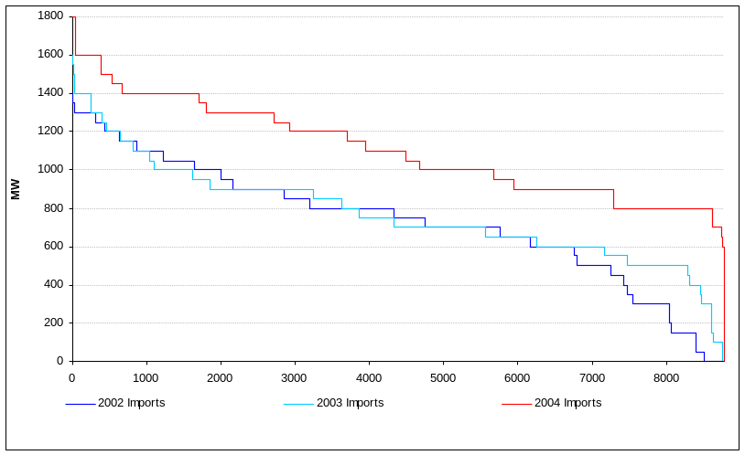

Figura 3-7 – Values of the hourly distribution per annum of the transmission capacity for export commercial purposes during 2002 to 2004
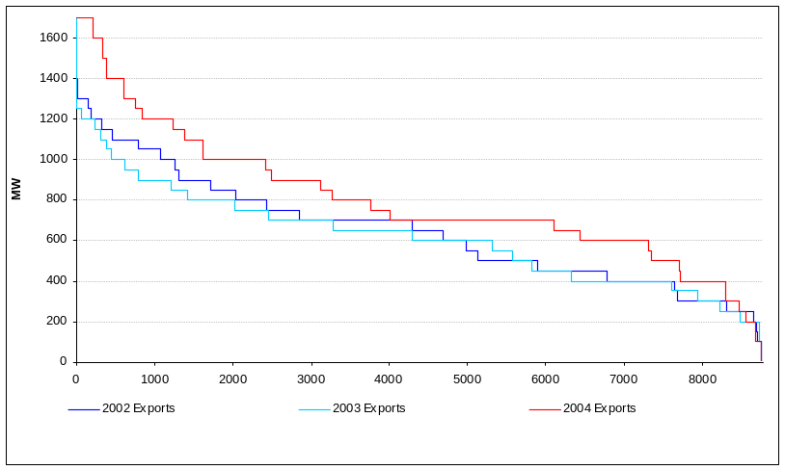

Regulation of Transmission System Operators (TSOs) and Distribution System Operators (DSOs)

System Operators in Mainland Portugal and in the Autonomous Regions
The Portuguese electricity system consists of three electricity sub-systems that are not interconnected, i.e. one in Mainland Portugal, interconnected with Spain, and two island systems – corresponding to the Autonomous Regions of the Azores and Madeira.
Each of these sub-systems has dedicated public-service transmission and distribution system operators in charge of building and operating the respective infrastructures.
System operators currently working in each of the electricity sub-systems mentioned above are the following.
- Mainland Portugal
The transmission system operator in Mainland Portugal is Rede Eléctrica Nacional, S.A. (REN), holder of a concession awarded by the Portuguese State.
As regards electricity distribution, the status of electricity distribution system operator has been awarded to EDP Distribuição – Energia, S.A. (EDP Distribuição), a company belonging to Group EDP that holds the infrastructures of the electricity distribution grid in Medium Voltage and High Voltage by means of a license. In addition to this license, EDP Distribuição manages and operates most of the Low Voltage (LV) distribution grid in Mainland Portugal, pursuant to agreements signed with different Municipalities.
The LV distribution grid that is not operated by EDP Distribuição has little relative weight in the total LV distribution grid. It consists of concessions awarded to small-scale distribution companies, located in the central and northern regions of Mainland Portugal.
- Autonomous Region of the Azores
In the Autonomous Region of the Azores, Electricidade dos Açores, S.A. (EDA) is both the transmission system operator and the distribution system operator. This company holds the concession of electricity transmission and distribution in each of the nine islands that compose the Azores Archipelago. This concession was awarded by the Regional Government of the Azores.
- Autonomous Region of Madeira
In the Autonomous Region of Madeira, Empresa de Electricidade da Madeira, S.A. (EEM) is both the transmission system operator and the distribution system operator. This company holds the concession of electricity transmission and distribution in the islands of Madeira and Porto Santo. This concession was awarded by the Regional Government of Madeira.

Grid Tariffs
Forms ofRegulation
All entities mentioned above, which have been assigned the functions of operating the electricity grids, also include other activities – subject to ERSE regulation – in the respective concession contracts and binding licenses.
The regulated activities of each entity are the following:
- REN
Electricity Transmission Activity – This activity includes the planning, definition, operation, maintenance and co-ordination of the National Transmission System (RNT).
Global System Management Activity – Consisting of activities developed by the System’s Manager and the Offers Manager (REN internal units), this activity includes the technical co-ordination of the integrated SEP system, commercial co-ordination and the system of settlement of accounts between SEP and SENV.
Power Purchase Activity – Consisting of activities developed by the SEP Commercial Operator (REN internal unit), this activity includes buying the power required to supply consumption of SEP customers, as well as making studies to plan the expansion of the power generation system.
- EDP Distribuição
Electricity Distribution Activity – Consists in planning, defining, operating, maintaining and co-ordinating the distribution system, so as to send electricity from the points of reception to the end users.
Network metering, billing and settlement Activity – Consists of activities related to the marketing of the electricity distribution service, including contracting, metering, billing and settlement of services associated with the use of distribution systems.
SEP contracting, billing and settlement Activity – Consists of the commercial structure involved in selling electricity to the final SEP customers, including activities such as electricity contracting, billing and settlement.
Electricity Buying and Selling Activity – EDP Distribuição buys from REN the electricity and the services of global use of system and transmission use of system required for the binding distribution operator to (i) supply the SEP end users and (ii) manage the power purchase from non-binding generators and direct imports, in the framework of the SEP’s “free market parcel”.
- EDA and EEM
Electricity Distribution Activity – This activity involves the planning, definition, operation, maintenance and co-odination of the distribution system, so as to send electricity from the points of reception to the final customes, in each island.
Contracting, billing and settlement Activity – Consists of the commercial structure involved in selling electricity to end users, including activities such as electricity contracting, billing and settlement, in each island.
Power Purchase and System’s Management Activity– Consists in buying the electricity required to supply customer consumption, as well as making studies to plan the expansion of the power generation system in each island.
The forms of regulation associated with each of the above activities are indicated in the table below:

COMPANY | ACTIVITIES | FORM OF REGULATION
REN | Power Purchase | Regulation by rate of return. Costs accepted on annual basis.
REN | Global System Management
REN | Electricity Transmission
EDP Distribuição | Electricity Distribution | Regulation by price cap established for the regulation period.
EDP Distribuição | Network Metering, Billing and Settlement | Regulation by rate of return. Costs accepted a priori, on annual basis.
EDP Distribuição | SEP Contracting, Billing and Settlement | Regulation by rate of return. Costs accepted a priori, on annual basis.
EDP Distribuição | Electricity Buying and Selling | Generation and transmission costs transferred to SEP customers.
 | Power Purchase and System Management | Regulation by rate of return. Costs accepted on annual basis.
EDA e EEM | Electricity Distribution
 | Contracting, Billing and Settlement

REN and EDP Distribuição usually have a three-year regulation period, while the regulated operators of the Autonomous Regions of the Azores and Madeira have a one-year regulation period.
Methodology for Calculating Grid Tariffs
ERSE is in charge of preparing and publishing the Tariff Code, establishing the methodology for calculating tariffs and prices and the forms of regulation of the allowed income. Before approval, the Tariff Code must be submitted to public hearing and receive advice from the Tariffs Board.
Tariff calculations must comply with the calculation methodology previously established in the Tariff Code. The tariffication process – including its timeframe, is also laid down by the Code. Up to the 1 May, every year, the regulated operators send to ERSE last year’s physical and accounting data. Then estimates concerning the current year and forecasts of the coming year must be sent up to the 15 June. Based on this information, plus possible additional clarifications, ERSE drafts a duly justified proposal of Tariffs that must be submitted to the Tariffs Board up to the 15 October. The Tariffs Board, composed of representatives of the consumers and of regulated operators, among others, appraises the proposal and gives advice to ERSE up to the 15 November. Taking in account this non-binding advice, up to the 15 December ERSE publishes the tariffs that will be in force as from the 1 January next year.
In order to explain the adopted tariff calculation methodology, we briefly describe the existing Portuguese tariffs system – as essentially laid down in the 1995 legislation. Thus we have considered supplies to customers that have chosen a supplier operating in the Non-binding Electricity System (SENV) and to customers who have chosen to be supplied by the Public Service Electricity System (SEP).
Tariffs and regulated activities
Income generated by regulated activities is recovered by way of specific tariffs, each with its own tariff structure and characterized by a given set of billing variables.
Tariff prices are established in each activity in a way that (i) makes its structure reflect the structure of marginal or incremental costs, and (ii) enables the recovery of income generated by each activity.
Tariffs charging and billing are based on the principle of non-discrimination depending on the energy use. Tariff options are available to all consumers.
The Global Use of System tariff makes it possible to recover income generated by the global system management activity – including system’s operation, ERSE-related costs, overcosts due to generation from renewables and other energy policy costs.
The Transmission Use of System tariff makes it possible to recover income generated by the electricity transmission activity – including the definition, operation and maintenance of transmission systems.
The (HV and MV) Distribution Use of System tariffs make it possible to recover income generated by the regulated HV and MV distribution activities, which include activities such as the planning, operation and maintenance of distribution systems with a view to sending electricity from the points of reception to the end users. Likewise the LV Distribution Use of System tariff makes it possible to recover income generated by the regulated LV electricity distribution activity.
The Network Commercial Management tariff makes it possible to recover income generated by the network commercial management activity, which includes activities such as the contracting, metering, billing and settlement of services associated with the use of grids and other regulated services. These activities are developed on monopoly basis.
The Energy & Power tariff (TEP) makes it possible to recover income generated by the regulated power purchase activity, which includes charges related with the generation of electricity for supplying SEP customers.
The SEP Network Commercial Management tariff makes it posible to recover income generated by the regulated SEP network commercial management activity, which includes activities such as electricity contracting, billing and settlement.
Grid Access Tariffs
Grid access paid by all electricity consumers includes the following tariffs: Global Use of System, Transmission Use of System, Distribution Use of System and Network Commercial Management. Non-binding customers who chose their supplier in the market pay the grid access tariffs and freely bargain power purchase with their supplier.
Calculation of the SEP end-user tariffs, charged by the regulated supplier to SEP customers, is based on the tariffs by activity included in grid access plus the SEP Energy & Power tariff and the SEP Network Management tariff.
Prices of access tariffs for each billing variable are determined by adding the corresponding tariff prices by activity. This tariff calculation methodology is presented in a simplified manner in Figure 3-8 and is called tariff additivity.
Figure 3-8 – Tariff additivity methodology for calculating access tariffs
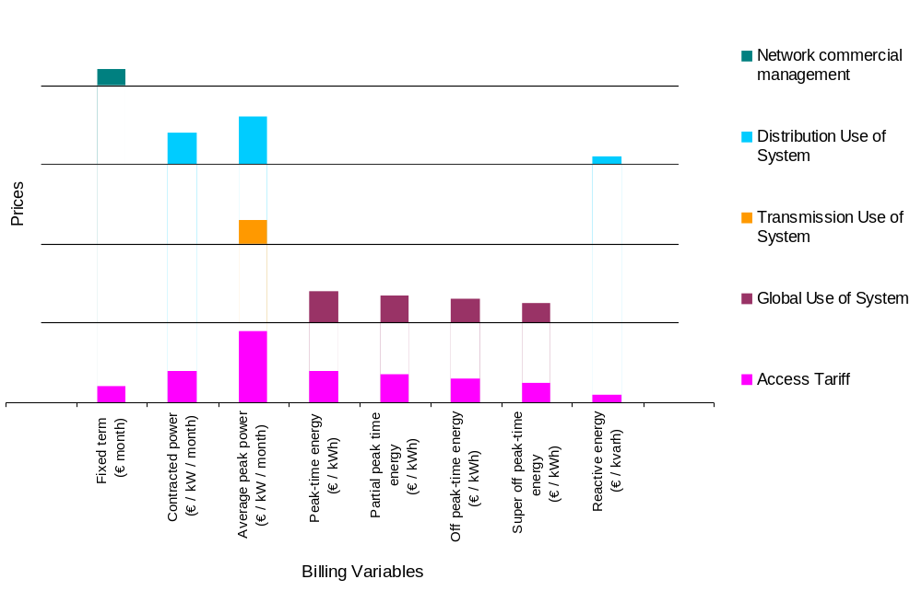
If tariffs that compose the sum are based as much as possible on marginal costs, this helps avoid inter-costumer cross-subsidization. The closer the prices of such tariffs are to marginal costs, the closer we will be to an efficient resource allocation that maximizes social well-fare.
This tariff calculation methodology makes it possible to have a detailed knowledge of all tariff components by activity or service. Thus customers may know exactly how much they pay, for example, for using the MV distribution system and how is that value considered in terms of billing. Upon request, customers may receive a breakdown of of their electricity bill by each applicable regulated tariff component, by average price and by tariff term. This possibility is laid down in the electricity sector codes currently in force.
It should be noted that tariffs are charged by delivery point. Their prices, if necessary, are converted into different voltage levels – by applying loss adjustment factors. When the metering equipment does not make it possible to directly apply the billing variables of activity-specific tariffs, then prices to be applied to the metered variables are calculated, based on consumption profiles typical of each tariff option.
Transparent definition of the tariffs – resulting from the implementation of this type of system – is especially important to customers who cannot choose their supplier, in particular those less informed.
The allowed income and the forms of economic regulation of the different regulated activities, as described above, are established in the Tariff Code.
ERSE’s models of economic regulation – and, consequently, the procedures adopted for determining the regulation parameters – may vary. It may be a cost-driven regulation – as applicable to REN activities, to the marketing activities of EDP Distribuição and to the activities developed by the operators in the Autonomous Regions – or a price cap regulation – as applicable to the Electricity Distribution Activity of EDP Distribuição.
In the cost-regulated activities, the key parameter is the cost-of-capital rate, the value accepted as remuneration rate of the asset basis for regulation purposes. This parameter is calculated at the beginning of each regulation period and has been determined through internally developed research, supported by studies made by independent consultants. The calculation method has been based on the weighted average cost-of-capital (WACC) methodology.
In the electricity distribution activity, the basic formula adopted – i.e. [P x (RPI-X)] – relies on the establishment of a base unitary price (by voltage level) for the distributed electricity, which varies (at usually decreasing rate) throughout the regulation period according to the variation of the consumer price index, minus an efficiency factor. Determining a cost of capital for EDP Distribuição is a need inherent to the remuneration of the distribution activity, which underlies the calculation of the base price values. In addition it has also been essentially important to determine an appropriate X parameter by voltage level, for securing the economic regulation of the electricity distribution activity. Initially ERSE calculated these parameters based on a benchmarking study made by an international consultant. The said parameters have since then continued to be updated, based on internal studies made by ERSE taking in account the evolution of operating costs associated with this activity.
Quality of service
Both the Tariff Code and the Quality of Service Code have provisions regarding the quality service of regulation in Portugal mainland.
The Tariffs Code, approved by ERSE, establishes an incentive to continuity of supply in the MV systems, whose value may be reflected in the income allowed for the MV and HV distribution network operator in Portugal mainland.
The value of the incentive to continuity of supply depends on the annual value of non-distributed energy and is determined by way of a “dead band” function, with established maximum limits, as laid down in Figure 3-9.
Figure 3-9 – Mechanism of Incentive to Continuity of supply
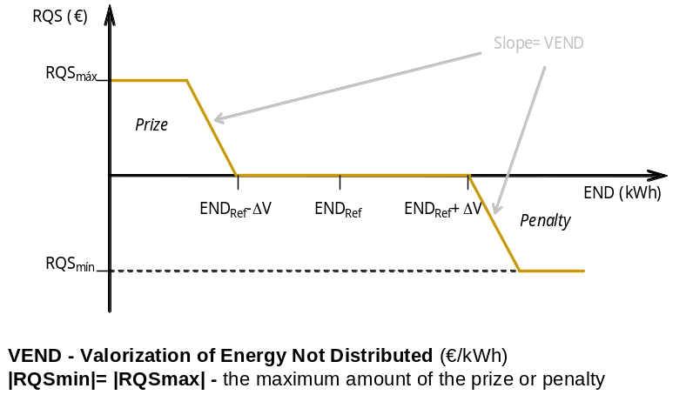

In the first year (i.e. 2003 performance) of enforcement of the incentive to quality of service, the value of non-distributed energy remained in the “dead band” zone and therefore the value of the incentive was nought (Figure 3-10).
Figure 3-10 – Mechanism of Incentive to Continuity of Supply
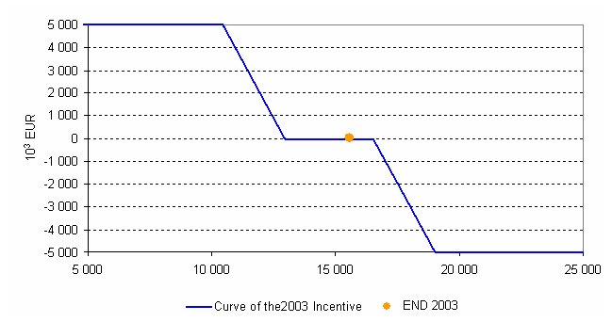

The Quality of Service Code (RQS) deals with the technical quality of service (continuity of supply and voltage quality) and with the commercial quality of service (relationship between the supplier/distribution operator and the customer), defining:
- Powers, responsibilities and obligations.
- Indicators and standards.
- Compensation to be paid to consumers when individual indicator standards are exceeded.
- Obligations to check on Quality of Service – Monitoring Plans.
- Obligations to supervise information – Quality of Service Reports.
- Customers with special needs.
The Directorate-General for Geology and Energy, an agency of the Ministry of the Economy and Innovation, is responsible for the technical provisions of RQS and its publication.
ERSE proposes the commercial provisions of RQS and is responsible for monitoring the enforcement of the Code.
RQS establishes general and individual indicators for continuity of supply.
The size of the town where the customer facilities are located defines its geographical area of service quality:
- Area A – Regional capitals and towns with more than 25,000 customers.
- Area B – Towns with more than 2 500 customers and less than 25 000.
- Area C – Towns with less than 2 500 customers.
Table 3-2 presents the continuity-of-supply general indicators established in the RQS. The general indicators apply to long interruptions (t>3 minutes) and exclude interruptions due to: casualty cases or acts of God, reasons of public interest, service or safety, agreement with the customer, and fact ascribable to the customer.
Table 3-2 – Continuity of supply general indicators
SARI
SAIDI (
min
)
SAIDI (
min
)
SAIDI (
min
)
SAIFI
SAIFI
SAIFI
TIEPI (h)
TIE (h)
END (
MWh
)
ENF (
MWh
)
LV Grids

MV Grids
Distribution
Transmission
SARI
SAIDI (
min
)
SAIDI (
min
)
SAIDI (
min
)
SAIFI
SAIFI
SAIFI
TIEPI (h)
TIE (h)
END (
MWh
)
ENF (
MWh
)
ENF: Energy Not Supplied
END: Energy Not Distributed
TIEPI: Time of Interruption Equivalent of Power Installed
TIE: Equivalent Time of Interruption
SAIFI: System Average Interruption Frequency Index
SAIDI: System Average Interruption Duration Index
SARI: System Average Restore Index
RQS establishes standard values for the general continuity of supply indicators, shown in Table 3-3 as a function of the geographical area of service quality and voltage level.
Table 3-3 – Standard-values for the general indicators of continuity of supply
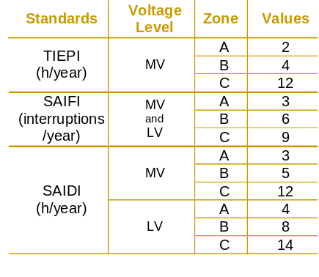
As an example, Figure 3-11 and Figure 3-12 show the evolution of two general indicators of continuity of supply: SAIFI (system average interruption frequency index) and SAIDI (system average interruption duration index). We present the evolution, in the last five years, of the SAIFI and SAIDI indicators in MV and LV, with a breakdown by geographical areas with A, B and C service quality.
Figure 3-11 – Evolution of SAIFI – system average interruption frequency index
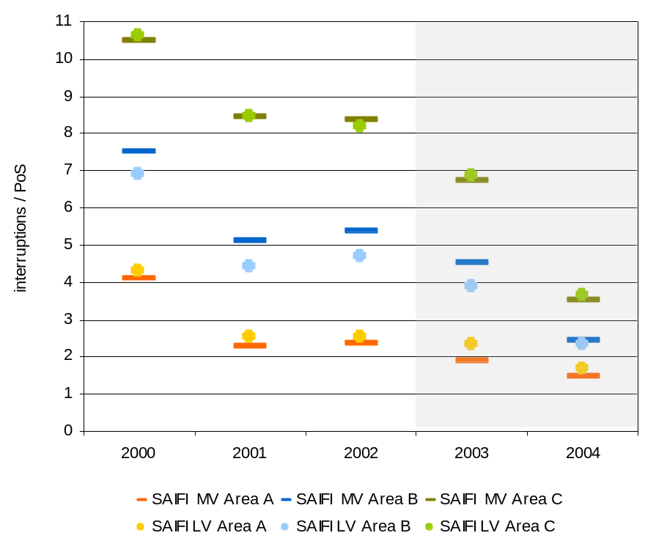
Figure 3-12 – Evolution of SAIDI – system average interruption duration index
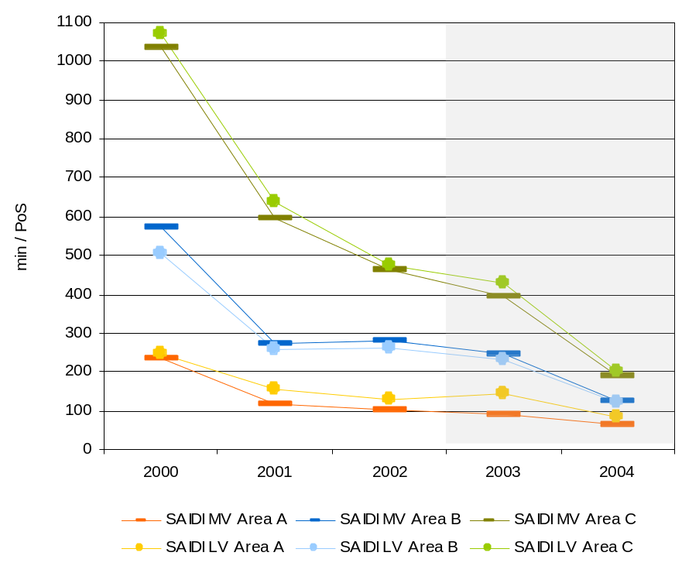
The individual continuity-of-supply indicators established in RQS are:
- Number of interruptions per year.
- Duration of interruptions (h/year).
Table 3-4 shows the standard-values for the individual continuity-of-supply indicators, as a function of the geographical area of service quality and the voltage level used by the customer.
Table 3-4 – Standard-values for individual continuity-of-supply indicators
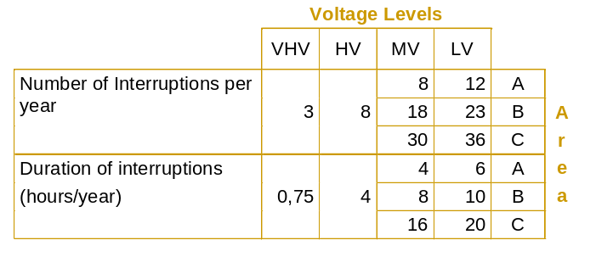
The formulas for calculating the amount of compensation to be paid by system operators to the customers, for not complying with the individual continuity-of-supply indicator standards, are shown in Table 3-5.
When there is non-compliance with the two standards shown on the referred table, system operators will pay the highest compensation.
Table 3-5 – Compensation to be paid for non-compliance with the individual continuity-of-supply indicators (2004 values)

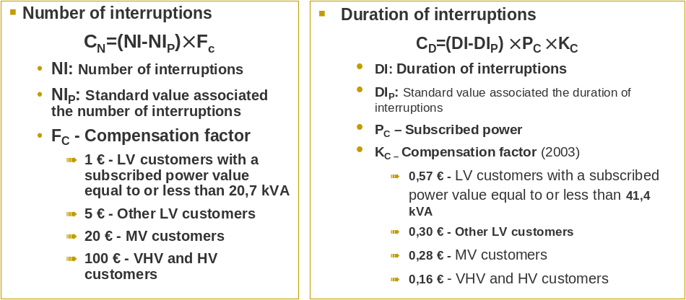

Payment of compensation for non-compliance with the individual continuity-of-supply indicators is automatic since 2004. For that first year of automatic enforcement, the company forecasted the number of non-compliance cases and the amounts to be paid shown in Table 3-6.
Table 3-6 – Compensation forecasted for non-compliance with the individual continuity-of-supply indicators
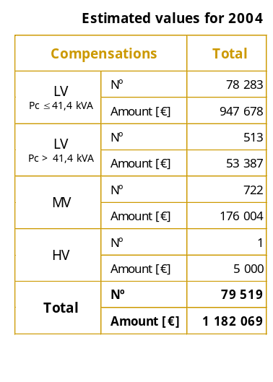
RQS establishes the main mandatory attributes of the suppllied voltage waveform at the point of delivery to the customer in normal operating conditions, namely as regards:
- Frequency.
- Voltage value variations.
- Flicker.
- Harmonic distortion.
- Imbalance in the triphasic voltage system.
- Voltage dips.
For analysing the quality of the voltage waveform, RQS uses as technical reference, among others, the Portuguese Standard NP EN 50160 “Voltage characteristics of electricity supplied by public distribution systems”, published by CENELEC and transposed for Portugal.
The commercial quality of service is associated with the servicing levels provided to customers and their relationship with their suppliers of electricity.
Overall indicators of commercial service and their corresponding standards are shown in Table 3-7.

Table 3-7 – Overall indicators and standards of commercial quality of service
General indicator | Standard (%)
Percentage of telephone enquiries to be responded within 60 seconds | 80
Percentage of visiting customers with a waiting time up to 20 minutes, in customer centres | 90
Percentage of customer complaints to be responded within 15 working days | 95
Percentage of written information requests to be responded within 15 working days | 90
Percentage of LV (P < 41,4 kVA) customer’s meters with a firm reading at least once a year | 98
Percentage of estimated charges for supplies in LV to be responded within 20 working days | 95
Percentage of LV customer’s premises to be connected to electricity distribution system within 20 working days | 95
Percentage of LV customers to be provided with supply and meter within 2 working days, after signature of the supply contract | 90
Percentage of electricity supplies to be restored following faults within 4 hours | 80

As an example, Figure 3-13 and Figure 3-14 show the evolution of the two indicators of commercial quality of service – the indicator called “Percentage of written information requests to be responded within 15 working days” and the indicator “Percentage of estimated charges for supplies in LV to be responded within 20 working days”.
Figure 3-13 – Evolution of the indicator “Percentage of written information requests to be responded within 15 working days”

- 2004
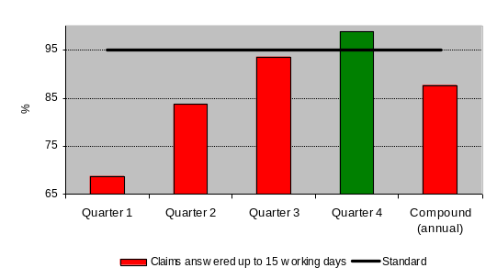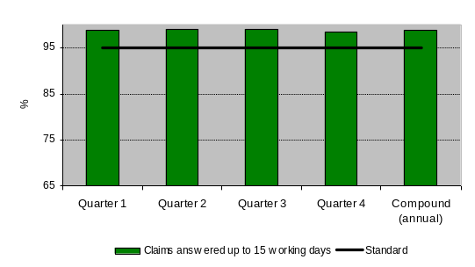

Figure 3-14 – Evolution of the indicator “Percentage of estimated charges for supplies in LV to be responded within 20 working days”
- 2004
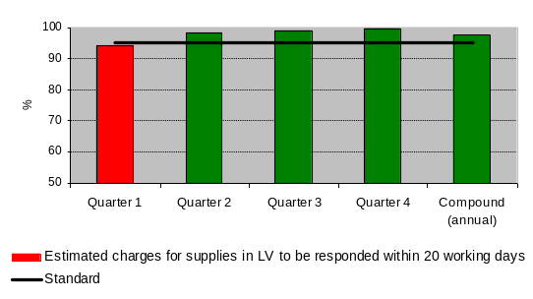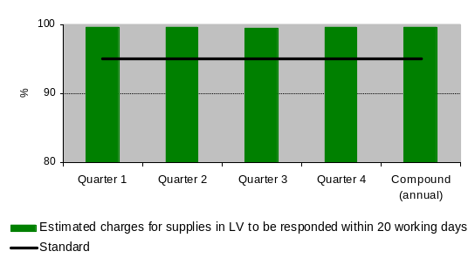

RQS establishes guaranteed standards of commercial quality of service, which correspond to quality of service commitments between distribution operators and their customers, on individual basis. Should the distribution operator fail to comply, then it must compensate the customer. RQS establishes six commercial quality standards:
- Visit to the customer’s facilities, within the agreed 3-hour delay.
- Technical assistance after the customer reports a failure of his individual electricity supply, which must be provided within 4 hours (Area A and B) or 5 hours (area C).
- Restoring supply after a disconnection caused by customers which must take place within a maximum 8-hour delay (in case of MV), or up to 5 pm of the next working day (in case of LV).
- Responding to customer’s claims about billing and invoicing, within the maximum delay of 15 working days.
- Investigation of voltage complaints, within the maximum delay of 15 working days.
- Processing of claims regarding the operation of the metering equipment, within the maximum delay of 15 working days.
Non-compliance with the individual commercial quality standards implies the payment of compensation to the affected customer, as follows:
- € 15,00 to LV customers with contracted power equal to, or lower than, 20.7 kVA.
- € 25,00 to the remaining LV customers.
- € 75,00 to the remaining customers.
The automatic payment of compensation for non-compliance with the individual standards of commercial quality of service began in 2004 – 17 703 payments were made, corresponding to approximately 274 315 euros.
RQS establishes a set of provisions aimed at securing that distribution operators maintain a quality commercial relationship with their customers with special needs – namely as regards access to information and pre-warning of scheduled interruption (in the case of customers relying on electrical medical equipment).
Customers with special needs are the following:
- Disabled people who can only displace themselves on a wheelchair.
- The visually disabled with total blindness.
- The hearing disabled with total deafness.
- People relying on medical equipment without which they cannot survive, whose functioning is ensured by the electricity system.
Distribution operators must keep a permanently updated record of the customers with special needs. Each customer should request his/her own registration.
As regards customers relying on electrical medical equipment, the distribution operate should establish a preferential mode of contact, as well as make a tailor-made pre-warning of scheduled interruptions, with at least 36 hours in advance. As regards the commercial relationship with the remaining categories of customers with special needs, the distribution operator must ensure a quality commercial relationship, namely by using appropriate means of information.
As laid down in RQS, the transmission system concession-holder and the distribution operators must prepare an annual report on quality of service. The Code defines the minimum contents and the deadline for submitting it. ERSE must also prepare an annual report on quality of service.
Grid connection / Connection to the grids
Electricity system operators, within their catchment areas, must connect to their grids the facilities of customers who request such connection, as long as the technical and legal requirements are met.
The Commercial Relations Code establishes two types of connectors:
- Connectors for exclusive use – physical infra-structure for the exclusive transmission of electricity generated or used at a given electrical energy use facility.
- Connectors for shared use – physical infra-structure enabling the connection to the grid of more than one electrical energy use facility.
This Code defines the type of charges that must be paid by the applicants of grid connections, establishing the guiding principles governing the sharing of such charges – as well as the modes of payment and its possible split into instalments.
Charges due to the construction of grid connections for exclusive use are fully paid by the connection applicants.
Charges due to the construction of connectors for shared used must be shared by the various applicants – or, in those cases where there has been overscaling of the connector, they must be shared by the applicants and the system operator. If the system operators, with a view to promoting a technically and economically more beneficial resource allocation, decide on their own initiative to add extra capacity to the connector for shared use, then the overscaling cost must be borne by the said operators – who are given the right to recover such costs, as the said connector is used for new grid connections.
Operators of electricity transmission and distribution systems should demand cost-sharing in actions required to reinforce the grid, following a request for connection or increased power. In the case of MV and LV connections, cost-sharing should take place whenever the requested power is higher than the reference power established for the voltage level and the type of facility concerned. Cost-sharing should be made as a function of the requested power. ERSE has the responsibility of defining the conditions and values of cost-sharing in this type of connections.
Thus the regulations currently in force tried to establish economic indicators regarding to the location of the facility whose connection to the grid has been requested, as well as the requested power, considering the attributes of each individual application. To this effect and for the purpose of sharing costs due to the connection of customer facilities to the grid, ERSE adopted the guiding principle of matching the induced costs with the responsibility for their payment.
Information-wise the code states that the system operator must inform and advise the grid connection applicant, namely as regards the voltage level appropriate to the connection, in order to secure the best technical and economic conditions – considering all aspects involving the connection application. This mandatory duty to inform involves the preparation and publication of information leaflets on the procedure required to make connections to the grid, as well as the mandatory submittal of a budget concerning the requested connection.
The legislation currently governing the connection of electricity generation plants to the electricity transmission and distribution grids establishes that any charges due to grid connection must be paid by electricity generators.
Conditions regarding grid connection and the possible payment of charges due to grid reinforcement, as well as the payment conditions, are defined by agreement between the parties. Failing agreement between the generator and the system operator, ERSE must decide how costs related to grid connection should be shared, following the submittal of proposals by the entities concerned.
In the case of special-regime generators (from renewables and waste, as well as CHP plants) it is established that the generation plant is connected to the receiving grid by means of an connection built on initiative of the electricity generator. Charges related to the construction of the connection are borne by the generator if the connection is for its exclusive use. If a connection is used by more than one generator, charges related to the construction of common sections are shared as a proportion of the power to be subscribed. Whenever a connection starts to be used by a new special-regime generator within its pay-back period, generators who have borne the charges related to its construction receive compensation for the part that has not been paid back yet.
SENV electricity generators with an installed capacity higher than 50 MVA must agree on the grid reinforcement costs with the operator to which grid they want to be connected.
Prices of grid access tariffs
ERSE establishes the prices of grid access tariffs on yearly basis. This approval, duly justified, is preceded by advice from the Tariffs Board, a body of ERSE where consumers and regulated companies have their representatives. ERSE publishes and divulges the prices of grid access tariffs on the official journal, its website and information leaflets. In addition, regulations establish that system operators must give information and advice to grid users on (i) the tariffs and prices that they pay for accessing the grids, and (ii) the most beneficial and appropriate tariff options for each situation. To this effect, they must prepare and publish information leaflets.
Table 3-8 shows the cost components included in the 2005 grid access tariffs. This Table also shows the total income provided by each tariff.
Table 3-8 – Breakdown of costs included in grid access tariffs
System management
7
System services
28
Energy Services Regulatory Authority (ERSE)
2
Special-regime generation Overcost
40
Autnomous Regions’ Convergence Overcost
24
TRANSMISSION USE OF SYSTEM
161 759
Transmission Grid
100
HV/MV DISTRIBUTION USE OF SYSTEM
369 807
Distribution Grid
100
Distribution Grid
65
Concession rents paid to Municipalities
35
NETWORK COMMERCIAL MANAGEMENT
137 939
Metering, billing and settlement of tariffs charged to grid users

100
GLOBAL USE OF SYSTEM
LV DISTRIBUTION USE OF SYSTEM
357 954
573 242
GRID ACCESS TARIFFS
INCOME
(10
3
EUR)
COST COMPONENTS
(%)

From Table 3-9 to Table 3-11 we present prices to be paid for grid access in High Voltage (HV), Special Low Voltage (SpLV) and Standard Low Voltage (StLV), by customers with a contracted demand power lower than 20,7kVA, and two active-energy prices differentiated by day/night period (two-rate time-of-day tariff). Prices have been unbundled by tariff of each activity (Global Use of System, Transmission Use of System, Distribution Use of System and Network Commercial Management) and billing variable (Fixed term, Contracted Power, Average Peak Power, Active Energy and Reactive Energy). Prices of grid access tariffs in each voltage level are determined by adding up, for each billing variable, the tariff prices by activity converted into the voltage level of energy delivery. For example, the peak power price of the grid access tariff in SpLV is determined by adding up the peak power prices of the following tariffs, i.e. HV Transmission Use of System, HV Distribution Use of System, MV Distribution Use of System and LV Distribution Use of System.
Table 3-9 – Prices to be paid by HV Customers for grid use
Contracted
Peak-time
Peak-time
Off
Peak-time
Super off peak-time
Supplied
Received
Global Use of System
-
-
-
0,0082
0,0081
0,0081
0,0081
-
-
HV Transmission Use of System
-
-
1,877
-
-
-
-
-
-
HV Distribution Use of System
-
0,175
0,262
-
-
-
0,0120
0,0090
HV Network Commercial Management
101,22
-
-
-
-
-
-
-
-
HV Grid Access Tariff
101,22
0,175
2,139
0,0082
0,0081
0,0081
0,0081
0,0120
0,0090
Reactive energy
(EUR/kvarh)
Active energy
PRICES OF THE HV ACCESS TARIFF
Tariff
(EUR/kWh)
Fixed Term
(EUR/ month)
Power
(EUR/kW.month)
Partial
peak-time

Table 3-10 – Prices to be paid by customers for grid use in SpLV
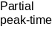
Supplied

Received

Global Use of System

-
-
-
0,0094
0,0089
-
-
HV Transmission Use of System
-
-
2,162
-
-
-
-
-
-
HV Distribution Use of System

-
-
0,503
-
-
-
-
-
-
MV Distribution Use of System

-
-
3,799
-
-
-
-
-
-
LV Distribution Use of System

-
0,642
5,780
-
-
-
-
0,0151
0,0115
LV Network Commercial Management
26,26
-
-
-
-
-
-
-
-
SpLV Grid Access Tariff
26,26
0,642
12,244
0,0094
0,0089
0,0151
0,0115
0,0086
0,0086
PRICES OF THE ACCESS TARIFF IN SpLV

Tariff
Fixed term
(EUR/
month
Power
(EUR/kW.month)
Active energy

Reactive energy

(EUR/kvarh)
(EUR/kWh)
Contracted
Peak-time
Peak-time
Super off peak-time
Off
Peak-time

Table 3-11 - Prices to be paid by customers for grid use in two-rate time-of-day StLV <20,7kVA
Supplied

Received

Global Use of System

-
-
-
-
-
HV Transmission Use of System

-
-
-
-
-
HV Distribution Use of System

-
-
-
-
-
MV Distribution Use of System

-
-
-
-
-
LV Distribution Use of System

-
0,642
-
-
-
LV Network Commercial Management

1,42
-
-
-
-
HV Grid Access Tariff
1,42
0,642
-
-
-
0,0514
0,0075
-
-
-
-
-
-
PRICES OF THE ACCESS TARIFF IN TWO-RATE TIME-OF-DAY StLV <20,7kVA
Tariff
Fixed term
(EUR/
month)
Power

(EUR/kW.month)
Active energy

Reactive energy

(EUR/kvarh)
(EUR/kWh)
0,0086
0,0086
0,0090
0,0017
0,0132
0,0200
Contracted
Peak-time
Peak-time
Super off peak-time
Off
Peak-time

Figure 3-15 shows the average prices paid by Dc-, Ib- and Ig-type consumers for grid access. These average prices are determined by applying the tariffs shown in the tables above to the consumption profiles established for the Dc-, Ib- and Ig-type consumers, as shown in Table 3-12. The values indicated herein do not include the Value Added Tax (VAT), at the legal rate of 5 percent currently in force.
Table 3-12 – Characterization of Dc-, Ib- and Ig-type consumers
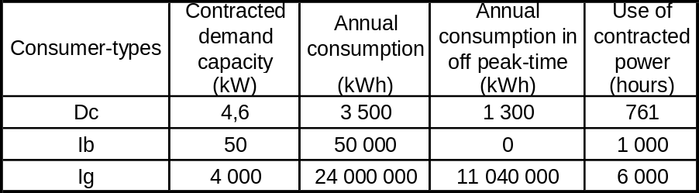

Figure 3-15 – Average prices paid by Dc-, Ib- and Ig-type consumers for grid access
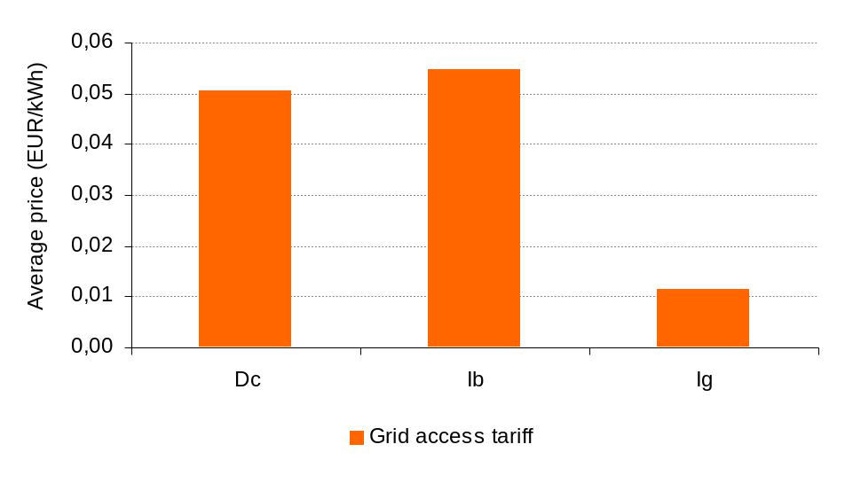
As can be noted in Figure 3-15, lb-type consumers, although using a contracted demand power that is higher than Dc-type consumers, pay a higher average price than the latter for their grid access. This situation is due to the fact that lb-type consumers, contrary to Dc-type consumers, do not use electricity in off peak hours. The average price of the former is thus higher.
Figure 3-16 and Figure 3-17 show the structure of the average grid access prices paid by the Dc-, Ib- and Ig-type consumers. Figure 3-16 gives a breakdown of each customer’s average price into the different tariffs by activity that compose its grid access tariff.
Figure 3-16 – Structure of average prices paid by Dc-, Ib- and Ig-type consumers for grid access
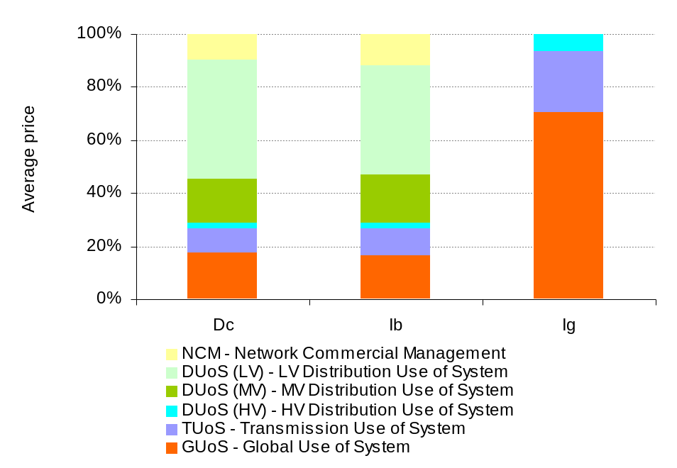
Figure 3-17 – Breakdown of the average price paid by Dc-, Ib- and Ig-type consumers for grid access
Dc
9%
19%
29%
10%
5%
7%
4%
16%
1%
Ib
10%
20%
26%
12%
5%
7%
4%
15%
1%
Ig
23%
6%
0%
0%
20%
28%
17%
0%
6%
Transmission Grid
HV/MV Distribution Grid
LV Distribution Grid
Metering, billing and settlement of grid use tariffs
System Services
Special-regime Generation Overcost
Autonomous Regions’ Tariff Convergence Overcost
Rental Fees paid to Municipalities for Concessions
Other Costs

Table 3-13 summarizes the average prices shown in Figure 3-15 and in Figure 3-16.
Table 3-13 – Average prices of Grid Access tariffs
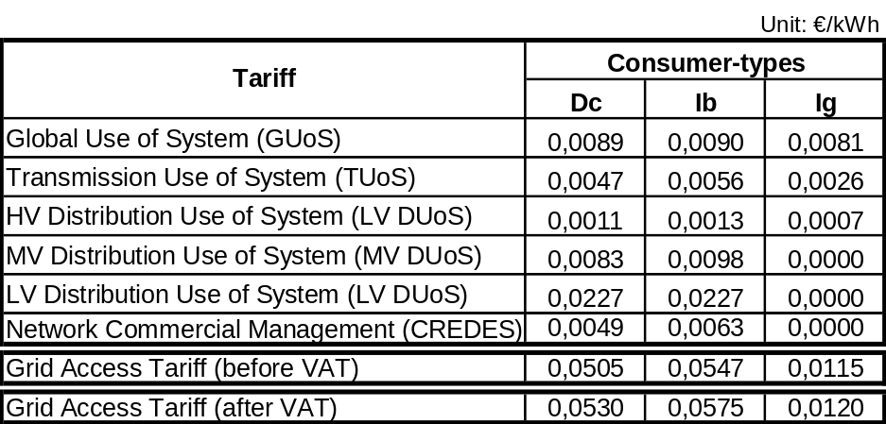

Electricity consumption is subject to a 5-percent VAT rate.

Balancing
Mainland Portugal has a single balance area, corresponding to the entire territory.
REN, through the System’s Manager, is the entity responsible for managing the balance between generation and consumption. The balance energy is supplied by generators of the Public Service Electricity System, grouped by a merit order established as a function of the variable generation cost.
In the Non-binding Electricity System, the specific balance mechanism regards recorded imbalances between the forecasted generation and consumption schedules and the corresponding value metered for each generator and its customers.
Generators send their generation and consumption schedules to the Offers Manager (a function performed by the Transmission System Operator) and are responsible for paying the charges due tot imbalances associated with their production and consumption portfolio.
Periods of settlement of accounts are fixed and last one hour. Generation and consumption schedules must be delivered up to 10:00 a.m., for each hour of the week starting on the next day.
Delivered generation and consumption schedules may be modified up to:
- 10:00 a.m., for the period ranging from 12:00 - 24:00 of the same day.
- 9:45 p.m., for the period ranging from 0:00 às 24:00 of the next day.
Prices to be paid depend on the type of imbalance (by default, or by excess) and are related with the price of active energy of the Energy & Power tariff, by values than may be higher or lower than 1.
The gap between generation and consumption results in two kinds of imbalances:
- Imbalances by default: when consumption, from the point of view of the system, is higher than forecasted. In this case, the agents of the non-binding system pay a penalty to the Offers Manager, corresponding to the share of consumption supplied by the SEP power plants.
- Imbalances by excess: when consumption, from the point of view of the system, is lower than forecasted. In this case, the Offers Manager pays to the agents of the non-binding system the surplus energy injected into the grid.
Figure 3-18 shows the evolution of imbalance energies in 2004. Imbalances by default are shown in blue and imbalances by excess are shown in red.
Figure 3-18 – Evolution of imbalances in SENV (2004)

- 30
- 20
- 10
0
10
20
30
January
February
March
April
May
June
July
August
September
October
November
December
[GWh]
Imbalances by
excess [GWh]
Imbalances by
default [GWh]
Source: REN
Table 3-14 shows the total annual value of imbalance energies by excess and default, as well as their valuation. Unitary imbalance rose to an average annual value of 22,93 €/MWh and 57,75 €/MWh, respectively for imbalances by excess and by default.
Table 3-14 – Total annual imbalance and unitary values in the SENV (2004)

 | Unit | Value
Imbalance by excess | MWh | 167 006
Valuation of imbalances by excess | EUR | 3 829 335,48
Unitary imbalance by excess | €/MWh | 22,93
Imbalance by default | MWh | 154 213,00
Valuation of imbalances by default | EUR | 8 906 284.00
Unitary imbalance by default | €/MWh | 57,75
Source: REN

Accounting unbundling
As mentioned above, in addition to operating the Electricity Transmission system (TEE), REN also develops activities of Power Purchase Activity (AEE) – for supplying consumption of SEP customers, and of Global System Management (GGS).
REN is a separate entity, with legal autonomy vis-à-vis the electricity generation and marketing operators. Its share capital is owned by the State (70 percent) e by EDP, S.A. (30 percent), the latter being the holding company of Group EDP.
EDP Distribuição, as mentioned above as well, in addition to the Electricity Distribution Activity, also develops activities of Network Metering, Billing and Settlement (CR), SEP Contracting, Billing and Setllement (CSEP) and Electricity Buying and Selling (CVEE).
EDP Distribuição, although a legally autonomous entity, belongs to Group EDP and is 100 percent owned by EDP, S.A..
On the 31 December 2004, EDP, S.A. had the shareholding structure indicated on Table 3-15.
Table 3-15 – Shareholding structure of EDP, S.A.
Shareholder | Capital (%)
Parpública - Participações Públicas, SGPS, S.A. | 15,59
Caixa Geral de Depósitos, S.A. | 9,76
Iberdrola - Participações, SGPS, S.A. | 5,70
Caja de Ahorros de Asturias (CajAstur) | 5,33
Banco Comercial Português, S.A. | 5,06
Brisa - Participações, SGPS, S.A. | 2,00
EDP (owner’s equity) | 0,39
Other shareholders | 55,97
TOTAL | 100,00

Until very recently EDA was 90 percent owned by the Regional Government of the Azores, with a 10 percent stake belonging to EDP, SA. In early 2005, the Regional Government decided to sell 39,9% of the company’s share capital, in two phases. In phase one, 33,92% were open to bidding from especially qualified entities. In phase two, 5,98% were open to employees and small investors. Phase one ended in early July. The winning bidder was the consortium ESA - Energia e Serviço dos Açores, S.G.P.S., S.A., composed of the following companies: Bensaúde Participações, S.G.P.S., S.A, BENSAÚDE, S.A., BENTRANS - Carga e Transitários, S.A., Agência Açoriana de Viagens, S.A. Banco Espírito Santo, S.A., Banco Espírito Santo dos Açores and STDP - Sociedade Transnacional de Desenvolvimento de Participações, S.G.P.S., S.A. Phase two will take place over the coming month of August.
The share capital of EEM is entirely owned by the Regional Government of Madeira.
REN, EDP Distribuição, EDA and EEM have all a separate identity and there is no risk of confusion among them. EDP Distribuição, however, belongs to an economic group and its corporate image is defined by Group EDP. So it can be easily mistaken with its holding company (for example, they have the same logotype).
REN, EDA and EEM have their own websites, respectively www.ren.pt, www.eda.pt and www.eem.pt. Information on EDP Distribuição, however, may be found on www.edp.pt, the website of Group EDP.
The Tariff Code issued by ERSE establishes that all regulated companies must adopt accounting unbundling for each of the activities and activities mentioned above, as if these were autonomous entities, so that balance sheets and income statements may be obtained for each of them. Such information is submitted to ERSE on yearly basis, both in terms of occurred values and forecasted values for the next year. The occurred values of each regulated activity must be audited and have an attached report produced by an independent auditing company.
Taking stock of the kind of accounting information that must be made public by virtue of the tax laws, ERSE issued standards as a complement to the Tariff Code. These standards specify and unbundle the information by activity that may be also divulged from the other information, which, due to its confidentiality or breakdown level, should not be made public - being use by ERSE only for the purpose of calculating tariffs. In its annual paper that accounts for next year’s tariffs, ERSE presents the information on occurred and forecasted values deemed more important to the public concerned, while preserving the confidentiality of information that is potentially sensitive in commercial terms.
ERSE has the power to accept or refuse the values sent by the companies for the purpose of calculating tariffs. Its practice is, whichever its decision, to always justify the values considered.
EDP Distribuição has a commercial and financial relationship with other companies of Group EDP, involving multiple transactions. The companies and types of costs associated with such transactions in 2004 are identified below.

Group company | Type of cost
EDP, SA (Holding) | External charges for services (rents and outsourcing)  Financial expenses
EDP Valor, SA | External charges for services (outsourcing)
Sãvida, SA | Personnel Costs (health services)
Edinfor, SA | External charges for services (outsourcing – IT services)  Investments (computer systems)
Enernova, SA | Power Purchase
Labelec, SA | External charges for services (conservation, repairing and outsourcing – laboratory services)  Investments (Laboratory services - manpower)
MRH, SA | External charges for services (training)
OniTelecom, SA | External charges for services (communications services)
EDP Imobiliária, SA | External charges for services (outsourcing)
Acebnet, SA | External charges for services (outsourcing – IT services)
Ace, SA | Investments (computer systems - manpower)
IT LOG, SA | External charges for services (conservation, repairing and outsourcing – IT services)
TER, SA | Power Purchase
EDP Energia, SA | Power Purchase
EDP Energia Ibérica, SA | Power Purchase
HDN, SA | Power Purchase
Hidrocenel, SA | Power Purchase
Hidrinor, SA | Power Purchase
Soporgen, SA | Power Purchase

It should also be noted that EDP Distribuição also has transaction with each of the companies of Group EDP regarding sales of electricity related with the consumption of their facilities.
The company has presented since 2003 a report drafted by an independent auditing firm, which certifies that the said transactions with companies of Group EDP are consistent with the Portuguese laws on transfer prices.
The costs of these transactions, unrelated with power purchase, represented approximately 12 percent of total costs borne by EDP Distribuição in 2004. Costs incurred in connection with IT services and services provided by the holding company and EDP Valor had the most significant weight.
Since it began to operate, ERSE never received any reports of serious cases of failure to freewillingly provide information, or defficient information.

Competition

Characterization of the wholesale market
In Mainland Portugal, the structure of electricity supply in the wholesale market relies on the existence of generators in the Non-binding Electricity System (SENV) and import flows; only they compete among themselves for supplying consumption. Generators in the framework of the Public Service Electricity System (SEP) and special-regime generators (i.e. renewables, waste and CHP) only supply the SEP, being paid the administratively established prices. They do not compete, neither among themselves nor with the remaining generators. This situation will change after cessation of the long-term contracts that bind generators to the SEP. In the Portuguese case, there is only cross-border trade of electricity with Spain. Nevertheless Portugal can, at least theoretically speaking, access other European markets.
There is not an organized market in Portugal and therefore the wholesale electricity market cannot be characterized including information on transactions effected in the said market. On the contrary, productions costs associated with the SEP and with special-regime generation are regularly made public by ERSE.
Figure 3-19 compares the costs of power purchase in Portugal (via the Power Purchase Agreements – CAE - signed with binding power plants) and in Spain (in the organized market). In Portugal the unitary cost has been based on the fixed and variable charges of CAEs, including the interconnection’s trade balance (import balance). In Spain the unitary cost corresponds to the average monthly price in the market, based on the final price at OMEL for production units—which includes payments of firm capacity, resolution of restrictions, intra-daily markets and overcost of system services. The unitary costs are calculated considering the energy produced by the power plants.
Figure 3-19 – Evolution of the unitary costs of power purchase in
Portugal and Spain
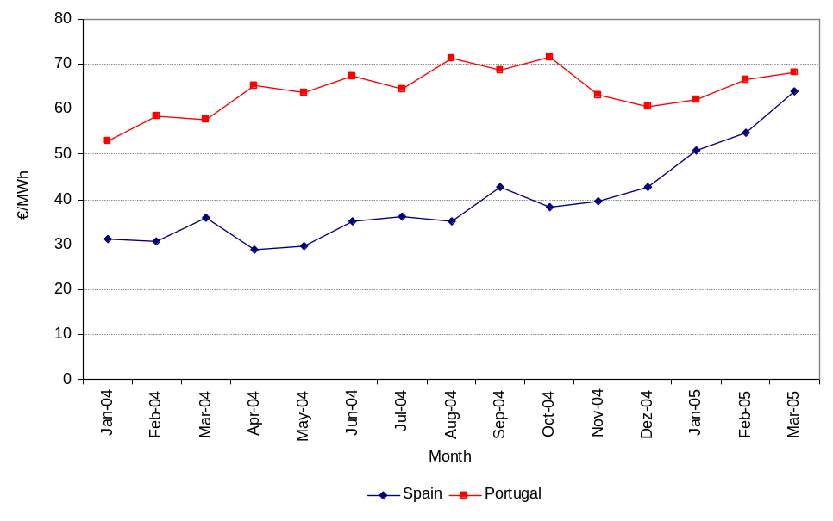
Meeting National Consumption Requirements
Assessment of total consumption in Mainland Portugal, with a view to characterizing the wholesale electricity market, is made by considering deliveries to the system by generators incorporated in the scope of SEP and SEI, as well as the import balance of electricity.
Using emission as reference, total consumption in Mainland Portugal has grown in a sustained fashion since 1999. In 2004 there was a 5,6 percent growth vis-à-vis 2003. On the other hand, the parcel of total consumption allocated to the SENV has been continuously growing. In late 2004 it corresponded to approximately 15,8%.
Figure 3-20 shows the evolution of annual consumption, using emission as reference, both of the SEP and the SENV, in 1999 to 2004. Total national consumption is determined by simply adding the two parcels. This figure also shows the evolution of the system’s annual peak demand over the same period.
Figure 3-20 – Evolution of annual consumption (using emission as reference) and annual peak demand
Mainland Portugal
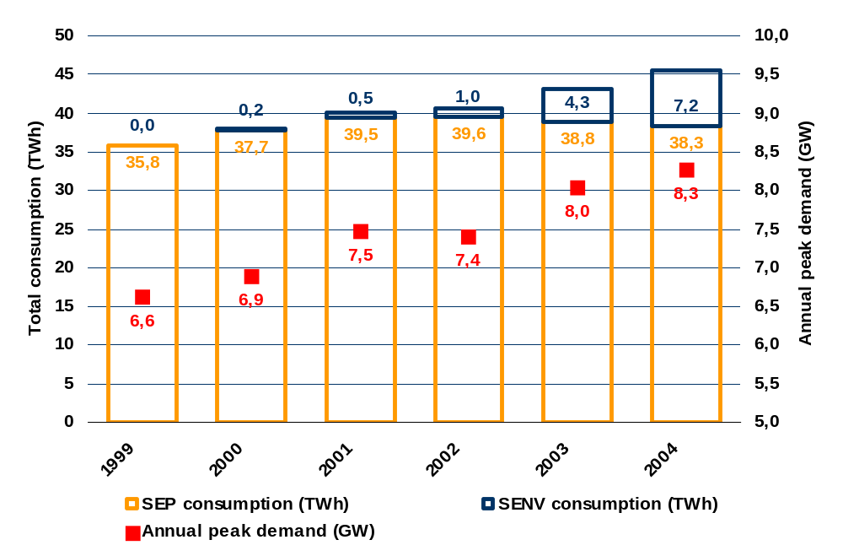
Source: REN
Also it should be noted that the system’s operator in Portugal is in charge of the centralized load dispatching of all SEP power plants, with which REN has signed very long-term Power Purchase Agreements (CAE), receiving the generation schedule from the SENV power plants. The information regarding the amounts generated by these power plants in each hourly period is available. As regards the special-regime generation plants, information concerning their production is received with some delay.
The contribution made by different generators for meeting the requirements of national consumption is shown in Table 3-16, in which generation units are aggregated by corporate group – except in the cases of special-regime generation and electricity imports, where that cannot be done. On the other hand, the compound values of national consumption include consumption values in pumping, as it is not possible to obtain individual contribution values without making reference to consumption with pumping.
Thus, this table enables us to see that electricity supply in Mainland Portugal is essentially secured by three main entities: Group EDP, Tejo Energia and TURBOGÁS.
Group EDP produces electricity both in the framework of the SEP and of the SENV, as evidenced by Table 3-16. The two other entities are generators within the public service system.
Table 3-16 – Contribution to meet national consumption requirements
Mainland Portugal
Contribution to meet national consumption requirements
-
Mainland Portugal Continental
(TWh)
1999
2000
2001
2002
2003
2004
Group EDP
23,9
24,6
27,7
24,7
27,5
24,3
EDP
SEP
23,5
24,0
26,9
24,2
26,6
20,5
EDP
SENV
0,4
0,6
0,8
0,5
0,9
3,8
Tejo Energia
4,8
4,6
4,0
4,8
4,2
4,4
TURBOGÁS
6,1
5,9
6,0
7,1
5,4
6,2
EDIA
0,0
0,0
0,0
0,0
0,0
0,1
Special-regime generators

2,3
2,5
2,6
2,8
3,7
4,5
Imports
0,0
0,9
0,2
1,9
2,8
6,5
TOTAL (with pumping)
37,1
38,5
40,5
41,3
43,6
45,9
Source: REN
It should be stressed that imported electricity grew signicantly in 2004 (import balance), by approximately 132% vis-à-vis 2003. This growth trend has been observed since 2001. From 2003 to 2004, special-regime generation increased by more than 20%. TURBOGÁS and Tejo Energia, thermal power plants in the SEP (respectively using natural gas and coal), had a growth of 13.9 percent (TURBOGÁS) and 6.1 percent (Tejo Energia).
Electricity supplied to the grid by the SEP power plants controlled by Group EDP in the Portuguese territory decreased by roughly 11.6 percent, although electricity produced by the Group in the framework of the SENV grew significantly. Be that as it may, it should be noted that calculations of electricity produced by Group EDP did not consider the values produced by Hidrocantábrico, a company held by EDP in Spain, whose possible values of electricity imported to Mainland Portugal may be imbended in the import balance.
Table 3-17 shows the relative contribution made by different generators to meet national consumption requirements, which is an approximated calculation of the market shares of electricity generation. In this regard we again stress the limitations due to the absence of a breakdown of the electricity produced by entities operating in the special-regime market, as well as the fact that we cannot determine which share is attributable to Hidrocantábrico (Group EDP) in the import balance of electricity.
Table 3-17 – Relative contribution to meet national consumption requirements
Portugal continental
Relative contribution to meet national consumption requirements
-
Mainland Portugal
1999
2000
2001
2002
2003
2004
Group EDP
64,4%
63,9%
68,5%
59,8%
63,1%
52,9%
EDP
SEP
63,1%
62,3%
66,5%
58,5%
61,0%
44,6%
EDP
SENV
1,2%
1,6%
1,9%
1,2%
2,1%
8,3%
Tejo Energia
13,0%
11,9%
9,9%
11,6%
9,6%
9,6%
TURBOGÁS
16,5%
15,3%
14,7%
17,2%
12,4%
13,4%
EDIA
0,0%
0,0%
0,0%
0,0%
0,0%
0,2%
Special-regime generators
6,2%
6,4%
6,3%
6,8%
8,5%
9,7%
Imports
0,0%
2,4%
0,6%
4,6%
6,4%
14,1%
TOTAL
100%
100%
100%
100%
100%
100%
Source: REN and ERSE
Due to the above growth of the value of imported electricity in 2004, the relative contribution of this line for meeting national consumption requirements grew from approximately 6,4% in 2003 to a little more than 14 percent of total used electricity in 2004. Likewise the relative shares of special-regime generation and TURBOGÁS also increased, and Group EDP’s relative contribution to total electricity use dropped by nearly 10 percent. As regards Group EDP, it should also be mentioned that the relative contribution of its SENV power plants to meet national consumption requirements increased from approximately 2,1 percent in 2003 to 8,3 percent in 2004.
Having analyzed sector concentration in what concerns the contribution to meet total consumption requirements, Figure 3-21 shows the values resulting from calculations based on the Herfindhal (HHI) indices, as well as the joint share of the three largest operators. It should be noted that, in order to identify the joint share of the three largest operators, we considered the values of each individual entity, rather than compound values of entities such as Special-regime Generators, or Imports. For example, in 2004 we added the shares of Group EDP, TURBOGÁS and Tejo Energia, although the second largest input was the compound value of Imports, as shown in Table 3-17.
On the other hand, for calculating the Herfindhal indices we considered their upper and lower limits, which result respectively from the fact that (i) Imports and Special-regime Generation represent a maximum dispersion of those shares, and (ii) those values concern one single entity.
Thus Figure 3-21 makes it possible to confirm that the relative share of the three largest generators has dropped in a sustained fashion since 2001, although the HHI index shows a somehow irregular evolution. In terms of HHI, concentration decreased in 2004 vis-à-vis 2003, by virtue of both the decreasing relative contribution of Group EDP and the increased contribution of TURBOGÁS, Special-regime Generation and Imports.
Figure 3-21 – Concentration indicators of relative contributionto meet national consumption requirements
Mainland Portugal
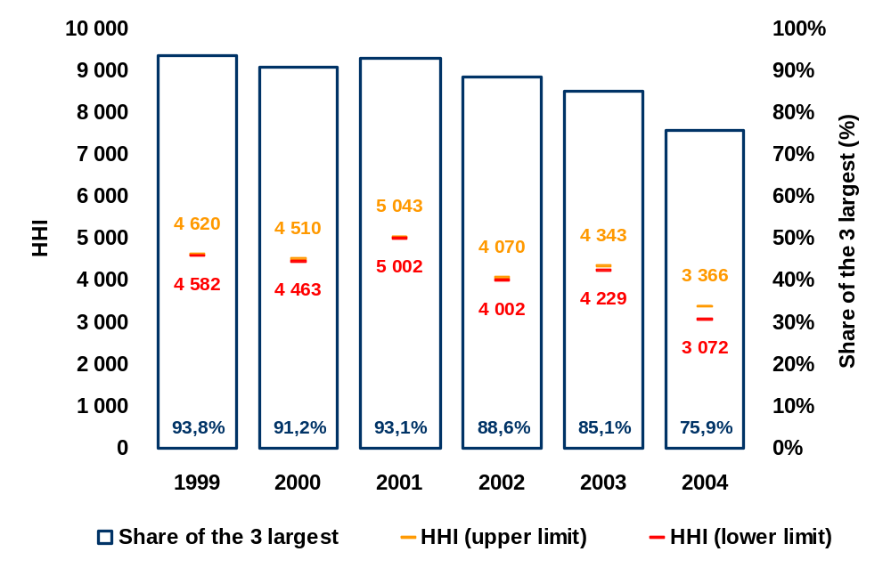
Another important way of analyzing the wholesale market is to characterize the installed generation capacity, namely as regards the evolution of total installed capacity and the distribution of installed capacity by each operator.
Figure 3-22 shows the evolution of installed capacity values, with a breakdown into the generating capacity of SEP, SENV and the capacity attributed to Special-regime generators. It also shows the evolution of annual peak demand.
Figure 3-22 – Evolution of installed capacity and annual peak demand
Mainland Portugal
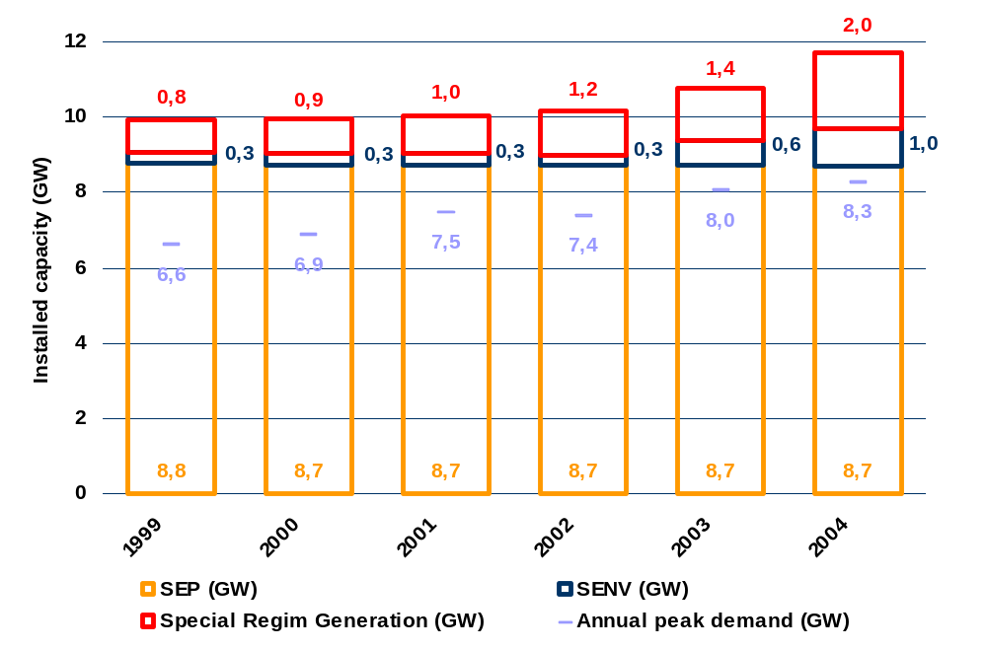
Source: REN
Figure 3-22 shows a continuous growth in the Portuguese installed capacity, particularly important after 2001. In 2004 it showed a value of approximately 11,7 GW, corresponding to a growth of 8,7 percent vis-à-vis 2003.
This capacity growth in the Portuguese installed capacity was mainly caused by the increasing capacity of the special-regime generation sector (growth of approximately 456 MW) and of SENV (growth of 392 MW).
The relative distribution of installed capacity by corporate entity is shown in Table 3-18, except for special-regime generation, due to the difficulties indicated above. Values of the imports capacity concern average annual values of commercial importing capacity at the interconnection, on working days. There is no information available for 1999.
Table 3-18 – Evolution of installed capacity
Installed capacity
(MW)
1999
2000
2001
2002
2003
2004
Group EDP
7 470
7 424
7 436
7 377
7 757
8 121
EDP
SEP
7 165
7 119
7 131
7 124
7 112
7 094
EDP
SENV
305
305
305
253
645
1 027
Tejo Energia
615
615
615
615
615
615
TURBOGÁS
990
990
990
990
990
990
EDIA
0
0
0
0
0
120
Special-regime generation
838
921
995
1 175
1 406
1 862
TOTAL
9 913
9 950
10 036
10 157
10 768
11 708
Imports capacity
---
588
600
690
728
1 057
TOTAL
(
with

imports
)
9 913
10 538
10 636
10 847
11 496
12 765
Source: REN
Group EDP has the largest share of installed capacity in Mainland Portugal. Such share grew from 2003 to 2004, as operations started at one more group of its CCGT plant in the framework of SENV. In 2004 the installed capacity of special-regime generation also increased significantly. Reference should also be made to operations start-up of the first group of the multipurpose Alqueva compound (hydropower plant held by EDIA).
Table 3-19 shows the relative installed capacity share of different operators in Mainland Portugal. The said table essentially confirms the viewpoints expressed above, namely regarding the relative weight of Group EDP in terms of total installed capacity. Nevertheless the Group slightly reduced its share from 2003 to 2004, as a result of a share growth of special-regime generation and EDIA.
Table 3-19 – Evolution of the relative share of installed capacity
Installed capacity
1999
2000
2001
2002
2003
2004
Group EDP
75,4%
74,6%
74,1%
72,6%
72,0%
69,4%
EDP
SEP
72,3%
71,5%
71,1%
70,1%
66,0%
60,6%
EDP
SENV
3,1%
3,1%
3,0%
2,5%
6,0%
8,8%
Tejo Energia
6,2%
6,2%
6,1%
6,1%
5,7%
5,3%
TURBOGÁS
10,0%
9,9%
9,9%
9,7%
9,2%
8,5%
EDIA
0,0%
0,0%
0,0%
0,0%
0,0%
1,0%
Special-regime generation
8,5%
9,3%
9,9%
11,6%
13,1%
15,9%
TOTAL
100%
100%
100%
100%
100%
100%

Also capacity use by each entity is shown in Table 3-20. For this purpose, we considered the ratio of maximum electricity generation to capacity (obtained by multiplying the number of 8760 hours per annum by the average capacity of each entity), including the importing capacity in the calculations as well.
Table 3-20 – Evolution of average capacity use
Average capacity use
(%)
2000
2001
2002
2003
2004
Group EDP
37,7%
42,6%
38,1%
41,5%
34,9%
EDP
SEP
38,4%
43,2%
38,8%
42,6%
32,9%
EDP
SENV
23,1%
29,4%
20,3%
23,1%
52,1%
Tejo Energia
85,4%
74,6%
89,0%
77,4%
82,1%
TURBOGÁS
68,0%
68,6%
82,2%
62,3%
71,0%
EDIA
0,0%
0,0%
0,0%
0,0%
19,1%
Special-regime generation
32,0%
30,5%
29,6%
32,7%
31,2%
Interconnection
18,1%
4,5%
31,4%
43,8%
70,0%

As evidenced by the above table, Tejo Energia – operator running a coal power plant – and TURBOGÁS – running a CCGT plant – are entities that use their respective installed capacity in a more intensive way, with values of 82 percent (Tejo Energia) and 71 percent (TURBOGÁS) of the maximum electricity generation allowed by the installed capacity.
Based on the values of relative installed capacity share of different operators in Mainland Portugal, evolution of the Herfindhal index and of the joint share of the three main operators is shown in Figure 3-23.
Figure 3-23 – Indicators of installed capacity concentration
Portugal continental
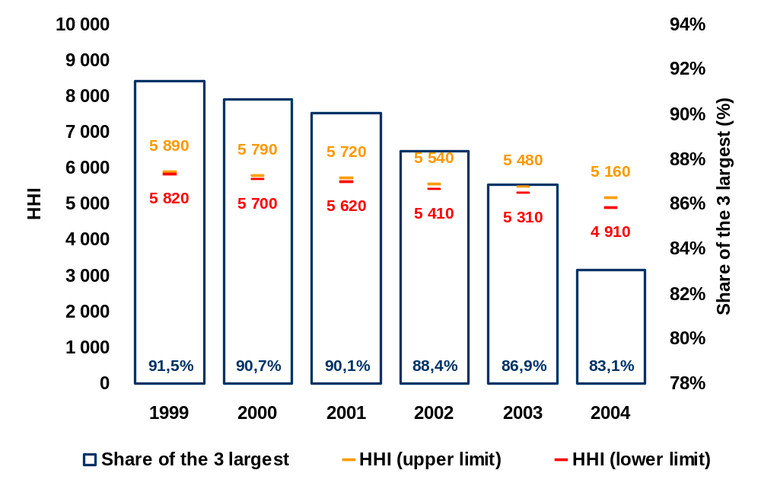
As consistently demonstrated by Figure 3-23, the evolution of both HHI and the joint share of the 3 main operators show that the concentration of electricity generation has decreased, in the light of the installed capacity of different operators. Such reduction is comparatively more obvious from 2003 para 2004, which adds to the notion of dispersion conveyed by Table 3-19.
As regards the characterization of the wholesale market based on the system services provided, the Portuguese electricity sector has specificities that do not make it possible to analyze corporate concentration at this level. In fact, system services are embedded into the Power Purchase Agreements currently in force, thus being excluded from market-driven contracting rationale. Therefore there are no relative participation shares available for each operator.
Concentration Operations
In the framework of the Portuguese electricity sector, the competent authorities—namely the Competition Regulatory Authority and ERSE—have been called upon to appraise a number of corporate operations, which can be considered concentration operations, namely the following cases:
- Acquisition by National Power to RWE of a 75-percent stake in the share capital of TURBOGÁS.
- Acquisition by EDP to National Power of a 20-percent stake in the share capital of TURBOGÁS, in addition to the 20-percent stake already held by EDP.
- Acquisition by ENERSIS to a vehicle-company belonging to group Caixa Geral de Depósitos of the exclusive control of company RES, which operates two wind farms.
The Competition Regulatory Authority decided not to oppose the operation mentioned in point 1, “(…) as the said operation raised no risk of creating or strengthening a dominant position and place significant barriers to actual competition in the relevant market of electricity generation—imports included, for supplying demand in the territory of Mainland Portugal”.
After assessing the situation described in point 2, the Competition Regulatory Authority, based on advice sought by from ERSE, decided that no concentration operation was taking place, as it did not change the existing shareholder control situation.
As regards the acquisition mentioned in point 3, the Competition Regulatory Authority decided not to oppose the operation.
“From the analysis of the above Tables, we infer that no serious barriers result from the said operation that may significantly impact on true competition in the national market. Mainly because the sum of the shares individually held by the companies involved, due to their reduced importance, would have no perceptible impact on the HHI (Herfindahl-Hirschmann Index) Index, as instrument of analysis proposed by the European Commission in its Guidelines for the assessment of horizontal mergers (2004/C31/03). Therefore we shall not perform such calculations.” (paragraph 43.).
“For the reasons exposed above, the Competition Regulatory Authority concludes that the operation does not involve the creation or reinforcement of a domination position, resulting in serious barriers to true competition in the national electricity generation market.” (paragraph 47).

Characterization of the retail market
In Mainland Portugal the retail market is based on the co-existence of a public system with regulated tariffs (SEP) and a market-driven system in which the energy is freely contracted (SENV), where regulated access tariffs are applied to customers.
Characterization of Electricity Demand
Table 3-21 characterizes electricity demand in Mainland Portugal. To this regard, it shows consumption and the number of customers by type of supply. The table shows 2005 forecasted values (i.e., values based on which the 2005 tariffs were determined).
Table 3-21 – Characterization of demand by type of supply
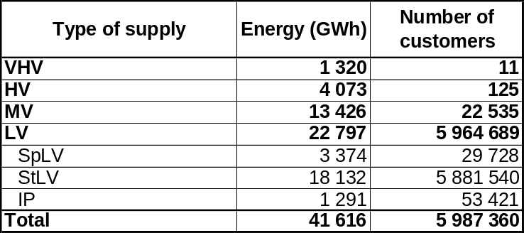

Table 3-22 shows a breakdown of consumption and customers into VHV, HV, MV and LV, for non-household supplies, by category of electricity consumption.
Table 3-22 – Breakdown of non-household VHV, HV, MV and LV consumption and customers by consumption categories
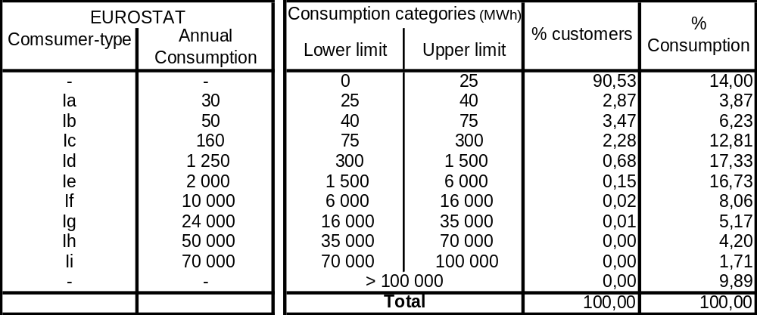
Table 3-23 presents a breakdown of household StLV consumption and customers, by electricity consumption categories.
Table 3-23 – Breakdown of StLV household consumption and customers into consumption categories
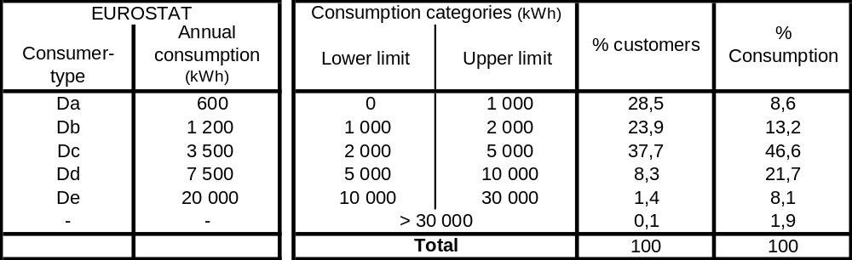
Evolution of Electricity Commercial Management
In the framework of the SEP, EDP Distribuição is in charge of the commercial management of electricity, performing both functions of electricity distribution and commercial management. Electricity is also marketed by 10 other local operators, whose electricity supply does not exceed 1 percent of total consumption in Mainland Portugal.
In the framework of the SENV, considering the entities of Group EDP as one, in late 2004 there were 5 main operators, i.e. EDP Comercial, Endesa, Iberdrola, Union Fenosa and Viesgo. As mentioned above, with regard to the evolution of market opening, the relative weight of the SENV in terms of total consumption in Mainland Portugal increased in the last years, with a corresponding reduction of the relative weight of SEP.
Figure 3-24 shows the evolution of consumption recorded between 1999 and the first half of 2005 – both in the SEP and the SENV – also making reference to the relative weight of SENV consumption vis-à-vis total consumption in Mainland Portugal.
Figure 3-24 – Evolution of SEP and SENV consumpotion and relative weight of SENV
Mainland Portugal
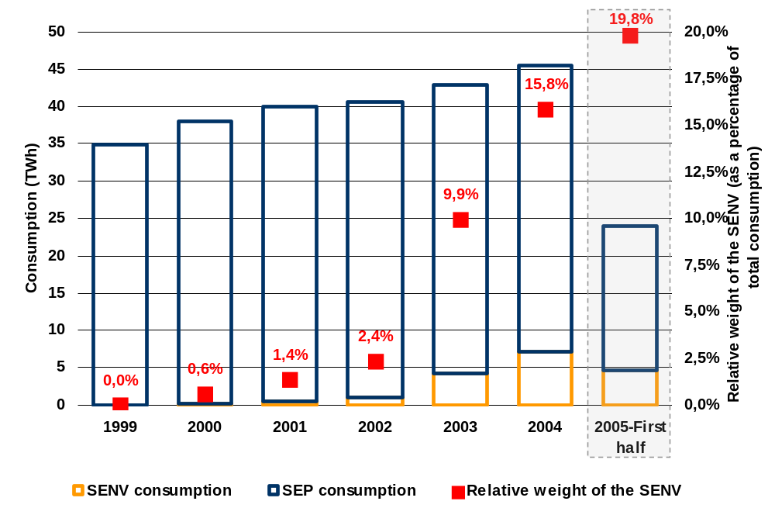
As shown in Figure 3-24, consumption made in the SENV has continuously grown from 2000 to 2005. In 1999 there was no SENV consumption, although the first SENV applications were filed that year. In the first half of 2005, actual consumption in the liberalized system represented approximately 19,8 percent of total consumption in Mainland Portugal, strengthening the growth recorded in 2004.
The trend of consumption growth in the SENV can also be noted if we look at the evolution of quartely SENV consumption, shown in Figure 3-25. The quarters of 2003, 2004 and 2005 (first two quarters), provide details on the growth trend recorded in each of the said years, as mentioned above.
Figure 3-25 – Quarterly consumption in the SENV
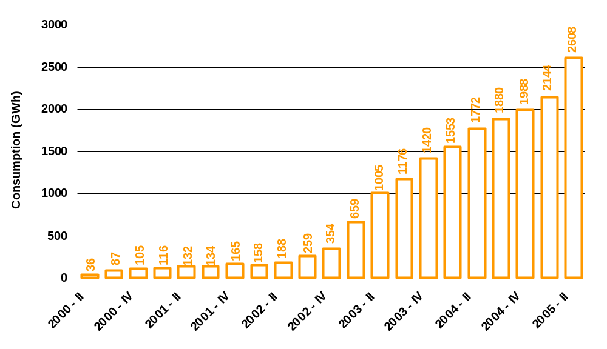
Source: REN
In 2004 the relative weight of actual SENV quarterly consumption in total SEP and SENV consumption varied from 13,2% in Quarter 1, to 16,5% in Quarter2, 17,2% in Quarter 3 and 16,5% in the last quarter.
Considering that, on the other hand, non-binding customers may choose any certified supplier to provide them electricity in the framework of SENV, we should analyze the distribution by supplier of the electricity supplied within the SENV so as to gauge the level of vitality of electricity supply in the free market.
Table 3-24 shows the customer portfolio of suppliers in the 2003 and 2004 quarters, showing the respective average number of customers.
Table 3-24 – Distribution of the average number of customers by supplier portfolio
Trimestres de 2003 e 2004
Average number of customers in each quarter
2003 - I
2003 - II
2003 - III
2003 - IV
2004 - I
2004 - II
2004 - III
2004 - IV
EDP Energia Ibérica
0
0
83
641
1 421
1 678
1 976
2 783
HIDROCENEL
238
246
246
248
0
0
0
0
Hidrocantábrico Energia
86
362
560
245
0
0
0
0
HDN
63
63
64
59
0
0
0
0
EDP Energia
142
142
138
140
137
138
298
312
Group EDP
529
813
1 091
1 333
1 558
1 816
2 274
3 096
CNV's Offers Agents
2
1
0
0
0
0
0
0
Endesa Energia
202
269
329
377
448
520
627
787
Iberdrola
7
26
53
96
133
148
180
304
Union Fenosa
0
0
0
0
0
0
3
19
Viesgo Generación
0
0
0
0
0
0
1
1
Analysis of Table 3-24 shows that, at the end of 2004, the customer portfolio of Group EDP in the framework of the SENV accounted for approximately 73,6 percent of the total number of non-binding customers. There was no significant variation vis-à-vis 2003. On the other hand, from 2003 to 2004 there was a share transfer from Endesa to Iberdrola, the former reducing its relative weight in terms of non-binding customers by roughly 2 percent at the end of each year.
It should be noted that the portfolios of operators that do not belong to the Group EDP represent approximately 26,4 percent of the total number of non-binding customers. In all the existing cases, this value was obtained by organic growth.
Table 3-25 shows the composition of the supplier portfolios in the quarters of 2003 and 2004, specifying the electricity supplies secured by each supplier to the whole of its customers.
Table 3-25 – Distribution of supplies within the SENV, by supplier portfolio
Quarters of 2003 and 2004
Average consumption in quarter
(GWh)
2003 - I
2003 - II
2003 - III
2003 - IV
2004 - I
2004 - II
2004 - III
2004 - IV
EDP Energia Ibérica
0,0
0,0
63,6
362,0
925,0
1 028,3
1 086,1
1 137,9
HIDROCENEL
145,8
158,3
149,5
140,5
0,0
0,0
0,0
0,0
Hidrocantábrico Energia
66,1
243,5
373,3
180,0
0,0
0,0
0,0
0,0
HDN
131,7
133,3
135,8
126,7
0,0
0,0
0,0
0,0
EDP Energia
115,0
116,0
107,0
114,0
117,5
120,2
107,6
109,3
Group EDP
458,6
651,2
829,3
923,2
1 042,5
1 148,5
1 193,8
1 247,2
CNV's Offers Agents
8,7
3,5
0,0
0,0
0,0
0,0
0,0
0,0
Endesa Energia
236,8
296,5
328,9
365,4
412,3
477,9
513,4
544,1
Iberdrola
7,5
24,6
66,8
96,1
131,6
150,6
172,6
189,3
Union Fenosa
0,0
0,0
0,0
0,0
0,0
0,0
0,3
6,5
Viesgo Generación
0,0
0,0
0,0
0,0
0,0
0,0
0,2
0,4

Relatively speaking, we can see consumption evolution in the SENV evolve if we look at portfolio distribution as a function of the supplied electricity – as shown in Figure 3-26. The concentration of supplier portfolios, as a function of the supplied electricity, is slightly lower in the entities operating within the universe of Group EDP than what we might infer from its composition as a function of the number of customers. On the whole, the share of electricity supplied by Group EDP in the two years in the framework of the SENV did not exceed 2/3. Moreover in 2004 Group EDP reduced its share.
Figure 3-26 – Distribution of supplies in the SENV by supplier portfolio
Quarters of 2003 and 2004
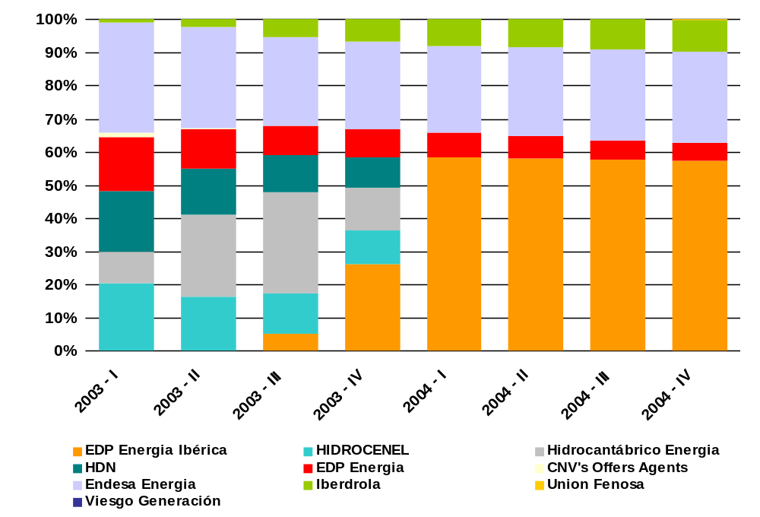
Source: REN
The distribution of electricity consumption by supplier portfolio in the framework of the SENV, into compound portfolios by corporate group, is found in Figure 3-27. We can see that the level of concentration when it comes to meeting consumption requirements in the SENV is lower than the adopted variable of analysis is the number of customers. Group EDP actually shows, both for 2003 and 2004, relative shares that are higher in terms of number of customers than in terms of compound customer consumption values. We may therefore conclude that, on the average, Group EDP customers have smaller annual electricity consumptions than the customers of the remaining entities that supply electricity in the framework of the SENV.
The recorded evolution of relative electricity supply shares in SENV, from 2003 to 2004, allows us to draw the following conclusions:
- Reduction of the relative share of Group EDP, dropping from 66,7 percent of electricity supplied within the SENV in 2003 to 62,8 percent in 2004.
- One-percent growth of Endesa’s share, which remains number two supplier within the SENV, in terms of electricity supplied.
- Growth of Iberdrola’s share from 6,9 percent to 9,5 percent. As a proportion, this was the largest portfolio growth in 2004.
Figure 3-27 – Relative portfolio share by consumption within the SENV
End of 2003 and 2004
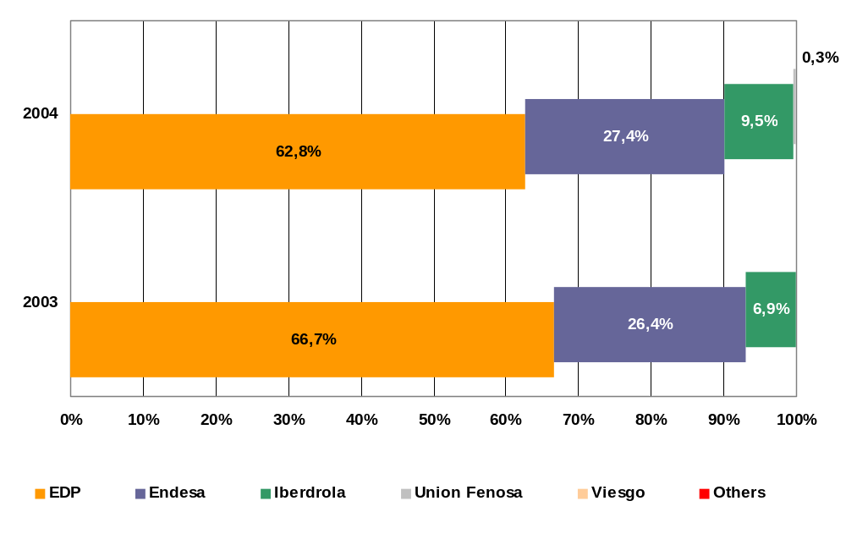
Source: REN, ERSE
As mentioned above in terms of number of customers, the portfolios of operators that do not belong to Group EDP secured their share of approximately 37,2 percent (corresponding to their supplies of electricity within the SENV) through the organic growth of their activity in Mainland Portugal.
Figure3-28 shows the quarterly evolution of the same concentration indicators in 2003 and 2004, using as element of analysis the electricity supplied to non-binding customers. We find a continuous trend, although not significant, towards reduced concentration in the SENV. This trend is clearer in the evolution of HHI than in the evolution of the shares of the three largest operators. This means that concentration has been reduced as a result of re-positioning of these three largest operators, to the detriment of the largest of all (loss of share of the main operator).
Figure3-28 – SENV concentration indicators – by electricity supplied
Mainland Portugal
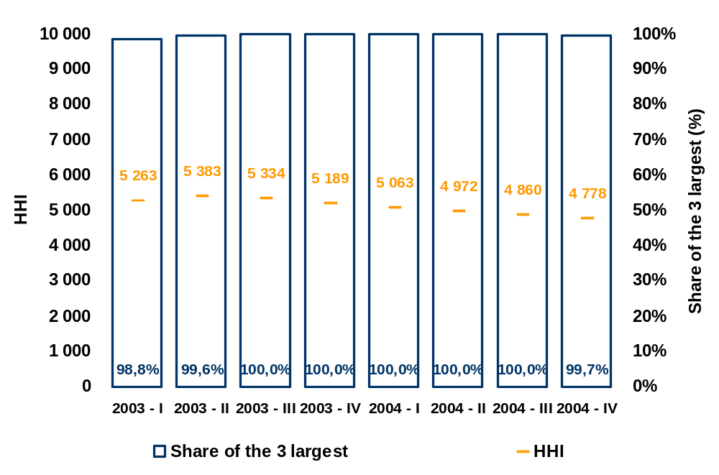
Supplier switching procedures
Market opening in Portugal has been phased in, as follows:
- From 1999 to 2001 only customers in medium-, high- and very high voltage, with an annual consumption equal to, or higher than, 9 GWh, were eligible. In this period, there were only approximately 220 eligible customers, whose consumption represented approximately 25 percent of total national consumption. For the purpose of market opening calculations, it should also be mentioned that the MV and HV distribution system operator could meet up to 8 percent of its energy and power requirements in the free market.
- Between the 1 January 2002 and February 2004, the number of eligible customers began to also include all customers in medium-, high- and very high voltage. In this period, the number of eligible customers rose to approximately 22 thousand (approximatley 46 percent of total national consumption).
- From February 2004 onwards, low voltage customers with subscribed demand power exceeding 41.4 kVA also became eligible. The universe of eligible customers increased to nearly 52 thousand customers (approximately 54 percent of total national consumption).
- Legislation published in August 2004 established that eligibility would be extended to all customers of electricity (i.e. including customers with subscribed demand power equal to, or lower than, 41,4 kVA). It should however be noted that the actual exercise, by these customers, of the right to choose one’s electricity supplier still depends upon the implementation of the computer systems required to render operational the opening of the market to all electricity customers.
Responsibility for both meter installation and management and for the computer system that will make it possible to manage supplier switching was assigned by law to the MV- and HV- distribution system operator.
Supplier switching procedures currently in force can be briefly described as follows:
- Customers wishing to buy electricity in the liberalized market enter into a Grid Access and Operation Agreement with the distribution operator whose grid their equipment is connected to. This agreement lays down the grid use conditions.
- Medium-, high- and very high-voltage customers wishing to be supplied in the framework of the liberalized market must have metering equipment that enables their incorporation into the centralized telemetering system and records the energy used at each 15-minute period. The system operator is responsible for installing the metering equipment.
- The Offers Manager (function performed by the National Transmission System) is in charge of managing supplier switching procedures.
- For medium-, high- and very high-voltage customers, the starting date of supply by the new supplier corresponds to the first day of the month in which the Grid Access and Operation Agreement was signed.
- For low-voltage customers with a subscribed demand power lower than 41,4 kVA, the starting supply date considered is the date of metering after the signature of the Grid Access and Operation Agreement. These customers do not have meters with energy consumption breakdown per hour; therefore consumer profiles approved by ERSE shall apply.
- System operators are responsible for collecting costumer consumer data, applying consumer profiles and provide consumer data to each actor in the electricity market.
- Rules approved by ERSE include the general conditions of the Agreement on Grid Access and Operation, consumer profiles, methodoloy for providing consumer data and standardized formats for providing consumer data to all actors in the market. These documents can be viewed by any one wishing to access them on the ERSE website (www.erse.pt).
Electricity sector codes were subject to significant changes, following the extension of the elegibility right to all electricity customers. ERSE recently adopted new procedures for electricity supplier switching. These procedures have not yet been implemented by the medium- and high-voltage distribution operator, the entity in charge of managing the supplier switching processes. As soon as they are implemented, the recenly adopted procedures shall apply to all electricity customers. We briefly describe the new supplier switching procedures, as follows:
- Responsibility for managing the supplier switching process will be assigned to the medium- and high-voltage distribution operator.
- Management of the supplier switching process will henceforth be based on a computer system still being installed, which relies on the exchange of messages among the various actors in the process (i.e. new supplier, current supplier and distribution operator – as manager of the supplier switching process). The new system is expected to start operating before the end of 2005.
- Rules concerning the supplier switching process govern the procedures and deadlines that must be complied with at each step of the process. The steps of each process are included in flowcharts that should be provided by the distribution operator on its website. Format standardization of messages to be exchanged in the framework of the supplier switching process will be approved by ERSE, following a proposal submitted by the distribution operator.
- Grid Access and Operation Agreements will henceforth be signed between suppliers and distribution operators. Thus suppliers become fully responsible for paying the access tariffs corresponding to all their customers. Therefore individual customers will no longer need to sign Grid Access and Operation Agreements with the distribution operators whose grid they are connected to.
- System operators will be responsible for (i) collecting their customers’ consumer data, (ii) applying consumer profiles, and (iii) providing consumer data to all actors in the electricity market.
- Consumer data to be considered for the purpose of supplier switching (in those cases where customers do not have telemetering equipment) should preferably be obtained by way of metering done by the distribution operator—although they may also be derived from consumption estimates made by the said operator. Customers—or their new suppliers—may also request an extraordinary metering operation, bearing the costs incurred in connection with the provision of such service.
- Distribution operators are responsible for managing the supplier switching process have the duty of keeping up-to-date data corresponding to the delivery point information set. Such data may be accessed free-of-charge by the customer or its new supplier—with prior authorization in writing by the customer. All suppliers can thus access the data required to propose commercial offers to their potential customers. Data contained in the delivery point information set have been approved by ERSE and is available on the ERSE website.
Breakdown of the end-user tariff price
Figure 3-29 shows the average prices of the end-user tariff in 2005, paid by SEP-supplied consumer-types Dc, Ib and Ig. These average prices were established by applying the prices of 2005 End-User tariffs to Dc, Ib and Ig type consumers.
Figure 3-29 – Average prices of the End-User tariff paid by Dc, lb and lg type consumers
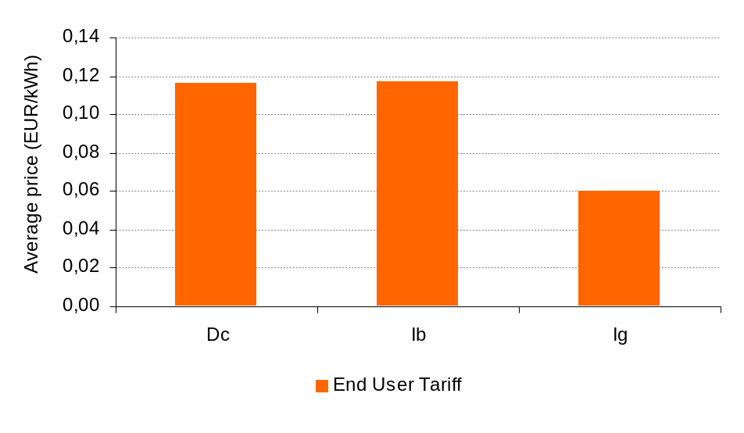
Figure 3-30 shows the structure of average prices of the End-User tariffs paid by Dc, lb and lg type consumers. In this figure, the average price of each customer is broken down into the following parcels: Energy and Commercial Management, Grids and General Interest Costs included in the grid access tariffs. In this figure, the prices indicated for “Grids” exclude a number of regulated overcosts resulting from legal obligations, which are included in the General Interest Cost parcel. These general interest costs are the following: Special-regime Generation Overcost, Autonomous Regions’ Tariff Convergence Overcost and Concessions Rents paid to Municipalities.
Figure 3-30 – Structure of average prices of the End-User tariff paid by Dc, lb and lg type consumers
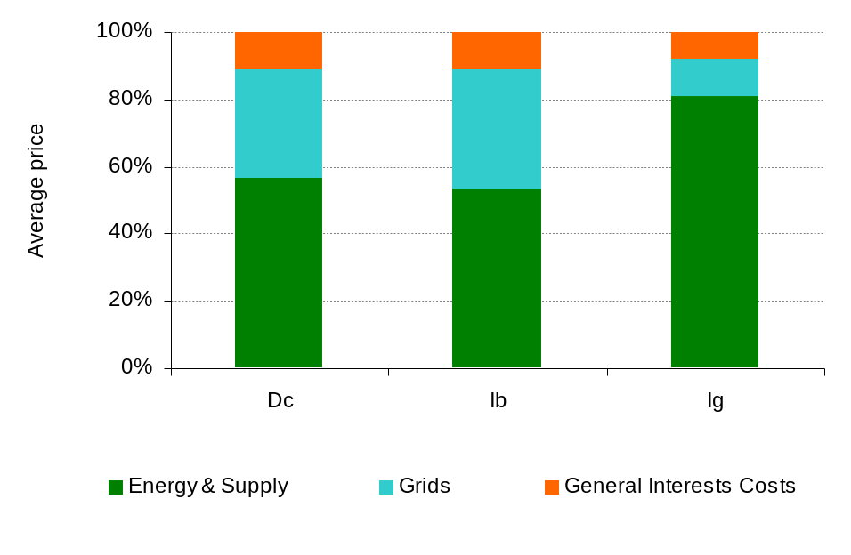
Table 3-26 summarizes the average prices indicated in Figure 3-29 and Figure 3-30.
Table 3-26 – Average prices of the End-User tariffs
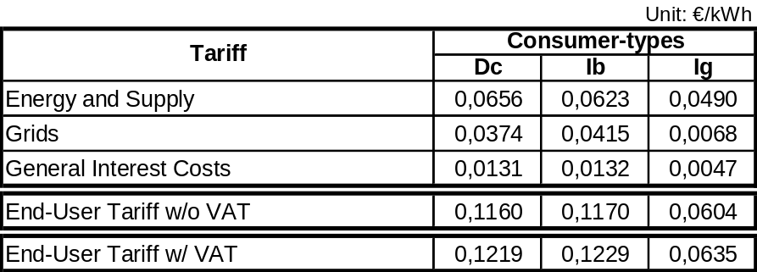

Measures for promoting competition
Creation of MIBEL
One of the key measures aimed to promote competition in the electricity sector was the signature by the Governments of Portugal and Spain, in November 2001, of a protocol for the creation of the Iberian Electricity Market – MIBEL. Initially scheduled for January 2003, the operational start-up of MIBEL has been successively delayed (see section 2.6).
Competition in the Iberian market will be promoted by drafting the rules required to create an efficient market. To this end, ERSE must cooperate with the Competition Regulatory Authority, the Commisison on the Securites Market (CMVM) and the Spanish Regulator (CNE).
In terms of oversight of the proper functioning of the market, a number of indicators regarding the level of competition will be established – i.e. number of operators, existence of admission barriers, existence of market power, level of cross-shareholding among sector operators and also market pricing. Also the mechanisms for the operational oversight of the (daily and on term) wholesale market will be defined by ERSE, CMVM and their Spanish counterparts.
Today there are four corporate groups in the Iberian Peninsula with a dominant position in the activities of electricity generation, distribution and supply. This situation is per se a potential barrier to the development of a competitive efficient market. We should therefore find out to which extent
- the vertical integration of these companies and the division of geographical areas among them are preventing the competitive development of the retail market constitute barriers preventing the admission of new operators.
- bilateral contracting between generation and distribution companies of the same group impacts on pricing.
- the existence of mechanisms for recovering stranded costs is a distortion to the market and constitutes a barrier preventing the admission of new generators/commercial operators.
Cessation of Power Purchase Agreements
Power Purchase Agreements (CAE) are preventing market opening on the supply side. Therefore, in the framework of the creation of the Iberian Electricity Market (MIBEL) and in order to comply with Directive 2003/55/EC, the Portuguese State enacted a law at the end of 2004 to anticipate the cessation of such agreements. Generators must however receive compensation for the Costs of Maintaining the Contractual Balance (CMEC) associated with such cessation. The methodology adopted for calculating such compensation was submitted to the European Commission and approved.
Special reference should be made to the advice of April 2004, given at the drafting stage, in which ERSE stressed the potentially negative impacts on the customers of the methodology underlying the CMEC calculation.
According to ERSE, implementation of the methodology outlined in Decree-Law 240/2004 will have the repercussions briefly described as follows:
- Global growth of costs to be paid by electricity customers throughout the time in which CMEC remain in force, by virtue of the costs related with the CAEs, due to:
- Compensation for the plots of land where power generation plants are located is included.
- The updating rate of annual amounts of fixed and variable costs to be paid to generators throughout the power plant’s lifetime will be differentiated from the interest rate adopted for calculating the rent value. The value of the rate to be used for calculating the annual rent will be defined by ministerial order, so it is not known yet.
- Costs associated with the CMEC securitization operations will be included.
- Indirect impact on factors that will cause customers to incur in costs and lose benefits in the future, as follows:
- Upfront inclusion of additional investments to be made at the Pego and Sines power plants, for complying with the emission ceilings of certain air pollutants.
- End of the hydraulicity correction mechanism that promotes tariff stabilization vis-à-vis the electricity generation costs associated with variable water availability, which will result in net loss to the well-being of customers. In addition to this net loss of the well-being of customers, we should add the uncertaintly regarding the final result of the balance of the hydraulicity adjustment mechanism. It should be noted that, being the hydraulicity correction mechanism a price stabilization system financed by the customers as a group, like a system of time self-insurance, the available balance should now revert to the customers, as the time smoothing service that accounted for such payment is no longer provided.
- Reduction of prices to be paid in the Energy and Power tariff by customers of the regulated supplier, versus a growth of of prices to be paid in the Global Use of System tariff by customers at large:
- The profile of CAE payments will change, evolving from a decreasing profile into a constant rent.
- CMEC-related costs of the Energy and Power tariff will be transferred to the Global Use of System tariff.
- Overcosts related with the special-regime generation will grow, by reduciton of the average acquisition cost of electricity for supplying the regulated supplier.
- Costs incurred in connection with the Autonomous Regions’ tariff convergence will grow, by reduction of the End-User tariffs.
- Strong customer-differentiated impacts of the tariff structure changes.
The adopted solutions are not neutral, from the point of view of equitable distribution among energy consumers. Some consumers will benefit, others will loose. Five types of re-distribution effects have been identified: from future to present generations of consumers, from customers of free-market operators to customers of the regulated supplier, from Very High Voltage and High Voltage customers to Low Voltage customers, from customers with very low consumption to customers with higher consumption and from customers with higher share of consumption in low-load hours to customers with higher share of consumption in peak-load hours.
Regulatory measures
Pursuant to its powers, ERSE has always tried to provide the sector with a highly transparent framework, by adopting rules that induce efficiency and competition. This spirit also guided the drafting of regulatory changes aimed at enabling the gradual opening of the electricity market to SpLV and StLV customers, occurred between 2004 and early 2005.
By adopting the above regulatory changes and the respective sub-regulatory specific standards, ERSE tried, among other purposes, to give its contribution to:
- Help electricity customers in Mainland Portugal to make conscious and well-informed choices.
- Create a regulatory framework—namely as regards the exchange of information among operators—and operating procedures in the liberalized market that securee simplicity, transparency and equitable treatment, while keeping such procedures reliable and efficient.
We can list the regulatory measures that render the electricity sector more transparent and competitive:
- Publication by the TSOs and DSOs of papers characterizing their grids, thus enabling all stakeholders to access up-to-date information on grid capacity and characteristics.
- Approval of the general conditions of Grid Access and Operation Agreements to be signed by suppliers and distribution operators. Due to these agreements, it became unnecessary to sign grid access and operation agreements between individual customers and the DSO who their grid is connected to.
- Simplification of the access to the liberalized market by customers supplied by the public system.
- Automatic cessation of the power supply contracts in the public system, when a customer signs a supply contract with a new supplier in the liberalized market. Cessation of these contracts does not mean that customers have to pay any compensation to the regulated supplier.
- Approval of the general conditions of hedging contracts to enable suppliers to buy electricity to the public system, in case the transmission capacity of the interconnection with Spain is reduced.
- Approval of the methodology and prices for valuating energy imbalances occurred in the framework of bilateral contracts signed in the liberalized market.
- Approval of rules governing the supplier switching procedures, to ensure speedy supplier switching and the absence of costs directly paid by customers wishing to switch suppliers. The distribution system operator in MV and HV is in charge of managing the supplier switching procedures and it must provide an equitable treatment to all stakeholders in the market. The supplier switching procedures may be audited by external independent entities, the result of said audits being referred to ERSE. Rules approved for managing the supplier switching process also anticipate that ERSE will be periodically given information for the purpose of monitoring the performance of supplier switching procedures.
- Free access to information available at the customers’ delivery point information set. After obtaining permission from the customers, suppliers operating in the liberalized market may have free access to information available at the customers’ delivery point information set. The access to this information is critical to ensure equal-opportunity conditions among suppliers when they submit their electricity supply offers to customers.
ERSE has also been monitoring as close as possible the development of liberalization in the electricity sector. For this purpose, ERSE publishes annual reports on the development of the liberalized market and makes them public. In these reports, it presents the evolution of market opening and assesses the depth level of liberalization by estimating the number of customers currently exercizing their right to choose electricity suppliers and the respective consumption. ERSE has also monitored the relative stakes held by different operators in electricity commercialization in the liberalized market, namely to help monitor the develop of competition in the sector.
Transparency of the tariff system has also been (and remains) decisively important to liberalization in the Portuguese electricity sector, namely by ensuring a close match between tariffs and costs and preventing cross-subsidization.

RegulaTION AND PERFORMANCE IN THE NATURAL GAS MARKET

Regulation matters

General
The Portuguese natural gas market benefits from a derogation under Directive 98/30/EC, as an emerging market (first commercial contract signed less than 10 years ago). As a consequence, liberalization has not yet begun in the natural gas market. According to the derogation scheme, the maximum deadline for market opening is indicated in Table 4-27.
Table 4-27 – Market opening
Year | Market opening  (GWh/year) | % market opening
1995-2007 | - | n.a.
2008 | - | 33%
2010 | - | 87%*
2012 | - | 100%
* Consumption corresponding to all non-household customers
Meanwhile the Portuguese government has already announced its intention to advance liberalization in the natural gas market and we are currently waiting for the respective timeframe to be divulged.

Mechanisms for managing congestions and awarding available capacity at the interconnections
The natural gas infra-structure is very recent in Portugal and its transmission capacity is far higher than the present transit levels. As a consequence, no congestions have occurred. Transmission and interconnection infra-structures are operated by a single TSO.

Regulation of natural gas transmission and distribution
The Portuguese natural gas transmission grid is operated by a single TSO, called Transgás, S.A. The regional distribution grids are run by 10 operators, who hold concession contracts or licenses. According to its Activity Plan, ERSE hopes to approve Codes for the natural gas sector in the second half of 2005.

Grid tariffs
As the right of access to the grids has not yet been awarded, there is no grid tariff. When appropriate, ERSE will develop a tariff-setting methodology compatible with the opening of the market. Today household customer tariffs (up to 10 000 cubic metres per year) are subject to Government clearance. As regards consumption higher than 10 000 cubic metres per year, tariffs are negotiated by the holders of concessions or licenses with their respective customers.

Quality of service
Companies have proposed internal quality of service regulations. These will be replaced on short term by nation-wide Quality of Service Code, approved and published by ERSE.

Balancing
Pursuant to the derogation, there are no more operators in the market other than the Transmission System Operator, who ensures the system’s balancing.

Access to linepack, storage and other system services
The existing storage facilities include 240,000 m³ of liquefied natural gas (LNG) in two storage tanks at the Sines harbour terminal. The transmission operator also owns underground storage facilities, some of which currently under construction.

Accounting unbundling
There is no legal unbundling between grid activities and supply. Nevertheless the law requires unbundling between the transmission activity (including supply to large consumers) and the distribution activity (including supply to the remaining consumers).

Competition

Characterization of the wholesale market
The main suppliers of natural gas are Algeria and Nigeria, through take-or-pay long-term contracts. In 2004 total consumption rose to 3,54 bcm. Natural gas was totally imported by the company that holds the transmission infra-structure, currently the holder of natural gas acquisition contracts.
The most important foreign company operating in the sector is ENI (Italy), holding a 33,34% stake in Galp, SGPS, the holding of GDP, SGPS, which owns Transgás, SGPS (TSO), as shown in
Figure 4-31.
Figure 4-31 – Shareholding structure
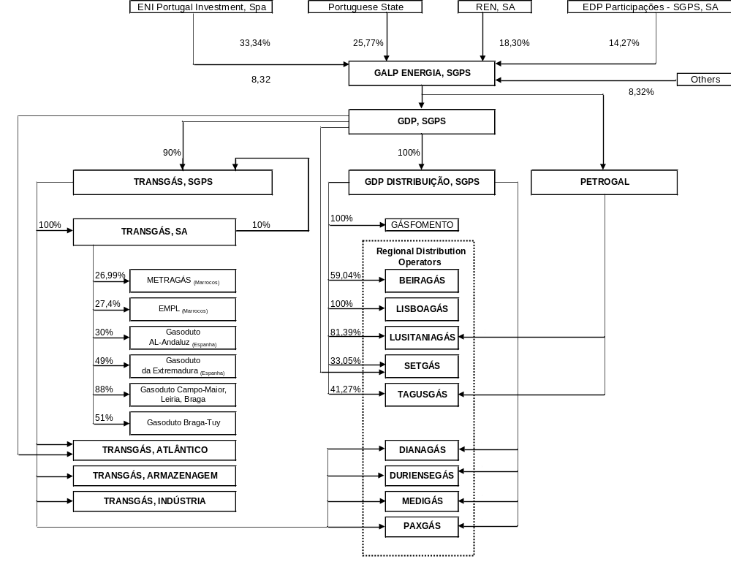
Concentration operations
In the framework of the natural gas market, the Competition Regulatory Authority gave advice on the NQUINTAS/CGD/EDP concentration operation, as follows:
“Competition Regulatory Authority found that the relevant market of the concentration operation currently examined is that of natural gas distribution and supply in the northern coast region’s concession of the Portuguese territory.
Objections were made that, as a result of the concentration operation, one single entity might henceforth control distribution and supply of natural gas and electricity within the same geographical area.
Other objections were made as to the existence of “some discretionarity on the part of the concession holder, as regards (i) the annual pace of network expansion and the annual pace of the number of users whom natural gas will be supplied, (ii) the tariffs to be applied to industrial customers via the bargaining process between them and the concession holder, and (iii) the quality of service to be provided to natural gas customers.”
In view of these conclusions Competition Regulatory Authority found it necessary to impose obligations and commitments, as follows:
- Company PORTGÁS shall remain legally separated from the notifying entity, so as to ensure autonomy and accounting unbundling between these activities; and
- The Concession Holder shall provide, on regular basis, statistical data that make it possible to gauge the variables affected by some level of discretionarity on behalf of the said Concession Holder.
As these obligations and conditions proposed by Competition Regulatory Authority were accepted by the notifying entity, the Competition Regulatory Authority Board decided not to oppose the concentration operation, subject to compliance with such obligations and conditions.”

Characterization of the retail market
The two largest natural gas consumers are the CCGT power plants of Tapada do Outeiro, with 3x330 MW, and Termoeléctrica do Ribatejo (TER), with 3x392 MW, (only two of these three groups are currently operating), as well as two natural gas single-cycle groups, 2x125 MW, at Carregado.
The consumption of natural gas in the electricity, industrial and commercial/household sectors recorded in Portugal in 2004 is shown in Table 4-28.
Table 4-28 – Natural gas consumption in 2004 (bcm)
Electricity sector’s consumption | 2,072 |  | 58,5%
Industrial consumption | 1,112 |  | 31,4%
Commercial and household consumption | 0,347 |  | 9,8%
Total consumption 2004 | 3,542 |  | 100,0%

The sector will continue to operate based on distribution concessions and licenses until the end of the status of emerging market. In 2004 the main distribution concession holders, in terms of volume of distributed gas, were Lisboagás (34.0%), Portgás (28.1%) and Lusitaniagás (23.3%).
Galp holds stakes in all distribution operators, except Portgás, S.A., as shown in Figure 4-31.
On the 1 January 2004, gas prices practised in Portugal for the selected levels of consumption, as published by the Directorate-General for Geology and Energy (DGGE), were the following:
Table 4-29 – Natural gas prices published by Eurostat
Consumer type (Eurostat) | Price (01.01.2004)
D1 (eur/GJ) with VAT | 18,82
D2 (eur/GJ) with VAT | 17,21
I2 (eur/GJ) with VAT | 7,68
I3-1 (eur/GJ) without VAT | 5,68
I4-1 (eur/GJ) without VAT | 3,73
I4-2 (eur/GJ) without VAT | 3,45
Source: DGGE, Preços de Energia n.º 48
These prices have not yet been unbundled into their different components, as the market has not been liberalized and, therefore, is not subject to tariff regulation.
Procedures for establishing natural gas tariffs are different, depending on the grid which the user is connected to:
a) Facilities connected to the Natural Gas Transmission Grid
As laid down in the Concession Contract for the Public Service of Natural Gas Importation, Transmission and Supply, signed by the Portuguese State and Transgás, customers with facilities using more than 2 000 000 m³ of natural gas per year – connected to the Natural Gas Transmission Grid owned by Transgás – and regional distribution operators have the power to freely negotiate natural gas prices, according to the terms agreed in the respective contracts between Transgás and each of said users. Prices charged by Transgás to regional distribution operators are updated on quarterly basis, after approval by the minister in charge of overseeing the Economics policy area, as defined in the natural gas supply contracts signed between these companies.
As regards the thermal power plants owned by the Public Service Electricity Sector, which generate electricity from natural gas, natural gas prices are determined as a function of the contract signed by Transgás and REN. Its fixed term is updated on annual basis and its variable term on quartely basis.
B) Facilities connected to the Natural Gas Distribution Grid
For customers with facilities using 10,000 m³ of natural gas per annum, or more – connected to the natural gas distribution grids owned by the regional distribution operators – the prices of natural gas are subject to negotiation between the concession holders of natural gas distribution and their customers.
For customers with facilities using less than 10,000 m³ of natural gas per annum – connected to the natural gas Distribution Grids owned by the Regional Distribution operators – the prices of natural gas are proposed every year by the natural gas distribution concession holders and subsequently approved by the minister in charge of the Economics policy area, as stipulated in the respective contracts and concession licenses.

Security of supply

Electricity

2004 summary
In 2004 electricity consumption increased at the same rate rate as in 2003, growing by 5,7% (4,5%, after correction of temperature and the number of working days).
Hydropower productibility dropped. The SEP and SENV hydropower plants helped meet 20 percent of consumption requirements, while thermal power plants gave a 56 percent contribution. Deliveries by Special-regime Generators to the grid continued to grow significantly, reaching 10 percent of consumption.
The net import with foreign markets was the highest ever. Fourteen percent of national consumption requirements were met by electricity imported through interconnections.
Consumption by SENV customers grew by 70 percent in 2004, representing 15,8% of total electricity supplied by the public grid.
In 2004 the second group of the Alqueva hydropower plant (120 MW) began to operate, as well as the second group of the Ribatejo CCGT plant (with a 392 MW power). A 457 MW-capacity of special-regime generators also became available, of which 186 MW installed by thermal power producers, 20 MW by hydropower producers and 251 MW by wind power producers.
The National Transmission System incorporated two new interconnections, i.e. the second interconnection at Alto Lindoso-Cartelle and the new interconnection at Alqueva-Balboa, both at 400 kV.
Breakdown of electricty generation by energy source in 2003 and 2004 is shown in Table 5-30.
Table 5-30 – Breakdown of generation

 | 2004 | 2003
Gas | 21% | 14%
Net import | 14% | 6%
Fueloil | 4% | 6%
Coal | 31% | 31%
Hydropower | 20% | 35%
Special-regime generation | 10% | 8%

Consumption requirements have been met by different supply means, as shown in Table 5-31.
Table 5-31 – Meeting consumption requirements

 |  |  | 2004 | 2003 | Variation
 |  |  | (GWh) | (GWh) | (%)
HYDROPOWER GENERATION |  |  | 9 216 | 14 670 | -37,2
 | SEP+EDIA power plants |  | 8 818 | 13 966 | -36,9
 | SENV power plants |  | 398 | 705 | -43,5
THERMAL POWER GENERATION |  |  | 25 749 | 22 394 | 15,0
 | SEP power plants |  | 22 331 | 22 191 | 0,6
 | SENV power plants |  | 3 418 | 203 | 1 584,4
TOTAL SEP+SENV GENERATION |  |  | 34 965 | 37 064 | -5,7
SPECIAL-REGIME GENERATION |  |  | 4 469 | 3 688 | 21,2
NET IMPORT |  |  | 6 480 | 2 794 | 132,0
HYDROPOWER PUMPING |  |  | 408 | 485 | -15,9
TOTAL CONSUMPTION |  |  | 45 507 | 43 061 | 5,7

The maximum power requested from the public grid – i.e. 8249 MW -- occurred on the 9th December, exceeding by approximately 200 MW the previous maximum, recorded in January 2003.
The evolution of maximum annual power is shown in Table 5-32.
Table 5-32 – Maximum annual power

Year | Day | Power (MW) | Variation (%)
2004 | 09-Dec | 8 249 | 2,52
2003 | 15-Jan | 8 046 | 8,82
2002 | 12-Dec | 7 394 | -0,96
2001 | 17-Dec | 7 466 | 8,36
2000 | 25-Jan | 6 890 | 4,05

Evolution of the maximum capacity to be requested from the grid, as forecasted by RNT concession holder for the coming years, is shown in Table 5-33.
Table 5-33 – Evolution of maximum power

Year | Power (MW) | Variation versus 2004 (%)
2004 | 8 249 | -
2006 | 9 075 | 10,0
2009 | 10 230 | 24,0
2014 | 12 245 | 48,4

Evolution of the installed power at the end of each year is shown in Table 5-34.
Table 5-34 – Electricity generation capacity
 |  |  | 2004 | 2003 | Variation
 |  |  | (MW) | (MW) | (MW)
SEP+SENV INSTALLED CAPACITY |  |  | 9 846 | 9 392 | 454
 | HYDROPOWER PLANTS |  | 4 386 | 4 277 | 109
 |  | SEP+EDIA power plants | 4 143 | 4 023 | 120
 |  | SENV power plants | 243 | 254 | -11
 | THERMAL POWER PLANTS |  | 5 460 | 5 115 | 345
 |  | Coal | 1 776 | 1 776 | 0
 |  | Fueloil | 1 476 | 1 523 | -47
 |  | Fueloil / Natural gas | 236 | 236 | 0
 |  | Gasoil | 197 | 197 | 0
 |  | Natural gas | 1 774 | 1 382 | 392
SPECIAL-REGIME INSTALLED CAPACITY |  |  | 1 862 | 1 406 | 457
 | Thermal producers |  | 1 033 | 847 | 186
 | Hydro producers |  | 331 | 312 | 20
 | Wind producers |  | 498 | 247 | 251
TOTAL |  |  | 11 708 | 10 768 | 940

Evolution of installed capacity and maximum requested power is shown in Table 5-35.
Table 5-35 – Capacity margin
 |  | 2004 | 2000
 |  | (MW) | (MW)
Total installed capacity |  | 11 708 | 9 947
 | Thermal | 5 460 | 4 855
 | Hydropower | 4 386 | 4 184
 | Special-regime | 1 862 | 908
Maximum annual power |  | 8 249 | 6 890
Capacity margin |  | 3 459 | 3 057
 |  | (30%) | (31%)

In 2004, the electricity generation capacity had the following main developments:
- Operations start-up of the second group of the Alqueva hydropower plant (120 MW) and of the second group of the Ribatejo CCGT plant (392 MW).
- More 457 MW of installed capacity in special-regime generation units.
- Grid connection, at the end of the year, of the Venda Nova II hydropower plant – for trials of the switching station – and of the Terras Altas de Fafe wind farm, the first to be directly connected to RNT.
- Decommissioning of the Tapada do Outeiro fueloil plant, with a 46,9 MW capacity.
The National Transmission system incorporated two more interconnections, the second Alto Lindoso-Cartelle interconnection and the new Alqueva-Balboa interconnection, both at 400 kV. On working days the import capacity showed an average value of 1057 MW, representing a growth of 300 MW versus 2003. The export capacity also increased versus 2003, growing from an average value of 582 MW to 757 MW.

Regulatory background
Government has the power to authorize investments in generation, via the Directorate-General for Geology and Energy (DGGE).

RNT planning and investments in interconnections
The Transmission System Operator (TSO) is in charge of preparing, every two years, the RNT Investment Plan for the next six years, which describes the key requirements of the transmission system – including the interconnections. The RNT Investment Plan should include the works required to connect to the grid consumers in Very High Voltage, conventional generators, special-regime generators and the facilities of the MV- and HV-distribution operator.
The TSO prepares the RNT Investment Plan based on the best available values for:
- Load forecast.
- Evolution of the power generation system.
- Forecast of new plant connections based on renewable energy sources, namely wind energy.
- Forecast of transits at the interconnections.
The TSO is in charge of making decisions in connection with investments to be made in the system, taking in account technical and economic criteria such as those related with the following matters:
- Technical standards.
- Safety standards.
- Reduction of network losses.
- Reduction of energy not supplied.
- Probability of load loss.
Technical transmission standards are defined in the Transmission System Code, which is prepared, approved and published by DGGE, upon proposal made by the TSO.
Planning safety standards are prepared by the TSO and submitted to ERSE’s advice.
These technical and safety standards are taken in account while preparing the Investment Plan. This means that the system has to be simulated according to the planning criteria, so as to ensure the proper functioning and operations of the said system, taking into account:
- congestions detected and other system operation problems.
- works currently in progress.
Decisions to reinforce or build new system components are based on economic criteria. In this process alternative solutions are considered and compared in terms of costs (investment, operation and maintenance) and benefits (reduction of load losses and not supplied energy).
Once decisions on the best solutions have been made, the RNT Investment Plan for the next ten years (although only the first six are covered by the formal plan, for which detailed projects are defined) is subject to ERSE’s advice every two years.
As regards the specific case of investment in interconnections, several additional aspects are taken in account, such as:
- Confirmation of the Safety Standards.
- Growth of the interconnection capacity for commercial purposes.
In parallel with this approach, the Portuguese and Spanish system operators are currently analyzing the planning criteria and procedures, as well as joint proposals of network expansion, in the framework of the ongoing works related with the implementation of the Iberian Electricity Market (MIBEL). Bearing this in mind, in addition to the start-up of operations at the Alqueva-Balboa and Alto Lindoso-Cartelle II lines, it has been forecasted to reinforce the Douro Internacional interconnection with a new line at 400 kV. ERSE regulates all investments in the transmission system – interconnections include. No agent benefits from any reserved interconnection capacity.

New investments in generation
The evolution forecasted by the RNT concession holder for the electricity generation capacity over the next years includes the start-up of operations of six base thermal groups, CCGT, with 400 MW and one peak power plant, SCGT, with 250 MW. As regards large-scale hydropower plants, no plant of this kind is expected to start functioning on short term. The forecasted evolution of special-regime generation is shown in Table 5-36.
Table 5-36 – Forecasted evolution of Special-regime generation
 | 2006 | 2009 | 2010
Wind | 1 350 | 3 200 | 4 500
Small-hydro | 370 | 430 | 450
CHP | 1 590 | 1 840 | 1 940
Urban Solid Waste | 82 | 130 | 130
Others | 101 | 306 | 400
Total (MW) | 3 493 | 5 906 | 7 420
In addition to support to investment, special-regime generation has a guaranteed price for its entire production. Established by the Government, this price depends on technology and on the generation profile delivered to the grid. This price is based on the calculation of avoided costs, included costs avoided with CO₂ emissions. The surplus cost resulting from this incentive is supported by the Global Use of System tariff – that is to say, it is paid by all electricity consumers.
The forecasted evolution of the electricity generation capacity also includes the decommissioning of the Tunes power plant (198 MW), up to 2008, and of the Barreiro (56 MW) and Carregado (710 MW) power plants, up to 2011.

Gas

2004 summary
Natural gas consumption in Portugal has rapidly grown, due to the following reasons:
- Increasing number of facilities using natural gas, due to the expansion of the distribution networks in the terms laid down in the concession contracts.
- Growing consumption of natural gas for electricity generation purposes.
In spite of this growing consumption, it should be noted that there is available capacity for a rapid development of the sector.
Start-up of operations of the LNG terminal in Sines, in addition to underground storage, will equip the country with a high-level security of supply. Thus the importing capacity in 2004, for a consumption of 3,542 bcm, was 8,95 bcm, as shown in Table 5-37.
Table 5-37 – Consumption and importing & storage capacity in 2004
Consumption in 2004 | 3,542 bcm
Importing capacity | 8,950 bcm
Storage capacity
- at the maritime terminal | 240 000 m³
- underground | 75 000 m³
- underground (under development) | 80 000 m³

Natural gas acquisition contracts
Sonatrach and Transgás signed the first supply contract in late 1993. This contract establishes that Sonatrach has the obligation of supplying natural gas to Transgás and Transgás has the obligation of acquiring and paying for the amounts – used or not. As laid down in the contract, Sonatrach undertakes to sell to Transgás the following amounts, called contractual annual quantities (QAC):
- 1 600 million m³ in 1998.
- 1 900 million m³ in 1999.
- 2 100 million m³ in 2000.
- 2 500 million m³ from 2001 to 2020 (last year of contract).
Two other natural gas acquisition contracts have been signed with Nigeria (NLNG I e NLNG II), in the form of of liquefied natural gas (LNG). Supply began in 2000 and 2002, for 20-year periods and contracted amounts of respectively 420 million m³/year (NLNG I) and approximately 1 000 million m³/year (NLNG II). Transgás announced current negotiations for two more LNG supply contracts. The first is to be signed with Nigeria (NLNG +), anticipating supply start-up in 2005/6, for a period of 20 years and a contracted amount of 2 0 million m³/year. The second contract will have a duration of only 1,5 years, for a contracted amount of 9 to 11 methane carriers, beginning in 2004. Methane will probably come from the Middle East or the Far East.

Natural gas transmission contracts
The current holders of concession contracts or licenses secure the supply to all consumers covered by their respective grids. The transmission system operator is binding by contract to permanently keep a strategic reserve equivalent to 20 consumption days of the previous year, except regarding consumption at the CHP power plant of Tapada do Outeiro.
- Natural gas used in 2004 – 3,54 bcm
- Natural gas imported in 2004 – 3,54 bcm
- Production in 2004 - 0 bcm
In late 1994 Spanish company Enagás (the Spanish transmission system operator) and Transgás signed an agreement, which established the key guidelines for the project of construction of a transmission pipeline system to supply the Portuguese and Spanish markets with natural gas imported from Algeria. In order to manage this transmission system, Enagás and Transgás set up a number of companies in charge of natural gas transmission in each gas pipeline. Today there are six natural gas transmission companies, operating along the pipeline system from the Algerian-Moroccan border to the Portuguese-Spanish border at Valença: Metragaz, S.A.; EMPL, S.A.; Gasoduto Al-Andaluz, S.A.; Gasoduto Extremadura, S.A.; Gasoduto Campo Maior-Leiria-Braga, S.A.; and Gasoduto Braga-Tuy, S.A.
The stakes held by Enagás and Transgás in the share capital of these companies vary directly as a proportion of the capacity contracted by each company. Nevertheless, majority in the share capital of these transmission operators shall always belong to the company with the same nationality of the territory where the respective transmission company is based. For example, the Gasoduto Extremadura transmission operator: even though its largest transmission capacity belongs to Transgás, the majority of its share capital (51 percent) belongs to Enagás and the remaining 49 percent to Transgás – as this gas pipeline is located in Spanish territory. Conversely, most of the natural gas carried by the Braga-Tuy operator belongs to Enagás, but it is based in Portuguese territory and, therefore, 51 percent of the share capital belongs to Transgás and 49 percent to Enagás.
The capacity allocation of the six companies and the stakes held by Enagás and Transgás in their respective share capital are specified in Table 5-38.
Table 5-38 – Capacity reserve and share capital stakes
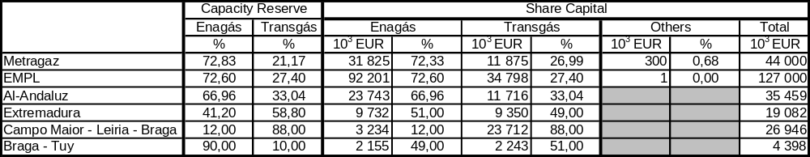
Source: Transgás

Two types of contracts have been signed by each of these companies, on the one hand, and Transgás, on the other hand: contracts for the assignment of transmission rights and contracts on transmission conditions. Accordingly Transgás assigned its transmission rights in Portuguese territory to the companies Gasoduto Campo Maior-Leiria-Braga, S.A. and Gasoduto Braga-Tuy, S.A. In Spain, Enagás assigned its transmission rights in Spanish territory to the companies Gasoduto Al-Andaluz, S.A. and Gasoduto Extremadura, S.A. As regards transmission, Enagás and Transgás signed transmission contracts with the six pipeline companies.
As from the Algerian-Moroccan border, natural gas transmission involves commercial and contractual relationships with the companies that own the different sections of the gas pipeline. These companies are in turn owned by Transgás and Enagás – the Spanish counterpart of Transgás. In fact these companies have signed an agreement (Heads of Agreement), which anticipates the shared use of the transmission infra-structure in both countries and in Morocco. This shared used of the facilities relies on the principle of reciprocity, based on the adopted model that establishes the existence of transmission operators jointly owned by Transgás and Enagás, for each gas pipeline used for joint gas transmission.
The creation of companies jointly owned by the Portuguese and the Spanish transmission operators followed a number of principles established beforehand:
- Each operator reserves capacity in the gas pipeline.
- Ownership of the transmission facility is proportional to the reserved capacity.
- Financial commitments linked to the enterpreneurial project of each section of the pipeline proportionally correspond to the reserved capacity.
The majority stake in the share capital of each jointly owned company belongs either to Transgás or Enagás, depending on whether the facility is located respectively in Portuguese or Spanish territory.
The contractual relationship between Transgás, S.A. and the transmission companies operating in Portugal – i.e. Gasoduto Campo Maior-Leiria-Braga, S.A. and Gasoduto Braga-Tuy, S.A. – is now briefly described.
On the 26 July 1996 Gasoduto Campo Maior-Leiria-Braga, S.A. and Gasoduto Braga-Tuy S.A. signed two contracts each with Transgás:
- Contracts for the assignment of transmission rights of Transgás, in force until the 14 October 2028
Under these contracts, Transgás assigns to these operators the right to natural gas transmission, but remains the single holder of the infra-structures and the entity responsible for operating and maintaining the respective gas pipelines. In turn the transmission operators are responsible for natural gas transmission and may respectively carry a maximum 417 500 m³/h (Campo Maior-Leiria-Braga pipeline) and 67 000 m³/h (Braga-Tuy pipeline). In exchange for the assignment of the natural gas transmission concession by Transgás to Gasoduto Campo Maior-Leiria-Braga, S.A. and Gasoduto Braga-Tuy, S.A., these two companies undertake to pay to Transgás compensation corresponding to the value of investment in gas pipeline infra-structures. The contacts also establish a monthly payment by Transgás related to the operation and maintenance costs of the pipelines.
- Contracts establishing the conditions for the transmission of Transgás’s natural gas, in force until the 31 December 2020 (may be potentially extended to the 31 March 2021).
Pursuant to these contracts, the natural gas transmission operators undertake to carry certain quantities of natural gas at a given tariff. Natural gas transmission is paid according to a tariff composed of a fixed term and a variable term (both by m³). The fixed term, expressed in Euros/m³/h and by kilometre, is applicable to the hourly capacity allocation. This allocation corresponds to the quantity of natural gas from Transgás – in standard m³ per hour – that the operators must carry at each section of the gas pipeline. The tariff’s fixed term is established on annual basis and billed on monthly basis, corresponding to 1/12 of the total. Transmission revenue from the fixed term is equal to the variable term revenue of the total quantities of natural gas.
The unitary variable term, expressed in €/m³ by kilometre, concerns the actually carried quantities. The variable term of the tariff is determined by multiplying the unitary value of the current year’s tariff by the quantity of natural gas actually carried and by the transmission distance between the point of reception of natural gas and the point of delivery of the same gas, expressed in kilometres.
Quantities carried by hour and by kilometre must be equal to, or lower than, the hourly capacity allocation. Transmission may however exceed the hourly capacity allocation, as long as the carried quantities are not higher than the available capacity. In these circumstances, in case the contract date is extended to the 31 March 2021, the carried natural gas will be valuated at a tariff identical to the added variable term of 30 percent. Due to the Ship-or-Pay agreement stipulated in the contracts, an amount of revenue is established that corresponds to the application of the unitary variable term to the minimum contracted quantities – even if the quantities requested by Transgás and carried by the transmission companies are lower than these minimum contracted quantities.
Enagás also signed a contract similar to this with the same transmission operators.

public service

Public service obligations

Electricity sector
Pursuant to the legislation and regulations currently in force, all players in the electricity sector are subject to a diversified range of public service obligations laid down in Directive 2003/54/EC for the areas of security (including security of supply), supply regularity, quality and prices and environmental protection.
As regards electricity generation, the holders of binding generation licenses have the obligation namely of supplying electricity to the concession-holder of the National Electricity Transmission System (RNT) and of adopting the appropriate measures to minimize environmental impacts. All power producers—holders of either binding or non-binding licenses, or special-regime generators governed by specific arrangements—must develop their activities based on the rational use of natural resources, their preservation and the maintenance of the ecological balance.
The RNT concession holder, through its contract with the Portuguese State, is in charge of globally managing the electric public system in technical terms, operating the RNT and building the respective infra-structures. The said concession holder must secure the supply of electricity to the holder of binding licenses of MV and HV distribution and deliver electricity to all consumers directly connected to the RNT. Electricity supply and delivery by the RNT concession holder and provision of the transmission service must comply with the applicable quality of service standards, pursuant to the Quality of Service Code. As regards environmental protection, it should be noted that the RNT concession holder must also develop its activity based on the rational use of natural resources, as well as the preservation and maintenance of the ecological balance.
The electricity distribution activity is also subject to the public service obligations. It is its duty to ensure the supply of electricity to all consumers whose facilities are inside its range of activity. First and foremost, all holders of binding distribution licenses have the obligation of ensuring connection to their grids, providing a universal service in this regard. Electricity distribution operators must develop their activity according to the quality of service, technical and (in some cases) commercial standards established in the Quality of Service Code. Like all other players in the sector, energy distribution operators must adopt all environmentally-related measures established in legislation and regulations and comply with them.
As regards electricity supply, the legislation currently in force establishes that suppliers will be subject to public service obligations. In addition to the said public service obligations, suppliers may also be subject to obligations related with the universal service of electricity supply—thus also becoming last resort suppliers. The activity of last resort supplier is temporarily developed by electricity distribution operators in those geographical areas where they hold licenses or concession contracts. They must secure the supply of electricity to all consumers who request it, being subject to the regulated tariff and price regime. The bill regulating license awarding to suppliers imposes certain obligations, including to:
- Buy electricity using the grid to supply their customers, according to the scheduled planning.
- Certify the origin of the supplied electricity, according to the existing environmental standards.
- Co-operate in the promotion of energy efficiency and demand-side policies.
While safeguarding the obligations specified above, as an example, the said bill determines that contracts signed with the consumers must contain the elements and offer the guarantees specificied in its appendix, which fully incorporates the contents of Annex A to Directive 2003/54/EC.
In what concerns the so-called vulnerable customers – those considered economically less-favoured, reference should be made to the existence of a social tariff. This tariff is applied to the consumption of houses exclusively used for residential purposes (though a small professional activity is accepted), with a subscribed power lower than 2,3 kVA and an annual consumption not exceeding 400 kWh. In this social tariff, the price of the power charge corresponds to ¼ of the power charge of the equivalent power level in the simple tariff. In parallel the Quality of Service Code establishes specific rules for customers with special needs, particularly focussed on the commercial quality.
The electricity supply obligations imposed on many players in the sector mean that supply interruptions—in particular the reasons potentially used for justifying such interruptions—must be considered exceptional measures and are duly categorized by types. In most cases, supply interruptions require a justified pre-warning sent within a minimum delay. Failure to pay electricity bills is one of the reasons for interrupting supply, in the case of customers of last-resort regulated suppliers, whose function is also performed by distribution operators in different geographical areas. In the case of other suppliers, who take responsibility on behalf of their customers for the payment of costs inherent to the use of the system, the failure to pay bills may lead to cessation of the supply agreement. Such failure to make payment may constitute grounds for interrupting the supply only in those situations where the customer does not sign a agreement with a new supplier within a given delay.
In 2004, in a universe of 6 million customers, there were 486 623 interruptions of the electricity supply caused by failure to pay the bills within the contractual deadline.

Natural gas sector
General regulations governing the organization of the natural gas sector currently in force establish that, for the benefit of general economic interest, natural gas operators—both concession and license holders—may be subject to public service obligations, concerning the security, regularity, quality and price of supply and environmental protection. These obligations must be defined in the respective concession contracts or license title-deeds. Inherent to the said general rules, the natural gas distrubtion or supply operators have the specific obligation of supplying customers located in a given area, or belonging to a given category.
Special reference should be made to the concession holder’s obligations laid down in the concession contract to provide for the public service of importation, transmission and supply of natural gas, including to:
- Procure natural gas and place it in the national territory.
- Supply to the concession-holders of regional distribution networks and major direct customers.
- Develop the activities according to the requirements of a regular, continued and efficient functioning of the public service.
- Ensure a number of technical attributes of natural gas.
In the concession contracts concerning the regional distribution networks of natural gas, we find a number of obligations imposed on the respective concession holders, namely to:
- Distribute and supply natural gas to consumers within the geographical area covered by the concession.
- Maintain and repair the facilities of the distribution network.
- Develop the activities according to the requirements of a regular, continued and efficient functioning of the public service.
- Ensure a number of technical attributes of natural gas.
Companies which have been awarded licenses for operating autonomous local networks develop their activities in a public service regime, benefiting from rights and obligations identical to those established by law for the activities developed under concession.

End-User tariffs with variations restricted by law
All consumers are free to choose their electricity supplier. Nevertheless tariffs charged to SEP end-users still exist. These tariffs are determined by adding the SEP energy costs to the grid access tariff. In the future, when SEP ceases to exist by cessation of power purchase agreements, there will be a last resort regulated supplier that will buy in the market to sell to customers who do not want to exercise their right of choosing suppliers, according to regulated tariffs, equally additive. There is not any compensation anticipated for developing this activity – and it has not been anticipated.
Every year, up to the 15 December, ERSE establishes and publishes the tariffs that will be paid by the customers of regulated suppliers for all voltage levels – End-User tariffs. These tariffs should be established in a way that includes not only payments related with the use of the system and of global use of system services – which constitute the access tariffs paid by all customers – but also the Energy and Supply tariffs, exclusively applied to the customers of regulated suppliers.
Annual tariffs are determined according to the principle of tariff additivity, thus ensuring that all customers pay the same for their access to the grids, irrespective of their commercial relationship. Grid access payments are only differentiated in connection with different electrical attributes related with electricity consumption or system use.
As regards the sale to LV end-users of regulated suppliers, this additive mechanism used for establishing the tariffs – whose calculation procedures are laid down in the Tariff Code prepared by ERSE – is subject to a restricted annual variation imposed by law, according to the provisions of Decree-Law no. 187/95, of July 27, which approved ERSE’s statutes.
This decree-law also establishes that the global value resulting from the application of the said tariffs, each year, may not grow at a rate higher than the inflation rate anticipated for that year. For the purpose of this indicator, ERSE adopts the annual variation of the implicit price index in Private Consumption.
In order to comply with the said Decree-Law, the Tariff Code also establishes that, whenever such situation occurs, the value of costs that are not reflected in the tariffs may be charged to the tariffs of the same type of customers in the following years, for a maximum period of five years, while respecting at all times the restricted annual variation of the expected implicit price index of Private Consumption. At the end of such period, if it is not possible to recover the costs that were not allocated to the tariffs of sale to LV end-users of regulated suppliers, ERSE will inform the Minister responsible for the Economy portfolio, who will decid how to act accordingly.
It should be noted that this mechanims has never been triggered. It has always been possible to accommodate the annual tariff increases of the LV end-user tariffs within the expected variations of the said price index.
Reference should be made to the fact that, for 2005, the value of the variation of the expected implicit price index in Private Consumption used for restricting the increase of LV end-user tariffs was 2,4 percent.
All the tariff calculation procedures, as well as the mechanism for restricting the annual growth of LV end-user tariffs, are described in the Tariff Code, which may be found on ERSE’s webpage on the Internet, www.erse.pt.
The MV, HV and VHV end-user tariffs in the SEP are subject to quarterly adjustments, which essentially reflect the variation of the variable power purchase cost.

General terms of supply contracts

Electricity sector
According to the regulations currently governing the electricity sector, the general conditions laid down in supply contracts to be signed with low-voltage and medium-voltage customers, in the framework of the public electricity system, must be approved by the Regulator, following a proposal submitted by the regulated distribution operators/suppliers and after hearing the consumers’ organizations. These general conditions of the contracts group the main rights and obligations of the parties in the established commercial and contractual relationship, as anticipated in the applicable legislation and regulations. A new regulation of the electricity sector, whose process of approval is currently under way, foresees that the Regulator must approve a minimum set of data that should be included in the supply contracts signed with the regulated/last resort suppliers—not the general conditions per se.
The remaining suppliers will be subject to the rules established in Annex A of Directive 2003/54/EC concerning the contents of the supply contract, which has been fully transposed to national regulations.

Natural gas sector
In the natural gas sector, general contractual clauses of supply contracts to be signed with their respective costumers are unilaterally drafted by distribution and supply operators. These clauses cover commercial and contractual aspects and technical and security information. So far no mechanism for approving or homologating the general conditions of natural gas contracts has been regulated. It is merely subject to compliance with the provisions of general law, namely the regime of general contractual clauses.

Voltage ranging between phases whose effective value is higher than 1 kV and equal to, or lower than, 45 kV.
Voltage ranging between phases whose effective value is higher than 45 kV and lower than, or equal to, 110 kV.
Voltage ranging between phases whose effective value is higher than 110 kV.
Voltage ranging between phases whose effective value is equal to, or higher than, 1 kV and contracted power higher than 41,4 kW.
Voltage ranging between phases whose effective value is equal to, or higher than, 1 kV and contracted power equal to, or lower than, 41,4 kVA.
According to the 1995 legislation, still in force, the binding MV and HV distribution operator (“regulated supplier”) can buy, in the SENV, an energy parcel corresponding to a maximum 8 percent of energy and power requirements. In practice, the SEP’s free market parcel that the binding HV and MV distribution operator is allowed to subscribe should be added to each year’s relative weight of consumption eligible for SENV access, so as to clearly determine the total level of market opening in Portugal.
There is no breakdown of consumption by voltage level into semesters. Therefore we considered a spread of total consumption over the first semester identical to that of the consumption values forecasted for 2005, according to the values published by ERSE to define the 2005 tariffs and prices.
The absence of a breakdown of actual consumption values of SENV customers determined the adoption of an approach similar to that adopted for total consumption. Accordingly we spread the SENV consumption by level of voltage in the first half of 2005, similarly to the spread drawn from the compound values of the respective annualized consumption.
Overscaling means to build a connector whose capacity is higher than that strictly required to feed the facilities included in the grid connection request.
For the purpose of this text, wholesale market corresponds to both electricity generation and the international import flows aimed to meet consumption requirements in Mainland Portugal.
For the purpose of assessing the installed capacity of special-regime generation, we considered the capacity connected to the public system of electricity transmission and distribution and the installed capacity for some thermal power generators (who adopted Decree no. 399/2002).
Herfindhal index values shown in this Figure assume that the Imports and Special-regime Generation values correspond to a maximum dispersion of the shares (lower limit) and that those values concern one single entity (upper limit).
Paper called “Analysis of the enforcement of Decree-Law no. 240/2004”.
Voltage ranging between phases whose effective value is equal to, or higher than, 1 kV and subscribed demand power higher than 41,4 kW.
Voltage ranging between phases whose effective value is equal to, or higher than, 1 kV and subscribed demand power equal to, or lower than, 41,4 kVA.
Calculated as the gap between the price paid to special-regime generation and the average price paid in the framework of the public service electricity system.
For a calorific value ranging from 9 150 e 9 600 kcal/cm³.

