spanish REGULATOR’S ANNUAL REPORT TO THE EUROPEAN COMMISSION

- PREFACE

This report is in response to the formal request made by the European Commission through the Director General of Energy and Transport to the President of the European Regulators Group for Electricity and Gas (ERGEG).

The electricity and gas Directives require of the European Commission the drafting of a series of follow-up reports on both sectors. These Directives also impose requirements on the regulatory authorities relating to the issuance of a report to the European Commission on certain areas of the electricity and gas markets.

For this reason, since the end of 2004 representatives of the European Commission and ERGEG have been working on the structure of the report presented here, which includes all the report requirements contemplated in the above-mentioned Directives.

Of the subjects dealt with, those which stand out most are questions relating to the behaviour and regulation of the agents in both electricity and gas network activities, the competency of the electricity and gas wholesale markets, the security of the supply and questions relating to the nature of electricity as a public service.

- SUMMARY/MAIN EVENTS OF THE YEAR

BASIC ORGANISATIONAL STRUCTURE OF THE REGULATORY AUTHORITY

Composition of the Administrative Council of the Spanish National Energy Commission (CNE)
The Commission is governed by an Administrative Council, which is made up of a President, in whom the Commission’s legal representation is vested, eight members and a Secretary, who shall act with the right to speak but without the right to vote.

Main Statutory Objectives
One: To act as the Administration’s advisory body on energy-related matters.

Two: To participate, through reports or proposals, in the process of drafting general provisions affecting the energy markets and, in particular, in the regulatory implementation of the present Law.

Three: To participate, through reports or proposals, in the energy planning process.

Four: To participate, through reports or proposals, in the process of preparing projects on the establishment of tariffs, tolls and the remuneration of energy activities.

Five: To report on the new energy installation authorisation proceedings, when they are the competence of the General State Administration.

Six: To issue the reports requested of it by the Autonomous Regions when this is deemed to be necessary in the exercising of their energy-related competencies.

Seven: To issue circulars for the application and execution of the rules contained in Royal Decrees and the Orders of the Ministry of Industry and Energy in application of the energy regulations, always provided that these provisions expressly authorise it to do so.

These provisions shall receive the name of Circulars and shall be published in the «Official State Gazette».

Eight: At the request of the General State Administration, the competent Autonomous Regions or, ex officio, the Spanish National Energy Commission, to inspect the plants’ technical conditions, fulfilment of the requirements established in the authorizations, the correct and effective use of autochthonous coal in electric power plants with the right to collect the autochthonous coal consumption premium, the activities and economic conditions of agents to the extent that they may affect the application of energy activity tariffs, prices and remuneration criteria, the effective availability of generating plant in the ordinary regime, the correct conditions of sale and billing by suppliers and distributors to consumers and qualified clients, the electric energy supply’s continuity, the quality of the service and the effective unbundling of these activities when so required.

Nine: To act as an arbitrage body in any conflicts which may arise between the agents who carry out activities in the electric or hydrocarbons sectors. The exercising of this arbitral function shall be free of charge and shall be of a non-public nature. This arbitration function, which shall be voluntary for the parties, shall be exercised in accordance with Arbitration Law 36/1988 of 5th December and the regulatory rules which may be issued on the corresponding arbitrage procedure and which shall be approved by the Government.

Ten: To establish the agents to whose activities shall be attributed responsibility for deficiencies in the supply to users, proposing any measures which may have to be adopted.

Eleven: To agree on the serving of penalty proceedings and to carry out the hearing thereof, when they are the competence of the General State Administration and, when so required, to report on penalty proceedings served by the different public Administrations, without prejudice to the competencies attributed to the Petrol Products Strategic Reserves Corporation in Section 52.4 of this Law.

Twelve: To ensure that the agents which act in the energy markets in the conducting of their activities respect the principles of free competition. To this end, whenever the Commission detects the existence of signs of restrictive practices prohibited by Restrictive Practices Law 16/1989 of 17th July, it shall make this known to the Restrictive Practices Service, contributing all the items of evidence within its scope and, as and when applicable, a non-binding opinion of the particulars of offence.

Thirteen: To settle any conflicts which may be raised in respect of contracts relating to the access of third parties to the transport and, as and when applicable, distribution networks, in the terms and conditions which may be established in the regulations.

Fourteen: To authorise the stakes taken by companies with activities deemed to be regulated in any trading corporation. Such authorizations may only be refused on the grounds of the existence of significant risks or negative effects, whether direct or indirect, on the activities regulated under this Law, being able for these reasons to issue authorizations which stipulate the conditions in which the aforesaid transactions can be carried out.

Fifteen: To report, with a binding effect, on transactions involving the concentration of companies or the taking of control of one or several energy companies by another which carries out activities in the same sector, when such transactions have been submitted to the Government for its decision, in accordance with the prevailing legislation on the subject of competition.

Sixteen: To agree on its organisation and internal working, and to select and hire its personnel, complying with the requirements established in the prevailing regulations on the subject within the scope of the General State Administration.

Seventeen: On an annual basis, to prepare a report on its activities, which shall be referred to the Government for its remission to the Spanish Parliament.

Eighteen: To perform all those other functions which may be attributed to it by virtue of the law or which, by virtue of the regulations, may be entrusted to it by the Government at the proposal of the Ministry of Industry and Energy.

In addition to the functions referred to in the previous section, in respect of the electricity sector, the Commission shall be responsible for the following:

One: To carry out the settlement of electric energy transport and distribution costs, the system’s permanent costs and all those other costs which may be established for the entire system, whenever their settlement is expressly entrusted to it.

Likewise, on a half-yearly basis, it shall report to the Ministry of Industry and Energy on the energy settlement carried out by the market operator in conjunction with the system’s operator.

Two: To settle any conflicts that may arise in connection with the system’s economic and technical management and transport.

In connection with the gas sector, and in addition to the functions referred to under point 1 above, the Commission shall be responsible for the following:

To make the settlement proposals corresponding to revenue obtained from tariffs and tolls relating to the use of the Basic Network, secondary transport and distribution installations referred to in Section 96, which shall be referred to the State Energy Policy and Mines Office for its approval.

To solve any conflicts that may arise in connection with the natural gas system’s technical management.

Main Instruments for exercising these Functions
The CNE does not have the power to impose penalties. This corresponds to the Ministry of Industry, Trade and Tourism.

Independence and Control
The President and members shall be appointed from amongst persons of well-known professional and technical competence, through a Royal Decree, at the proposal of the Ministry of Industry, Trade and Tourism, after the appearance thereof and a debate in the competent commission of the Lower House, so as to confirm the candidates’ compliance with the conditions indicated in this section. The President and members of the Spanish National Energy Commission shall be appointed for a period of six years and may be re-elected for a further period of the same duration.

Nevertheless, the Spanish National Energy Commission shall partially renew its members every three years. This renewal shall alternately affect five or four of its members, as applicable.

In the event that during the period of office, one of its members were to resign from or cease in its office, its successor shall cease on the termination of its predecessor’s term of office. When this latter cessation occurs before one year has elapsed since the appointment, the limit established in the second paragraph of this section shall not apply and such successor’s term of office may be renewed on two occasions.

The President and members may be removed from office for the following causes:

a) Expiry of the term of office, continuing to act until the appointment of the new members who replace him/her
b) Resignation accepted by the Government
c) Permanent disability for the exercising of his/her functions, incompatibility occurring subsequent to his/her appointment as a member of the Commission or conviction of an offence subject to the hearing of the proceedings by the Ministry of Industry and Energy, serious non-fulfilment of his/her obligations or dismissal by the Government, at the reasoned proposal of the Ministry of Industry and Energy.

The President and members of the Spanish National Energy Commission shall be subject to the incompatibility regime established for top-level offices of the General State Administration. On being removed from office and for the next two years, they may not conduct any professional activity relating to the energy sectors. The economic compensation which corresponds by virtue of this limitation shall be established in the regulations.

The Spanish National Energy Commission’s economic and financial control shall be carried out by the State Administration General Inspectorate, pursuant to the provisions of Sections 17 and 99.3 of the Revised Text of General Budget Law, without prejudice to the functions which correspond to the Court of Auditors.

Without prejudice to the control established in this connection by Spain’s General Budget Law, the Ministry of Industry and Energy shall exercise control over the efficacy of the Spanish National Energy Commission’s activities. The purpose of this control is to verify the degree of fulfilment of its objectives and the adequate use of the resources allocated to it.

In order to implement this control, on an annual basis, the Spanish National Energy Commission shall draw up an Action Plan in conjunction with the Ministry of Industry and Energy, which shall be responsible for monitoring its execution. Every quarter, the Spanish National Energy Commission must remit a report to the Ministry of Industry and Energy, in which it shall indicate the actions carried out and the annual Action Plan’s degree of execution during that quarter, justifying, as and when necessary, any deviations from the Plan’s forecasts which may have arisen.

The preparation of the Action Plan referred to in the previous paragraph shall be deemed to be without prejudice to the Action, Investment and Financing Programme which, in accordance with the Revised Text of General Budget Law, must be submitted to the Government for its approval on a yearly basis.

As per the provisions of Spain’s Hydrocarbons Sector Law, each year the Spanish National Energy Commission shall draw up an activity report, which it shall refer to the Government for its remission to the Spanish Parliament.

Information on the overlapping of Jurisdictions with other Government Agencies
The CNE’s jurisdiction does not overlap with that of any other government agencies. What do exist are complementariness and a spirit of co-operation.

Main Events in Spain’s Electricity and Gas Markets
Electricity Market

Since the last European Commission Benchmarking Report, worthy of note is the fact that the increase in the annual electricity demand continues to be important. In the coverage of this demand, the contribution of the combined cycles has also increased significantly. The year 2005 is one of very low rainfall, which has partly led to an increase in the wholesale market’s mean weighted prices. Last year also saw the approval of the new economic and legal framework for electricity production under a special regime.

As regards the retail market, there has been a mass transfer of consumers from the regulated market to the deregulated market.

At present, and at the request of the Ministry of Industry, the production market is in the process of being reviewed. The resulting study’s conclusions will be used to review the regulatory framework in the electricity production activity.

Gas Market
There has been a strong increase in demand, partly due to the incorporation of new combined cycles.

At the same time, there has been a greater diversification in the supply as a consequence of the legal provision approved last year relating to minimum safety stocks and diversification.

Also worthy of note in the retail markets is the large increase of consumers in the deregulated market.

Main Subjects handled or settled by the CNE

A list of the main questions recently handled by the regulator is given below:

- Report on the general criteria in joint electricity and natural gas offers

- Report on green energy publicity campaigns

- Report on existing obstacles to the access of qualified consumers to the deregulated electricity and natural gas markets

- Proposed methodology for remunerating the electric energy distribution activity

- Proposed Product Quality Measurement and Control Procedure

- Report on possible alternatives for transposing the new electricity and gas Directives 2003/54/EC and 2003/55/EC into Spanish law. This report was sent last year to what today is the Ministry of Industry, Trade and Tourism.

- REGULATION AND WORKING OF THE ELECTRICITY MARKET

3.1 REGULATORY ASPECTS (Section 23(1) except “h”)

3.1.1 General

Degree of liberalisation of the market and possible future developments including the current market percentages open to free competition and the eligibility threshold

The Spanish electric energy production market was set in motion in January 1998. Since its beginnings, all electric energy production plants under the ordinary regime with a power in excess of 50 mW had the obligation of participating in the free market, with only the plants under the special regime and those under the ordinary regime which had joined the bilateral contracting system being released from this obligation. Subsequently, in 2002, it was established that the production units under the special regime whose power exceeded the 50 mW threshold also had the obligation of participating in the free market.

In connection with electricity supplies, initially a progressive liberalisation calendar was established, which has been modified on several occasions. Thus, in January 1998, the retail electricity market’s consumption threshold was established at 15 GWh/year, representing in the region of 26% of the demand. Later, during 1999, the eligibility threshold was extended on four occasions, as follows:

- As at 1st January 1999, consumers with consumption in excess of 5 GWh/year, representing approximately 33% of the demand, were eligible.
- On 1st April 1999, consumers with consumption in excess of 3 GWh/year, representing approximately 37% of the demand, were eligible.
- On 1st July 1999, consumers with consumption in excess of 2 GWh/year, representing approximately 40% of the demand, were eligible.
- On 1st October 1999, consumers with consumption in excess of 1 GWh/year, representing approximately 43% of the demand, were eligible.

During the year 2000, the eligibility level was again extended, with the effective date being 1st July 2000, with which all the consumers connected to high voltage (greater than 1 kV) were offered the possibility of renegotiating their supply contacts.

Finally, and since January 2003, the Spanish regulation grants the right to all consumers to freely negotiate their supply contracts with any duly authorized electric energy supplier in Spain, as a result of which this date represents the retail market’s complete liberalisation to free competition (100% eligibility threshold). The foregoing notwithstanding, the prevailing regulation allows consumers to be supplied by the distributor under a regulated tariff, which is reviewed and published annually by the Government.

3.1.2 Management and allocation of the interconnection capacity and congestion-sharing mechanisms
The level of congestion at a domestic level and at the borders must be established.

The rules which are or must be applied under the electricity cross-border exchange regulation, including the rules which regulate the providing of market information by the transport and distribution network managers within the context of congestion management, must be specified.

At what level is congestion management integrated with the working of the production markets?

Evaluation of the interconnection capacity’s establishment by the System Operator

At present, the capacity of the international interconnections is allocated as laid down in Order of 14th July 1998, by virtue of which the legal regime applicable to external agents for carrying out intra-Community and international electric energy exchanges was established. The allocation mechanism comprises two related processes, one based on implicit auctions, executed within the Daily Market, and the other explicit auctions for the allocation of capacity to bilateral transactions. The distribution of capacity between the two processes takes place in proportion to the capacity requested in them.

In effect, these capacity allocation mechanisms serve to define the use of the capacity at the borders with Portugal and Morocco. However, in the interconnection with France, the Spanish and French sides use different mechanisms. With a view to co-ordinating allocation on the two sides of this interconnection, in January 2005 the Spanish and French regulators, CNE and CRE, reached a common position on a new joint allocation mechanism, which is pending application. This common position was presented by the CNE and the CRE at the mini Forum held on 21st January 2005 in Madrid. In the case of the interconnection between Spain and Portugal, the level of congestion has been reduced with the increase in capacity which took place in December 2004 with the connection of the new line between Alqueva and Balboa, with the review of the capacity allocation mechanism being pending after having been assigned to the activities for the creation of the Iberian Electricity Market (MIBEL).

3.1.3 Regulation of the Duties of Transport and Distribution Companies

In Spain, the System Operator is the transport company, REE. As the authority responsible for the system’s technical management, its purpose is to guarantee the electricity supply’s continuity and security and the production and transport system’s correct co-ordination.

Access Tariffs

Each year the Government approves both the electricity sector’s access tariffs and integral tariffs, through the publication of a Royal Decree. The tariffs are unique and maximum throughout Spanish territory. Similarly, pursuant to Hydrocarbons Sector Law 34/1998 of 7th October, the CNE has the function of participating, through proposals or reports, in the process of drawing up projects on the establishment of tariffs, tolls and the remuneration of energy activities.

In order to obtain a basis for the reports on the draft electricity tariff Royal Decrees which it sends annually to the Ministry or for making proposals to the Ministry, the CNE requests from the different agents in the sector the necessary information for estimating not only the system’s costs but also the revenue corresponding to the forecast year.

In particular, information is requested on the cost of the transport and distribution installations of each one of the companies, the installations’ characteristics, revenues and expense budgets from institutions whose remuneration is chargeable to the tariff, forecast demand in power plant bars and its coverage from the system’s Operator.

In order to calculate the system’s revenue, information is requested from companies on their forecast billing variables (number of customers, consumptions and power) and on the participation of customers in the deregulated market, broken down by tarification group, for both the end of the year in progress and the following year, in which the new tariffs will be applied. These data are compared with information available by this regulated activity settlement Commission. Likewise, information is requested on forecast generation under the Special Regime, which is compared with the information in the Commission’s possession.

Two stages can be differentiated in the tarification exercise: the first in which the mean tariff level is established, i.e. the cocient between the system’s costs and the forecast end consumer demand. When compared with the previous year’s mean tariff, this cocient provides the variation in the system’s mean or reference tariff. The calculation of the mean tariff and its maximum variation is explained in Royal Decree 1432/2002. The second stage consists of transferring variations to each integral tariff and each access tariff which allows the system’s costs to be recovered.

In connection with the transport activity, the remuneration of new installations is carried out at the service’s cost price, estimated at standard costs. Similarly, the remuneration base initially established in 1998 is up-dated using a CPI-x formula.

At the same time, remuneration of the global distribution activity, not individual for each company, is established in accordance with a revenue cap formula, the initial basis of which was established in 1998. In this connection, it should be noted that the CNE is currently working on the development of a methodology for establishing the individual remuneration of each distributor company. This methodology is based on an analysis of the regulatory information to be requested from distributor companies and the development of a reference network model.
Estimation of mean network access tolls, relating to the most recent information period available, referred to the typical consumers defined in Eurostat

Electricity Access Tariffs of Typical Consumers (cent€ /kWh). Year 2004
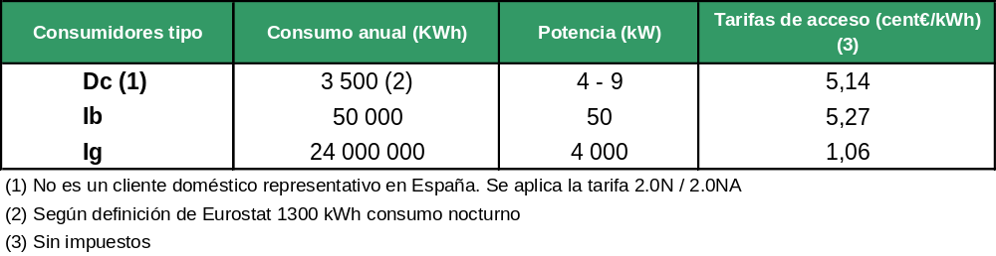
Typical Consumers Annual Consumption (kWh) Power (kW) Access Tariffs (cent€/kWh)

(1) This is not a representative domestic customer in Spain. Tariff 2.0N / 2.0NA is applied
(2) As per the Eurostat definition 1300 kWh nocturnal consumption
(3) Without tax

The prices shown in the above table, published in Royal Decree 1802/2003, correspond to the year 2004. The access tariffs (network charges) include transport, distribution and commercial management costs in addition to other levies included in the access tariff as per Law 54/1997, Royal Decree 1164/2001 and Royal Decree 1432/2002. In particular, the following costs are included: the Market Operator, the CNE, the System Operator, extra- peninsular Compensation, the cost of transition to free competition, the cost of the Nuclear Moratorium, the 2nd part of the nuclear fuel cycle, compensation to distributors included under the 11th Temporary Provision of Spain’s Interruptibility, Special Regime and Qualified Customer Law, the special regime surcharge in addition to the imbalance in revenues prior to 2003 and the review of the extra-peninsular generation cost for 2001 and 2002.

On the other hand, losses from access tariffs, which are included in the customer generation cost, are not taken into account.

Note: In connection with the three typical consumers selected in the questionnaire, it should be noted that the domestic consumer Dc, with nocturnal discrimination, is not representative of domestic consumers’ electricity consumption in Spain.

Balancing Markets

Regulators must summarize the constitution of balanced markets established by the System Operator and describe the function of the regulators when approving the methodology as per the Directive. A description should be provided of how the needs of small participants and new entrants have been taken into account. The following indicators must be established:

− Balancing period in minutes
− Description of the relevant regulation zones
− Interaction between areas, where the offers of other areas or of another Member State can be accepted by the System Operator and at what level this occurs
− Closing time
− Νυμβερ οφ ποσσιβιλιτιεσ οφ εντερινγ τηε δαιλψ μαρκετ
− Τψπιχαλ πριχεσ χηαργεδ το νετωορκ υσερσ φορ σολϖινγ δεϖιατιονσ
− Προχεσσ ανδ τιμεταβλε φορ τηε σεττλεμεντ οφ δεϖιατιονσ

What information should be provided to participants in the market in respect of the mechanisms established for balancing?

Subsequent to the holding of the intra-day market, and for the purpose of adjusting as close to real time as possible any deviations forecast by the agents, the possibility exists of being able to modify the programming established in the market through the presentation of offers to the intra-day market. For this purpose there are currently six sessions in the daily market with programming periods which vary between 28 hours (first intra-day) and 9 hours (sixth intra-day), as shown on the attached graph, and with a period for the reception of offers which, depending on the market session, varies between 2.15 and 3.15 hours.

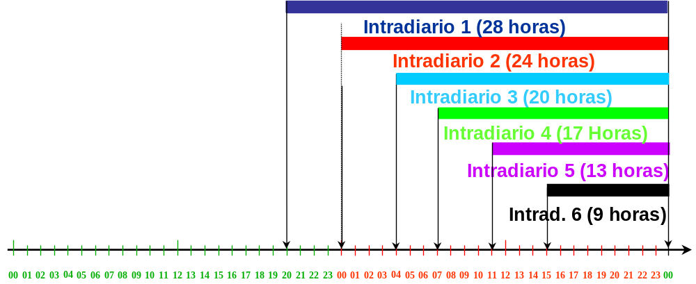
Intra-day 1 (28 hours)
Intra-day 2 (24 hours)
Intra-day 3 (20 hours)
Intra-day 4 (17 hours)
Intra-day 5 (13 hours)
Intra-day 6 (9 hours)

At the same time and in order to guarantee the electricity system’s security, Electricity Sector Law 54/1997 establishes that the objective of the System Operator is to guarantee the supply’s continuity and security under principles of transparency, non-discrimination and independence. For this, and in accordance with section 1 of Article 31 of Royal Decree 2019/1997 of 26th December, by virtue of which the electric energy production market is organized and regulated, the System Operator proposed the organisation of the management of the complementary services markets and the solving of the system’s technical restrictions in accordance with operating procedures which were approved by means of a Resolution approved by the Ministry of Industry, Trade and Tourism, after the report of the Spanish National Energy Commission.

In these procedures all the Spanish electricity system’s balancing markets in addition to the market mechanisms for offering these services are established and defined. Moreover, it is the System Operator itself which grants to the agents with the capacity to offer these services the necessary authorization for offering complementary services through effective technical accreditation. For the rendering of the secondary regulation service, there are 6 regulation zones which coincide with the groupings of the units of each one of the 6 major generating groups currently in existence (Endesa, Iberdrola, Hidrocantábrico, Unión Fenosa, Viesgo and Gas Natural), in which each company has its own plant control office or centre, which is automatically connected to that of the System Operator.

The allocation of complementary services, specifically the allocation of secondary and tertiary reserves, is carried out in a competitive market environment. Two hours prior to the holding of each market, the System Operator informs the market agents of the minimum needs or requirements for fulfilling these services. These markets are held on the day prior to and on the same day as the supply date and cover the following day’s 24 hours of programming in 60-minute programming periods.

The energy used in 2004 in the system’s technical operation processes amounted to 8,511 GWh and represented a cost of 407,139 k€ (including the cost of secondary tranche allocation), which represents a cost per unit of diverted energy of some 48 €/mWh.

So as to establish the correct allocation of payments for the agents’ balancing markets, it is necessary to know exactly the metering of each one of them. For this the maximum terms for the reception of metering figures in the System Operator’s main concentrator have been established in the corresponding operating procedure (these terms vary depending on the type of metering point) and, as from the fifteenth calendar day of the month following that to which these metering figures correspond, they are no longer accepted or taken into account for calculating the corresponding estimates which have to be made by the System Operator. In principle, and failing the necessary metering data for calculating the correct settlement of system deviations, a provisional settlement is made based on the generation and consumption programmes, so that subsequently, and no later than the nine months subsequent to the month to which the metering figures correspond, final settlements based on firm or estimated (failing real data) metering figures can be made.

3.1.4 Effective Unbundling

Degree of implementation of the legal unbundling of transport and distribution network managers

Spain’s Electricity Sector Law establishes that all trading corporations which conduct regulated activities must have as their exclusive corporate purpose the development of such activities and, consequently, they are unable to carry out production and commercialisation activities, without prejudice to the possibility of selling to consumers under the tariff authorized for distributors. Nevertheless, it also establishes that in the case of corporate groups, activities which are incompatible as per the Law can be carried out provided that this is done by different companies.
In fulfilment of the foregoing rule of law, the juridical unbundling has been implemented, with the distribution and transport companies only conducting regulated activities.
As regards the TSO, in Spain it is the company RED ELECTRICA DE ESPAÑA, S.A. (REE) which is responsible for carrying out the functions of system operator and transport network manager, as established in the Electricity Sector Law.
Apart from the two functions indicated above, this company conducts other regulated activities: transport of electric energy, co-ordination of international exchanges and management of the international contracts it has signed.
REE is the owner of practically the entire electric energy transport network in the Spanish peninsular. In 2002 a process was embarked upon consisting of the acquisition of the transport networks in possession of Spanish distributors. Thus, in 2003, the transport assets of ENDESA DISTRIBUCION ELECTRICA and UNION FENOSA DISTRIBUCION were acquired, in addition to 25 per cent of the corporate capital of the company which owned the transport assets owned by IBERDROLA DISTRIBUCION ELECTRICA.
With effect from 1st January 2005, the transport assets of ENEL VIESGO were acquired.
In February 2005, REE reached an agreement for the acquisition of a 75% stake in the company which controls the transport assets belonging to IBERDROLA, thereby becoming the owner of the complete network which at one time had belonged to that distributor.
In this way, REE has become the owner of 99% of the Spanish peninsula’s transport network, with only the acquisition of the transport assets of HIDROCANTÁBRICO remaining, which will probably be materialised during 2005. This situation represents advantages for the electricity sector and for the end consumer, resulting from the supply’s improved quality and security.
By virtue of the obligatory juridical unbundling of corporate activities, referred to above, in 2000 and 2001 companies were incorporated for conducting telecommunications and international activities, which gave rise to the creation of the REE GROUP, with the group’s parent company being the above-mentioned REE.
In 2003 a company was incorporated for capturing funds, carrying out financial transactions and rendering services to the group’s companies.
In connection with the distribution activity, there are five large companies which operate in different parts of Spain. These are ENDESA, IBERDROLA, UNION FENOSA, HIDROCANTABRICO (owned by EDP) and ENEL-VIESGO. In addition, there are numerous small distributors which operate in small municipalities and medium-sized towns. There are 308 distributors in all. Of these, a minority, approximately 19, are co-operatives.
The five electricity distributors referred to above have a 99.99% share of the tariff-based distribution market, with their shares in 2004 being as follows:

COMPANY | MARKET SHARE %
ENDESA | 38.2
IBERDROLA | 37.64
UNION FENOSA | 16.15
HIDROCANTABRICO | 5.39
VIESGO | 2.61
OTHERS | 0.01
TOTAL | 100

In fulfilment of the requirement of juridical unbundling of corporate activities, the corporate groups and small distributors have carried out a corporate reorganisation so that the group companies devoted to the distribution activity only conduct regulated activities, although they may hold shares in companies which carry out non-regulated activities.
In this connection, the Electricity Sector Law establishes that, subject to prior authorization, trading corporations which conduct regulated activities can take a stake in companies carrying out activities in economic sectors other than electricity.
The Electricity Sector Law and, subsequently, the Hydrocarbons Law establish the functions of the CNE, which include that of authorising the acquisition of stakes by companies with activities which are deemed to be regulated in any company carrying out trading activities. These authorizations can only be withheld in the event of the existence of significant risks or negative effects on the regulated electricity sector’s activities; consequently, for this reason, authorizations can be issued which contain the conditions under which the aforesaid transactions can be implemented.
Details of the ownership of transport network managers and general overview of the ownership structure of the distribution network managers

In connection with the system operator and transport network manager, REE, and in respect of its ownership structure, legislation has established limitations on the acquisition of stakes in its corporate capital, for the purpose of guaranteeing independence in the exercising of its functions.

Thus, the prevailing legislation, Royal Decree 5/2005 of 11th March 2005, has reduced the previous limits on the acquisition of stakes in the system operator, establishing that a trading corporation of which any natural person or body corporate can form part of its shareholders, always provided that the sum of the direct and indirect stakes in this company’s capital does not exceed 3% of the entity’s corporate capital or voting rights, shall act as the system operator. For those agents which carry out activities in the electricity sector and those natural persons and bodies corporate which hold a direct or indirect stake in their corporate capital with a share in excess of 5%, the maximum percentage of their stake in the system operator’s corporate capital shall be 1%.

This limitation is not applicable to the stake which the SOCIEDAD ESTATAL DE PARTICIPACIONES INDUSTRIALES (SEPI - STATE INDUSTRIAL SHARE COMPANY, a public entity reporting to the Ministry) can hold in REE, owing to the fact that the legislation establishes that the stake shall not be less than 10%.

Similarly, the sum of the direct and indirect stakes of agents carrying out activities in the electricity sector may not exceed 40%.

At present the shareholders of REE are as follows:

SHAREHOLDER | % STAKE
SEPI | 28.5
HIDROCANTABRICO | 3
UNION FENOSA | 3
IBERDROLA | 3
ENDESA GROUP | 3
FREE FLOAT | 59.5

By virtue of recent legislation, as indicated above, the system operator’s adaptation to these stakes must be carried out before 1st January 2008. As at 1st June, as established in the legislation, the articles of association of such trading corporation must have been amended so as to introduce the established maximum stake limitation. Non-fulfilment of the limitation in the corporate capital of REE shall be treated as a very serious offence.

In connection with the five main electric energy distributors, they form part of the five main electricity groups: ENDESA GROUP, IBERDROLA GROUP, UNION FENOSA GROUP, HIDROCANTABRICO GROUP and VIESGO ENEL GROUP.

ENDESA DISTRIBUCION ELECTRICA, S.L.U., IBERDROLA DISTRIBUCION ELECTRICA, S.A.U., UNION FENOSA DISTRIBUCION, S.A. and HIDROCANTABRICO DISTRIBUCION ELECTRICA, S.A. are 100% owned by the parent companies of their respective groups: ENDESA, S.A., IBERDROLA, S.A., UNION FENOSA, S.A. and HIDROCANTABRICO, S.A.

Similarly, the main shareholders of these parent companies are as follows:

ENDESA, S.A.
SHAREHOLDERS | % STAKE IN THE CORPORATE CAPITAL
CAJA DE AHORROS Y MONTE DE PIEDAD DE MADRID | 9
CHASE NOMINEES LTD | 5.732
STATE STREET BANK AND TRUST CO | 5.038

IBERDROLA, S.A.
SHAREHOLDERS | % STAKE IN THE CORPORATE CAPITAL
BANCO BILBAO VIZCAYA ARGENTARIA, S.A. | 5.460
BILBAO VIZKAIA KUTXA | 5.010
CHASE NOMINEES LTD | 8.359
STATE STREET BANK AND TRUST CO | 5.929

UNION FENOSA, S.A.
SHAREHOLDERS | % STAKE IN THE CORPORATE CAPITAL
BANCO SANTANDER CENTRAL HISPANO, S.A. | 20.343
CAJA DE AHORROS DE GALICIA | 5.040
CORPORACIÓN CAIXA GALICIA , S.A. | 6.760
SOTRON, S.L. | 7.160

At the same time, HIDROCANTABRICO, S.A. has a 95.7% stake in the ownership of the Portuguese company ENERGIAS DE PORTUGAL (EDP).

In connection with the distributor VIESGO ENEL GROUP, ELECTRA DE VIESGO DISTRIBUCION, S.L. is 100% owned by ENEL DISTRIBUZIONE, SPA, an Italian company in the ENEL GROUP devoted to the distribution business.

Indicate whether or not the transport network and distribution network managers have a different head office to that of their production and supply affiliates

As already indicated, in connection with REE, the TSO, this is the company responsible for conducting regulated electricity-related activities in Spain. It does not carry out electric energy production or commercialisation activities.

The corporate reorganisation deriving from compliance with the obligation of legally separating all the activities has resulted in the creation of different affiliates. The affiliate devoted to the rendering of telecommunications services and the affiliate constituted in order to agglutinate international stakes, to render consultancy, engineering and construction services and to perform electricity-related activities outside the Spanish electricity system share the same registered office as the REE GROUP’s parent company, REE, S.A., the system operator and transport network manager.

As regards the major electric energy distributors in Spain, in general they have the same registered office although in some cases there are different offices for the subsidiaries carrying out different activities within the group. The legislation does not impose the obligation of maintaining separate registered offices and, consequently, decisions are taken in this connection on the basis of aspects relating to business efficiency, housing in the same head office all or most of the companies within the group which, in general, take advantage of centralised services, thereby simplifying their organisation and management. At the same time, all communications procedures within the group are simplified, not only for consumers but also for all the other market agents.

To what extent are the transport and distribution network managers presented to consumers as separate entities: company name, logo, website, etc.

The unbundling of activities required by Law means that regulated and non-regulated activities have to be carried out by different corporate bodies, although both types of activity can be conducted within the same business group. As at today’s date, Spanish legislation does not require a greater level of unbundling than the juridical unbundling.

Thus, in general, the business groups which operate in Spain’s electricity sector are vertically integrated groups in which some affiliates carry out regulated activities and others carry out deregulated activities.

Although the juridical unbundling is effective, with the existence of legally differentiated companies with separate accounting systems, the companies which form part of a business group usually share the same group logo, website, publicity campaigns, customer care telephone lines, etc., to the extent that the aim is to maintain the corporate image, regardless of the activity, particularly now that electricity operators are also participating in the gas market in addition to other non-energy related markets. In this way, the benefits associated with the use of the trademark’s image, presence-based and virtual sales channels, tools for customer care, advisory services and communications with consumers can be taken advantage of.

Indicate whether or not the separate accounts of the transport and distribution network managers are published
Spain’s Electricity Sector Law establishes that, in the case of companies whose corporate purpose is to conduct regulated activities, they must keep separate accounts in their books, differentiating between the revenues and costs that are strictly attributable to transport activity, those attributable to the distribution activity and, when applicable, those corresponding to commercialisation activities and tariff-based sales to customers.

Similarly, it establishes that companies which conduct non-regulated electricity-related activities shall keep separate accounts for their production and commercialisation activity, their non-electricity related activities conducted in Spain and for all their foreign activities.

It also establishes that these companies must explain in the Report on the annual accounts the criteria applied in the distribution of costs to the other companies within the group which carry out different electricity-related activities.

At the same time, Royal Decree 437/1998 of 20th March, by virtue of which rules for the adaptation of Spain’s Accounting System (PGC) to companies in the electricity sector were approved, incorporates specific rules on public information separated by activities. It lays down that the consolidated accounts of groups comprising one or several companies carrying out electricity-related activities must incorporate the specific information which is regulated in the aforesaid Royal Decree relating to the unbundling of activities included in the Report, following the legal principles established in the Electricity Sector Law.

Thus, business groups operating in the electricity sector which conduct regulated activities publish their consolidated annual accounts with information separated by activities, as established in the Accounting System adapted to the electricity sector. Of the major electricity groups operating in Spain, ENDESA, IBERDROLA, UNION FENOSA and HIDROCANTABRICO publish their consolidated information separated by activities.

As far as VIESGO ENEL GROUP is concerned, the companies involved do not prepare consolidated accounts in Spain because they are not a group of companies as such, being direct investee companies of the Italian ENEL GROUP of companies, although they do in fact constitute a unit for the purpose of economic decisions.

The REE GROUP also prepares consolidated accounts separated by activities.

The public legal information relating to individual companies is not drawn up broken down by activities. Independent distributors, which do not prepare consolidated annual accounts, do not provide information broken down by activities.

Indicate whether or not the regulator establishes rules or guidelines for the preparation of separate accounts (for example, relating to the allocation of costs) and the consequences of their non-fulfilment

The agents operating in the electricity sector prepare their individual and consolidated accounts, separated by activities as and when applicable, in accordance with the rules established in the sector’s accounting system and in Spain’s general Accounting System.
The CNE does not issue any rules, guidelines or references in respect of the preparation of annual accounts separated by activities.

At the same time, by virtue of Circular 4/98 of 10th November, the CNE receives regular accounting and economic-financial information, which is required for performing the functions allocated to the regulator. Nevertheless, pursuant to the provisions of Royal Decree 437/1998 referred to above, the major part of the information requested in the above-mentioned Circular is public, with the information requested in the Circular having been adapted to such Royal Decree and incorporating only minimum additional information, without the CNE establishing any rules or criteria in connection with the allocation of items by activities or the preparation, in general, of accounts broken down by activities.
The Circular establishes that the information must be presented separately for the following activities: generation, transport, distribution, commercialisation, non-electric activities, activities carried out abroad and sales to tariff-based customers.

The economic and financial information which is required is that which companies normally make available to their shareholders: balance sheet, profit and loss account, the source and application of funds and important events, in addition to detailed information on extraordinary profit/(loss), operating charges, the composition of remunerated debt, stakes in companies, evolution in the payroll, general information on debts and subsidies, information on fixed assets, etc.

Subject to the preparation of the corresponding penalty proceeding, failure to make available to the CNE the information requested in the aforesaid Circular, when this is not merely occasional or an isolated case, may be penalised as a very serious offence, whereas the occasional or isolated failure to do so constitutes a serious offence, as per the provisions of the Electricity Sector Law.

The CNE does not have regulatory accounts nor is information requested on costs or internal accounts.

Indicate whether or not the separate accounts are subjected to a separate audit by the certified auditors and to what extent this audit meets the regulator’s requirements

Spain’s Corporation Law establishes that the annual accounts and management report must be reviewed by auditors. The persons who carry out this audit must be appointed by the general meeting of shareholders before the end of the financial year which is to be audited.

Thus, the individual and consolidated annual accounts are audited by expert independent auditors.

The consolidated annual accounts include information relating to the balance sheet and profit and loss account broken down by activities; consequently, this information is validated by the auditors within the framework of the audit which is made of the consolidated annual accounts.

The audit is performed in accordance with generally accepted auditing standards. The CNE does not issue any rules or criteria in respect of the procedure for auditing the sector’s agents.

In addition, the CNE has a department (Inspection and Administration Office), which carries out inspections of companies, checking the truthfulness of all the economic and technical information which may be of interest to it for its regulatory activities (metering equipment, etc.).

Indicate the role of the “compliance officer” in this process

Since the start of the unbundling of activities, documentation to support the incorporation of new companies whose sole corporate purpose is the regulated activity is being checked, and the CNE, in the performance of its duties, authorizes the implementation of corporate transactions designed to make effective the activities’ juridical unbundling.

In connection with the legal unbundling, what proportion of the network manager’s costs is shared with other affiliates as a general rule?

The CNE does not have information on costs.

In connection with the legal unbundling, what proportion of the network manager’s costs is contracted with other affiliates as a general rule?

The CNE does not have information on costs.

What other penalties are available to the regulator for application to companies which fail to comply with the requirements relating to the unbundling of accounts or management?

Apart from what has been indicated above on the obligation of submitting information to the CNE, the Electricity Sector Law specifies the actions and omissions which constitute administrative offences.

Thus, the performance of activities which as per the provisions of the Law are incompatible, i.e. non-fulfilment of the obligation of juridical unbundling of activities, is treated as a very serious offence.

As regards its competency to impose penalties, within the scope of the General State Administration, penalties for very serious offences will be imposed by the Council of Ministers and penalties for serious offences by the then Ministry of Industry and Energy, now the Ministry of Industry, Trade and Tourism. The application of penalties for minor offences will correspond to the Director General of Energy. Within the scope of the Autonomous Regions, the provisions of their own rules and regulations shall apply.

3.2 COMPETITION ASPECTS [Sections 23(8) and 23(1)(h)]

3.2.1 Description of the Production Market

A description of the generator floor and production market structure should be provided, contemplating the following indicators:
− Μαρκετ σιζε ιν τερμσ οφ τοταλ χονσυμπτιον (TWh) and maximum demand (GW)
− Ινσταλλεδ ποωερ (GW)
− Νυμβερ οφ χομπανιεσ ωιτη α σηαρε οφ ατ λεαστ 5% of the installed power
− ϑοιντ ινσταλλεδ ποωερ οφ τηε τηρεε λαργεστ
− Δεσχριπτιον οφ τηε μαρκετ στρυχτυρε φρομ τηε ποιντ οφ ϖιεω οφ τηε ορδερ ιν ωηιχη τηε πλαντσ χομε ιντο οπερατιον (ε.γ. βασιχ, ιντερμεδιατε, πεακ)
− Δεσχριπτιον οφ τηε χομπλεμενταρψ σερϖιχεσ μαρκετ (ε.γ. φρεθυενχψ οφ ρεσπονσε), ινχλυδινγ το τηε εξτεντ τηατ τηισ ισ ποσσιβλε τηε σηαρεσ ιν ενεργψ οφ εαχη χομπανψ ιν τηε ρενδερινγ οφ τηεσε σερϖιχεσ (πρεφεραβλψ ιν ενεργψ ανδ ωιτη αν ινδιχατιον οφ τηε ϖαλυε) ορ χονχεντρατιον ινδεξ, συχη ασ τηε ΗΗΙ

− Negotiated volume of electricity:
- Based on standard market products
- Typical over-the-counter bilateral contracts negotiating products which cover from 1 to 5 years
- Long-term contracts between producers and commercializers

− Τηε εξιστενχε οφ αχτιϖε δεμανδ ιν τηε προδυχτιον μαρκετ (ιν ενεργψ) σηουλδ βε ινδιχατεδ

The report must indicate the level of integration with neighbouring Member States and specify the extent to which the market is national, regional or goes beyond national borders. Negotiated energy volume and price correlation indices must be the indicators.

A summary should be provided of the most recent mergers and acquisitions in the sector with an indication of their impact on competition

Structure of Spain’s Electricity System
Spain’s generation equipment has a structure based on highly diversified technologies, encompassing nuclear, coal-fired (Spanish and imported coal), fuel oil, conventional cycle fuel oil and gas, combined cycle gas and hydraulic (conventional and pumping) plants and producers under the special regime (wind, photovoltaic, biomass, etc.). To start with, and commencing with the introduction of the electricity market in 1998, increases in demand in Spain’s electricity system were accompanied by an increase in production under the special regime, the output of which has seen an increase between the years 1998 and 2004 in the region of 180%. As from the year 2002, the first combined cycles were commissioned, resulting in an increase in the installed capacity under the ordinary regime of 6% with respect to 2001, with a further increase of 8% at the end of 2004. The following graph shows the evolution of installed power under the ordinary regime, segregated by technology, from 1990 up to the end of 2004.

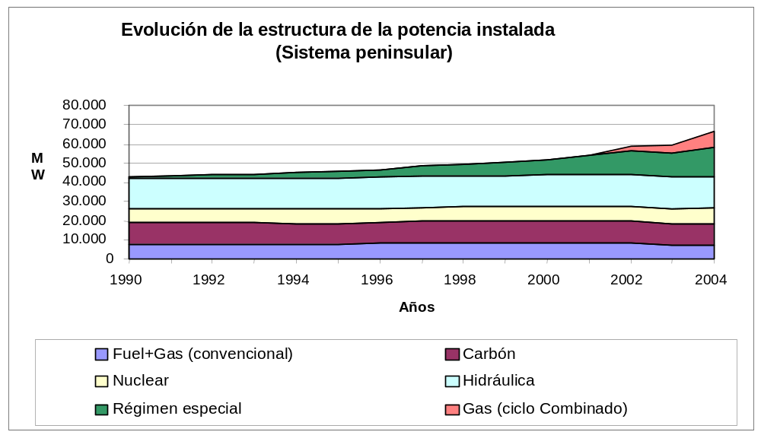
Evolution in the Installed Power Structure (Peninsular System)
Years
Fuel + Gas (conventional) Coal
Nuclear Hydraulic
Special Regime Gas (combined cycle)

At the end of 2004, the installed power structure in the Spanish electricity system by production technologies was as follows:
TECHNOLOGY | POWER (MW)
Fuel + Gas (conventional cycle) | 6,930
Gas (combined cycle) | 8,259
Coal | 11,565
Nuclear | 7,876
Hydraulic | 16,657
Special regime (total)* | 17,096
TOTAL | 68,383
*Including the power which at 31st December 2004 was offered to the production market, which represents 2860 MW

As at 31st December 2004, the shares of the different companies in the Spanish electricity system’s generator pool was as shown on the attached table. Four hypotheses were used to make the calculations, as follows:

Hypothesis 1: The power per company taken into consideration includes exclusively the production plants under the ordinary regime in operation at 31st December 2004.

Hypothesis 2: The power per company taken into consideration includes the production plants under the ordinary regime and the installed power under the special regime (without differentiating the company owning such plants) in operation at 31st December 2004.

Hypothesis 3: The power per company taken into consideration includes the production plants under the ordinary regime which were in operation at 31st December 2004 and the Spanish electricity system’s interconnection capacity.

Hypothesis 4: In this last hypothesis, the power per company of the production plants under the ordinary regime, the installed power under the special regime (without differentiating the company owning such plants) which were in operation at 31st December 2004 and the Spanish electricity system’s interconnection capacity were taken into consideration.

Market Shares in Installed Power (Year 2004)
 | HYPOTHESIS 1 | HYPO-THESIS 2 | HYPOTHESIS 3 | HYPOTHESIS 4
 | ORDINARY REGIME | ORDINARY + SPECIAL REGIMES | ORDINARY REGIME + INTER-CONNECTION CAPACITY | ORD. REG. + SPEC. REG. + INTERCONN. CAPACITY
IBERDROLA GENERACIÓN, S.A. | 37.2% | 27.8% | 35.4% | 26.8%
ENDESA GENERACIÓN, S.A. | 34.5% | 25.8% | 32.8% | 24.9%
UNIÓN FENOSA GENERACIÓN, S.A. | 12.7% | 9.5% | 12.1% | 9.2%
HIDROELÉCTRICA DEL CANTÁBRICO, S.A. | 5.1% | 3.8% | 4.8% | 3.7%
VIESGO GENERACIÓN, S.L. | 4.5% | 3.3% | 4.2% | 3.2%
GAS NATURAL SDG, S.A | 3.1% | 2.3% | 3.0% | 2.3%
OTHERS | 3.0% | 2.3% | 2.9% | 2.2%
Interconnection capacity |  |  | 4.8% | 3.7%
Total Special Regime |  | 25.1% |  | 24.2%
* Note: Companies under the ordinary regime are not allocated the power of the plants under the special regime which are their property

As can be seen on the above table, the number of companies with more than 5% of the Spanish electricity system’s installed power is 3, being Iberdrola, Endesa and Unión Fenosa, to which is added Hidrocantábrico if only the installed power under the ordinary regime is taken into account.

At the same time, the evolution of total demand in plant bars in Spain between the years 1998 and 2004 was 35%, representing a mean annual increase in this same period of 5.1%. During the last year, the total demand in plant bars amounted to 233,505 GWh, which was covered as follows:

Balance of Spanish Electric Energy in TWh in 2004
Hydroelectric | 29,750
Nuclear | 63,428
Spanish coal | 63,160
Imported coal | 13,073
Fuel+Gas (conventional cycle) | 7,700
Gas (combined cycle) | 29,043
Special Regime | 43,682
International exchanges | -3,026
Consumption in generation | -8,702
Consumption in pumping | -4,603
TOTAL (TWh) | 233,505

During this same year 2004, 2nd March was the day on which the greatest demand for mean hourly power was recorded (at 20:00 hours), with a value of 37.724 GW, although the demand for power in the Spanish system reached a peak of 38.21 GW at 18:38 hours on 9th December. The maximum daily energy value occurred on 2nd March and amounted to 753 GWh.

Structure of the Production Market
As a result of the merger and acquisition transactions carried out in the nineties, the electric energy production market in Spain started to function with four large electricity groups: Endesa, Iberdrola, Unión Fenosa and Hidrocantábrico. Subsequently, and since its commencement up to the present day, attempts have been made for the merger of two important companies (Endesa-Iberdrola) and one acquisition (Gas Natural over Iberdrola), which finally did not take place. However, other projects of minor importance have been brought to a positive conclusion, as is the case of the purchase of assets belonging to Endesa by part of the Italian ENEL group and the acquisition by EDP of Hidrocantábrico. At present there are six groups of a significant size competing in the market, which are Endesa, Iberdrola, Unión Fenosa, Gas Natural, Hidrocantábrico and Viesgo, the market shares of which will be seen below.
Electricity Sector Law 54/1997 of 27th November establishes that the production market is to be managed by two Operators: the Market Operator (the company, Operadora del Mercado Español de Electricidad, S.A. – OMEL), which is responsible for the market’s economic management, and the System Operator (Red Eléctrica de España – REE), which is responsible for its technical management. In Royal Decree-Law 5/2005 of 11th March of urgent measures for boosting productivity and improving public contracting, a series of reforms within the field of energy were regulated, modifying part of the functions which up until then had been carried out by each operator and attributing to the System Operator the balancing markets’ economic management.
Sellers in the market are the electricity producers (generator companies), external agents (electricity imports) and commercialisation companies (electricity imports and energy from bilateral contracts); buyers in the market are the distributors (tariff-based supply), commercialisation companies (sale to qualified consumers), external agents (electricity exports) and the qualified consumers themselves.
The producers, external agents, qualified consumers and, since the publication of Royal Decree-Law 6/2000, the commercialisation companies too can choose between going to the organized market, presenting economic offers or signing and implementing physical bilateral contracts.
The production market in Spain is made up of an organized part and a non-organized part. The organized market is structured around a series of sessions held on the day prior to and on the day of the electric energy supply, in which the final generation price’s different components and the programming of the generator groups are established. The non-organized part consists of physical bilateral contracts, the economic terms and conditions of which are agreed between the signing parties and are not known by this Commission but whose execution has to be notified to the Market Operator, meaning that the negotiated quantities are known. During 2004 bilateral contracts corresponding to a volume of energy of 1,555 GWh, representing 0.7% of the market’s total volume, were executed.
An energy volume of 213,778 GWh, representing approximately 91% of the plant bar demand for electricity in Spain, has been negotiated in the production market. The final average market price was 3.565 c€/kWh. The daily market price has represented in the region of 81% of the final price, the power guarantee in the region of 12%, with the solution to technical restrictions, the secondary regulation tranche and other technical operation processes account for the remaining 7%.
Based on the same hypotheses as those used above in power, the energy market shares are analysed below:

Market Shares in Energy (Year 2004)
 | HYPOTHESIS 1 | HYPOTHESIS 2 | HYPOTHESIS 3 | HYPOTHESIS 4
 | ORDINARY REGIME | ORDINARY REGIME + SPECIAL REGIME | ORDINARY REGIME + IMPORTS | ORD. REG. + SPEC. REG. + IMPORTS
ENDESA GENERACIÓN, S.A. | 41.8% | 33.7% | 40.2% | 32.7%
IBERDROLA GENERACIÓN, S.A. | 29.8% | 24.1% | 28.6% | 23.3%
UNIÓN FENOSA GENERACIÓN, S.A. | 12.2% | 9.9% | 11.7% | 9.5%
HIDROELÉCTRICA DEL CANTÁBRICO, S.A. | 7.2% | 5.9% | 7.0% | 5.7%
OTHERS | 3.1% | 2.5% | 3.0% | 2.4%
VIESGO GENERACIÓN, S.L. | 3.1% | 2.5% | 3.0% | 2.4%
GAS NATURAL SDG, S.A | 2.7% | 2.2% | 2.6% | 2.1%
Imports |  |  | 3.9% | 3.2%
Total Special Regime |  | 19.3% |  | 18.7%
* Note: Companies under the ordinary regime are not allocated the energy of the plants under the special regime of which they are the owners
As can be seen in any of the cases analysed, there are 4 companies with market shares in excess of 5%.
For each hour of the daily programming horizon, the Market Operator establishes the order of economic precedence of the sales offers, starting with the cheapest and going up to the most expensive that is necessary for meeting the electric energy demand in this hourly programming period. The entry into operation of the power plants occurs on the basis of their variable cost; thus, the first units to enter into operation are those which do not have the capacity or have only limited capacity to modify their dispatches and low fuel costs, as is the case of hydroelectric and mini-hydroelectric flow plants, nuclear power plants and wind farms. Coal-fired and combined cycle powerplants enter into operation in second place and the dispatch of units with the most expensive fuels, such as fuel+gas plants and hydroelectric plants with modulation capacity, takes place last. Co-generation plants are dispatched on the basis of their variable production costs and the conditioning factors of the production processes with which they are associated. Thus, in general terms, the coverage of demand in the system follows the order of economic precedence determined by fuel costs. Consequently, the order in which the plants enter into operation is covered as follows:

Hydraulic Flow and Nuclear, Co-generation and other Renewable Fuels | → | Basic Energy
Coal and Combined Cycle | → | Intermediate Energy
Modulated Hydroelectric and Fuel+Gas | → | Peak Energy

At the same time, competitive markets managed by the System Operator exist within the organized production market in Spain; these are the markets which correspond to the system’s technical operation processes (balancing markets), the aim of which is to guarantee the electricity generation and transport system’s reliability and security.
Three types of regulation reserve have been defined in the Spanish market: primary reserve, secondary reserve and tertiary reserve.
Primary regulation has been established as a complementary service to the system, which is obligatory and not remunerated and, consequently, there is no market.
As already indicated above, the rendering of the secondary regulation service has been broken down into regulation zones, which group together several generation units within the same automatic generation control system. This service’s contracting process consists of two phases: provisioning of the regulation tranche made on the day prior to the system’s real exploitation and this regulation tranche’s use in real time. The System Operator establishes the regulation tranche that needs to be maintained in each one of the 24 hours of the following day, using as criteria possible errors in forecast demand, the size of the programmed groups and their fault rates, and the programmed power’s hourly variation. The market agents whose units have the technical capacity to provide this service submit their offers indicating, per production unit, the offer of increase or decrease in power together with the price at which they are prepared to provide this tranche. Tranche allocation to the different units is based on economic criteria and is remunerated at the highest price of all the offers accepted in the auction. At the same time and, in this case, during exploitation in real time, the energy that is needed to cover positive and negative system deviations is remunerated at the marginal hourly price, which is calculated as the price which would have resulted for the equivalent tertiary energy which ideally it would have been able to replace (tertiary energy marginal price).
The tertiary regulation reserve’s function is to maintain the balance of generation-demand when faced with unscheduled variations in demand or faults in the generator equipment. Its use in time is situated after the use of the primary and secondary reserves and it can be provided by those groups which can vary their power with respect to the allocated generating programme in a maximum time of 15 minutes and that can be maintained for at least 2 consecutive hours. There is no payment per tranche in the tertiary regulation market, with only the reserve’s use being remunerated. The System Operator establishes the value of the minimum tertiary regulation reserve which must exist in the system so that it can simultaneously withstand faults in any generator unit and errors in forecast demand. The agents whose units have the technical capacity to provide this service have the obligation of submitting hourly regulation tranche offers to cover possible positive (increase) or negative (decrease) deviations. If the deviation is positive, the System Operator will give the order to increase the scheduled power in the units which have submitted offers to increase, starting with the cheapest, until the detected deviation has been covered. At the end of the hour, the price at which all the tertiary energy used is to be remunerated is set at the price of the most expensive offer which has had to be used within that hour. In the case of negative deviations, the System Operator issues the order to reduce the power with respect to the programme in the units which have submitted offers to decrease, with the price being the lowest (energy buyback price) of those of the offers which have been used (allocation in descending order of price).
Finally, and in the event that important deviations are detected between the forecast demand and scheduled generation between two intra-daily market sessions, the System Operator may have recourse to the deviation management procedure, with a market mechanism similar to that of the tertiary reserve.
The HHI concentration indices for these markets are analysed below, using for the purpose the following criteria:
- Secondary regulation HHI: share per agent calculated on the basis of the annual tranche allocation average, both to increase and to decrease. In this case the allocated energy is not used because, as has already been seen, it is remunerated at the tertiary regulation market’s marginal price. Data for the year 2004
- Tertiary regulation and deviation management HHI: share per agent calculated on the basis of the use of energy without a sign (both to increase and to decrease) in both markets. Data for the year 2004

 | Share | Secondary HHI
END | 44.7 | 3351
IBL | 34.1 | 3351
UEF | 12.1 | 3351
HC | 6.0 | 3351
GN | 1.6 | 3351
VIEGE | 1.4 | 3351

 | Tertiary Regulation Energy |  | Deviation Management Energy
 | To decrease (MWh) | To increase (MWh) | To decrease (MWh) | To increase (MWh) | TOTAL | Share | Secondary HHI
IBL | 641,570 | 619,906 | 352,771 | 310,461 | 1,924,708 | 36.1 | 2598
END | 501,313 | 554,543 | 327,058 | 293,859 | 1,676,773 | 31.5 | 2598
UEF | 222,774 | 275,138 | 92,439 | 78,869 | 669,219 | 12.6 | 2598
VIEGE | 188,444 | 153,286 | 82,152 | 66,891 | 490,773 | 9.2 | 2598
HC | 113,442 | 140,293 | 58,029 | 57,033 | 368,796 | 6.9 | 2598
GN | 72,298 | 91,401 | 12,180 | 24,015 | 199,895 | 3.8 | 2598
Sum | 1,739,840 | 1,834,567 | 924,629 | 831,127 | 5,330,163

From the demand-side point of view, the existence of active demand in the electric energy production market has been very much conditioned by potential eligibility levels in each one of the years and the existence of the regulated tariff which coexists with the free market.
The evolution in the access to the internal demand market can be seen on the following graph.
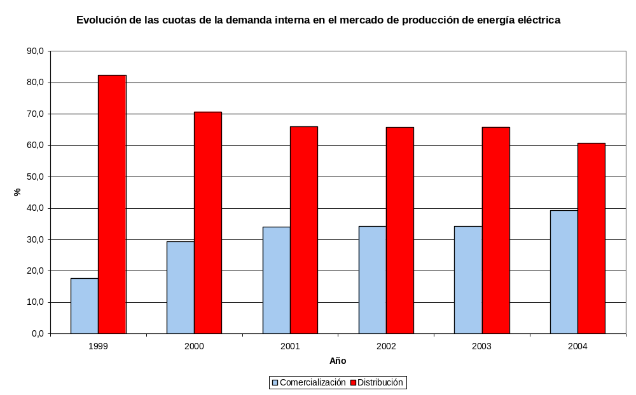
* Note: Sales of energy from producers under the special regime which sell to distributors outside the market have not been taken into account, meaning that the distribution quota would be a little higher than that shown.
Evolution of Internal Demand Shares in the Electric Energy Production Market
Year
Commercialisation Distribution

3.2.2 Description of the Retail Market

Description of the most up-to-date information on the end consumer retail market of the main companies and their market shares in
- Domestic and small businesses ( e.g. 50MWh/year or less)
- Medium sized consumers in the industrial and commercial sectors (e.g. up to 2GWh/year)
- Large and very large industrial consumers (more than 2GWh/year)

Number of active companies with market shares in excess of 5%, the joint share of the three major commercialisation companies in each defined segment and the penetration of new non-national incoming companies indicating at which level this penetration has occurred, whether by organic growth in the market or through the acquisition of another company

The report must specify the degree of integration between generator and commercialisation companies in the market.

The report must also specify the number of independent commercialisation companies without an associated distribution company in the transport network and distribution managers in the Member State which have entered the market since it was opened up to free competition.

Changes of supplier (preferably in volume of energy) in each segment indicated in the last 12 months and the accumulated volume since the opening of the market.

The report must also include information on supplier change procedures (maximum change time, change tariffs, charges, etc.).

As already indicated, in connection with the hiring of energy, the existing regulations allow qualified consumers to choose from amongst a range of possibilities. Basically, these can be classified as follows:

- To exercise their condition of qualified consumer. For this they can acquire all the energy in the market, negotiate it through other hiring modalities or through a combination of different energy hiring modalities. This can be materialised in the following manner:

- Through a commercialisation company (the most common way)
- By them direct in the market, making the corresponding offers to the Market Operator

There are other possibilities, which do not normally arise, such as purchasing energy by signing a bilateral agreement with a producer or through an external agent.

- To remain tariff-based.

All the information on the situation in the market and tariffs as regards number of customers and consumption, which is analysed in the following sections, corresponds to the information that is made available to this Commission every six months by the five major distribution companies and which reflects the situation of customers in the market and tariffs on two specific dates of the year (30th June and 31st December) and includes information on the energy consumed by these consumers during the last calendar year as at the corresponding date. Consequently, the data provided reflect neither the number of times a consumer has changed throughout the year nor the accumulated number of changes since the deregulation of each tranche analysed. The most up-to-date information available as at the date of this report’s preparation corresponds to the situation of customers in the market and at tariff as at 31st December 2004; therefore, all the data on customer loyalty and capture relate to that date, where ‘loyal’ is deemed to be the number of consumers (or, when applicable, the associated volume of energy) which have renegotiated their contracts with the commercialisation company in the same business group as the distributor which makes the supply and ‘captured’ the number of consumers which have changed supplier (or, when applicable, the associated volume of energy). In addition, this information is sent aggregated by type of consumer, where:

Type 1: Very large consumers connected in High Voltage with consumption in excess of 5 GWh/year
Type 2: Large consumers connected in High Voltage with consumption in excess of 750 MWh/year
Type 3: All other High Voltage consumers with consumption below 750 MWh/year
Type 4: Consumers connected in Low Voltage with a hired power in excess of 15 kW (mainly businesses and small companies)
Type 5: Consumers connected in Low Voltage with a hired power of less than 15 kW (basically domestic consumers)

In order to analyse the market shares as regards both number of customers and energy and with the proposed groupings, the five categories of consumer described above have been concentrated in three, endeavouring to reproduce as best as possible the criteria indicated:

Shares in Number of Customers by Company and Type of Consumer at 31st December 2004
Large Consumers (Types 1 and 2)
COMMERCIALISATION COMPANY | Loyal | Captured | Total | Share
IBERDROLA | 3,060 | 496 | 3,556 | 31%
ENDESA | 4,322 | 359 | 4,681 | 41%
UEF | 1,045 | 241 | 1,286 | 11%
OTHERS | 0 | 369 | 369 | 3%
VIESGO | 35 | 126 | 161 | 1%
HIDROCANTÁBRICO | 192 | 360 | 552 | 5%
GAS NATURAL | 0 | 807 | 807 | 7%
TOTAL | 8,654 | 2,758 | 11,412 | 100%
Medium-sized Consumers (Type 3)
COMMERCIALISATION COMPANY | Loyal | Captured | Total | Share
IBERDROLA | 10,936 | 972 | 11,908 | 52%
ENDESA | 3,341 | 468 | 3,809 | 17%
UEF | 2,881 | 943 | 3,824 | 17%
OTHERS | 0 | 842 | 842 | 4%
VIESGO | 38 | 96 | 134 | 1%
HIDROCANTÁBRICO | 293 | 1,029 | 1,322 | 6%
GAS NATURAL | 0 | 1,039 | 1,039 | 5%
TOTAL | 17,489 | 5,389 | 22,878 | 100%

Small Businesses and Domestic (Types 4 and 5)
COMMERCIALISATION COMPANY | Loyal | Captured | Total | Share
IBERDROLA | 449,645 | 14,607 | 464,252 | 36%
ENDESA | 548,160 | 16,373 | 564,533 | 43%
UEF | 37,814 | 17,515 | 55,329 | 4%
OTHERS | 0 | 5,694 | 5,694 | 0%
VIESGO | 2,139 | 319 | 2,458 | 0%
HIDROCANTÁBRICO | 1,228 | 1,042 | 2,270 | 0%
GAS NATURAL | 0 | 210,622 | 210,622 | 16%
TOTAL | 1,038,986 | 266,172 | 1,305,158 | 100%

As can be seen, in any of the segments analysed there are at least five companies with significant market shares above 5%, with the exception of small consumers where there is greatest concentration and the number of companies is reduced to three.

Shares in Energy, by Company and Type of Consumer at 31st December 2004

COMMERCIALISATION COMPANY | Large Consumers (Types 1 and 2) | Medium-sized Consumers (Type 3) | Small Businesses and Domestic (Types 4 and 5)
IBERDROLA | 33% | 56% | 33%
ENDESA | 39% | 17% | 42%
UEF | 10% | 13% | 10%
OTHERS | 4% | 4% | 4%
VIESGO | 2% | 1% | 1%
HIDROCANTÁBRICO | 5% | 5% | 1%
GAS NATURAL | 7% | 5% | 8%
TOTAL | 100% | 100% | 100%

The market shares in energy reproduce almost the same values as in number of customers, as there are five companies with shares in excess of 5% for large and medium-sized consumers, but in this case in the segment of small and domestic consumers they are reduced to four.

Thus, the number of changes of regular supplier, estimated in energy and by type of consumer, according to the data which reflect the consumer situation at 31st December 2004, considering the total energy commercialised in the free market, amounts to 23%, a value which is reduced to 8% if distributors’ sales at regulated tariff are taken into account.

Percentage of Energy Volume involved in the Change of Supplier (with the Commercialisation Company from a different business group to that of the Distributor)

Large Consumers (Types 1 and 2) | Medium-sized Consumers (Type 3) | Small Businesses and Domestic (Types 4 and 5) | Total
25% | 22% | 19% | 23%

During the year 2004, 27 commercialisation companies made purchases in the market with market shares as per the table shown below. The companies with the largest market shares are those which belong to the large electricity business groups, i.e. Endesa, Iberdrola and Unión Fenosa, whose market shares add up to 84%. In general, the way in which all the other commercialisation companies have entered the market has been through organic growth, without being associated with any distribution company, with the exception of Hidrocantábrico, in which the Portuguese EDP holds 96% of its corporate capital, and Viesgo, which was acquired by the Italian ENEL. At the same time, the company Gas Natural is the largest Spanish business group as regards sales and distribution in the gas sector in Spain. It started to operate in the electricity market in the year 2000 in the commercialisation business, taking advantage of its gas sales commercial infrastructure, and in the year 2002 in the production business with the installation of combined cycles (it currently has 4 combined cycles with a total installed power of 1600 MW).

COMMERCIALISATION COMPANY | Share 2004
IBERDROLA COM. | 38.14
ENDESA ENERGÍA | 36.26
UNION FENOSA MULTISERVICIOS | 9.66
GAS NATURAL ELECTRICIDAD | 6.09
HIDROCANTABRICO ENERGÍA | 5.80
HISPAELEC COMERCIALIZADORA FRANCIA | 1.00
VIESGO ENERGÍA COMERCIALIZACIÓN | 0.95
NEXUS ENERGIA S.A. | 0.58
ENERGY FACTORY GROUP | 0.36
CYD ENERGIA S.A | 0.34
VIESGO COMERCIALIZACIÓN | 0.22
CENTRICA ENERGIA COM (ESP) | 0.18
ELEKTRIZIACTS GESELLSHAFF LAUFENBURG ESPAÑA | 0.15
SALTEA COMERCIAL, S.L. | 0.10
NATURGAS COMERCIALIZADORA S.A. | 0.06
DETISA COMERCIALIZADOR S.A | 0.05
ELECTRA CALDENSE ENERGÍA | 0.02
BP AMOCO | 0.01
FUERZAS ELECTRICAS DE VALENCIA S.A. | 0.01
GLOBAL3 ENERGIA COMERCIALIZADORA | 0.004
ELECTRABEL ESPAÑA | 0.004
HIDROELECTRICA DLE CABRERA COMERCIALIZACION | 0.003
ENERCO CUELLAR S.L | 0.003
SNIACE ENERGIA | 0.002
ELECTRA NORTE 1997 S.A. | 0.001
La Unión Electro Industrial, S.L.U. | 0.001
RWE Trading GMBH | 0.000

Consequently, taking Gas Natural as an independent commercialisation company, there are 11 companies which act in the market and which are independent of the transport network and distribution managers, although the sum of their market shares amounts to just 9%.

There are 9 commercialisation companies of a non-Spanish scope which have penetrated the retail market, including in this figure Hidrocantábrico and Viesgo, where, as already indicated, EDP and ENEL have entered the Spanish market through the acquisition of these companies. The sum of the external commercialisation companies’ market share is in the region of 8%.

Procedures currently exist for the change of supplier prepared by the Spanish National Energy Commission, but which have not yet been published in the Official State Gazette and which, based on the experience accumulated in these years of deregulation, are now being reviewed and updated. At present no charge is being applied for a change in the energy hiring modality (tariff to market or vice versa) or for a change of supplier.

The foregoing notwithstanding, and for low voltage, the maximum time allowed for the change of supplier to be implemented has been laid down in Article 6 of Royal Decree 1435/2002, which establishes that, in general, the change of supplier must take place within 15 days of the request for a change, with the option of this change coinciding with the supply reading cycle.

Information on current end price levels (as per Eurostat data) for typical consumers referred to in point 3.1.3. Calculate an end price estimation broken down as per the following components: network costs, levies included in network costs, energy cost plus commercial margin and taxes.

In Spain the access tariffs are regulated prices which encompass within a single payment the different access costs defined in Royal Decree 1164/2001. The breakdown of the different cost components defined in the questionnaire (energy, networks, other levies and taxes) in each one of the access tariffs selected in the questionnaire is not known.

An estimation exercise is presented below in which the access costs of each valid access tariff are distributed by components, following the cost percentage structure included in the mean access tariff.

The hypotheses considered for separating the different cost concepts in the estimation exercise requested in this questionnaire are as follows:

- The access tariffs on which the components have been calculated are those specified in Royal Decree 1802/2003:
  - 2.0nA for Dc consumers
  - 3.0A for Ib
  - 6.2 for Ig

- The transport, distribution and commercial management costs (network costs) have been calculated on the basis of the access tariff corresponding to each type of consumer, after deducting the percentage corresponding to other levies (Costs of the Market Operator, CNE, System Operator, extra-peninsular Compensation, cost of transition to free competition, the cost of the Nuclear Moratorium, the 2nd part of the nuclear fuel cycle, compensation to distributors included under the 11th Temporary Provision of Spain’s Interruptibility, Special Regime and Qualified Customer Law, the special regime surcharge, the imbalance in revenues prior to 2003 and the cost of extra-peninsular generation in 2001 and 2002). The percentage of these levies is a proportional distribution which is calculated in accordance with the 2004 cost pricing.

- The amount corresponding to “levies included in network costs” is that which is obtained by applying to each corresponding access tariff the cost percentage of the Market Operator, CNE, the System Operator, extra-peninsular Compensation, the costs of transition to free competition, supply diversification and security (the cost of the Nuclear Moratorium, the 2nd part of the nuclear fuel cycle, compensation to distributors under the 11th Temporary Provision of the Interruptibility, Special Regime and Qualified Customers Law, the special regime surcharge), the imbalance in revenues prior to 2003 and the review of the extra-peninsular generation cost of 2001 and 2002.

- The energy component is calculated by adding to the average market price corresponding to the year 2004 the cost of complementary services, power guarantee payments and losses, corresponding to each time block access tariff. The same generation cost has been applied for all consumer types, with the exception of consumer type Dc, for which the charge profile defined in Resolution of 28th December 2004, by virtue of which the consumption profile and calculation method was established for the purpose of energy settlements applicable to type 4 and type 5 consumers which do not have nocturnal time register, has been used.

- The electricity suppliers’ commercial margin has not been included in the final calculated price in the following table.

- Taxes are obtained by applying to the end price the electricity tax (5.113%) and then VAT (16%).

End Price by Components of Typical Consumers (cent€/kWh). Year 2004
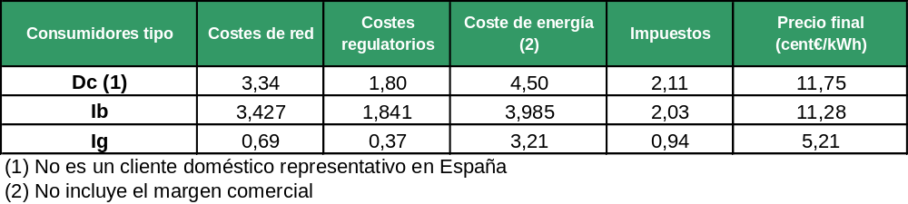
Typical Consumers Network Costs Levies Energy Cost Taxes End Price
(2) (cent€/kWh)
(1) This is not a representative domestic customer in Spain
(2) Commercial margin not included

Note: If, as requested in the questionnaire, each one of the end prices estimated by components is compared with the prices resulting from the application of the integral tariffs, the result would be that for consumer type Dc there is no commercial margin, for type Ib the margin is in the region of 6% and for consumer type Ig the margin could go up to 20%.

It should be pointed out that the domestic consumer type defined in this questionnaire is not representative of domestic consumption in Spain given the fact that it is a consumer with the nocturnal tariff. At present, only 5% of all domestic and other uses customers have chosen this tariff. In Spain, the representative domestic consumer enjoys tariff 2.0 without discrimination for nocturnal consumption (94.5% of all domestic consumers). The calculation of the end price by components of type Dc consumers, without taking into account price time discrimination, that is, applying access tariff 2.0A, is that shown in the following chart. It should be noted that the end price published by Eurostat for this consumer type applies integral tariff 2.0N.

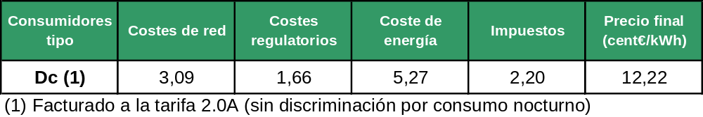
Typical Consumers Network Costs Levies Energy Cost Taxes End Price
(cent€/kWh)

(1) Invoiced at tariff 2.0A (without discrimination for nocturnal consumption)

3.2.3. Measures to prevent Abuse of Power
The report must also establish codes of conduct for generation companies in the wholesale markets, including:

- Transparency (what information on availability is required, what information close to real time, forecasts, etc.)
- Behaviour in offers
- Market supervision
- Experience in virtual capacity auctions and other measures to release capacity

The report must also establish codes of conduct for supplier companies, including:

- Transparency
- Rules relating to the structure of the contract
- Provision of information

The report must give details of any competition policy measures in any other market or sector

In Spain numerous instruments exist for avoiding situations of abuse of power.

In general, the competition authorities responsible for avoiding positions of abuse of power are the Restrictive Practices Court and the Restrictive Practices Service, all in accordance with Spain’s Restrictive Practices Law.

The aforesaid bodies prepare the proceedings corresponding to specific cases reported to them and for those about which they have received information. The proceeding is initiated ex officio or at the request of the interested party. Consequently, any agent acting in the electricity sector can report to the Service any situation which may involve practices that are contrary to free competition.

At the same time, Hydrocarbons Law 34/1998 attributes to the Spanish National Energy Commission (CNE) certain functions, of which that of ensuring that the agents which act in the energy markets carry out their activities with full respect for the principles of free competition stands out. To this end, whenever the CNE detects the existence of signs of restrictive practices, prohibited by the Restrictive Practices Law, it will make this known to the Restrictive Practices Service, providing all the facts within its scope and, when applicable, a non-binding opinion on such facts.

In the exercising of the foregoing function and in connection with the electric energy wholesale market, the CNE has drawn up numerous reports, approved by the CNE’s Administrative Council and submitted to the Restrictive Practices Service, on establishing the existence of signs of abuse of power by certain companies in the electric energy production market. These reports refer to the market’s working since the year 2000, with the last of them referring to the working of the production market in 2004.

The CNE considers it important to act in the face of situations which can alter the market’s normal working and which may constitute practices that are contrary to free competition, with the aim of avoiding their continuation in time and even their repetition by other agents.

As a result of the sending of one of the previous reports by the CNE to the Restrictive Practices Service, in July 2004 the Restrictive Practices Court decided that the companies denounced by the CNE in its report had infringed Section 6 of the Restrictive Practices Law, consisting of an abuse of power in the electricity supply markets, within a context of technical restrictions, on certain specific days in the year 2001, through the presentation of offers at prices substantially higher than their revealed variable costs, with the aim of their being excluded from the daily market’s matching process and knowing that, at any event, their offer would be necessary to meet the demand in the ulterior electricity supply market so as to solve technical restrictions, which resulted in the application of the corresponding fines.

Similarly, in connection with the electric energy and gas distribution and commercialisation activities, the CNE receives complaints and has knowledge of actions contrary to free competition, proceeding to analyse them by virtue of the exercising of the above-mentioned function of safeguarding free competition in the market, such as, for example, difficulty in gaining access to the distribution network, unfair practices in the capture of customers for the deregulated market, discriminatory treatment in the access to the distribution network, application of discriminatory prices, incidents in the change of supplier procedure, etc.

In respect of the electric energy production activity, the Electricity Sector Law establishes that the market operator shall exercise its functions respecting the principles of transparency, non-discrimination and independence, under the control and monitoring of the so-called Market Agents Committee, thereby constituting another instrument for controlling the working of the electric energy wholesale market.

The functions which the legislation allocates to such Committee are the supervision of the working of the system’s economic management and the proposal of measures that may result in the production market’s better working. This Committee is made up of representatives from all the agents with access to the market, qualified consumers and the market and system operators.

Of the Market Agents Committee’s specific functions, the most important one is that of obtaining regular information from the market operator on all aspects of the system’s economic management that allow the degree of competition of the electric energy production market to be analysed.

Rules for the working of the electric energy production market have been established for the purpose of carrying out its economic management, which buyers and sellers in the electric energy production market must expressly abide by, through the signing of the corresponding adhesion agreement.

Thus, the rules for the market’s working establish that the market’s agents will act in the market in compliance with legal and regulatory provisions and in accordance with what is established therein.

Likewise, it is established that the market agents may demand both the result of the validations and the result of the different markets, in addition to the settlements, as established in the rules.

Complaints will be made known to all agents, with the exception of those which, owing to their sensitive content, the agent may decide to establish as confidential. All disputes, disagreements, claims and differences that may arise shall be settled by the CNE.

In short, the market agents can lodge claims relating to the market’s working, at the first signs or suspicion of incorrect behaviour.

Although the electric energy production market’s working rules do not include specific rules relating to the behaviour of the buying and selling companies, they do include guidelines for its working which represent a guarantee for the correct energy matching process and, consequently, for the avoidance of obligations contrary to the market’s correct working, including behaviour that is contrary to free competition:

- Obligation of abidance by the electric energy production market’s Working Rules through the signing of the adhesion agreement
- Obligation of registering the electric energy production and buying units in the market operator’s data system, through which offers are made. Authorization for the use of the market operator’s electronic means of communication is conferred on a personal and non-transferrable basis to the physical person appointed to act in the name and on behalf of the selling agent. Nobody can be authorized to act on behalf of more than one agent simultaneously or to act on behalf of an agent other than the one with which it maintains a dependent services relationship. To this end, whoever wishes to act on behalf of an agent, before being registered in the market operator’s electronic means of communication, must present a declaration to the latter certifying that he/she does not maintain a dependent services relationship with any other agents. In general, it can be concluded that these measures have been designed, amongst other objectives, to avoid pre-arranged lines of behaviour and, consequently, abuse of power.
- Once buyers and sellers have submitted their offers to the market operator, the latter checks them, as a condition prior to their possible acceptance, the aim of this procedure being to avoid offers that are incorrect or that may injure the market’s working: verification at the moment of the offer’s reception; that the agent is registered in the data system; that it has been authorized to submit offers; that the production unit has been registered in the market operator’s system; verification of the adaptation of the offer’s data to the information contained in the market operator’s data system; that the energy included in the offers falls within the permitted margins and verification of the offers’ content: tranches, tranche prices, etc.
- Information on lack of availability is sent by the system operator to the market operator’s data system and is carried out via the latter, always containing all the unavailabilities that the system operator has had confirmed by any of the physical units at the moment it is sent. The market operator assumes that all the production units not included in the last information received from the system operator are available.

Once the final matching of selling and buying offers has taken place, the market operator informs the system operator of the data relating to the results of the match, in the daily and intra-daily markets, and sends to the agents a notification with data corresponding to their production and buying units.

The final result of the match is adjusted by the energy supplies which the market and system operators agree on to overcome any technical restrictions, referring not only to the Spanish electricity system but also to international interconnections and any exceptional situations in the transport or distribution networks.

Finally, reference should be made, as another instrument designed to guarantee the good working of the gas and electricity markets, to the existence of codes of conduct for the companies involved, established for the purpose of ensuring legal, ethical and transparent behaviour. In general, it can be said that all the large Spanish operators have codes of conduct.

In turn, and in connection with the electric energy production market, Spanish legislation established for the market operator, which is responsible for the wholesale market’s working, the necessity of drawing up and publishing a code of conduct applicable to this company, available since 1998.

The above-mentioned code of conduct establishes the principles of action in the market for the IBERIAN ENERGY MARKET OPERATOR, POLO ESPAÑOL, S.A., indicating that it must act at all times with full respect for the principles of transparency, non-discrimination and independence, of which the following should be highlighted:
- Discriminatory treatment of any of the Electric Energy Production Market Agents shall not be allowed.
- No type of undue preference shall be given to the orders issued by Market Agents.
- Avoidance of arbitrary actions, being guided by the legally established procedural requirements.
- Obligation not to reveal to some Market Agents the selling and buying offers made by other Market Agents, except in those cases in which this is authorized by the applicable rules and standards.
- Not to stimulate the preparation of an offer by one Agent for the purpose of benefiting another.
- To reject transactions involving any physical person or body corporate which does not have the legal consideration of Market Agent and to reject any transaction of which it has knowledge that infringes the applicable regulations.
- Not to request or accept direct or indirect gifts or incentives, the aim of which is to influence the transactions or which may create conflicts of interest with other Market Agents.
- To foster transparency in the price establishment and diffusion process, avoiding the disclosure of false or inaccurate data.
- To safeguard market information, avoiding and correcting cases of abusive or unfair use of such information and their consequences.
- Duty of strict confidentiality of the information handled.
In connection with professional relations, except when expressly authorized, no director or employee can have a labour relationship of any type nor can it carry out any orders, work or duties for any of the Electric Energy Production Market’s Agents.
A register of the securities issued by entities with the legal consideration of Electric Energy Production Market or System Operator Agents that are in the possession of their board members, directors and employees shall be kept up-dated, with such securities portfolios being monitored on an annual basis.
At the same time, the market operator shall carry out a permanent activity of transfer of information on the market, its working and its results. Thus, it immediately publishes the market’s results and places at the disposal of the general public the following information, as indicated in the prevailing legislation:
- Publication of market supply and demand aggregate curves
- Publication of commercial capacities and intra-community and international cross-border capacities
- Monthly publication of the results of the energy programmes aggregated by agent and calendar month of the electric energy production market, once one month has elapsed since the last day of that to which they refer.
- Monthly publication, once three months have elapsed since the last day of that to which they refer, of the offers submitted by the market agents.
Finally, Royal Decree-Law 6/2000, of 23rd June, of urgent measures for the intensification of free competition in goods and services markets, amended by Royal Decree-Law 5/2005, established in its Article 34 a limitation on the participation in more than one main operator in the energy sectors. Main operator is deemed to be any operator which, having the condition of operator in such markets and sectors, is in possession of one of the five largest shares in the market or sector in question.
Thus, it is established that those physical persons or bodies corporate which directly or indirectly hold a stake in the corporate capital of two or more companies with the condition of main operator in the same energy market or sector affected by the rule (the electricity, gas, liquid hydrocarbon and LPG markets), in a proportion that exceeds 3 per cent of the total capital or voting rights, may not exercise the voting rights which correspond to the excess over and above such percentage.
The physical persons and bodies corporate to whom the excess referred to above is attributed shall inform the Spanish National Energy Commission, within one month from the date on which such circumstance arises, of the company in respect of which they wish to exercise their voting rights without any limitations.
Likewise, without prejudice to the provision relating to the exercising of voting rights, no physical person or body corporate may directly or indirectly appoint members of the administrative bodies of more than one company with the condition of main operator in the same market or sector of those affected by the rule.
The aim of the foregoing limitations is to avoid pre-arranged decisions plus any other type of commercial practices which may be materialised between the most important operators in the energy markets and whose consequences may result in the effective restriction of free competition. Thus, the fact that the same physical person or body corporate holds stakes in more than one main operator in an energy market will necessarily result in the possibility of information flows between both operators, thereby offering competitive advantages and the possibility of abuse of joint power, being able to adopt decisions and strategic activities to benefit one or several operators in detriment to all the others.
Royal Decree-Law 5/2005 introduced a new figure, the dominant operator in the above-mentioned energy markets, which is defined as any company or business group with a market share in excess of 10 per cent. The prevailing legislation refers to certain limitations to be applied to dominant operators, in their capacity as operators with a significant market share, relating to the conducting of their activities, such as the prohibition of electric energy purchases in other Community countries outside the scope of the Iberian Electricity Market or in third countries. The limitations and prohibitions which affect dominant operators have also been designed to exercise a certain control over the activities carried out by these operators, for the purpose of protecting free competition, thereby avoiding situations of abuse of power by the agents with the largest market share which operate in the energy sectors.
- REGULATION AND OPERATION OF NATURAL GAS MARKET

4.1 REGULATION [ARTICLE 25(1)]

4.1.1 General

Degree of openness and progress, including the percentage of the market open to competition and the level at which customers are eligible.

Eligibility levels:

At present there is no minimum level of consumption for exercising the right to obtain supplies on the deregulated market. That is, since 1 January 2003, all customers are eligible, regardless of the consumption level and the final use of gas.

Below is a figure with the evolution of eligibility levels:

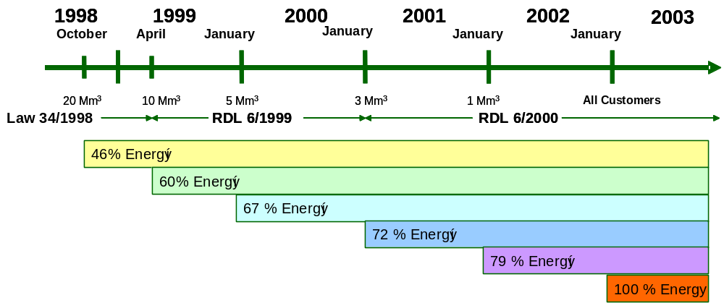
Figure. Evolution of eligibility levels.

Market opening:

In 2004, consumption supplied through the deregulated market totalled 80%. The figure below shows the evolution of the share of consumption between the regulated and the deregulated markets:

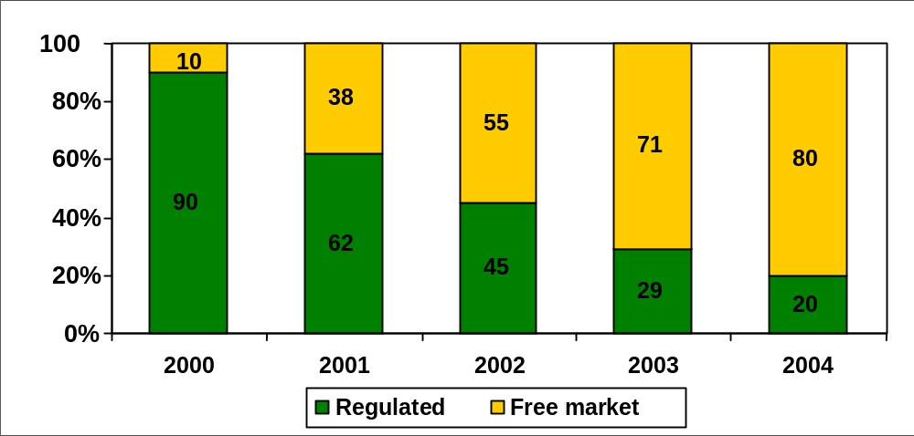
Figure. Evolution of market opening

As regards shares of the deregulated market, it should be noted that 46% of this market was supplied by companies other than the incumbent (Gas Natural) and the number of suppliers participating in it was high, as shown in the figure below:

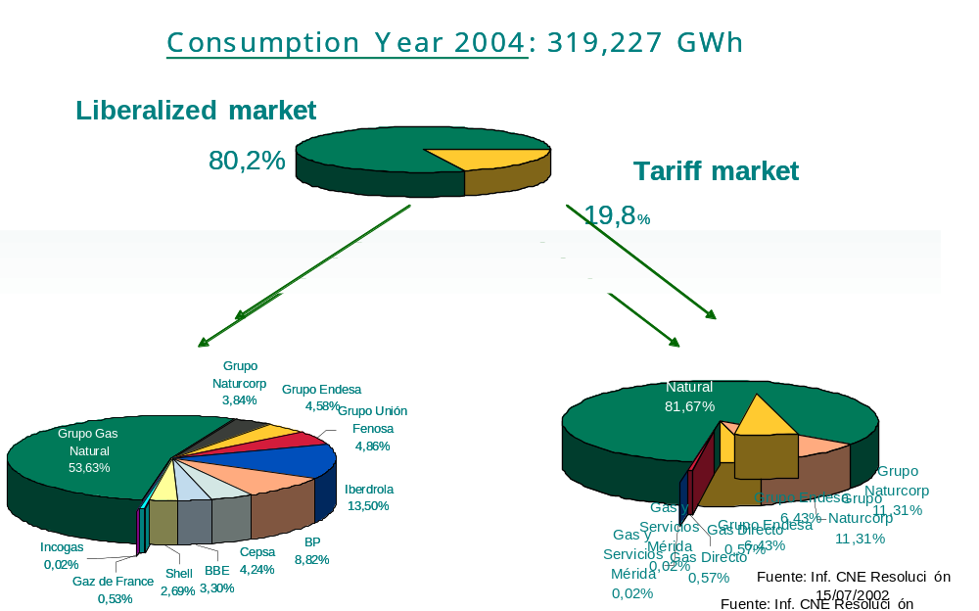
Figure. Opening of market in 2004. Shares of suppliers.

4.1.2 Management and assignment of interconnection capacity, mechanisms for handling congestion.

Quantification of congestion, both in the national system and in interconnections. The report must indicate, in reference to the physical flows, whether congestion is physical or the result of long-term capacity contracts, which means that the unused capacity can be offered on the market on an interruptible basis.
The regulation that must be established, as a result of the transposition of the Directive or the coming into force of the Gas Regulation, including the information the transporter must give to the Market.

Following the publication of a series of regulatory measures published for the purpose of eliminating contractual congestion, it is now believed that there are no situations of congestion owing to contractual capacity at the system’s input points.

The regulatory measures that eliminated the contractual congestion consisted essentially of the posting of a bond when transport capacity is reserved, and the loss of reserved capacity in case of continuous underuse of the same or when congestion might cause a denial of access to other actors.

Below are verbatim excerpts from the regulations containing these principles, as published in the Royal Decree 1434/2002 of 27 December, which modified Royal Decree 949/2001 of 3 August, regulating access by third parties to gas facilities and which provides for an integrated economic system of the natural gas industry:

“4. In order to ensure use of the capacity reserved and regardless of the payment of any tolls, applicants for access must post a bond for the owner of the facility, the amount of which shall be equal to twelve months of the fixed term of the relevant toll (Tfr for regasification, Tfe for transport and distribution and Tf for storage) as applied to 85% of the capacities contracted. Said bond shall be returned to the applicant one year after the beginning of supply, save for the provisions of paragraph four in this section.
The bond shall be posted upon the signing of the relevant access contract.
The bond may be posted by one of the following methods:
a) Guarantee provided by one of the banks, savings banks, credit co-operatives, lending institutions or mutual guarantee schemes authorized to operate in Spain.
b) Contract for insurance guarantee undertaken with an insurance company authorized to operate in the field of guarantees.
If six months elapse from the date specified in the contract for the start of supply or, if applicable, from the date of any modification of the capacity contracted, and the capacity actually used is below 80% of that called for in the contract, the capacities contracted shall diminish automatically by the amount unused, whereby the applicant shall lose the equivalent proportion of the bond in accordance with the foregoing.
The sum deposited by the proprietor of the facility as a consequence of the execution of said bond shall be considered assessable income.
5. Should the Technical Director of the System observe the existence or possible existence, as regards contracts or circumstances of reserve capacity, continuous underuse of the capacity reserved, and should said underuse constitute possible cause of denial of access to other applicants owing to lack of available capacity, the capacity reserved shall be reduced in an amount equivalent to the capacity unused, with the proportional loss, if applicable, of the bond.
The above shall be without detriment, as applicable, to an analysis of said situation in accordance with laws regarding defence of competition.
In the event the entity subject to reduction of capacity does not agree with the decision, the entity may lodge an appeal with the Spanish National Energy Commission within one month following reception of the notification from the Technical Director of the System of the decision to reduce capacity. The dispute shall be settled and notified within three months; otherwise, in the absence of a decision, the appeal shall be understood to have been dismissed.”

As regards congestion of a physical nature, it should be noted that the international connections at Tarifa and Larrau have nearly reached that point, though expansions of capacity are planned for Larrau. Moreover, it is also the case that the capacities of Tarifa and Larrau are intended for long-term contracts; but this capacity is being used. The regasification plants have unused capacity.

At present, operators of transport, regasification and storage facilities must publish a quarterly report on capacity contracted and available in each of their facilities, wherein they must distinguish between capacity assigned to access contracts with a duration greater or equal to two years, and access contracts with a duration of less than two years.

In particular, operators of input points currently in operation publish on their websites this information for a timeframe of 10 years, broken down by months for the first four years and in annual figures for the remainder of the period.

When a high proportion of capacity at interconnections (> 50%) is reserved for long-term contracts, the report must specify the rates charged by the incumbent for sale of capacity in the secondary market. A description is provided of the secondary market for capacity, including transparency provisions, “use-it-or-lose-it” and other anti-congestion measures.

Under present regulations, transport companies must set aside at least 25% to contracts of less than two years’ duration the capacity of their facilities of regasification, storage and input to the system of transport and distribution. No single marketer may accede to more than 50% of these capacities. These percentages may be revised by the Ministry of Industry according to trends in the market. As noted above, the capacity of the Larrau and Tarifa interconnections is reserved for long-term contracts that predate the regulation requiring assignment at least 25% of capacity for short-term contracts, though it should be born in mind that there is no underuse of these infrastructures.

As indicated above, transporters are compelled to publish the capacities contracted and available for each of their facilities, with a distinction between capacity assigned to contracts with a duration longer or equal to two years and contracts of less than two years, respectively. Similarly, as special measures to prevent congestion, the law envisages the posting of bonds and the loss of both the bonds and the capacities reserved in case of underuse.

Nevertheless, it should be stressed that the law does not include this possibility for secondary capacity markets. A secondary capacity market, though, is being planned by the Ministry of Industry and should be implemented in early 2006.

When interconnections are co-managed, the role of trading must be described so as to avoid congestions, particularly when the effect is discriminatory in practice.

At the international connection of Larrau in northern Spain, numerous applications are being presented for access to natural gas transport in a direction contrary to the dominant flow, which should presumably contribute to decongesting the connection with France by means of swaps.

The report must indicate whether agreements have been reached for transit contracts, as per article 3(1) of Directive 91/296, and specify the transit capacity they occupy. The end date should also be provided, if possible.

The collaboration agreements between ENAGAS and TRANSGAS were based upon the joint development of natural gas infrastructures on the Iberian Peninsula. As a result, the parties worked closely together on the construction of Maghreb-Europe gas pipelines through Morocco, Tarifa-Cordoba, Cordoba-Campo Maior through Spain and other pipelines through Portugal up to the Tuy interconnection point with Spain, the gas pipelines Campo Maior-Leira-Braga and Braga-Tuy, thereby enabling supply of Algerian natural gas to the Portuguese and Spanish markets from the production deposits of Hassi-R’Mel, Algeria.

Thus, there is now a natural gas transit line from the entry to the Spanish system in Tarifa to the exit through Campo Maior in the Badajoz province, through gas pipelines that have been jointly developed and owned by the managers of the Spanish and Portuguese transport grids. This transit is governed by a private contract negotiated between the parties separately from the regulated transport tolls. The transport contract signed by the Portuguese company TRANSGAS with Spanish transporters is prior to 1998, the year in which EC Directive 98/30 was transposed. It is a long-term contract.

Opinion on the reliability of the transporter’s method of calculating maximum technical capacity.

There is no substantive reason to doubt the reliability of the method used by the manager of the transport grid to evaluate the maximum technical capacity available.

4.1.3 Regulated obligations of transport and distribution companies.

Access rates

By publishing Ministerial Orders, the Government annually determines the rates, tolls and fees of natural gas. These are the single applicable prices for the entire country. Under Law 34/1998 of 7 October on the Hydrocarbon Industry, the CNE shall participate, either by making a proposal or report, in the process of creating projects for determining the rates, tolls and remuneration of energy activities.

To undertake the studies necessary to underpin the reports on the Ministerial Order projects on the sale rates, tolls, levies and remuneration in the gas industry, the CNE gathers the necessary information from the different actors in the industry.

To calculate the income of the system, information is gathered from suppliers on projections for invoicing variables – number of customers, capacity contracted and customer consumption – both in the regulated market and in the deregulated market, broken down by tariff groups. This information is gathered both for the end of the year in progress and for yearly rate forecasts. Forecasts provided by companies are compared to available information by the CNE for settlements of regulated activities in natural gas. In like manner, individualised information is requested on the forecasts of major consumers of gas such as combined cycles, electrical plans and supplies under the interruptible sale rate.

In the annual rate exercise, determination is made of the variations to be applied in sale rates, tolls and levies of natural gas, so as to cover the regulated costs of the system.

For transport, storage and regasification, remuneration for new facilities is set at service cost, calculated at standard levels. Operating costs are remunerated at standard levels. Further, the initial remunerative base set in 2002 is updated through an IPC-x formula. Nevertheless, remuneration of each distribution company is set according to a revenue cap formula, the basis of which was established in 2002.
Estimation of average network access tolls for the most recent period of information available, in relation to consumer types as defined by Eurostat.

Network tolls by types of natural gas consumers (cent€ /kWh). 2004
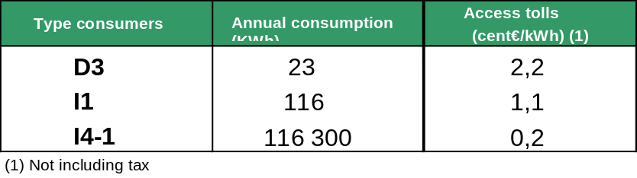

The prices in the above table are for 2004, as published in Order ECO/32/2004. They are the result of adding levies for regasification, transport and distribution and the underground storage fee as applied to each type consumer. The prices also include network costs, other regulated costs included in levies and fees, such as the CNE quote, the GTS quota and the provisional re-routing owning to the settlement of 2002.

A load factor has been assumed at the entry point of 85% and at the exit point of 50% for consumer type D3. For I1 and I4-1 consumers, the load factors used in the questionnaire, 56% and 69% respectively, have been used.

Balance

Regulators must summarize the balance mechanisms designed by transporters and the role of regulators in the approval of their methodology, under the terms of the Directive. A description must be provided of how the needs of small and new participants have been taken into account. The following data must be provided:

The balance scheme is included and detailed in the Rules of Technical Management of the System, the detailed rules that address diverse aspects related to the operation and technical management of the gas system. Nevertheless, these rules are still under discussion between actors and have not yet been approved by the Ministry of Industry on the basis of the report of this Commission. At present, a version of these rules is being annexed to capacity reserve contracts signed between transport infrastructure and actors exercising their rights of access to the system.

Below is a description of the primary characteristics of the balance scheme. The balance period is daily. There are balances at three points in the system:
- Regasification plants
- Transport and distribution system
- Subterranean storage

An imbalance occurs when the days of storage are above or below those included in the access rates of the gas system. Specifically, tariffs of access to regasification plants include in-plant operative storage of LNG equivalent to five days of capacity contracted daily. In addition, tariffs for access to the transport and distribution system include operative storage equivalent to two days of contracted transport and distribution capacity.

- How are balance costs set?

- How are penalties decided?

Once the necessary information has been obtained, if it is observed that a user has incurred in an imbalance by default of gas and the user does not have sufficient stocks of gas in the system, thus having used gas that was not his property; said user must cover the value of the totality of the gas consumed – not owned – at a unit price equivalent to 150% of the market rate. As a reference market, the System Technical Manager will conduct an organized auction of gas among system users to cover situations of imbalance. Offers in this auction can be presented within the week prior to the balance day, though no offers that exceed 150% of the lowest cost obtained by comparing the gas costs in the secondary reference market within the same timeframe. Nevertheless, in the absence of this auction market, or of a secondary market, the reference market shall be the lowest value resulting from comparing the cost of natural gas at Henry Hub and the NBP.

In the event that a user incurring in a gas imbalance reaches minimum levels, that is, achieves balance, in less than five days counting from the discovery of the data (balance day +2), said user shall be repaid 25% of the market price previously calculated.

If, after collection of the necessary information, it is found that a user incurring in imbalance owing to an excess of gas in the transport system, that is, if said user exceeds the maximum limit of operative storage included in the access rate for the transport and distribution system – the excess shall be charged at a rate 5% higher for subterranean storage, which shall include losses and self-consumption.

According to available information, there have been, to date, no penalties levied for gas imbalances in the system to any of the agents, though they are expected to be levied in the near future.

- Are there tolerance levels? If so, what are they?

There are regulatory tolerance levels. Specifically:

  - In addition to rights of usage of facilities needed to unload ships, of transport to LNG tanks and regasification or tanker loading, access rights include in-plant operative storage of LNG equal to five days at the daily contracted capacity.
  - All users accessing a regasification plant must maintain a minimum level of LNG storage in tanks that is equal to 9% of the total storage capacity of LNG. Said amounts are distributed proportional to the regasification capacity contracted by each user.
  - In addition to the right to use facilities necessary to transport gas from the network entry point to the transport network to the qualified user, system access rates include operative storage equal to two days of contracted transport and distribution capacity.
  - A minimum of one day of gas must be maintained immobile for the purpose of filling the transport and distribution system.

- How TSO/DSO obtain the energy they need to perform their functions, and at what cost? (in the open market, or under certain conditions, and from whom?) [The balance is a market that is regulated under article 25(2) of the second Directive]

The System Technical Manager, being responsible for balance in the system – there is a single equivalent balance zone for the entire country – can in certain circumstances use gas from other agents that have gas in the system and that are in balance, whereupon the manager shall restore said supply and compensate the agent for use of the gas, in accordance with the auction system provided for in the Rules of Technical Management of the System described above.

- How do TSO/DSOs define their necessities in this area and what resources are available to them?

The System Technical Manager performs tasks of monitoring the balance of the system on the basis of nominations, forecasts and final measurements of the consumption of natural gas. As already noted, the manager may use the gas of other agents in the system that are in balance, through a system of daily bidding organized for this purpose.

Moreover, and until the upcoming transposition of EC Directive 2004/55/CE, Operators of Transport Networks buy gas freely and sell it to Operators of Distribution Networks at a regulated cession price.

Distribution Network Operators buy from Transport Network Operators at the ex-plant price the gas necessary to supply sufficient gas to the regulated market of consumers connected to networks that have chosen not to buy in the deregulated market.

- What incentives are provided by TSO/DSOs for system users to maintain a balance between inputs and outputs?

Incentives to users to maintain stocks within the balance range stem from the penalties they would be compelled to pay in situations of imbalance.

- Balancing regime (timetable, calendar, etc)

The balancing regime is daily.

Description of the most relevant balancing areas if they do not correspond to the national system of transport and distribution.
The balancing area encompasses the entire national transport system.

- Can TSOs accept interaction between areas, offers made in other areas or member states and to what extent does this exist?

There is only one balancing zone that encompasses the entire national transport and distribution system. A balance is also made in each of the regasification plants and in underground storage facilities.

- Can suppliers group imbalances in a single access contract, for instance, by joining imbalances ex-ante and ex-post?

To avoid situations of imbalance, agents often achieve a balance in their stocks through ex-ante gas trading, both in the LNG tanks themselves in regasification plants and in gas trading in the Gravity Centre of the transport system (NBP).

- The process and calendar of imbalance settlement

Prior to a situation of imbalance and with an imbalance forecast, the Rules of Technical Management of the System specify a series of instruments that the user can employ on an ex-ante basis:

- Purchase/sale transactions of gas with other users in the system
- Modify scheduled plan of programming and nominations.
- Exercise clauses of interruptibility with customers with whom they have entered into such contracts.
- Negotiate with firm customers voluntary interruptions of service.
- Negotiate with other users to exercise interruptibility clauses with other customers.
- Use the capacities of underground storage up to their technical limit, to the point of compatibility with the system.

However, if a network user exceeds the tolerance limits specified in regulations, a situation of imbalance will ensue, which will have to be dealt with by the System Technical Manager. To determine the balance situation of each user, daily commercial balances are used, day n + 2.

While the procedure for calculating and applying penalties has already been described above, it should be noted that the user can reduce the penalties if the imbalance is corrected within five days following reception of the “n+2” information.

In any event, the final results of the income associated to the balance shall be considered payable income into the system and shall accrue to its benefit.

What information is to be provided by TSOs to users on balance mechanisms?

The System Technical Manager must publish a daily report of the aggregate curve of prices for offers received for each of the days in which the auction is active to deal with imbalance situations, and also provide the n+2 as well as the daily balance of each user.

4.1.4 Access to underground storage, pipeline stock and other ancillary services.

The regulatory framework for the use of underground storage facilities must be described with the inclusion of the following factors:

- Whether the access regime is regulated or negotiated and whether the facilities or part of them are exempt from access by third parties, as per article 2(9) of EC Directive 2003/55/EC

The third-party access regime to storage is regulated.

- A description of the main gas facilities – type, capacity – and the most significant operators, the services provided – whether there are grouped or separate services, firm or interruptible- as well as the main usage of the facilities (seasonal variations, points coverage, balance)

Natural gas in Spain is stored in the gas system, underground storage, in LNG tanks and in the gas pipelines themselves.
In terms of usage, there are two types of storage: operational and strategic. The concept of operational storage is linked to gas of high availability in the system, which attenuates the hourly and weekly differences between emission and demand, or the typical discontinuity of the unloading of LNG ships. Seasonal storage helps the system cope with the variation in demand between summer and winter. At present, the input capacity of the gas system, without counting underground storage, is below the daily demand of the system. For this reason, in periods of low demand – summer – gas is injected into storage, and in periods of high demand – winter – the storage facilities are used as an input point for the system. Thus, gas input in the system is constant throughout the year and increases the use factor of plants and gas pipelines.
Generally, gas in pipelines and tanks in regasification plants is part of operational storage, while strategic and seasonal storage is usually based on underground storage facilities.
The other function of underground storage is strategic storage, the purpose of which is to maintain minimum reserves of gas in case of incidences affecting supply security.

Existing storage capacity is offered solely as firm capacity.

Underground storage:

Facilities | Storage capacity  Mm³(n) |  |  | Vehiculation capacity Mm³(n)/day
Facilities | Cushion gas* | Useful gas | Total gas | Injection | Extraction
SERRABLO (Aurín and Jaca) | 420 | 635 | 1.055 | 3,9 | 6,9
GAVIOTA | 1.702 | 779 | 2.481 | 4,5 | 5,7
TOTAL | 2.122 | 1.414 | 3.536 | 8,4 | 12,6
* According to data provided by ENAGAS, the transport company that manages both underground storage facilities, one third of this gas is extractable by mechanical means and can also be put on the market. Thus, for the purposes of calculating total capacity available for contracting, ENAGAS refers to 1.414 + (1/3) 2.122 = 2.121 Mm³ (n).

Both underground storage facilities are operated by ENAGAS.

Contracting of storage capacity does not require specification of a minimum amount, or a minimum contract duration; contracting gives usage rights to a proportional capacity of injection and extraction in storage.

LNG storage capacity:

Regasification plant | Capacity Mm³ (n) GN
Barcelona | 140
Bilbao | 175
Cartagena | 93
Huelva | 181
TOTAL | 589

ENAGAS operates all regasification plants except that of Bilbao, which is operated by the company Bahía de Bizkaia Gas.

The storage capacity of LNG is not contracted, but it is associated to the contracting of a certain regasification capacity. There is a specific storage fee for amounts of LNG stored in excess of five days, included in the access tariff to regasification capacity.

- What is the legal situation of the operator of underground storage facilities? Is it an independent operator? Is it a combined operator with TSO/DSO/LNG under article 15 of EC Directive 2003/55, or is it part of a vertically integrated company that performs other functions in the gas system such as supply, trading or production?

ENAGAS, the underground storage operator, can be considered a combined operator in the natural gas industry, as it engages in activities of pipeline transport, storage and regasification. It has separate accounting for each of these activities.

In addition, the company acquires gas exclusively for sale to other transporters, or distributors connected to its networks in order to meet supply demands in the regulated market, that is, at the full tariff of natural gas.

ENAGAS has separate ownership for other business operations, as its shareholding therein is limited, with maximum voting rights up to the value of 5%.

- If the storage operator is part of a vertically integrated company, How can it be ensured that storage users and new participants are not discriminated against and confidentiality maintained?

- If the storage operator is part of a vertically integrated company, Has the operator prepared a document with the terms and conditions for the use of storage by its subsidiaries and provided this document to the regulator?

- Does the regulator intend to request this document prior to 1 September? If not, why not?

- What services are provided in a transparent manner?

Access to storage capacity is provided in a transparent way, as is injection and extraction of natural gas in underground storage.

The operator publishes values of total, available and reserve capacity.

Applications for access are processed within a month, on a first-come-first-served basis.

The possibility is also available to allege an access conflict before this Commission when access is denied to storage capacity, and should the applicant disagree with the decision.

- Do published prices serve as the basis for most contracts?

Access prices for storage capacity are regulated and are therefore public and equal for any agent. These regulated prices are applied to all access contracts.

To all effects, underground storage is treated as transport infrastructure, and as such there is third-party access regulated under the same conditions as in access to gas transport pipelines and regasification plants.

- Have new participants been able to contract storage capacity?

As of April 2005, 12 users has access rights to underground storage, while in the year 2000, only one vertically integrated company had all storage capacity for its sole use.

4.1.5 Effective unbundling

Degree of implementation of legal unbundling of transport and distribution network operators.

The Hydrocarbons Law requires unbundling of activities, where it distinguishes between regulated and unregulated activities. Specifically, article 63 of the Hydrocarbons Law provides the following:

- Companies that engage in one or more of the activities regulated as named in article 60.1 herein – regasification, strategic storage, transport and distribution are considered regulated activities – must have as their sole corporate objects the performance of said activities, where they may not engage in commercialization.
- Companies engaged in the marketing of natural gas must have the sole corporate object of that activity in the gas industry, where they may not engage in activities of regasification, storage, transport or distribution.
- Proprietary companies of any of the facilities in the basic network of natural gas, as defined in point 2 of article 59, must have as their sole corporate object in the gas industry the transport activity defined in section a) of article 58; they may include among their assets gas pipelines in the secondary transport network, where they must have separate accounting internally for activities of regasification, storage and transport.
- Natural gas companies engaged in more than one of the activities listed in article 60.1 of this Law shall have separate internal accounting for each of them, as if said activities were performed by different companies, in order to prevent discrimination, subsidies between different activities and distortions of competition.
Transporters must also keep separate accounts of their buying and selling of gas and the distributors of their activity of rate commercialization.
- The System Technical Manager must keep separate accounting that reflects the costs and revenue imputable to the activity of technical management of the system.
- A group of companies may undertake activities that are incompatible under the preceding sections, provided they are performed by different companies. Thus, the corporate object of a company may include these activities provided that one activity is to be performed in a direct manner, while the other activities are performed through stock ownership or holdings in other companies.
- Companies that engage in regulated activities may take holdings in other companies that perform activities in economic sectors other than the natural gas industry, provided they obtain authorization as per the additional provision eleven, third 1, thirteenth of this Law. In any event, companies included in this article must keep separate accounting for all activities they perform outside the natural gas industry and for any others they perform abroad.
The legal obligation to separate activities has been implemented. At present, there are five transport natural gas companies and 25 companies that engage the distribution of natural gas. Nevertheless, it should be stressed that some companies with regulated activities engage in activities in other economic sectors, such as production of electrical energy.
The leading transporter in Spain is ENAGAS, which is also the operator of technical management of the Spanish gas system. Under the provisions of the Law of Hydrocarbons, the company ENAGAS has the status of technical manager of the gas system, and no natural or legal person may have direct or indirect stock holdings in the company of more than 5% of the equity or voting rights in the company.
In Spain, at present there are four main groups of companies in the gas industry: ENAGAS, GAS NATURAL, NATURCORP and ENDESA.
Details on ownership of the managers of the transport network and an overview of the ownership structure of the distribution network.

Under article 58 of the Hydrocarbons Law, transporters are legal persons that own facilities for the regasification of liquid natural gas, transport of natural gas, or storage of natural gas. Distributors are legal persons that own facilities of distribution, with the function of distributing natural gas through canalization, as well as building, maintaining and operating distribution facilities used to situate gas in points of consumption.

In transport, the primary operator is ENAGAS, which is also the operator of technical management of the Spanish gas system. In the shareholder structure of ENAGAS, no natural or legal person may hold directly of indirectly a share of more than 5% of the equity or voting rights of the company. In compliance with the foregoing, shareholders must sell ENAGAS capital – if necessary – prior to 30 December 2006, in order to reduce their holdings to the maximum of 5% allowed under the Hydrocarbons Law.

At present, the shareholder structure of ENAGAS is as follows: GAS NATURAL (19.995%), SAGANE (5.022%), CAM (5.030%), BP ESPAÑA S.A. (5%), BANCAJA (5%), CAJASTUR (5%) and floating capital (54.953%).

In the gas industry, the leading distributors are under the ownership of the groups GAS NATURAL, NATURCORP and ENDESA. It should be noted that not in all cases are they 100% held by their respective parent companies. For example, in the group NATURCORP, the parent company holds some 40-55% of the equity of the five gas distributors.

As regards structure, these are usually subsidiaries of a parent company (as is the case with GAS ARAGON and other companies under the parent company ENDESA, S.A.), though in the case of GAS NATURAL, it is the parent company which engages in the regulated activity of distribution, and a series of regional distributors flow from the parent company.

State whether the managers of the transport network and the managers of the distribution network have different head offices than the production and supply subsidiaries.

In most cases, the gas company subsidiaries of a single group have a different registered office than the parent company; thus, there are separate registered offices for each company performing a different activity in the same business group.

To what extent do transport network managers and distribution network managers present themselves to consumers as separate entities: company names, logos, websites, etc.?

There is a legal unbundling, so each company bills its customers separately and each subsidiary has its own company name. Distributors have their own logo for each company; however, they have a common website for their operations.

State whether the separate accounting of the transport network managers and the distribution network managers are published or not.

In accordance with the provisions of article 62 in the Hydrocarbons Law, entities that engage in one or more of the activities listed in article 58 of the same law – transporters, System Technical Manager, distributors and marketers - shall conduct their accounting in conformity with Chapter VII of the Law on Limited Liability Companies, even if said companies are not limited liability companies.

Companies must explain in the report of their annual financial statement the criteria applied in the division of costs in comparison with other group companies that engage in different gas activities. These criteria must be maintained and shall not be modified, barring exceptional circumstances. Modifications and their justifications must be explained in the annual report of the year.

Furthermore, article 63 of the Hydrocarbons Law provides the following on unbundling of activities:

- Companies that are proprietors of facilities in the basic network of natural gas must have as their sole corporate object in the gas industry the activity of transport; their assets may include gas pipelines in the secondary transport network, where they must keep separate internal accounting of the activities of regasification, storage and transport.
- Natural gas companies engaged in more than one gas activity shall keep separate accounting for each of them, as if the activities were performed by different companies, in order to prevent discrimination, subsidies between different activities and distortions of competition.
- Transporters must also keep separate accounting for the buying and selling of gas and distributors of their activity of rate commercialization.
- The System Technical Manager must keep separate accounting that reflects the costs and revenue imputable to the technical management of the system.
- Companies that engage in regulated activities may take holdings in other companies that perform activities in economic sectors other than the natural gas industry, provided they obtain authorization pursuant to additional provision eleven, third 1, thirteenth of this Law. In any event, companies included in this article must keep separate accounting for all activities they perform outside the natural gas industry and for any others they perform abroad.

Individual accounts separated by activities are not published by gas transport companies or gas distribution companies; thus, only consolidated accounts of the large gas groups are published, with no unbundling by activities.

State whether the regulator has rules or guidelines for the compilation of separate accounts – for example, for the assignment of costs – and the consequences of their non-compliance

Under the provisions of article 62 of the Hydrocarbons Law, entities that operate in the Spanish gas system must provide authorities with information required of them, particularly as regards contracts for the supply of natural gas and their financial statements, where the latter must be verified by audits that are external to the company. When said entities are part of a group of companies, the obligations of information also include the company exercising control over that which engages in gas operations, provided that it operates in an energy sector, as well as any other companies in the group that operate in the gas system.

They must also provide the relevant authorities all manner of information on their operations, investments, supply quality as measured by official standards, markets served and planned with the utmost detail, prices paid and passed on, as well as any other information that the relevant authority considers appropriate for the exercise of its functions.

Further, the CNE has collaborated with the Ministry of Industry, Commerce and Tourism to prepare a Ministerial Order for the requesting of information of an accounting or financial nature, though said ministerial order has not yet been adopted. The information to be requested would only be financial - not costs –, the kind companies generally provide to their shareholders: balance sheet, profit and loss account, flow of funds statement and significant facts.

Because there are no guidelines regarding unbundling of accounting, there are no possible violations vulnerable to sanctions. The law does consider a refusal to submit information to the authorities or the CNE a grave infringement. Similarly, a very grave infraction is to engage in activities that are incompatible under the provisions of the law, though this is in reference to legal, not unbundling of accounting.

Very grave infractions are sanctioned with a fine of between 601,012 and 3,005,060 euros, and grave infractions between 60,000 euros up to the lowest point of very grave infractions, as envisaged in article 113 of the Hydrocarbons Law. Moreover, commission of a very grave infraction may lead to revocation or suspension of administrative authorization and a subsequent temporary disqualification from the performance of the activity for a maximum period of one year. Revocation or suspension of authorizations shall be decided, in any event, by the authority with the power to grant said authorization.

In conformity with article 116 of the Hydrocarbons Law, very grave sanctions shall be levied by the Council of Ministers, and grave sanctions by the Minister.

State whether separate accounts are subject to a separate audit by a certified auditor and to what extent this audit meets the regulator requirements.

Companies are audited by independent companies that follow the regulations applicable to any given case. In addition, the regulator has a department that performs inspections in companies to verify the veracity of the information provided, whether financial or technical in nature, in so far as they are of concern to the regulator (measuring equipment, etc).

Specify the role of the compliance officer in this process

From the start of unbundling of activities, documentation has been checked that accredits the effective founding of new companies with the sole corporate object engaging in the regulated activity.

As regards legal unbundling, the proportion of costs of the network manager which are typical shared with other subsidiary firms.

No information is available on costs.

As regards legal unbundling, the proportion of costs of the network manager that are typically contracted to subsidiary firms

No information is available.

What other sanctions are available to the regulator for companies that fail to comply with accounting or management unbundling?

Failure to comply with requirements for unbundling of accounting is not considered a very grave or grave infringement, though it might be considered a minor infringement.

The law does consider a grave infringement a refusal to submit information to the authorities or the CNE. Similarly, a very grave infraction is to engage in activities that are incompatible under the provisions of the law, though this is in reference to legal, not unbundling of accounts.

Very grave infractions are sanctioned with a fine of between 601,012 and 3,005,060 euros, and grave infractions between 60,000 euros up to the lowest point of very grave infractions, as envisaged in article 113 of the Hydrocarbons Law. Moreover, commission of a very grave infraction may lead to revocation or suspension of administrative authorization and a subsequent temporary disqualification from the performance of the activity for a maximum period of one year. Revocation or suspension of authorizations shall be decided, in any event, by the authority with the power to grant said authorization.

In conformity with article 116 of the Hydrocarbons Law, very grave sanctions shall be levied by the Council of Ministers, and grave sanctions by the Minister.
4.2 COMPETITION ISSUES [Article 25(1)(h)]

4.2.1 Wholesale market description.

A description of the wholesale market in relation to the area of each of the TSO, including the following indicators:

- Size of national market in terms of annual consumption (bcm/year)

The table below shows the evolution of gas procurement in the Spanish market, including both domestic production and imports:

 | 2002 |  | 2003 |  | 2004
 | Bcm | % | Bcm | % | Bcm | %
Procurement | 21,4 |  | 24,0 |  | 27,4
NG | 9,0 | 42,2% | 8,9 | 37,2% | 9,7 | 35,5%
LNG | 12,4 | 57,8% | 15,1 | 62,8% | 17,7 | 64,5%

- Proportion of production and import capacity (bcm/year)

The figure below shows the evolution of procurement in the Spanish market, with a distinction between domestic production and imports:

 | 2002 |  | 2003 |  | 2004
 | Bcm | % | Bcm | % | Bcm | %
Procurement | 21,4 |  | 24,0 |  | 27,4
Domestic | 0,5 | 2,3% | 0,2 | 0,9% | 0,3 | 1,2%
Imports | 20,9 | 97,7% | 23,8 | 99,1% | 27,1 | 98,8%

- A description of the principal origins of gas – domestic, Russian, Algerian, Dutch, Norwegian, and others from the Northern Sea, LNG)

The figure below shows the origin of gas procurement in 2002 in the Spanish market:
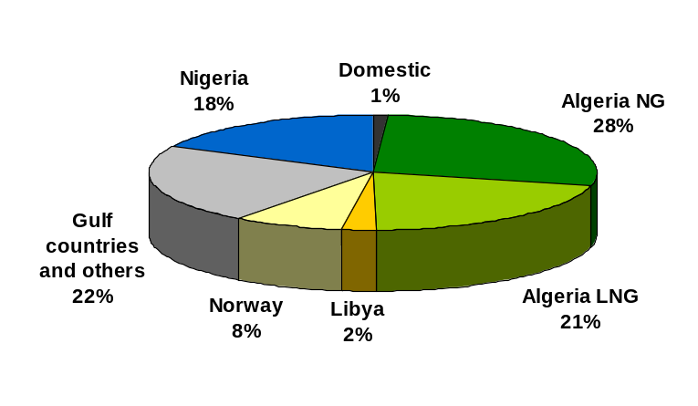
Procurement of natural gas is from Algeria NG, Norway and domestic production. The remainder of procurement is in the form of LNG.

- The number of companies that have at least 5% of the gas available in the market

Four companies

- The proportion of gas held by the three main companies.

The three largest supply companies account for 73% of the domestic market.

- The proportion of production and import capacity of the three largest companies

One of these, Gas Natural, owns the entirety of domestic production, which in 2004 accounted for 1.2% of the value of total procurement, where the remainder of its contribution to the Spanish market based on imports. The other two companies have no domestic production, and are instead supplied through gas imports in short and long-term procurement contracts.

The figure below shows that Gas Natural Comercializadora, with 42.7% of total capacity contracted in the deregulated market, is the marketer with the largest capacity of access reserved. Iberdrola stands second in terms of capacity contracted, with 17.1% and then BP, with 8.8%, stands as the third largest agent in terms of capacity contracted.

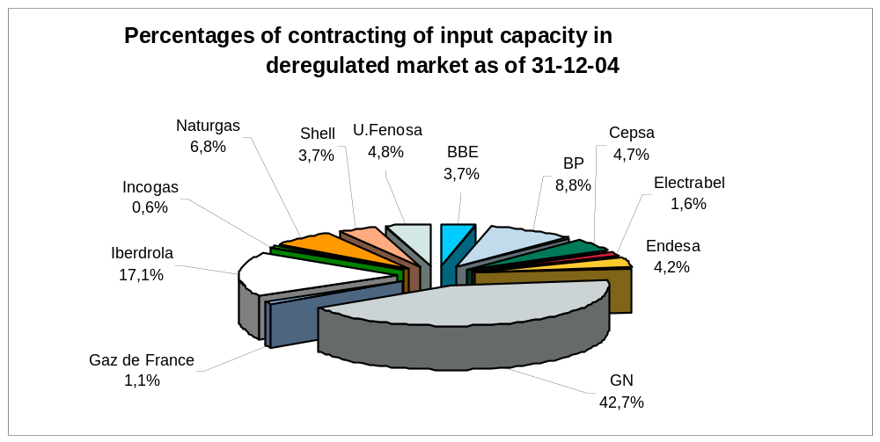
Figure. Contracting of input capacity in deregulated market as of December 2004, with start date of services as of 31 December 2004. Source: Access contracts submitted by proprietors of facilities

- The number of foreign companies active in the Market (EU and not EU) and their share in the same.

Throughout 2004, three foreign companies procured gas to supply the Spanish market, companies which are considered non-Spanish, whether EU or not. The joint market share of these three companies in the procurement market in that year was 9%. There is also a fourth major company with 4% of the market, the majority of which is held by a non-Spanish company.

This value does not coincide precisely with the sum of market shares to final customers of these companies, since they usually buy and sell gas to other marketers that participate in the Spanish gas system, for instance to Gas Natural, the historic incumbent.

Foreign companies operating in the Spanish market are fully integrated and participate in the market as other actors do, on a level playing field with Spanish companies.

- How active are foreign companies in the relevant domestic market – joint marketing activities, own marketing activities, joint ventures, shareholdings.

Foreign companies in the Spanish market act as marketers, procuring gas on international markets and then marketing and supplying it to final customers in the deregulated market.

They also trade gas in the system with other marketer companies.
One of these holds 5% - the maximum allowed – of the capital of ENAGAS, the System Technical Manager.

- Volume of gas marketed
  - On the basis of standard products,
  - Bilateral over-the-counter trading
  - In long-term contracts between producers/importers and suppliers (estimate proportions)

Given that gas procurement has been deregulated and can be performed freely, there is no information available on gas procurement contracts signed by agents.

Bearing in mind the peculiar nature of the Spanish market compared to other European markets, as procurement of LNG accounts for 64% of total procurement, and given the nature of these shipments, it must be remembered that there is a major LNG market in international waters prior to the unloading of gas in regasification terminals. This market accounts for a growing volume of buying and selling.

In any event, although at present there is no organized gas trading market, this trading between marketers have been occurring since 2002, following application of the new regulatory framework, which has the following features:
- It would seem that the main objective of the new framework is optimisation of logistics and finance, so their number will grow progressively as actors learn to optimise flexibilities in the system, and operational profit margins included in the access tariffs adapt to the reality of the system.
- The total transactions completed as of June 2005 is some 5,000, which means a volume of some 130 TWh. As for 2004 solely, there were more than 2,100 transactions with more than 58 TWh. These are physical trading transactions.
- It is unknown how many contacts or offers were necessary to achieve this number of transactions, that is, what might be called the churn rate.
- In the month of June 2005, the volume of gas traded was equivalent to 45% of the demand for that month.
- Trading is conducted in three system infrastructures, namely: the transport network, regasification plants and underground storage. In underground storage facilities, some 1% of trades have taken place, both in number of deals and volume; in the transport network, 55% of the trades occurred and 15% of volume; the remaining trades occurred in plants.
- There is no information on prices.

At present, development is under way of systems and procedures to organize and standardize these transactions. Plans call for an organized secondary market to be in operation by the end of the year.

The report must also examine the degree of integration with neighbouring transporters in other regions and member states and explain if the market is domestic, sub-domestic or if it goes beyond national borders. Correlations of prices and volumes marketed must be used as indicators.

Spain has several international gas pipeline connections to other countries: to Morocco through Tarifa, to Portugal through Tuy and Campo Maior and to France through Larrau.

The interconnection with Morocco is solely for imports. There are no plans for a gas market with Morocco in the short term. Gas from this connection accounted for 27% of supplies to the Spanish market in 2003.

The interconnection with France is a net importer, though there are some applications for access and short-term contracts for supplies in the opposite direction from the dominant flow. In addition, soon there will be a new interconnection to France through Irun which will broaden gas trading options with the neighbouring country, which are limited at present owing to the congestion of existing capacity. It would seem that, in the future, the connection to France could become a net exporter. Gas from this interconnection accounted for 9% of supplies in the Spanish market in 2003.

Existing interconnections to Portugal do in fact have sufficient capacity to develop an authentic Iberian gas market. The system can be considered fully integrated in terms of infrastructures. Indeed, and in continuation of the process of integrating the two countries’ electrical systems, the authorities have expressed their intention to extend the integration process to the natural gas market. There is already trading of natural gas between agents that operate on both sides of the border, though it cannot yet be stated that there is a proper market for gas between the two countries, owing to asymmetries in regulation. Until the coming on line of the regasification plant at Sines in the fourth quarter of 2003, the totality of Portuguese demand was met through the interconnection at Campo Maior in the Spanish province of Badajoz. Consequently, in 2004, gas exported to Portugal through this interconnection decreased by 8.5%. Transit to Portugal from Spain has provided 80% of supplies to the Portuguese market.

The specific nature of the Spanish market, in which gas supply in the form of LNG accounts for more than 60% of the total, also promotes the possibility of establishing an LNG market with neighbouring countries. In fact, at present, specific access rates are being designed for loading LNG in Spanish regasification plants for export to other markets.

The report must provide details on the rules of conduct of producers and importers in the wholesale market, including:
  - Transparency: What information must be provided by market agents, at what term of day of gas, forecasts?
  - Availability of gas to new participants and their access to secondary markets
  - Supervision of market
  - Supervision of competition

The report must reflect any experience with gas releases in relation to liquidity and promotion of competition. It must provide a brief description of the terms and conditions under which the program was implemented.

Natural gas can be purchased for consumption in Spain by transporters for sale to other transporters, or to distributors that are connected to their networks to meet rated supplies to non-qualified customers, marketers for sale to qualified consumers or to other marketers, and to qualified consumers for their own consumption.

Under present legislation, no agent operating in the gas industry can provide natural gas for consumption in Spain at a level above 70% of total national consumption.

Marketers must provide their annual, quarterly, monthly and daily forecasts to the System Technical Manager. Daily nominations for inputs and monthly ones for unloading of ships of LNG are contractually binding.

Program of gas capacity release

In Spain, program of gas and capacity release has been implemented, the specific features of which are summarized below. The program was highly beneficial for the process of liberalization in the country, since it provided access to capacity and gas to new agents under quite competitive conditions, thereby facilitating their entry to the market. The beneficiaries of the program were two foreign companies and four Spanish electricity companies.

- Introduction
The process of deregulation of the Spanish gas market brought with it the assignment of 25% of the contract for Algerian gas by pipeline to marketers, as per Royal Decree 6/2000 and the Ministerial Order of 29 June of 2001 (Royal Decree 6/2000 of June 2000 described the method of the process, while the Ministerial Order of June 2001 provided specific rules).

- Description of assignment process

The specific rules of the program were as follows:

- Property transfer point: Entry point to the Spanish gas system
- Measurement point: Zahara de los Atunes in the province of Cadiz.
- Director of measurement: ENAGAS (measurement procedure included in the acquisition procedure)
- Time: from the day of adjudication to 1 January 2004
- Total amount: 49.350 GWh (4.24 bcm)
- Price of gas: Determined quarterly in accordance with the formula:

P ($/MWh)=8.1858 x G/G0+4.1074 x LF/LF0+3.4509 x HF/HF0- 1.0751 [1]
Where:
- G, LF and HF are the average prices CIF in Genova of the six prior months of Gasoil, FO 1% and FO 3,5%, respectively
- G0= 298,10 $/Tm
- LF0= 173,74 $/Tm
- HF0= 145,97 $/Tm

(If the resulting price is lower than 5.449 $/MWh, this value would be applied)

This is what would be billed by Sagane, S.A., the owner of the gas. The real price that each marketer had to pay depended on the economic offer upon presenting the application.

The adjudication process was composed of a prior tender process and then an auction according to the price offered. Marketers with a market share above 50% were excluded. One could bid for between 10% and 25% of the gas tendered. The following information was required with the offer:

    - Charter
    - Deposit: 2% of the product price times the amount bid for.
    - Report on operational forecasts for the period 2000-2005: Supplies (origin and volume), number of customer and sales by geographic areas.
    - Documented forecast to incorporate gas starting in 2003.
    - Projected market share, direct or indirect.
    - Economic offer (percentage premium over price)

- Tender phase:
The evaluation criteria consisted of selecting companies that would increase the deregulated market and competition
  - Commitments to supply gas starting in 2003.
  - Balanced sales
  - Foreseeable number of customers
- Bidding phase:
  - Offers were excluded if the premium exceeded by 10 percentage points the arithmetic average of the applications selected.
  - Award according to the premium offered from highest to lowest until the assigned amount is covered.
  - Final price: formula + premium and a coefficient that allows the weighted average price to be equal to that resulting from the formula.
  - Excess of gas goes to Enagas for sale at rate price.

- Result of process
a) Bidders

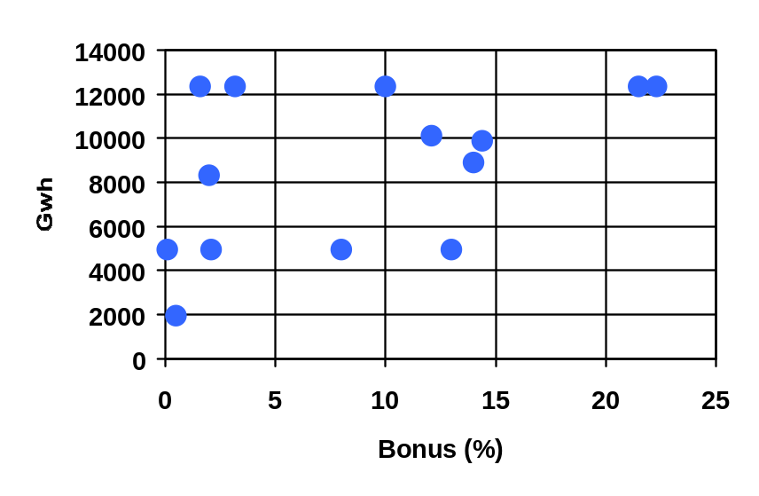
There were 14 bids at a volume of two and a half times the amount tendered. The volume of gas and the bonus established by companies is shown in the figure below:

Bonus (%) | 3,18 | 10 | 21,5 | 14,4 | 22,3 | 12,1 | 2,09 | 1,6 | 2 | 0,5 | 14 | 8 | 13 | 0,1
Quantity (GWh) | 12.337 | 12.337 | 12.337 | 9.870 | 12.337 | 10.100 | 4.935 | 12.337 | 8.303 | 1.935 | 8.883 | 4.935 | 4.935 | 4.935
Figure 1. Quantities of gas applied for and reference prices.

b) Final result

The results of the process were announced on 22 October 2001. Companies had to sign a contract within fifteen days in order to begin supplying customers. Only nine of the fourteen companies reached the bidding phase, and in the end six were awarded gas, as follows:
Company | Gas awarded (GWh)
1. BP Gas España, S.A. | 12.337,5
2. Iberdrola Gas, S.A. | 12.337,5
3. Unión Fenosa Gas Comercializadora, S.A. | 9.870,0
4. Endesa Energía | 8.883,0
5. Hidrocantábrico energía, S. A. U. | 4.935,0
6. Shell España, S.A. | 987,0
Figure 2. Final result of tender

One of the obligations of these companies was to supply customers in the deregulated market, excluding companies in the same group of companies. They were required to submit monthly information to the Directorate General of Energy Policy and Mines on gas consumed and its destination. If the marketer did not take 50% of the gas awarded – based on the monthly amount assigned – in a period of six consecutive months, that company would lose all rights to the gas awarded in the tariff price market, to where the gas would be returned.
.

4.2.2 Description of retail market

A description of the retail market must reveal, for the most recent period possible, the primary actors and their share of the supply market.

The figure below shows the volume of annual consumption in the Spanish market in 2004, broken down by type of supply, whether regulated or deregulated, as well as by supplying business group:

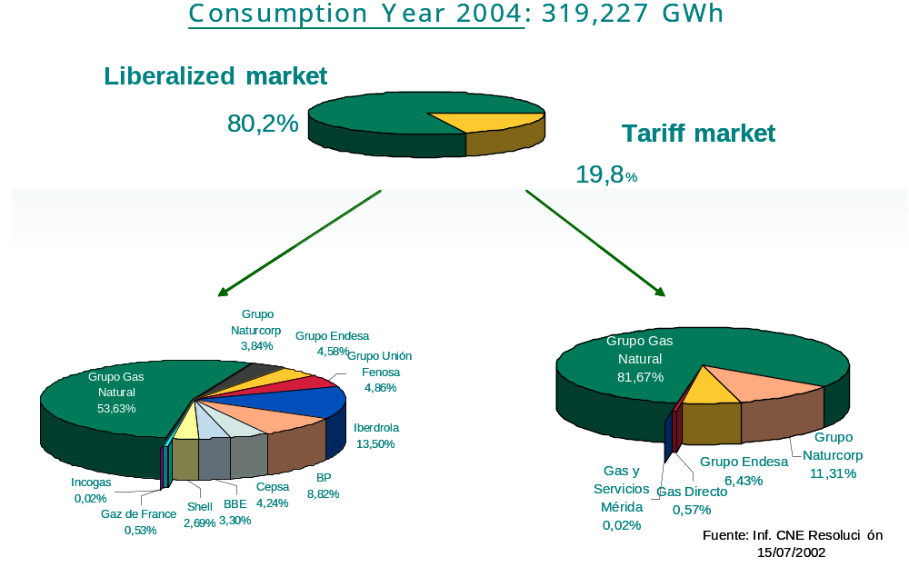

At the beginning of 2005, there were 24 companies inscribed in the registry of marketers. These were as follows:
Gas Natural Comercializadora, S.A., Naturgas Comercializadora, S.A., Hidrocantabrico Energia, S.A. (Sociedad Unipersonal), BP Gas España, S.A., Endesa Energia, S.A. (Sociedad Unipersonal), Shell España, S.A., Cepsa Gas Comercializadora, S.A., Union Fenosa Gas Comercializadora, S.A, Carboex, S.A. (Sociedad Unipersonal), Gaz de France Comercializadora, S.A., RWE Trading Gmbh, Sucursal en España, Unión Fenosa Comercial, S. L., Ingeniería Y Comercialización del Gas, S.A. (Incogás), Eni España Comercializadora de Gas, S.A., Investigación Criogénica y Gas, S.A., Gas Natural Servicios SDG, S.A., Electrabel España, S.A. (Sociedad Unipersonal), Repsol Comercializadora de Gas, S.A. , Iberdrola, S.A., Bahia de Bizkaia Electricidad, S.L., Regasificación y Equipos S.A., Nexus Energía, S.A., Comercializadora de Gas Extremadura and Liquid Natural Gaz, S.L.

- Gas for electricity generation
- Household and small business consumption (for example, 50MWh/year and less)
- Medium industrial and commercial consumption (above 1mcm)
- Consumption of large industrial and very large customers (above 25mcm /year)

Consumption of natural gas by sectors:
- Residential-commercial sector: 16%
- Industrial sector: 61%
- Use of natural gas as raw material: 2%
- Electrical generation (combined cycles and bi-propellant plants): 21%

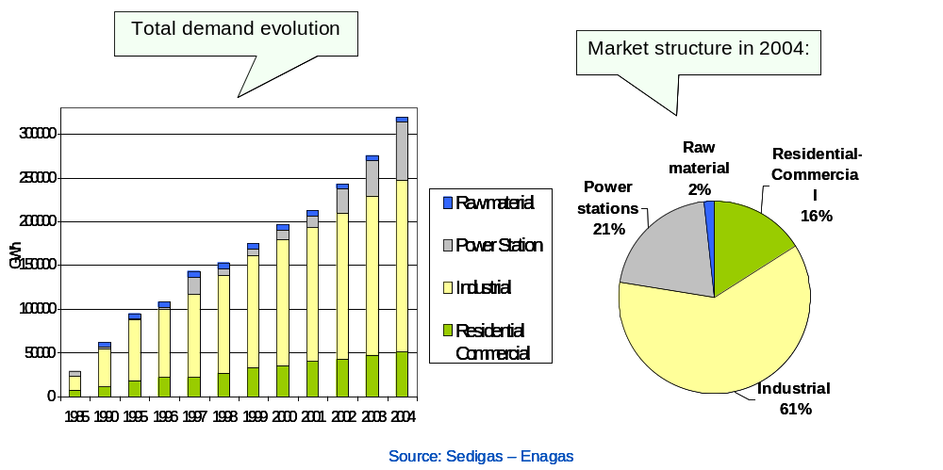

The figure below shows once again consumption in the Spanish market in 2004, but with different criteria for the itemization. In this case, consumption is shown broken down by levels of pressure and consumption, according to different tariff groups:

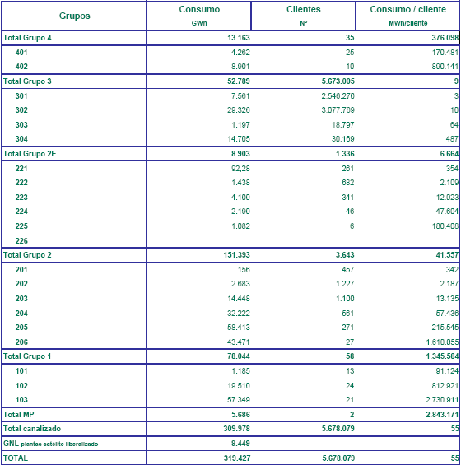

Groups Consumption Customers Consumption/customer
Total Group 4
Total Group 3
Total Group 2E
Total Group 2
Total Group 1
Total RM
Total Canalised
Total LNG Deregulated satellite plants
Total

Where the different groups have the following meanings:

Group 4: Industrial consumers of natural gas on an interruptible basis.
- 401: Consumers connected to a gas pipeline with design pressure above 4 bar and below or equal to 60 bar
- 402: Consumers connected to a gas pipeline with a design pressure above 60 bars.
Group 3: Consumers connected to a gas pipeline with design pressure below or equal to 4 bars.
- 301: Consumption equal to or below 5,000 kWh/year.
- 302: Consumption above 5,000kWh/year and equal to or below 50,000 kWh/year.
- 303: Consumption above 50,000 kWh/year and equal to or below 100,000 kWh/ year.
- 304: Consumption above 100.000 kWh/ year.
Group 2: Consumers connected to a gas pipeline with design pressure above 4 bars and equal to or below 60 bars.
- 201: Consumption equal to or below 500,000 kWh/ year.
- 202: Consumption above a 500,000 kWh/ year and equal to or below 5,000,000 kWh/ year.
- 203: Consumption above 5,000,000 kWh/ year and equal to or below 30,000,000 kWh/ year.
- 204: Consumption above 30,000,000 kWh/ year and equal to or below 100,000,000 kWh/ year.
- 205: Consumption above 100,000,000 kWh/ year and equal to or below 500,000,000 kWh/ year.
- 206: Consumption above 500,000,000 kWh/year.
Group 2E: Consumers connected to a gas pipeline with design pressure below 4 bars but with annual consumption equal to or above 200,000 kWh/ year
- 221: Consumption and equal to or below 500,000 kWh/ year.
- 222: Consumption above 500,000 kWh/ year and equal to or below 5,000,000 kWh/ year.
- 223: Consumption above 5,000,000 kWh/ year and equal to or below 30,000,000 kWh/ year.
- 224: Consumption above 30,000,000 kWh/ year and equal to or below 100,000,000 kWh/year.
- 225: Consumption above 100,000,000 kWh/ year and equal to or below 500,000,000 kWh/ year.
- 226: Consumption above 500,000,000 kWh/ year.
Group 1: Consumers connected to a gas pipeline with maximum design pressure above 60 bars
- 101: Consumption equal to or below 200,000,000 kWh/year.
- 102: Consumption above 200,000,000 kWh/ year and equal to or below 1,000,000,000 kWh/year.
- 103: Consumption above 1,000,000,000 kWh/ year.
RM: Raw material
LNG satellite plants: Liquid natural gas for supply to satellite plants

The number of companies active in the market with a share above 5% and the three largest suppliers in each market segment, as well as the presence of foreign companies, and whether this occurred through natural growth or through acquisition of companies.

The list below shows the market shares of the different company groups, based on sales volumes to final customers, with a distinction between the deregulated market and the regulated market.

Regulated market:
1. | Grupo Gas Natural | 82%
2. | Grupo Naturcorp | 11%
3. | Grupo Endesa | 6%
4. | Others | 1%
Deregulated market:
1. | Grupo Gas Natural | 54%
2. | Iberdrola | 14%
3. | BP | 9%
4. | Endesa | 5%
5. | Unión Fenosa | 5%
6. | Others | 13%

It can be said that the growth in the market of all new companies and entrepreneurial groups is generally due to their own efforts at winning new customers, or already existing customers that they had supplied through the regulated market. Except for Naturcorp, an entrepreneurial group that has achieved consolidation through acquisition of its capital by Hidrocantábrico, which in turn integrated into Naturcorp its own gas subsidiaries, Gas de Asturias and Gas Figueres.

As for non-Spanish companies, mention should be made in the deregulated market of BP which as a share of 9%, of Shell with a share of nearly 3%, and Gaz de France, with a share of 1% of the market. Further, significant shares are held by foreign companies in the equity of gas companies operating in the Spanish market:

- ENI: holds 50% of the capital of Unión Fenosa Gas,
- EDP-Electricidade de Portugal, S.A.: holds 95.7% of the capital of Hidrocantábrico, the company that holds a majority share in Naturcorp.

The report must identify the number of suppliers with no relations with TSOs or DSOs in the country, provided that they entered the market following liberalization.

Companies with significant operations in both the deregulated and the regulated markets through legally separated distribution companies are Gas Natural, Endesa and Naturcorp.

Mention should also be made of some companies operating in the deregulated market in transport activities, such as Gas Natural (secondary gas pipelines) Iberdrola (regasification plant in Bilbao), Naturcorp (transport networks and regasification plant in Bilbao), Endesa (regasification plant in Sagunto and Mugardos), Unión Fenosa (regasification plant in Sagunto and Mugardos) and BP (regasification plant in Bilbao).

The following marketing companies have no operations in the activities of transport or distribution: Shell, Gaz de France, Incogas and Cepsa.

The report must discuss the degree of integration in the country between producers, importers and final suppliers.

Leaving aside an analysis of production, owing to its low level of importance for supplies to the Spanish market (totalling 1.2% in 2004 in 2004, which is operated in its entirety by Gas Natural) it can be said that there is a great correlation between shares of imports and shares of supply of different agents, given that they generally go directly to international markets to obtain stocks of the natural gas necessary to supply their customers. Nevertheless, there are small differences in the buying and selling of natural gas in the system between agents. For example, the agent with the largest market share, Gas Natural, usually has stocks that are above its market share, given that it sets aside a part of this stock for sale to other marketing firms.

Estimates of supplier changes (preferably by volume) specific market segments for the last 12 months and the total since the beginning of liberalization.

The figures below show, for the year 2004, the total market share supplied through the networks of different company groups, divided between shipments made by the company itself to the regulated market and shipments to the deregulated market either by the marketer of the same company group or by the marketer of a different company group.

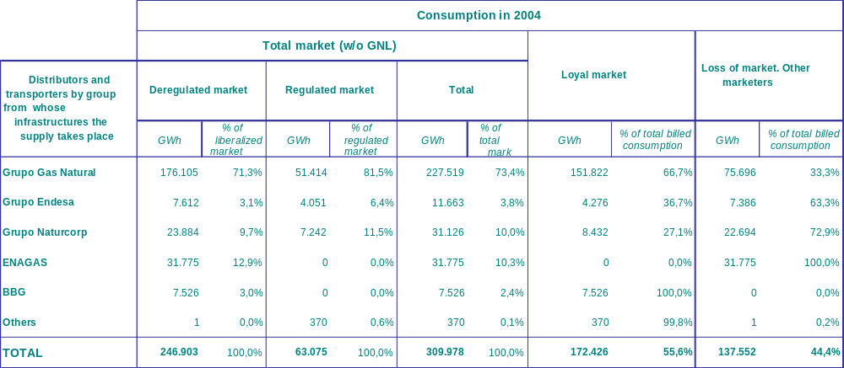

As an example, we shall interpret the results for Gas Natural. Here, 23% of shipments made through the networks of the group were destined for the regulated market, (51,414 of 227.519 GWh), while the remaining 77% , 176.105 GWh, were for the deregulated market. Of these 176,105 GWh, 66,7% was supplied by marketers of the same group, while the remaining 33.3% was for marketers that belonged to other entrepreneurial groups.

These figures give a rough idea of the loyalty of customers to the different companies operating in the market.
w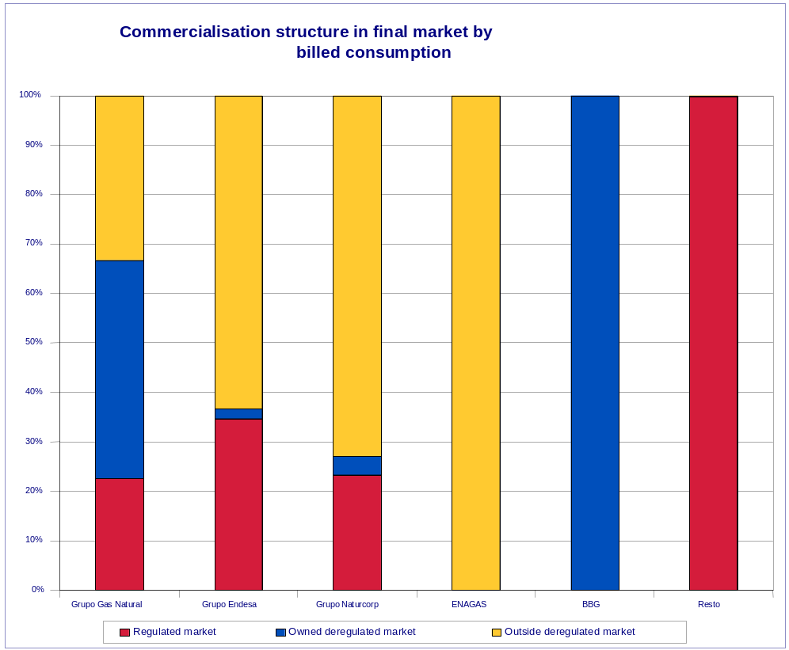

Specific mention should be made, owing to its particular nature, of the result of loyalty efforts in the case of tariff group 3, the group that generally contains consumption in the household-commercial sector.

The table and figure below show, first of all, in contrast the preceding case, which covered the entire market, in the specific case of the household-commercial sector the percentage of customers that have decided to buy on the deregulated market is much lower. In like manner, the degree of loyalty of consumers is much higher. That is, those deciding to change to the deregulated market do so, generally, through the marketer company of the same group of companies.
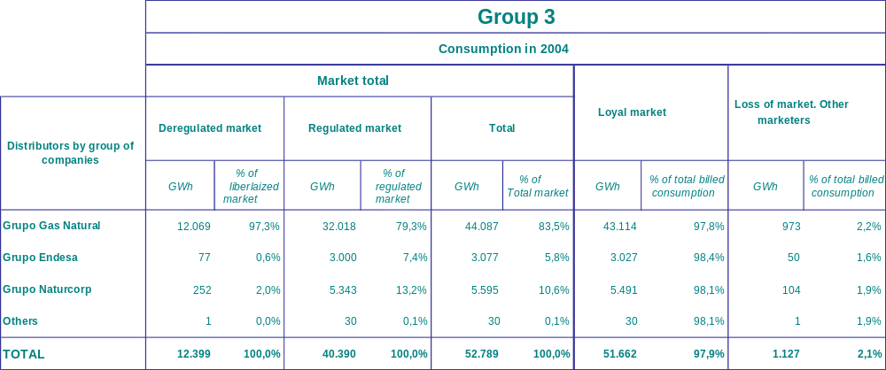

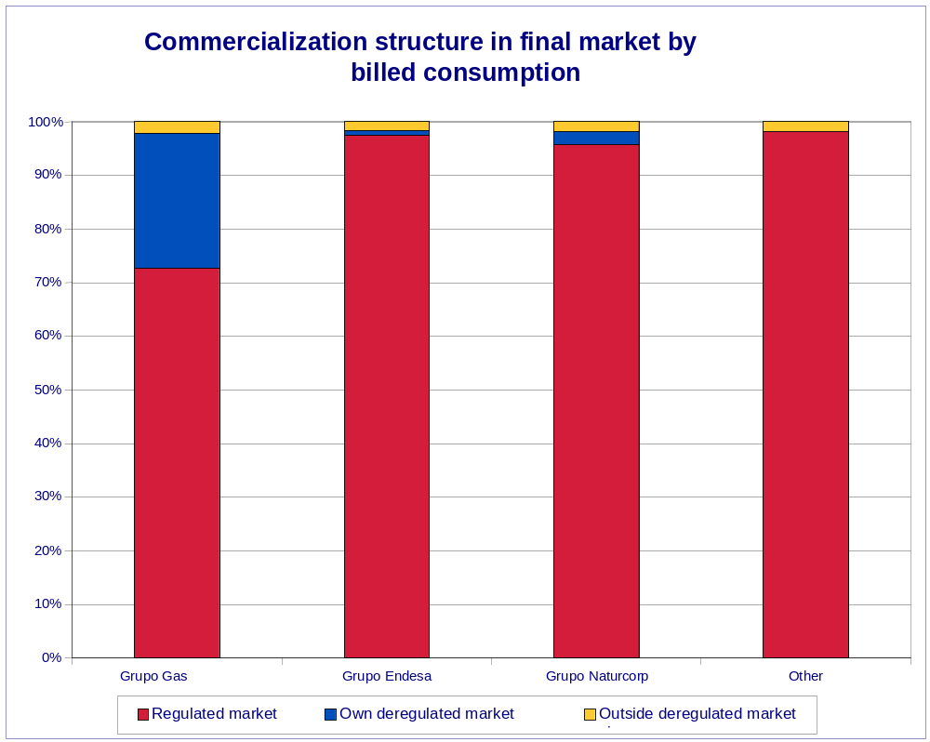

The following table and chart shows the evolution of the market deregulation in the last two years. One can see two significant facts. First, the progressive decrease of the proportion of customers supplied through the regulated market. Second, the progressive increase of the deregulated market proportion supplied by companies that do not belong to the group of the distributor that had been making shipments at tariff, which suggests a higher mobility and rate of change in consumers.

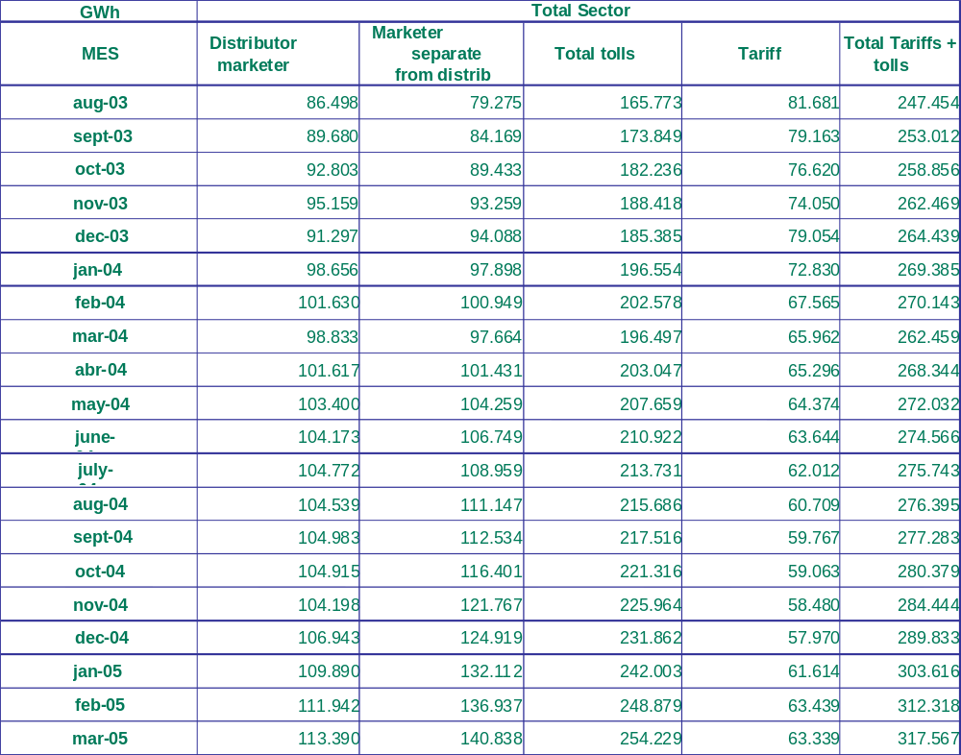

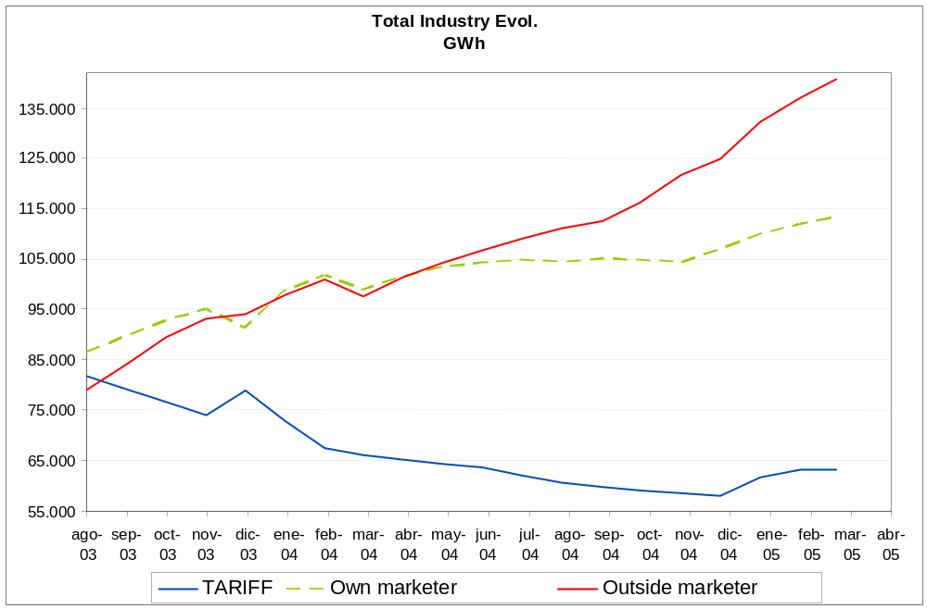

The report must include information on regulated procedures for change (deadline for change, rate of changes, cost, etc)

The procedure for customer change is regulated under Royal Decree 1434/2002 of 27 December. It regulates both a change of the supplier from the regulated market to the deregulated market and a change of marketer in the deregulated market and a change of a consumer from the deregulated market to the regulated one.

None of these changes should involve additional costs for any of the parties.

The deadline for the validation of applications is six business days following reception of the application and the effective data of change will depend on the following: for annual consumption below 100,000 kWh, the date of effective change will coincide with the 1st, 11th, or 21st of each month – the day closest the validation day; for consumption above 100,000 kWh, it will coincide with the real date of reading to be performed in the first five business days of each month; and for consumers with telemetering, the change date will be within the six business days following the validation date of the application.

Estimation of the extent to which the retail market is cornered by long-term contracts

As indicated above for procurement, because the commercialisation of natural gas has been deregulated and can be practised by agents freely, precise information is not available on the totality of gas supply contracts signed with consumers. In any event, the duration of contracts, in so far as information is available, does not generally exceed two years.

Information is provided on the proportion of contracts of capacity access for the long term – with a duration above two years – which will not necessarily coincide with the duration of the supply contracts.

At the end of 2005, capacity contracted for the long term for supply to the deregulated market at different entry points is as follows:
- In regasification plants in commercial operation: about 67% of capacity contracted.
- At entry through Larrau: about 95% of the capacity reserved.
- At entry through Tarifa: about 95% of the capacity reserved.

Evidence of anti-competitive joint services – refusal to supply L type gas to the consumer if he does not consume H, denial of capacity access separate from that of gas, discriminatory discounts or other discriminatory practices)

No practices restricting competition have been detected related to the joint offer of products and/or services.
As of 16 June 2005, the Competition Court handed down a ruling in a case presented by the CNE regarding a contract between GAS NATURAL COMERCIALIZADORA, S.A. and ENAGAS, S.A, both part of the GAS NATURAL group, for allegedly prohibited practices under articles 6 of the Competition Law and 82 of the EU Treaty, involving an abuse of a dominant market position.
On 22 November 2002, the CNE submitted to the Anti-Trust Department a complaint which reported indications of alleged prohibited practices regarding the contract signed in 2001 between ENAGAS, S.A. and GAS NATURAL COMERCIALIZADORA, S .A., involving an alleged abuse of dominant market position on the part of the GAS NATURAL group in activities of transport, distribution and commercialisation of natural gas by contractually hindering access by third parties to regasification capacity, a mechanism which is essential in the gas market.
The object of the above-cited contracted was a reserve for GAS NATURAL COMERCIALIZADORA of a certain regasification capacity in plants owned by ENAGAS. The capacity reserved would be used, firstly, to meet needs in the regulated market, where excess capacity would be for the sole use of GAS NATURAL COMERCIALIZADORA for sale in the deregulated market.
In 2002, ENAGAS had a regasified gas capacity that was superior that which it needed to meet demand in the regulated market, so excess capacity, under the contract, was to be placed under the control of GAS NATURAL COMERCIALIZADORA instead of being made available to all agents authorized under the law, such as other marketers, transporters and qualified consumers under equal conditions.
The Competition Court decided that GAS NATURAL had engaged in practices prohibited by law involving abuse of dominant market position by contractually preventing access by third parties to regasification capacity, as said access is essential for the supply of natural gas in the Spanish market. The Court levied a fine against the parent company a fine of eight million euros.
Finally, mention should be made of a report by the CNE which identifies a series of obstacles to liberalization of energy industries, either of a regulatory nature or owing to the practices of companies; the report suggests solutions for removing these obstacles.
Also include information on the level of retail prices (with reference to Eurostat figures if necessary) for the types of clients referred to in 4.1.3. Divide them as follows:

- Network costs
- Taxes as part of network costs
- Profit margin of supply operation
- Taxes

Please indicate whether the data refers to market prices or complete tariffs for regulated final customers.

Below, details are provided on the hypotheses included in the calculation of the final price by components of consumer types of natural gas as defined in the questionnaire. The timeframe for these prices is the year 2004.

- The cost of energy is calculated on the basis of the costs of raw materials as published quarterly by the Ministry. To calculate the cost of raw material for 2004, the different levels published in 2004 have been weighted according to the number of days they were in effect. This price has been modified by the pertinent losses as specified in Order ECO/31/2004.

- Network costs have been calculated by applying the tolls published in Order ECO/32/2004 for regasification, transport and distribution and underground storage to each consumer type. From the total network costs, a calculation has been made of levies included in network costs, namely, the CNE levy, the fee of the System Technical Manager and the provisional diversions of 2002.

- An entry load factor of 85% has been estimated for billing the regasification toll and the capacity reserve term of the transport and distribution toll.

- Billing of underground storage has assumed strategic storage of 20 days for each of the consumer types. For the household type, seasonal storage of 19.4% of firm annual consumption has also been included.

- The item ”levies included in network costs” is obtained by deducting from the total amount of tolls and levies the percentage reflecting other costs, as such as the CNE levy, the fee of the System Technical Manager and the provisional diversions of 2002. The percentage to deduct, in every case, has been taken from the provisional cost table of 2004.

- Calculation of the final price did not include the supply profit margin. Nevertheless, if each of the prices calculated is compared by cost aggregation – tolls, levies, Raw material unit price and losses – with the price resulting from the application of sales tariffs, the result for the D3 consumer would be about 5%, for I1 it would be 17% and for the consumer type I4-1 the margin would be 3%.

- The tax item is a result of applying 16% for VAT to the final price before taxes as calculated for the aggregation of applicable tolls and levies, losses and Raw material unit price.

Final consumer price by type of components (cent€/kWh). 2004
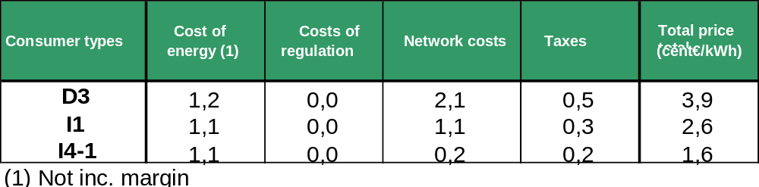
Note: It should be pointed out that consumer type I1 as defined in this questionnaire is not representative of industrial consumption in Spain. Specifically, consumers included in this toll to which this consumer type (toll 2.1) would apply, according to the characteristics defined in the questionnaire represent 14% of the number of total consumers in the tariff group to which the type belongs –customers connected at pressure levels between 4 and 60 bars), and solely 0.15% of the consumption of this tariff group.

5. SECURITY OF SUPPLY

5.1 ELECTRICITY (Article 4)
General outline
Article 4 of the Electricity Sector Act refers to electrical planning, which shall be indicative, except in relation to transport installations, and shall be carried out by the government with the participation of the Autonomous Communities. Planning shall be mandatory in the case of transport installations.
Furthermore, in Royal Decree 1955/2000 a planning procedure was established leading in 2002 to the drawing up of a Planning Document for the 2002 – 2012 period. The planning process for electricity and gas transportation infrastructures is being revised for its forthcoming update by the Ministry of Industry, Tourism and Trade.
In addition, as a result of concern regarding security of supply, the National Energy Commission has drawn up, on an annual basis, a study for short term electrical coverage. This is a specific report on demand for and coverage of electricity and gas over a five year timescale.

Current peak electrical demand levels (MW) and outlook for the next three years (e.g. 2006 – 08)
Energy demand reports constant annual growth. The average increase in recent years stands at 5%, considering both mainland and ex-mainland demand. During 2004, gross domestic demand virtually reached 250 TWh.
Demand for electrical power has also increased gradually. The peak demand for maximum power was recorded in winter 2004/2005: 43,378 MW. It is important to highlight the increased demand for power in the summer months, 38,600 MW being reached during summer 2005.
The evolution of peak hourly power demand, from 2000 to 2004, including the forecast to 2008, is as follows:
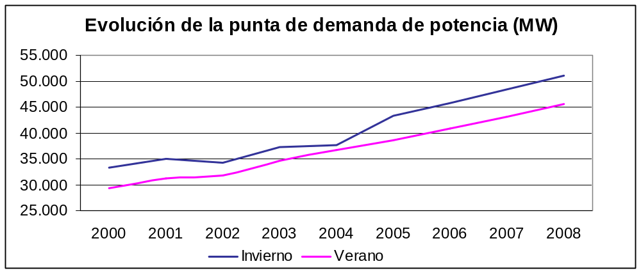

Current level of power generation capacity
At the end of 2004, power capacity in Spain stood at 71,961 MW, according to figures of the System Operator and the National Energy Commission. The breakdown of this power by technologies is as follows:

Power capacity (MW)
Technology | Mainland | Ex-mainland | Total domestic
Hydroelectric | 16,657 | 1 | 16,658
Nuclear | 7,876 |  | 7,876
Coal | 11,565 | 510 | 12,075
Fuel / Gas | 6,930 | 3,023 | 9,953
Combined cycle | 8,259 |  | 8,259
Total Ordinary Regime | 51,287 | 3,534 | 54,821
Cogeneration | 5,801 | 77 | 5,877
Wind | 8,019 | 134 | 8,152
Mini hydroelectric | 1,648 | 0 | 1,649
Rest | 1,425 | 37 | 1,462
Total Special Regime | 16,892 | 248 | 17,140
Total | 68,179 | 3,782 | 71,961

Forecast of investments in generation for the next three years:
- Authorised
- Currently under construction
Investments in new capacity in the ordinary regime are expected to be in combined cycle power plants.
From 2004 on, already authorised combined cycle power plants comprise a total of 9,600 MW split over the following three-year period in the following way:
2005 | 2006 | 2007
4,000 MW | 4,000 MW | 1,600 MW
For virtually all this future power in combined cycles, contracts are signed for access to the gas network. These two aspects – the holding of administrative permits and access contracts – allow a certain degree of assurance that these new stations will be incorporated to the domestic generation system.
The National Energy Commission monitors combined cycle installations under construction. By this means, it has learned that the construction of the sets planned for 2005 is continuing as planned, while the four sets planned for start-up on 2006 are delayed. There is an increase in delays in 2007, the number of sets being delayed (between 5 days and 2 years) standing at 19.
There are also authorisations for generation installations on the islands and for special regime production installations (cogeneration, renewable energies and waste).

Current generation mix and outlook for development

During 2004, mainland electrical generation derived from the following fuels/technologies, as per the percentages displayed in the chart:
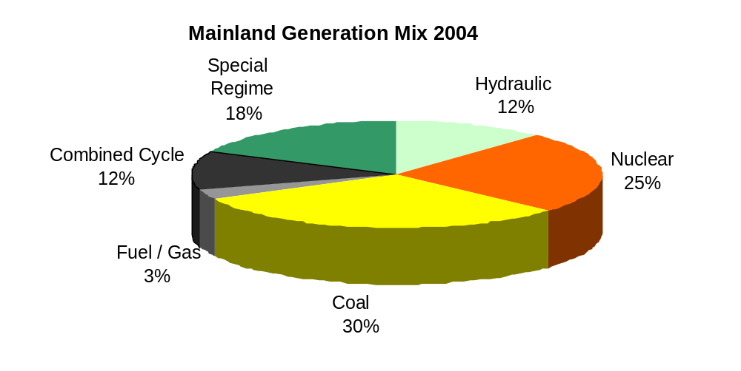
In the future, the proportion of coal-based generation is expected to decrease, due to the restrictions imposed by the Mining Plan, and fuel generation is also expected to fall. These decreases should be replaced with combined cycle natural gas power generation, which is more efficient and pollutes less. Furthermore, a gradual increase in special regime generation is expected.

Start-up of new projects and cancellation of equipment during 2004, including new power capacity from coal/fuel, gas, renewable energies, cogeneration and others.
During 2004, variation in power capacity on mainland Spain was positive, yielding a figure of more than 6,000 MW. 63% of this increase was due to the start-up of combined cycle plants, and 31% arose from the installation of new wind power.

The increase in power by technologies is as follows:
Increases in power in 2004
Combined cycle | 3,865 MW
Cogeneration | 125 MW
Wind | 1,870 MW
Mini hydroelectric | 42 MW
Rest | 186 MW
Total | 6,089 MW

Outline of the functions of the regulator and other authorities:
- Criteria for authorisation of new projects and function in long term planning
The Electricity Sector Act stipulates that prior administrative authorisation is required for the construction of electricity production installations. The granting of this authorisation must be governed by the principles of objectivity, transparency and non-discrimination. Administrative permit applicants will have to provide evidence of the following:
- Energy efficiency, technical and safety conditions of the proposed installations.
- Proper compliance with conditions for environmental protection and minimising of environmental impacts.
- The particulars of the location for the installation.
- Their legal, technical and economic-financial capacity for the carrying-out of the project.
These administrative permits shall be granted by the competent Administration, subject to the concessions and authorisations which may be required pursuant to other provisions. Furthermore, all authorised electricity production installations must be recorded in the Registry of the Ministry, providing information on the conditions and power thereof.
It is also stipulated that production activity shall include the transformation of electricity and connection with the transport and distribution network.
Regulation of the procedure for granting permits to generation installations is set forth in Royal Decree 1955/2000, and shall be the competence of the State, provided that more than one Autonomous Community is affected. In this case, the National Energy Commission must issue a report on the installation. Otherwise – in other words, if the power plant does not affect more than one Autonomous Community - the pertinent Autonomous Government shall be responsible. Electrical generation through nuclear power plants is an exception, given that these plants are governed by a specific regulation.
Furthermore, in accordance with the type of plant and its power, it must comply with law in force regarding:
- Environmental impact.
- Integrated pollution prevention and control.
- Trading of greenhouse effect gas emission rights.
It is important to note that the Electricity Sector Act stipulates that long term planning is indicative (except in relation to transport installations) and is effectuated by the State with the co-operation of the Autonomous Communities. The Act mentions that planning will have to refer to the forecast for electrical demand, the minimum power capacity that must be installed to cover the expected demand, the forecasts relating to transport and distribution installations, lines of action regarding service quality, energy saving and efficiency measures, evolution of market conditions and criteria for environmental protection.
Furthermore, on an annual basis this Commission draws up the Framework Report, which includes forecasts for the evolution in electricity and gas demand, and the situation and outlook in energy supply.

- Implicit and explicit incentives for construction of new capacity (e.g. power guarantee payments, premiums, balance mechanism designs)
The implicit incentive for installation of new power is the market price obtained from the sale of electricity production.
The power guarantee payment (or capacity payment) is an explicit generation incentive. This payment completes the market price, remunerating the installation's fixed costs in accordance with availability, without considering its operation. The power guarantee is therefore a long-term indication for the installation of new generation.
As far the special regime is concerned, there are special tariffs or premiums on market prices. The objective is for this regime to meet the targets laid down in the plan.

Progress of major infrastructure projects, in particular of the interconnections with Member States, including the regulatory framework in which they operate
The basic object of the Electricity Sector Act 54/97 is threefold: guaranteeing the electricity supply, the quality of that supply, and ensuring the supply is offered at the lowest possible price, without overlooking the environment. The Act also stipulates that all consumers are entitled to the supply of electricity, nation-wide, under quality and safety requirements laid down by regulation.

Electrical planning for the electrical transport grid is carried out by the government, with the participation of the Autonomous Communities, with these objectives in mind, considering a timescale which is broad enough for them to be satisfied.

The basic principle under which the transport grid must operate is that of guaranteeing supply, at the lowest possible cost, without forgetting environmental protection. The principles of objectivity, transparency and free competition, which are explicit in the regulation, must be employed by the Transport Grid Manager when deciding between the different options which arise in the course of its activities.
The electricity transport grid must therefore be conceived and planned in such a way that the continuity of supply is assured in the operation of the electrical system with the required level of quality.

The parameters whereby the state of the electrical system are supervised are basically: frequency, the node voltages and the load levels of the different components of the transport grid (lines, transformers and associated switchgear).

Under normal system operation, load levels should not exceed the nominal capacity of the transformers, nor the permanent thermal capacity of the lines defined for the different seasons of the year.
Furthermore, the system must maintain its control parameters within certain limits, even in the event of contingencies. The contingencies which must be taken into account in safety analyses are:
- The simple failure of any of the system components (criterion N-1).
- The simultaneous failure of two circuits of the double circuit lines which share supports over more than 30 km of their length.
- In special situations, when the testing of post-contingency operational measures requires an excessive period of time, the failure of the largest generation set in the area and its interconnection lines with the rest of the system must also be considered.

Planning of the transport grid is in accordance with three types of criteria: technical, economical and strategic, which are interrelated.

The object of the technical criteria is compliance with safety and reliability requirements for future grid configurations. These requirements must be consistent with the technical criteria set out in the system operation procedures.
The economic criteria allow for decision making between the different alternative options arising after the application of the technical criteria. The benefits of a particular action are evaluated in accordance with:
- More efficient management derived from:
  - Reducing transport losses.
  - Eliminating restrictions which could generate a higher global cost of the energy supplied.
  - The efficient incorporation of new generators to the system.
- More reliable and safer management keeping non-supplied energy to a minimum.
Strategic criteria comprise a set of general principles of a miscellaneous nature:
- Obligation to supply on the part of the distributors.
- Need to integrate environmental criteria in selecting developmental solutions, so keeping the global environmental impact to a minimum.
- Absence of capacity reserve in the electrical transport grid for generators.
- Co-ordinating the evolution of the transport grid with that of the distribution network and with the entry of new producers and consumers, with the aim of ensuring coherence in the development of the electrical system overall.
- Increase in international interconnection capacity.

The National Energy Commission draws up a Framework Report on an annual basis including forecasts on evolution in electricity demand and the situation and outlook for energy supply.

Said report includes the short-term forecasts shaping actions for the development of minimum infrastructures thought to be necessary to allow gas and electricity supply under appropriate quality and safety conditions.

Furthermore, the report explicitly identifies the areas of the electricity and gas system which might require high levels of investment due to the special development of demand at regional level or which could entail bottlenecks for the system in the mid-long term.

In addition, the National Energy Commission monitors the infrastructures referred to in the Framework Report. To this end, communication is held with the developers of said infrastructures.

- Since the 2002 Planning Document the objective is to promote “explicitly the development of international interconnections especially those shaped towards fostering the single European market".
- The plan is currently being revised.
- The National Energy Commission’s Framework Report for 2004 addresses possible initiatives to be carried out to reinforce international interconnections.
- Creation of MIBEL: the intention is to increase interconnection capacity with Portugal.
- Intention of increasing interconnection capacity with France.

Outline of the processes in which the System Operator participates for the construction of new network installations and to what degree they are integrated with congestion management and the operation of the production market.

Article 34.1 of the Electricity Sector Act 54/1997, of 27 November, provides that:

“1. The objective of the system operator, as supervisor of the technical management of the system, will be to guarantee the continuity and safety of the electrical supply and the correct co-ordination of the production and transport system.

Furthermore, article 22.7 of Royal Decree 5/2005, of 11 May, on urgent reforms for the promotion of productivity and to improve public contracting, which amends article 34.2 of the aforesaid Electricity Sector Act, includes the following amendments regarding the functions of the system operator:
“…..
d) Co-ordinate and modify, as the case may be, transport installation maintenance plans, in order to assure their compatibility with the generation set maintenance plans and assure an appropriate position of availability on the grid which might guarantee the security of the system.
e) Set up and control reliability measures for the production and transport system, affecting any component in the electrical system which might be necessary, and manoeuvre plans for service replacement in the event of general failures in the electricity supply and co-ordinate and control the execution thereof.
f) Provide operating instructions for the transport grid, including international interconnections, for real time manoeuvres.
….
l) Provide instructions required for the correct operation of the production and transport in accordance with the reliability and security criteria established, and manage the system adjustment service markets which may be required for that purpose.
…”

These functions are also complemented by those set forth in article 30.2 of Royal Decree 2019/1997, of 26 December, organising and regulating the electricity production market, which include the following:

“…
g) Establishing, in conjunction with transport agents, producers and distributors, manoeuvre plans for replacing the service in the event of general failures in the electricity supply and controlling the execution thereof, affecting any component of the electrical system which may be necessary. The foregoing shall be carried out pursuant to the regulation established for that purpose, and, in the absence thereof, with generally accepted criteria known to agents, subsequently justifying its actions before the affected agents, the National Electrical System Commission and the competent Administration.
…”

Likewise, in Royal Decree 2019/1997, of 26 December, organising and regulating the electricity production market, article 31, on operation procedures, provides that:

“1. The system operator shall submit, for approval by the Ministry of Industry and Energy, the operating procedures of a technical and instrumental nature which may be required for the proper technical management of the system, said Ministry handing down a decision following a report by the National Electrical System Commission.

2. Operating procedures will have to include at least the following aspects:
……
d) Analysis of security in short term coverage.
……
g) Operating information.
…….
h) System programming.
……
k) Operating conditions of the production and transport and quality, reliability and security criteria.
……
m) Management of each one of the complementary services.

n) Warning and emergency situations.
…...”

These sections are taken up in different operating procedures, amongst which we may highlight the following:

P.O. 1.1 “Operating and security criteria for the operation of the electrical system”, approved by Decision of 30 July 1998.
P.O.-1.2 “Admitted network load levels” approved by Decision of 30 July 1998.
P.O.-1.3 “Admitted network node voltages”, approved by Decision of 30 July 1998.
P.O. 1.6 “Establishment of security plans for system operation”, approved by Decision of 30 July 1998.
P.O. 2.2 “Forecast of coverage and analysis of security in the electrical system”, approved by Decision of 17 March 2004.
P.O. 3.4 “Transport Grid maintenance program”, approved by Decision of 17 March 2004
P.O.-4.0 “Management of International Interconnections” approved by Decision of 17 March 2004.
P.O. 6.1 “Operating measures to assure coverage of demand in warning and emergency situations", approved by Decision of 31 October 2002

P.O.-7.4 “Transport Grid Voltage Control complementary service”
P.O.-8.1 “Grid managed by the System Operator”, approved by Decision of 30 July 1998.
P.O.-8.2 “Network operation”, approved by Decision of 18 December 1998.
P.O.-8.3 “Voltage control” approved by Decision of 18 December 1998.
P.O.-11.1 “General protection criteria in the managed grid” approved by Decision of 24 June 1999.
P.O.-11.2 “Criteria for installation and operation of automatisms” approved by Decision of 24 June 1999.
P.O.-11.3 “Analysis and monitoring of the operation of system protection and automatisms”, approved by Decision of 24 June 1999.
Revenues from transport and distribution activities are included in the regulated revenues of the electricity sector and the remuneration by company is established, in order to subsequently finance from these items the future projects for the construction of new installations.

5.2 GAS [Article 4]

A general outline of the situation of supply-demand which includes the following indicators, must refer to the forecasts of the TSO when they are available:

- Current gas consumption levels (bcm) and forecasts for the next 3 years ( 2005-08)

The following table displays natural gas consumption in 2004 and the forecasts for change in demand for the 2005-2008 period:

Source: National Energy Commission
TOTAL annual demand (bcm) | 2004 | 2005 | 2006 | 2007 | 2008 | Average increase  [%]
Higher Scenario | 27.4 | 32.9 | 39.4 | 51.2 | 57.7 | 20.6%
Central Scenario | 27.4 | 30.4 | 32.3 | 34.8 | 37.2 | 8.1%
Lower Scenario | 27.4 | 29.9 | 32.0 | 34.2 | 36.5 | 7.5%

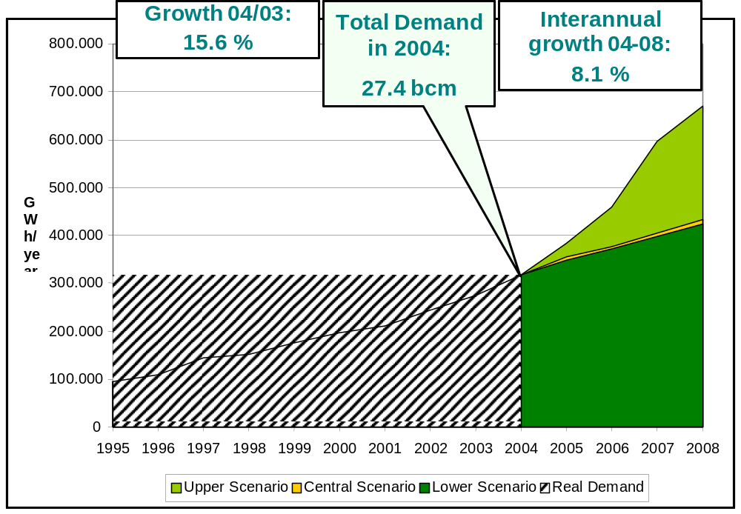

- Current production and import capacity (bcm)

- Capacity of regasification plants

Regasification plant | Storage capacity (bcm) | Vaporisation capacity (bcm/year) | Maximum docking capacity m³ LNG
Barcelona | 0.14 | 10.5 | 1x 80,000  1x140,000
Huelva | 0.18 | 7.9 | 140,000
Cartagena | 0.09 | 7.9 | 140,000
Bilbao | 0.18 | 7.0 | 140,000
TOTAL | 0.59 | 33.3 | 560,000

- Capacity of international connections by gas pipeline

Location | Peak traffic  bcm  (End of 2004)
Larrau | 2.5
Tarifa (Spain & Portugal) | 13
Badajoz (exit towards Portugal) | -3.1
Tuy (entry towards Spain) | 04
NET ENTRIES TO THE SPANISH SYSTEM | 12.8

- Production capacity of domestic fields

Solely three natural gas fields are currently in production in Spain: two of them are land-based, Marismas and Palancares, in the Guadalquivir valley; and one of them, Poseidón, is offshore, in the Gulf of Cadiz. However, production levels are declining, evidenced by the reduction in peak production capacity (and annual production) against former years, and the fields are expected to be totally exhausted by 2006.

Field | Production capacity (bcm)
Guadalquivir valley (Marismas and Palancares) | 0.05
Poseidón (Gulf of Cadiz) | 053
TOTAL | 0.58

- Investment in production and import capacity for the next three years:

  - authorised

  - under construction

No investments in new natural gas production fields are expected over the next three years.
The new projects for increasing entry capacity over the next three years are specified below. All of them are included in the Ministry of Industry planning document. Those in which construction is under way are indicated:

- Regasification plants

PROJECT | DEVELOPER | COMMERCIAL OPERATION PLANNED BY DEVELOPER | COMMENTS
Barcelona regasification plant
Increase in emission capacity to 72 bar network of 2.6 bcm/year. Final capacity of 13.1 bcm/year | ENAGAS | 30/08/2005 | Under construction
Increase in emission capacity to 72 bar network of 1.3 bcm/year. Final capacity of 14.4 bcm/year | ENAGAS | 31/12/2005 | Under construction
Increase in emission capacity to 72 bar network of 1.3 bcm/year. Final capacity of 15.8 bcm/year | ENAGAS | 30/11/2009
5th storage tank with 0.087 bcm capacity. Final capacity of 0.227 bcm. | ENAGAS | 1/12/2005 | Under construction
6th storage tank with 0.087 bcm. Final capacity of 0.314 bcm | ENAGAS | 30/04/2007 | Under construction

Cartagena regasification plant
Increase in emission capacity of 1.3 bcm/year. Final emission capacity of 9.2 bcm/year | ENAGAS | 31/03/2006
Increase in emission capacity of 1.3 bcm/year. Final emission capacity of 10.5 bcm/year | ENAGAS | 31/10/2006
3rd storage tank with 0.074 bcm capacity. Final capacity of 0.167 bcm | ENAGAS | 30/6/2005 | Under construction
4th storage tank with 0.087 bcm capacity. Final capacity of 0.255 bcm | ENAGAS | 30/6/2008
5th storage tank with 0.087 bcm capacity. Final capacity of 0.342 bcm | ENAGAS | (2008)
Huelva regasification plant
Increase in emission capacity to 72 bar network of 1.3 bcm/year. Final emission capacity at 72 bar of 9.2 bcm/year | ENAGAS | 30/09/2005 | Under construction
Increase in emission capacity to 72 bar network of 2.6 bcm/year. Final emission capacity 72 bar of 11.8 bcm/year | ENAGAS | 31/12/2006
4th storage tank with 0.087 bcm capacity. Final capacity of 0.268 bcm. | ENAGAS | 31/08/2006 | Under construction
5th storage tank with 0.087 bcm capacity. Final capacity: 0.355 bcm. | ENAGAS | (2006)

Mugardos regasification plant
New plant with emission capacity of 2.8 bcm /year and two storage tanks of 0.087 bcm each. | REGANOSA | 26/12/2006 | Under construction
Increase in emission capacity of 4.2 bcm/year. Final capacity of 7 bcm/year. | REGANOSA | 26/12/2006
Sagunto regasification plant
New plant with emission capacity of 6.6 bcm/year and two storage tanks of 0.087 bcm each | SAGUNTO REGASIFICATION PLANT | 1/3/2006 | Under construction
Gran Canaria regasification plant
New plant with emission capacity of 1.3 bcm/year and a storage tank of 0.087 bcm. | CANARIAS GAS TRANSPORTER | 1/3/2009

- Interconnections by gas pipeline

  - Larrau connection (Enagas) The increase in interconnection capacity via Larrau is associated with the construction of the Navarra compression station (formerly known as Lumbier), which according to its developer should be started up on 31/12/2008. Transportation capacity via this interconnection could be increased to 4.5 bcm/year.
  - France – Spain connection by Irún (Sociedad de Gas de Euskadi) As stated in the Framework Report, the Spanish section “Irún – French border” was started up at the end of 2004. However, the 23 km of the French section to Lussanec are still to be constructed; they are expected to be operational by the end of 2005. The initial capacity of this interconnection will be 0.5 bcm/year.
  - Medgaz connection According to the information at the Commission’s disposal, this project is expected to start up commercially at the end of 2008. The initial capacity of this infrastructure will be 8 bcm/year, although by 2015 it is expected to be increased to 16 bcm/year.

Outline of the role of the regulator and other authorities, as described specifically in the Directive:
- Requirements relating to the supplier of last resort
- Incentives of any kind for increasing production or import capacity

The different regulatory Authorities and Bodies take part in determining and supervising security of supply in different ways.

We may highlight the Gas System Planning procedure, the final responsibility of which rests with the Government, and in which the Autonomous Communities, the Technical System Manager, other system agents, transporters, distributors and marketers, and this Commission, also take part. Said Planning is of a indicative nature, except in respect of the basic network gas pipelines, the calculation of the total regasification of liquefied natural gas necessary to supply the gas system, hydrocarbon strategic reserve storage plants and the establishing of general criteria for setting up retail oil product supply installations, in which case it shall be on a mandatory and minimum enforceable basis for the guaranteed supply of hydrocarbons. The document deals, inter alia, with the following areas:
- The forecast for demand for oil and natural gas derivative products over the stipulated period (ten years).
- The forecasts for development of the basic natural gas transportation network and total liquefied natural gas regasification capacity required to supply the gas system, with the aim of meeting demand with using gas infrastructure optimisation criteria nation-wide.
- Defining of priority gasification areas, network expansion and stages of execution, with the aim of assuring uniform development in the gas system nation-wide.
- Forecasts relating to gas fuel transportation and storage installations, and liquefied natural gas reception and regasification plants, with the aim of assuring the stability of the gas system and the regularity and continuity of the gas supplies.
- Environmental protection criteria are established.
Therefore, the promotion of an increase in the entry capacity to the system is secured via centralised planning and the application of an appropriate rate of remuneration for the infrastructures.

Furthermore, it is important to note, in relation to security of supply, that the Law renders it compulsory for all agents incorporating gas to the system:
- To maintain minimum security stocks of 35 days of sales or final consumption.
- To diversify supplies, in order that the proportion thereof deriving from a single country should not exceed 60%. Supplies used for the consumption of installations with alternative fuels, and under certain circumstances, are exempt from this requirement, so as not to hinder the entry of new agents and also taking into account global diversification conditions of all imports.
The Corporación de Reservas Estratégicas de Productos Petrolíferos (Oil Products Strategic Reserves Corporation), CORES, is responsible for compliance with these conditions.

This Commission also performs a study, updated on an annual basis, analysing electrical demand and the coverage thereof, in the short term, under a four-year timescale. This report, which is no substitute for the Government Planning, but is a complement, is a detailed analysis of foreseen demand and supply, and of the adequacy of infrastructures to assure that demand will be covered over the next four years.

As far as the supplier of last resort is concerned, it should be noted that all consumers who choose to be supplied via the deregulated market currently have the possibility of returning to the regulated market. No prior conditions are established to return to the regulated market, except in the following cases:
- Consumers with an annual consumption equal to or higher than 100 million kWh will have to remain in the deregulated market for a minimum period of 3 years and must make the application for change at least six months in advance.
- Consumers connected to a gas pipeline designed for pressure of above four bars and up to 60 bars with an annual consumption of less than 100 million kWh will have to make the application of change at least six months in advance.

- Requirements relating to the availability of storage to meet public service obligations

Pursuant to Act 34/1998, of 7 October, implemented by Royal Decree 1716/2004, of 23 July, regarding public service obligation in relation to strategic storage, all agents incorporating gas to the system must maintain minimum security stocks equivalent to thirty five days of sales or final consumption.

According to the latest analysis made by this Commission, maximum system storage capacity, including underground storage, LNG and gas pipeline stock, is equivalent to 45 days of average daily demand. Nevertheless, considering the use of underground storage facilities (which fill in summer and are emptied in winter) as operating and seasonal storage, it is very unlikely that the average annual gas storage level in the system could reach the 35 days laid down by law.

Lastly, the regulator must specify any progress in respect of large-scale infrastructures and, in particular, important interconnections with other Member States and the regulatory framework under which they shall operate.

The current entry capacity and the degree of progress of the new increase projects and new interconnection infrastructures with other countries have been specified in previous sections.
No particular access regime is contemplated for any of the new infrastructures; in other words, access of third parties shall be regulated in the same way as for the existing infrastructures.

6. PUBLIC SERVICE ASPECTS [Article 3 (9) electricity and 3 (6) gas]

Implementing primary energy labelling (electricity)

The Royal Decree proposal that adapts regulations relating to the electricity industry to the provisions of Royal Decree-Law 5/2005, regarding urgent reforms to boost productivity and to improve public contracts, contains a section on consumer protection measures including informing the latter on the source of the electricity consumed and the environmental impact.

Specifically, a new article has been added to Royal Decree 1955/200, article 110 bis, as regards informing the consumer on the source of the electricity consumed and environmental impact, which sets down the following:

Electricity suppliers must specify in or with the bills, or attached thereto, and in promotional materials made available to final customers:
- the contribution of each energy source to the overall fuel mix of the supplier over the preceding year,
- the reference to existing reference sources where information on the environmental impact, in terms of at least emissions of CO2 and the radioactive waste resulting from the electricity produced by the overall fuel mix of the supplier over the preceding year is publicly available.
With respect to electricity obtained via an electricity exchange or imported from an undertaking situated outside the European Community, aggregate figures provided by the system operator over the preceding year may be used. For this purpose, the system operator shall publish these aggregate figures during the first term of the year following that to which the information refers.

Implementing Annex A (Directive) criteria

ELECTRICITY

Royal Decree 1955/2000 regulates all matters relating to fixed-rate supply and access contracts and cutting off of the supply.

Before studying the regulation of contracts in detail, it is worth mentioning that the Royal Decree proposal that adapts regulations relating to the electricity industry to the provisions of Royal Decree-Law 5/2005, regarding urgent reforms to boost productivity and to improve public contracts, contains, in the section on consumer protection measures, the minimum requirements that must be included in contracts signed with domestic customers.

Specifically, a new article has been added to Royal Decree 1955/200, article 110 ter, regarding the minimum requirements of contracts signed with domestic customers, which sets down the following:

- The contracts must clearly specify the following:
- the distributor or supplier’s ID and address:
- the duration of the contract, the conditions for renewal and the causes of cancellation and termination thereof;
- the dispute settlement procedure and overseeing Organisations or Tribunals;
- information on applicable prices and rates and, where appropriate, official provisions that set the latter. This information should be constantly updated through billing;
- the minimum quality level required under the terms established in the present Royal Decree and the consequences on billing in the event of breaches;
- the periods for initial connection established in the present Royal Decree;
- other services rendered, including, where applicable, maintenance services proposed, in accordance with existing law.
- The conditions included in the contracts must be in keeping with existing law and must be notified before the latter are entered into or signed, either directly or via third parties.
- Consumers should be duly notified of any intention to change the contract conditions and informed of their right to terminate the contract upon receiving this notification.

At present, existing regulations on contracts signed between electricity suppliers and consumers are included in the following articles of Royal Decree 1955/2000:

Article 79 of Royal Decree 1955/2000 sets down the general conditions of fixed-rate supply and access contracts with the following provisions:

    - The supply shall take place:
a) By means of fixed-rate supply contracts.
b) By means of freely contracting energy and the relevant network access contract.
    - The supply contract is personal, and the owner should be the energy consumer, who should not use it in a different place to that for which the supply was contracted, nor transfer or sell it to third parties.
    - Fixed-rate supply and network access shall be contracted with the distributors by signing a contract. The Ministry of Finance has prepared sample supply and network access contracts.
Although existing law may consider other periods for specific supplies, the duration of fixed-rate supply and network access contracts shall be annual and shall be extended by tacit agreement for equal periods. Nonetheless, the consumer may terminate it early provided that they notify the distributor at least five working days prior to the date on which they wish to cancel the supply, notwithstanding the resulting economic conditions in accordance with existing law on rates.
- The consumer shall have the right to choose the rate that they deem suitable, from those officially approved, bearing in mind the network voltages available in the area, as well as the power supply that they wish to contract from those that result from applying the standardised intensities for control equipment that is going to be used.
- The distributors shall be obliged to meet the requests to change a rate, the method of applying the latter and the power supply contracted. Consumers who have voluntarily changed the rate, power contracted or methods of application or other can be refused use of another rate provided that at least twelve months have not passed, unless changes are made to the pricing system that affects them.
- Upon signing the contract, the distributor can require a guarantee deposit of an amount equal to the monthly billing for fifty hours of using the power supply contracted.
The distributor shall require the guarantee deposit from the dealer when the latter contracts the access on behalf of the qualified consumer.
Where the deposit is not required in a given geographical area and specific consumer category, this exemption should be published and notified to the Directorate General for Energy and Mining Policy. In any other case, the exemption cannot discriminate between consumers with similar characteristics, which must be reported to the Directorate General for Energy and Mining Policy.
The deposit shall be considered to be assigned to the consumer as the owner of the contract and cannot be required once six months have passed since the first time this is executed.
Returning the guarantee deposit, which shall be given to the consumer regardless of whether the latter has contracted the access directly or via the dealer, shall be automatic upon the official termination of the contract, and the distributor shall be authorised to apply the part of the aforementioned deposit that corresponds to the balance of the outstanding amounts once the contract has been terminated.
- Apart from the deposit, the distributor cannot require advance payment of any amount. As an exception, for temporary, short-duration supplies, i.e. less than two months, early billing of the estimated consumption shall be admitted, based on the requested power supply and the foreseeable number of hours of use. In this case, the deposit shall not be paid.
- Distributors can refuse to sign supply rate or access rate contracts with consumers who have been found to be debtors by an unappealable judgement vis-à-vis any distributor and for any amount included in the present Royal Decree provided that the payment of this debt was not proven and exceeded 25,000 pesetas (€150.25). Likewise, they can refuse to sign the fixed-rate supply and network access contract when the consumer’s installations do not meet required technical and safety conditions.
- All consumers have the right to receive the supply under the minimum quality conditions established in the present Royal Decree.

Article 80 of Royal Decree 1955/2000 sets the fixed-rate supply contract conditions with the following provisions:

    - Fixed-rate supply contracts can be signed with distributors by any consumer who do not have a qualified status or, having this, do not exercise it in accordance with existing law.
    - The consumer has the right to be informed and advised by the distributor upon signing the contract, regarding the information provided on rates and the most suitable power supply or power supplies to contract, extra rates and other conditions in the contract, as well as the power supply assigned to the building in accordance with the electricity supply chapter of the present Royal Decree.
    - If the connection of the consumer’s installations takes place in the transport network, the supply rate contract shall be signed with the local distributor, upon submission of the technical contract signed with the transporter. In cases of cancelling supply and terminating contracts, the distributor shall notify the transporter to whom the consumer is connected so that the former can cut off the supply.

Article 81 of Royal Decree 1955/2000 sets the network access contract conditions with the following provisions:

- Network access contracts can be signed with distributors by any qualified consumer and other persons under the terms established in existing law.
- Qualified consumers who opt to exercise this right will be able to contract the network access and purchase the energy together or separately.
- Where the qualified consumer opts to contract the energy and network access together with a dealer or another qualified person, the latter can only contract the network access with the distributor on behalf of the former, being obliged to specify the duration of the energy purchasing contract, which shall not be valid until access to the network is provided.
- In these cases, the dealer or qualified person shall be obliged to inform the consumer, on an annual basis, about the breakdown of the bill that corresponds to the access rate that they have contracted with the distributor on their behalf, unless the consumer decides that they want this to be included in each bill, in which case the dealer is obliged to provide this information.
- In any case, in relationships between the consumer and the dealer or another qualified person that agreed by the parties shall apply, regardless of whether the network access rates are regulated.
- Qualified persons and qualified persons who opt to contract the energy purchasing and network access separately shall directly contract the network access with the distributor, being obliged to notify the latter of the specific person with whom they have signed, at each moment, the energy purchasing contract and the duration thereof.
- The network access contract shall be signed for each of the connection points thereto, regardless of whether this is a single building, unless the Directorate General for Energy and Mining Policy has authorised the group of connection points in accordance with existing law on rates.
- The qualified consumer or person has the right to be informed by the distributor, upon signing the contract, about the available power supplies in accordance with the different available voltages in the area.
- If the connection of the consumer’s installations takes place in the transport network, the network access contract shall be signed with the local distributor, upon submission of the technical contract signed with the transporter.
- Where the access is cancelled or the contract terminated, the distributor shall notify the transporter to whom the qualified consumer or person is connected so that they can disconnect their networks.

In addition, the sixth temporary provision of Royal Decree 1955/2000 establishes the following in relation to third party access to the networks:

- All qualified persons and consumers who, prior to being given their qualified status, received a fixed-rate supply, shall automatically be given the right to access the networks, at the power supply assigned to the installation, which in no case can be lower than that contracted in the price, without there being any charge as a guarantee deposit, unless the contracted power supply increases.
With this in mind, the consumer or their representative shall notify the distributor in writing about the change in the supply method, one month in advance of the date on which they wish to make the switch. During this period, they must sign a new access contract and complete the fixed-rate supply readings within fifteen days from when the fixed-rate supply contract is cancelled.

Article 98 of Royal Decree 1955/2000 establishes the following with regard to making claims:

- Claims or disagreements that are caused by the fixed-rate supply or network access contract or by the bills resulting from the latter shall be settled by administrative procedures by the competent energy authority of the Autonomous Region or the Cities of Ceuta and Melilla, wherever the supply is provided, regardless of the jurisdictional actions that may occur at the request of any of the parties, notwithstanding the eleventh provision, third point, of Law 34/1998, of 7 October, regarding the Hydrocarbons Industry.

As well as these general conditions for all consumers, for consumers with a low voltage connection, Royal Decree 1435/2002 regulates the basic conditions of energy purchasing and network access contracts.

Article 3 of Royal Decree 1435/2002 regulates the execution of access rate and energy purchasing contracts:

- The consumer may opt to contract the network access directly with the distributor and the energy with a dealer, or to contract the energy and network access through a dealer.
- Consumers who opt to contract the network access directly with the distributor shall be obliged to provide the latter with documentary evidence of the existence of an energy purchasing contract with a dealer, as well as documentary evidence of the duration thereof.
- Where the consumer opts to contract the energy and network access through a dealer, the latter can only contract with the network access distributor as the consumer’s representative. The supply contract between the consumer and the dealer must be made official in writing. It must include the consumer’s consent for the dealer to act as their representative, by contracting the access rate with the distributor and providing the distributor the necessary information for the supply. The inclusion, processing and transfer of this information must at all times adhere to the provisions of applicable personal data protection regulations.
- Where the consumer opts to contract the energy and network access through a dealer who stands in for the consumer, the distributor may require the sufficient power of attorney granted by the consumer in favour of the dealer.
In this case, in the signed access contract the dealer will act as the relevant consumer for all intents and purposes.
- Where the qualified consumer opts to contract the network access through a dealer, the latter shall inform the consumer about the appropriate billing of the access rate.

The duration of the contracts and the change in contracting method are regulated by article 4 of Royal Decree 1435/2002, which establishes the following:

- Access rate contracts have a duration of one year, and are renewed for equal periods by tacit agreement. The exceptions included in regulations regarding access rates in relation to the duration of temporary, seasonal, international interconnection, extra energy supply contracts and contracts for supplies to special installations shall not apply for low voltage access rate contracts. 2. Consumers who opt to return to the supply rate must keep this contracting method for at least one year, without being able to sign a new energy purchasing and network access contract before the end of this period.
- Where a consumer switches from a fixed supply rate to an access rate and where this switch only involves the contracting method being amended, no extra charge will apply. Where the power supply contracted is changed or actions affecting measuring and control equipment or the installations are carried out, the provisions of existing law shall apply.
- Switching from fixed supply rate to access rate shall not end the payment obligations agreed between the parties as a result of the previous contracting method. In particular, the distributors will still have the possibility of cancelling the supply in the event that the previously contracted rate is not paid.

The termination of low voltage energy purchasing contracts is regulated by article 5 of Royal Decree 1435/2002, which establishes the following:

- Except for cases where the cause of termination of a contract is failure to pay bills by the consumer, in which case Royal Decree 1955/2000, of 1 December, shall apply, when a low voltage energy purchasing contract between a consumer and a dealer is cancelled early, or the duration of the contract ends, the dealer must notify the consumer and the distributor.
In the notification sent to the consumer and the distributor, the dealer shall specify that, unless the consumer proves that they have an energy purchasing contract with another dealer or requests that the distributor switches to a supply rate, the distributor shall bill the consumer for the relevant supply rate once fifteen days have passed since the date of the notification. This bill must be sent by registered mail or any other means that shows proof of the notification. The distributor shall bill the consumer in accordance with the foregoing as from the abovementioned period, unless during the fifteen days’ notice the consumer indicates otherwise or the consumer proves that they have a new energy purchasing contract with a dealer or that they have signed a supply rate contract.
- Where the electricity dealer does not notify the consumer and the distributor of the termination of the energy purchasing contract, the distributor shall be exempt from any responsibility regarding the energy supplied to the consumer, which shall fall on the dealer.

Lastly, article 6 of Royal Decree 1435/2002 establishes the conditions and terms for switching from a fixed supply rate to an access rate and the terms for switching dealers, setting the following procedure:

- In order for consumers to sign energy purchasing and access rate contracts, their power supply measuring and control equipment must meet the applicable requirements to be able to calculate access rates and pay for the energy.
- At low voltage supply points that do not require actions to be taken on the installation to be able to switch from a fixed supply rate to a access rate, this switch must be made within the following terms:
a) For energy supplies with a two-monthly reading and billing cycle, the consumer may opt for the switch to the deregulated market to take place within fifteen days following the request, or when this falls in accordance with the reading cycle, of which they shall inform the distributor or the dealer when the latter acts as their representative or stand-in.
b) For energy supplies with a monthly reading and billing cycle, the switch to the energy purchasing and access rate contract shall take place when this falls according to the reading cycle.
At low voltage supply points that require that the distributor take actions on the installation to be able to switch from a supply rate to an energy purchasing and access rate contract, this switch shall take place when the actions are carried out, which in any case must be in keeping with the set periods. With this in mind, the distributor shall complete the readings together with the actions on the installations.
- The periods set in the previous section must be met during processes of switching dealers.
- At supply points that do not record hourly consumption, energy purchasing cannot be contracted with more than one dealer. If the hourly consumption is recorded, it may only be contracted with a single dealer in each energy payment period.

GAS

In the natural gas industry, the consumer protection measures specified in Annex A of Directive 2003/55/CE are not regulated. Moreover, in this industry, unlike in the electricity industry, there is no legislative reform regarding the aforementioned consumer protection measures, although some of these measures are already included in the industry’s current regulations.

Royal Decree 1434/2002 regulates all matters relating to switching suppliers in the natural gas industry.

Article 44 of Royal Decree 1434/2002 provides for the following relating to switching suppliers.

- Any consumer with a natural gas supply who has a qualified status may request, either themselves or through a dealer, to switch suppliers.
- Applications to switch suppliers must include the following information at least:
a) Date of request or notification.
b) Consumer’s ID: Customer’s ID or tax ID number, name,
address.
c) Identification of the supply point.
d) Customer’s consent to the supplier switch.
e) Company with which the supply is being provided.
f) Company that is going to provide the supply.
g) Company in charge of metering.
h) Characteristics and owner of measuring equipment.
i) Conditions of the new contract (Rate, Tolls,
etc.), that allow the consumption and the associated tolls to be billed.
j) Contract duration and type.
- For supplies at a pressure of equal to or less than 16 bars, the application shall be submitted to the distributor, who shall validate the latter, checking that the information contained therein matches that stored in the database to which article 43 refers, and that the new supplier is duly authorised to carry out this activity. As regards supplies that involve an annual unitary consumption of over 10 GWh, they shall obtain the validation of the applications by the transporters that own the installations entering the transport and distribution system.
The transporters shall check applications with annual consumptions of less than 10 GWh, grouped by dealer and point of entry in order to perform the checks on who authorise the existing regulations on third party access.
The maximum term to validate applications shall be six working days as from the date on which the application is received, notifying the applicant of possible shortcomings within this period.
- For supplies at a pressure of over 16 bars, applications to switch suppliers shall be validated and processed in accordance with Royal Decree 949/2001, of 3 August, which regulates third party access to gas installations and establishes an integrated economic system for the natural gas industry.

Article 45 of Royal Decree 1434/2002 establishes the following with regard to a consumer who switches from the regulated market to the deregulated market:

- Any consumer whose natural gas supply is provided at set rates and who has a qualified status may request, either themselves or through their new dealer, that the distributor who has the supply point assigned switch suppliers, providing the consumer’s consent.
- For consumers with an annual consumption of less than 100,000 kWh, once the application has been validated in accordance with article 43, the distributor shall estimate the consumption and pay the fixed-rate supply, notifying the dealer of the switch date. The switch shall always take place on the 1st, 11th or 21st of each month, the distributor being in charge of selecting the closest date to the validation date.
- For consumers with an annual consumption of equal to or more than 100,000 kWh, once the application has been validated the distributor shall take the reading and pay the fixed-rate supply, notifying the dealer of the switch date. The switch shall coincide with the date on which the reading is taken, which shall take place during the last five days of each month, the distributor being in charge of selecting the closest date to the validation date.
For consumers with telemetering, the switch date shall be within six working days following the application validation date.
- Switching from a fixed-rate supply to the deregulated market shall not involve any costs for the consumer or for the dealer. The supply payment bill shall only include the amounts charged for the supply up until the switch date and any other contracts between the consumer and distributor shall not be affected by the switch to the deregulated market, and can be kept or terminated in accordance with the contract conditions.
- The switch to the deregulated market by a consumer shall automatically, and as soon as it takes place, change the dealer’s relevant access contract for the transport and distribution system and the bills sent to the latter for the appropriate tolls. This change shall not apply to access contracts for regasification plants, warehouses or entry to the transport and distribution system, which shall be subject to the same conditions established in the contracts signed by each dealer.
- As regards payment of the fixed-rate supply, the provisions regarding claims in article 61 shall apply, and in the event of failure to pay the supply shall be cut off in accordance with article 57 of the present Royal Decree.
- The distributors and dealers shall keep, for a period of five years, a record of all correspondence exchanged for customers switching from the regulated market to the deregulated market with a view to solving possible disputes.

Article 46 of Royal Decree 1434/2002 establishes the following with regard to switching dealers in the deregulated market:

- Any consumer whose supply is provided in the deregulated market may request, either themselves or through their new dealer, that the distributor who has the supply point assigned switch dealers, providing the consumer’s consent.
- For consumers with an annual consumption of less than 100,000 kWh, once the application has been validated the distributor shall estimate the consumption and notify the dealer who used to provide the supply and the new dealer of the switch date. The switch date shall always fall on the 1st, 11th or 21st of each month, the distributor being in charge of selecting the closest date to the validation date.
- For consumers with an annual consumption of equal to or more than 100,000 kWh, once the application has been validated the distributor shall read the meter, notifying the dealer who used to provide the supply and the new dealer of the switch date. The switch date shall fall on the date on which the reading was taken, which shall take place during the last five working days of each month, the distributor being in charge of selecting the closest date to the validation date.
For consumers with telemetering, the switch date shall be within six working days following the application validation date.
- Switching dealers shall automatically, and as soon as it takes place, change the relevant access contracts to the transport and distribution system of the dealers involved. This change shall not apply to access contracts for regasification plants, warehouses or entry to the transport and distribution system, which shall be subject to the same conditions established in the contracts signed by each dealer.
- Possible disputes regarding payment and termination of the supply contract shall be settled in accordance with the conditions therein, and in any case in accordance with company law.

Article 47 of Royal Decree 1434/2002 modified by Royal Decree 5/2005, establishes the following with regard to consumers switching from the deregulated market to the regulated market:

- Any consumer who fulfils the conditions established in section 2 may apply to their distributor to switch to the regulated market.
- To be able to apply for a switch from the deregulated market to the regulated market, the following conditions must be met:
a) Consumers with an annual consumption equal to or more than 100 million Kwh shall remain in the deregulated market for a minimum period of three years and shall submit their application to switch to the distributor with a minimum notice of six months prior to the date on which the switch is planned to take place.
The three-year period shall be counted as from the date on which this Royal Decree enters into force or as from the switch date in the event that the switch to the deregulated market takes place afterwards.
b) Consumers connected to a gas pipeline with a design pressure of more than four bars or less than or equal to 60 bars and whose annual consumption is less than 100 million k.o. shall submit their application to the distributor with a minimum notice of six months prior to the date on which the supplier switch is planned to take place.
c) No conditions are set for other consumers.
- The distributor shall make the requested switch by following the same procedure and terms established in article 46 once the six months’ notice has passed, where appropriate.
- Once the return to the fixed-rate has been made, the consumer must stay in the regulated system for at least one year.

Article 61 of Royal Decree 1434/2002 establishes the following with regard to making claims:

- Claims or disagreements that are caused by the fixed-rate supply contract or the resulting bills shall be settled by administrative procedures by the competent energy authority of the Autonomous Region or the Cities of Ceuta and Melilla, wherever the supply is provided, regardless of the jurisdictional actions that may occur at the request of any of the parties.

Suitable treatment of vulnerable customers

ELECTRICITY

In Spain, vulnerable electricity customers are not regulated explicitly. However, there is a very cheap low-usage rate (T.0 rate), which could be considered to be a social rate targeted at this type of consumer.

Electricity supply is considered to be an essential service, as set out in article 2 of the Ley del Sector Eléctrico (Electricity Law), as follows:

“1. Recognition is given to the free business initiative to carry out the activities aimed at supplying electricity regulated in the present Law.
2. These activities shall be carried out by guaranteeing electricity supply for all consumers who request the service within national territory and shall be considered to be an essential service.”

As regards guaranteed supply, article 10 of the aforementioned LSE establishes that all consumers shall have the right to receive electricity supply in national territory, under conditions of quality and safety set by the Government, in collaboration with the Autonomous Regions. In particular, Article 10 lays down the following provisions:

“1. All consumers shall have the right to receive electricity supply in national territory, under conditions of quality and safety set by the Government, in collaboration with the Autonomous Regions.
2. The Government may take, for a set period, the necessary measures to guarantee electricity supply under any of the following circumstances:
a) Real risk for providing the electricity supply.
b) Shortage of supply of one or several primary energy source(s).
c) Situations that may lead to threats to the safety of the people, equipment or installations or to the condition of the electricity transport or distribution network.
In the above situations, the Government shall determine the payment system applicable to those activities that are affected by the measures taken, guaranteeing, in any event, a balanced distribution of the costs.
When the measures taken by the Government in accordance with the provisions of this section only affect one or several Autonomous Regions, the decision shall be made in collaboration with the latter.
3. The measures taken by the Government to deal with the situations described in the previous point may refer to the following, among others:
a) Temporary limits or changes in the electricity market to which chapter I of Heading IV of the present Law refers.
b) Setting special obligations regarding back-up stock of primary sources in order to produce electricity.
c) Temporary Cancelling or changing the rights temporarily that chapter II of Heading IV establishes for special self-producers and producers.
d) Changing the general regulation conditions in supply in general or for specific consumer categories.
e) Cancelling or changing third party network access rights and guarantees temporarily.
f) Limiting or assigning primary energy supplies to electricity producers.
g) Any other measures that may be recommended by the international organisations of which Spain is a member or as established by conventions in which it participates”

GAS

In Spain, vulnerable gas customers are not regulated explicitly.

Piped combustible gas supply activities are considered to be activities with a general economic interest, as established by article 2 of the Hydrocarbons Law, as follows:

“2. Recognition is given to the free business initiative to carry out the activities to which Heading III and IV of the present Law refer.
These activities shall be carried out by guaranteeing the supply of piped petrol and gas products to consumers who so request within national territory and shall be considered to be activities of a general economic interest. As regards these activities, the Public Administrations shall exercise the powers envisaged in the present Law.”

With regard to the guaranteed supply of piped combustible gases, article 57 of the Hydrocarbons Law lays down that “it shall be provided for all consumers that so request within the regions that fall under the scope of the relevant authorisation and under conditions of quality and safety set by the Government, after consulting the Autonomous Regions”.

Number of supply cuts due to non-payment during 2004.

Royal Decree 1955/2000 of 1 December, establishes the following in article 85 concerning “Cutting off fixed-rate supply due to non-payment”:

- The distributor may cut off supply to private fixed-rate consumers when at least two months pass since it is proved that payment was requested from them, without the consumer having made this payment. For this purpose, the request shall be sent to the address that appears in the fixed-rate supply contract for the purposes of notification, by any means that provides proof of reception by the interested party or their representative and the date, identity and contents thereof. The distributor is obliged to keep in their possession said proof of the warning sent. Should the warning be rejected, the circumstances of the attempt to warn the customer shall be specified and the proceedings shall be considered to have been begun. This warning shall refer to the procedure to cut off supply due to non-payment, specifying the date on which it shall be disconnected should the appropriate amounts not be paid beforehand.
- In the case of the Public Administrations, the distributor may cut off the supply due to non-payment provided that this service has not been declared essential if four months pass since the first payment request was made without this having been fulfilled.
- To be able to cut off the supply due to non-payment, the distributor may not set this date for a public holiday nor days on which, for any reason, no commercial nor technical customer service is provided in order to restore the supply, nor on the day before the aforementioned days.
- Once the supply has been cut off, this shall be restored at the most on the day following payment of the appropriate amount, the accrued interest in accordance with the previous article and of the authorised amount required to reconnect the supply.

In addition, article 86 of the aforementioned Royal Decree on “Cutting off supply to qualified consumers and persons” lays down that:

- Cutting off energy supply to qualified consumers shall be subject to the agreed guaranteed supply and suspension conditions.
The general contract conditions for the electricity supply between qualified consumers and suppliers and the existence of special agreements that may determine the guaranteed supply shall be reported to the Directorate General for Energy and Mining Policy, the National Energy Board and the Autonomous Regions in those cases where the supplies are provided exclusively in the territorial area thereof.
- When a supply contract between a consumer and a dealer is cancelled early, the dealer may submit a request to the distributor for the supply to be cut off. The distributor shall cut off the supply if five working days pass after this notification and the dealer does not indicate otherwise or the consumer does not prove that they have signed a new contract with another dealer.
In these cases, when the electricity dealer does not notify the distributor of the termination of the supply contract, the distributor shall be exempt from any responsibility regarding the energy supplied to the consumer.

Bearing in mind all applicable legislation, it is worth mentioning that the number of cuts in supply due to non-payment during 2004 carried out by distributors amounted to 499,247, of which more than 99.5 % referred to Low Voltage, that is, for customers connected to a voltage of less than 1 kV.

Aspects regarding price regulation for users (electricity and gas)

In the electricity sector, all consumers have the possibility of continuing to receive their supply in the regulated market, through a distributor and at the full rate established for each customer. Nonetheless, Royal Decree-Law 6/2000, regarding urgent measures to increase competition in goods and services markets, includes the cancellation of high-voltage electricity supply rates as from 1 January 2007.

The full rates applied in the regulated market are published on an annual basis by Royal Decree and are revised in accordance with the provisions of Royal Decree 1432/2002, which establishes the method to approve or change the average or reference electricity rate (please see point 3.1.3).

As regards the last resort supplier, at present the distributors are in charge of supplying customers in the regulated market.

The following table shows the percentage of customers in each segment, both domestic and other (commercial and industrial) who receive their supply in the regulated market.

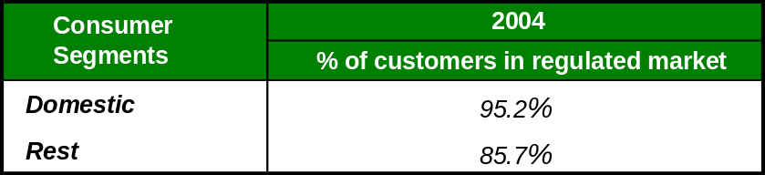

In the gas sector, all consumers have the possibility of continuing to receive their supply in the regulated market, through a distributor at the relevant sale price. However, in accordance with the Royal Decree proposal that adapts regulations relating to the hydrocarbons sector to the provisions of the Council of Ministers Agreement of 25 February 2005, which adopts mandates to implement measures to encourage productivity: “consumers whose annual natural gas consumption is equal to or less than 100 million kWh, in order to apply for the switch from the deregulated market to the regulated market must remain in the deregulated market for a minimum period of three years and must submit their application to switch to the regulated market at least six months prior to the date on which the switch is planned to take place”.

The sale prices applied in the regulated market are updated every three months, in January, April, July and October, in accordance with Order ITC/104/2005, which establishes natural gas and piped manufactured gas prices, meter rental and connection rights for consumers connected to networks with a supply pressure of equal to or less than 4 bars (please see point 4.1.3).

As regards the last resort supplier, at present the distributors are in charge of supplying customers in the regulated market.

The following table shows the percentage of consumers in each segment, both domestic and other (commercial and industrial) who receive their supply in the regulated market.

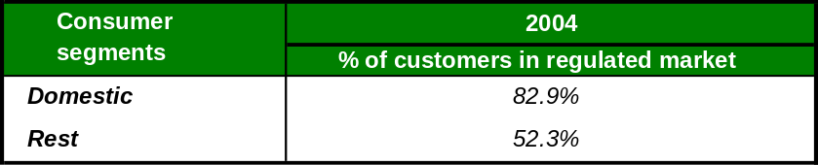

Information taken from the eleventh provision of the hydrocarbons law (Law 34/1998) and from the Spanish National Energy Commission’s Regulations (Royal Decree 1339/1999)
For example, aggregate flows, available capacity, demand forecast and maintenance programs.
Not including the LNG storage fee
i.e. a quantity of imbalance that network users can maintain without being the subject of charges.
The Commission has asked regulators to examine compliance by access regimes for underground storage with the GGPSO (guidelines for good TPA practice for storage system operators) and to report it in the Madrid Forum. Furthermore, these results will be used in the 2005 report.
Mm³(n): Millions of normal cubic meters (10⁶)
Defined as covering any transaction of gas between market participants other than final end use customers.
Description of the products being traded in organised markets and the degree of liquidity for each product.
What prices were paid, which companies and what were the effects on the market
Data on ordinary regime.
Data on special regime.
Solar, biomass, waste and waste treatment.
Domestic consumers include customers subject to rates 2.0, 2.0 N and 1.0.
The pricing system in force does not distinguish between uses, therefore the following distinction has been established considering the rates that are generally applied to domestic customers (3.1 and 3.2) and the other rates.

