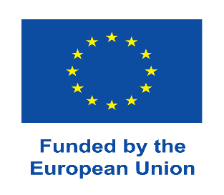 |  | 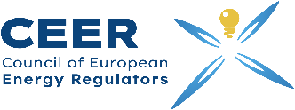

PR-26-02
Press release

Unlocking Flexibility for a Clean Energy Future:
EU4Energy Phase III (CEER) Brings Together European and Eastern Partnership Energy Experts in Brussels

Brussels, Belgium, 10 June 2026 – As Europe accelerates its clean energy transition and renewable energy integration, flexibility is becoming a cornerstone of resilient, secure and future-proof electricity systems. Against this backdrop, the Training Academy of the Council of European Energy Regulators (CEER), within the framework of the EU4Energy Phase III Project on Promoting the Clean Energy Transition and Connectivity in the Eastern Partnership countries, organised a two-day regional training “Unlocking Flexibility for a Clean Energy Future” on 9–10 June 2026 in Brussels, Belgium.
The event brought together representatives of the line ministries and energy regulatory authorities from the Eastern Partnership countries, as well as energy experts from the European Union, to exchange experiences and explore innovative regulatory and market solutions that enable greater system flexibility in increasingly decarbonised power systems. Experts from CEER, ENTSO-E, ACER, Energiavirasto, Smart Energy Europe, ARERA and Energy Storage Europe Association shared European best practices and practical experience.
As renewable energy deployment accelerates across Europe and neighbouring regions, electricity systems require more adaptive and responsive market structures capable of balancing supply and demand in real time. The training course, therefore, focused on the evolving policy, regulatory and technical frameworks needed to support this transformation and facilitate the integration of renewable energy sources.
Opening the event, Mr Bram Claeys, Secretary General of CEER, underlined the strategic importance of flexibility in ensuring both the reliability and affordability of future electricity systems, while highlighting the value of regional cooperation and knowledge sharing in addressing common energy transition challenges.
Beyond technical discussions, the training course also reinforced regional dialogue and cooperation, supporting Eastern Partnership countries in advancing modern, interconnected and sustainable electricity markets aligned with EU objectives.

The EU4Energy Phase III is funded by the European Union with a total budget of €6 million and is implemented by CEER. The project aims to contribute to the accelerated transition to interconnected, secure, sustainable, and low-emission energy systems in the Eastern Partnership Countries.

Media Contact:
 | Council of European Energy Regulators (CEER)
 | Nino Bukhnikashvili
Phone | +99 5 5 99 53 7178
Email | Nino.bukhnikashvili@ceer.eu
Website | www.ceer.eu
Twitter | twitter.com/CEERenergy
LinkedIn | linkedin.com/company/council-of-european-energy-regulators
Facebook | facebook.com/CEERenergy

